Linear Search Code:
#include<stdio.h>
int main()
{
int arr[50],n,flag=0,k;
printf("Enter the number of elements: \n");
scanf("%d",&n);
printf("Enter the elements in array: \n");
for(int i=0;i<n;i++)
{
scanf("%d",&arr[i]);

}
printf("Enter the element to search: \n");
scanf("%d",&k);
for(int i=0;i<n;i++)
{
if(arr[i]==k)
{
printf("Element found at position %d\n", i + 1);
flag = 1;
break;

}

}
if(flag==0)
{
printf("Element not found \n ");
}

}
Output:
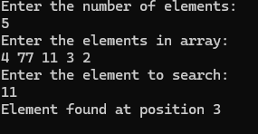

Binary Search Code:
#include <stdio.h>

int binarySearch(int arr[], int n, int key)
{
int low = 0;
int high = n - 1;
int mid;
while (low <= high)
{
mid = (low + high) / 2;
if (arr[mid] == key)
return mid;

else if (arr[mid] > key) // search left half
high = mid - 1;

else // search right half
low = mid + 1;
}
return -1;
}
int main()
{
int n, key, i;

printf("Enter number of elements: ");
scanf("%d", &n);

int arr[n];
printf("Enter sorted elements:\n");
for (i = 0; i < n; i++)
scanf("%d", &arr[i]);

printf("Enter element to search: ");
scanf("%d", &key);

int result = binarySearch(arr, n, key);

if (result == -1)
printf("Element not found");
else
printf("Element found at index %d", result);

return 0;
}
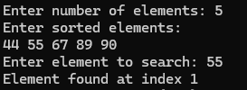

Binary Search in Linked List
Code:
#include <stdio.h>
#include <stdlib.h>

struct Node
{
int data;
struct Node* next;
};

// Create new node
struct Node* create(int data)
{
struct Node* new = (struct Node*)malloc(sizeof(struct Node));
new->data = data;
new->next = NULL;
return new;
}

int countNodes(struct Node* head)
{
int count = 0;
while (head != NULL)
{
count++;
head = head->next; // semicolon fixed
}
return count;
}

struct Node* getNode(struct Node* head, int pos)
{
for (int i = 0; i < pos; i++)
head = head->next;
return head;
}

int binarySearch(struct Node* head, int key)
{
int low = 0;
int high = countNodes(head) - 1;

while (low <= high)
{
int mid = (low + high) / 2;
struct Node* midNode = getNode(head, mid);

if (midNode->data == key)
return mid;

else if (midNode->data > key)
high = mid - 1;

else
low = mid + 1;
}
return -1;
}

int main()
{
int n, i, x, key;
struct Node* head = NULL;
struct Node* temp = NULL;
struct Node* tail = NULL;

printf("Enter number of elements: ");
scanf("%d", &n);

printf("Enter sorted elements:\n");
for (i = 0; i < n; i++)
{
scanf("%d", &x);
temp = create(x);

if (head == NULL)
{
head = temp;
tail = temp;
}
else
{
tail->next = temp;
tail = temp;
}
}

printf("Enter element to search: ");
scanf("%d", &key);

int pos = binarySearch(head, key);

if (pos == -1)
printf("Element not found");
else
printf("Element found at position %d", pos + 1);

return 0;
}

Output:
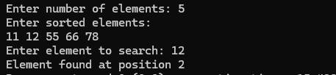

Quick Sort
Code:
#include <stdio.h>

int partition(int a[], int low, int high) {
int pivot = a[low];
int i = low + 1;
int j = high;

while (1) {
while (i <= high && a[i] <= pivot)
i++;

while (a[j] > pivot)
j--;

if (i < j) {
int temp = a[i];
a[i] = a[j];
a[j] = temp;
} else {
int temp = a[low];
a[low] = a[j];
a[j] = temp;
return j;
}
}
}

void quickSort(int a[], int low, int high) {
if (low < high) {
int p = partition(a, low, high);

quickSort(a, low, p - 1);
quickSort(a, p + 1, high);
}
}

int main() {
int a[] = {5, 2, 9, 1, 6};
int n = 5;

quickSort(a, 0, n - 1);

for (int i = 0; i < n; i++)
printf("%d ", a[i]);

return 0;
}
Output:
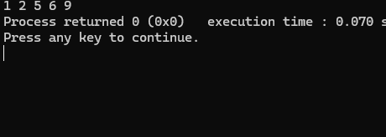

Merge Sort
Code:
#include <stdio.h>

void merge(int a[], int l, int m, int r)
{
int i = l;
int j = m + 1;
int k = 0;
int temp[50];

while (i <= m && j <= r)
{
if (a[i] < a[j])
temp[k++] = a[i++];
else
temp[k++] = a[j++];
}

while (i <= m)
temp[k++] = a[i++];

while (j <= r)
temp[k++] = a[j++];

for (i = l, k = 0; i <= r; i++, k++)
a[i] = temp[k];
}

void mergeSort(int a[], int l, int r)
{
if (l < r)
{
int m = (l + r) / 2;
mergeSort(a, l, m);
mergeSort(a, m + 1, r);
merge(a, l, m, r);
}
}

int main()
{
int n, i;
int a[50];

printf("Enter number of elements: ");
scanf("%d", &n);

printf("Enter elements:\n");
for (i = 0; i < n; i++)
scanf("%d", &a[i]);

mergeSort(a, 0, n - 1);

printf("Sorted array:\n");
for (i = 0; i < n; i++)
printf("%d ", a[i]);

return 0;
}

Output:
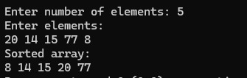
Linked List Addition with Carry
Code:
#include <stdio.h>
#include <stdlib.h>

struct Node {
int data;
struct Node* link;
};

struct Node* createNode(int value) {
struct Node* temp = (struct Node*)malloc(sizeof(struct Node));
temp->data = value;
temp->link = NULL;
return temp;
}

int lengthOfList(struct Node* head) {
int count = 0;
while (head != NULL) {
count++;
head = head->link;
}
return count;
}

struct Node* addLeadingZeros(struct Node* head, int count) {
while (count--) {
struct Node* temp = createNode(0);
temp->link = head;
head = temp;
}
return head;
}

int carryValue = 0;

struct Node* addListsRecursive(struct Node* a, struct Node* b) {
if (a == NULL && b == NULL) {
return NULL;
}

struct Node* next = addListsRecursive(a->link, b->link);

int total = a->data + b->data + carryValue;
carryValue = total / 10;

struct Node* current = createNode(total % 10);
current->link = next;

return current;
}

struct Node* addTwoLinkedLists(struct Node* first, struct Node* second) {
int len1 = lengthOfList(first);
int len2 = lengthOfList(second);

if (len1 < len2) {
first = addLeadingZeros(first, len2 - len1);
} else if (len2 < len1) {
second = addLeadingZeros(second, len1 - len2);
}

carryValue = 0;
struct Node* sumList = addListsRecursive(first, second);

if (carryValue > 0) {
struct Node* temp = createNode(carryValue);
temp->link = sumList;
sumList = temp;
}

return sumList;
}

struct Node* buildList(char* number) {
struct Node* head = NULL;
struct Node* tail = NULL;

for (int i = 0; number[i] != '\0'; i++) {
struct Node* temp = createNode(number[i] - '0');

if (head == NULL) {
head = temp;
tail = temp;
} else {
tail->link = temp;
tail = temp;
}
}
return head;
}

void displayList(struct Node* head) {
while (head != NULL) {
printf("%d", head->data);
if (head->link != NULL)
printf(" -> ");
head = head->link;
}
printf("\n");
}

int main() {
char input1[100], input2[100];

printf("Enter first number: ");
scanf("%s", input1);

printf("Enter second number: ");
scanf("%s", input2);

struct Node* num1 = buildList(input1);
struct Node* num2 = buildList(input2);

printf("First List: ");
displayList(num1);

printf("Second List: ");
displayList(num2);

struct Node* result = addTwoLinkedLists(num1, num2);

printf("Sum List: ");
displayList(result);

return 0;
}
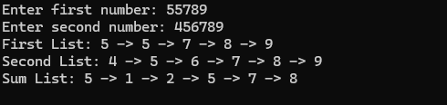

Subtraction with Borrow
#include<stdio.h>
#include<stdlib.h>

struct Node{
int data;
struct Node* next;
};

struct Node* createNode(int val){
struct Node* temp=(struct Node*)malloc(sizeof(struct Node));
temp->data=val;
temp->next=NULL;
return temp;
}

struct Node* reverseList(struct Node* head){
struct Node* prev=NULL;
struct Node* curr=head;
struct Node* next=NULL;

while(curr!=NULL){
next=curr->next;
curr->next=prev;
prev=curr;
curr=next;
}
return prev;
}

struct Node* buildList(char* num){
struct Node* head=NULL;
struct Node* tail=NULL;

for(int i=0;num[i]!='\0';i++){
struct Node* temp=createNode(num[i]-'0');

if(head==NULL){
head=temp;
tail=temp;
}else{
tail->next=temp;
tail=temp;
}
}
return head;
}

void displayList(struct Node* head){
while(head!=NULL){
printf("%d",head->data);
if(head->next!=NULL)
printf(" -> ");
head=head->next;
}
printf("\n");
}

struct Node* subtractLists(struct Node* l1,struct Node* l2){

l1=reverseList(l1);
l2=reverseList(l2);

struct Node* result=NULL;
struct Node* tail=NULL;

int borrow=0;

while(l1!=NULL){

int d1=l1->data;
int d2=(l2!=NULL)?l2->data:0;

int diff=d1-borrow-d2;

if(diff<0){
diff+=10;
borrow=1;
}else{
borrow=0;
}

struct Node* temp=createNode(diff);

if(result==NULL){
result=temp;
tail=temp;
}else{
tail->next=temp;
tail=temp;
}

l1=l1->next;
if(l2!=NULL)
l2=l2->next;
}

result=reverseList(result);

return result;
}

int main(){

char num1[100],num2[100];

printf("Enter first number (>= second): ");
scanf("%s",num1);

printf("Enter second number: ");
scanf("%s",num2);

struct Node* n1=buildList(num1);
struct Node* n2=buildList(num2);

printf("First: ");
displayList(n1);

printf("Second: ");
displayList(n2);

struct Node* ans=subtractLists(n1,n2);

printf("Result: ");
displayList(ans);

return 0;
}
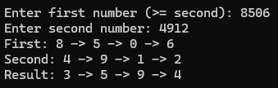

Linked List Multiplication
#include<stdio.h>
#include<stdlib.h>

struct Node{
int data;
struct Node* next;
};

struct Node* createNode(int val){
struct Node* temp=(struct Node*)malloc(sizeof(struct Node));
temp->data=val;
temp->next=NULL;
return temp;
}

struct Node* buildList(char* num){
struct Node* head=NULL;
struct Node* tail=NULL;

for(int i=0;num[i]!='\0';i++){
struct Node* temp=createNode(num[i]-'0');

if(head==NULL){
head=temp;
tail=temp;
}else{
tail->next=temp;
tail=temp;
}
}
return head;
}

void displayList(struct Node* head){
while(head!=NULL){
printf("%d",head->data);
if(head->next!=NULL)
printf(" -> ");
head=head->next;
}
printf("\n");
}

/* Convert List to Number */
long long listToNumber(struct Node* head){

long long num=0;

while(head!=NULL){
num=num*10+head->data;
head=head->next;
}

return num;
}

/* Convert Number to List */
struct Node* numberToList(long long num){

if(num==0)
return createNode(0);

struct Node* head=NULL;

while(num>0){
struct Node* temp=createNode(num%10);
temp->next=head;
head=temp;
num/=10;
}

return head;
}

int main(){

char num1[50],num2[50];

printf("Enter first number: ");
scanf("%s",num1);

printf("Enter second number: ");
scanf("%s",num2);

struct Node* n1=buildList(num1);
struct Node* n2=buildList(num2);

printf("First: ");
displayList(n1);

printf("Second: ");
displayList(n2);

long long a=listToNumber(n1);
long long b=listToNumber(n2);

long long product=a*b;

struct Node* result=numberToList(product);

printf("Product: ");
displayList(result);

return 0;
}
Output:
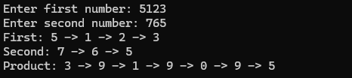

City Database Array
Code
#include <stdio.h>
#include <string.h>
#include <math.h>

struct City {
char name[50];
int x;
int y;
};

struct City database[100];
int count = 0;

void insert() {
if (count < 100) {
printf("Name: ");
scanf("%s", database[count].name);
printf("X and Y: ");
scanf("%d %d", &database[count].x, &database[count].y);
count = count + 1;
}
}

void search() {
char target[50];
printf("Search Name: ");
scanf("%s", target);
for (int i = 0; i < count; i++) {
if (strcmp(database[i].name, target) == 0) {
printf("Found: %s at %d,%d\n", database[i].name, database[i].x, database[i].y);
return;
}
}
printf("Not found\n");
}

void deleteCity() {
char target[50];
printf("Delete Name: ");
scanf("%s", target);
for (int i = 0; i < count; i++) {
if (strcmp(database[i].name, target) == 0) {
database[i] = database[count - 1];
count = count - 1;
printf("Deleted\n");
return;
}
}
printf("Not found\n");
}

void distance() {
int x1, y1, d;
printf("Enter x, y and distance limit: ");
scanf("%d %d %d", &x1, &y1, &d);
for (int i = 0; i < count; i++) {
int x2 = database[i].x;
int y2 = database[i].y;
float dist = sqrt(((x2 - x1) * (x2 - x1)) + ((y2 - y1) * (y2 - y1)));
if (dist <= d) {
printf("%s is %.2f away\n", database[i].name, dist);
}
}
}

void display() {
for (int i = 0; i < count; i++) {
printf("%s (%d, %d)\n", database[i].name, database[i].x, database[i].y);
}
}

int main() {
int choice;
while (1) {
printf("\n1.Add 2.Search 3.Delete 4.Dist 5.Show 6.Exit: ");
scanf("%d", &choice);
if (choice == 1) insert();
else if (choice == 2) search();
else if (choice == 3) deleteCity();
else if (choice == 4) distance();
else if (choice == 5) display();
else break;
}
return 0;
}

Output:
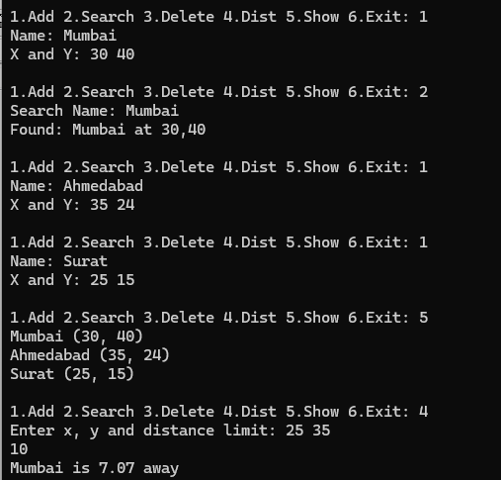

City Database Sorted
#include <stdio.h>
#include <string.h>
#include <math.h>

struct City {
char name[50];
int x;
int y;
};

struct City database[100];
int count = 0;

void insert() {
if (count >= 100) return;

char n[50];
int tx, ty;
printf("Name: ");
scanf("%s", n);
printf("X and Y: ");
scanf("%d %d", &tx, &ty);

int i = count - 1;
while (i >= 0 && strcmp(database[i].name, n) > 0) {
database[i + 1] = database[i];
i--;
}

strcpy(database[i + 1].name, n);
database[i + 1].x = tx;
database[i + 1].y = ty;
count++;
}

void search() {
char target[50];
printf("Search Name: ");
scanf("%s", target);

int low = 0, high = count - 1;
while (low <= high) {
int mid = (low + high) / 2;
int res = strcmp(database[mid].name, target);
if (res == 0) {
printf("Found: %s at %d,%d\n", database[mid].name, database[mid].x, database[mid].y);
return;
}
if (res < 0) low = mid + 1;
else high = mid - 1;
}
printf("Not found\n");
}

void deleteCity() {
char target[50];
printf("Delete Name: ");
scanf("%s", target);
int i, found = 0;
for (i = 0; i < count; i++) {
if (strcmp(database[i].name, target) == 0) {
found = 1;
break;
}
}
if (found) {
for (int j = i; j < count - 1; j++) {
database[j] = database[j + 1];
}
count--;
printf("Deleted\n");
} else {
printf("Not found\n");
}
}

void distance() {
int x1, y1, d;
printf("Enter x, y and distance limit: ");
scanf("%d %d %d", &x1, &y1, &d);
for (int i = 0; i < count; i++) {
float dist = sqrt(((database[i].x - x1) * (database[i].x - x1)) + ((database[i].y - y1) * (database[i].y - y1)));
if (dist <= d) printf("%s is %.2f away\n", database[i].name, dist);
}
}

void display() {
for (int i = 0; i < count; i++) printf("%s (%d, %d)\n", database[i].name, database[i].x, database[i].y);
}

int main() {
int choice;
while (1) {
printf("\n1.Add 2.Search 3.Delete 4.Dist 5.Show 6.Exit: ");
scanf("%d", &choice);
if (choice == 1) insert();
else if (choice == 2) search();
else if (choice == 3) deleteCity();
else if (choice == 4) distance();
else if (choice == 5) display();
else break;
}
return 0;
}
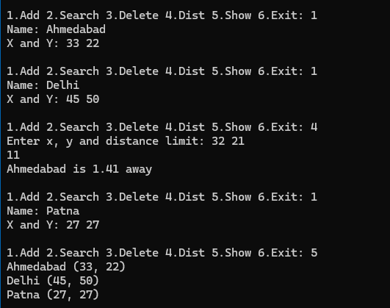
City Database Linked List
#include <stdio.h>
#include <stdlib.h>
#include <string.h>
#include <math.h>

struct Node {
char name[50];
int x;
int y;
struct Node* next;
};

struct Node* head = NULL;

void insert() {
struct Node* newNode = (struct Node*)malloc(sizeof(struct Node));
printf("Name: ");
scanf("%s", newNode->name);
printf("X and Y: ");
scanf("%d %d", &newNode->x, &newNode->y);
newNode->next = head;
head = newNode;
}

void search() {
char target[50];
printf("Search Name: ");
scanf("%s", target);
struct Node* temp = head;
while (temp != NULL) {
if (strcmp(temp->name, target) == 0) {
printf("Found: %s at %d,%d\n", temp->name, temp->x, temp->y);
return;
}
temp = temp->next;
}
printf("Not found\n");
}

void deleteCity() {
char target[50];
printf("Delete Name: ");
scanf("%s", target);
struct Node *temp = head, *prev = NULL;
while (temp != NULL) {
if (strcmp(temp->name, target) == 0) {
if (prev == NULL) head = temp->next;
else prev->next = temp->next;
free(temp);
printf("Deleted\n");
return;
}
prev = temp;
temp = temp->next;
}
printf("Not found\n");
}

void distance() {
int x1, y1, d;
printf("Enter x, y and distance limit: ");
scanf("%d %d %d", &x1, &y1, &d);
struct Node* temp = head;
while (temp != NULL) {
float dist = sqrt(((temp->x - x1) * (temp->x - x1)) + ((temp->y - y1) * (temp->y - y1)));
if (dist <= d) {
printf("%s is %.2f away\n", temp->name, dist);
}
temp = temp->next;
}
}

void display() {
struct Node* temp = head;
while (temp != NULL) {
printf("%s (%d, %d)\n", temp->name, temp->x, temp->y);
temp = temp->next;
}
}

int main() {
int choice;
while (1) {
printf("\n1.Add 2.Search 3.Delete 4.Dist 5.Show 6.Exit: ");
scanf("%d", &choice);
if (choice == 1) insert();
else if (choice == 2) search();
else if (choice == 3) deleteCity();
else if (choice == 4) distance();
else if (choice == 5) display();
else break;
}
return 0;
}
Output:
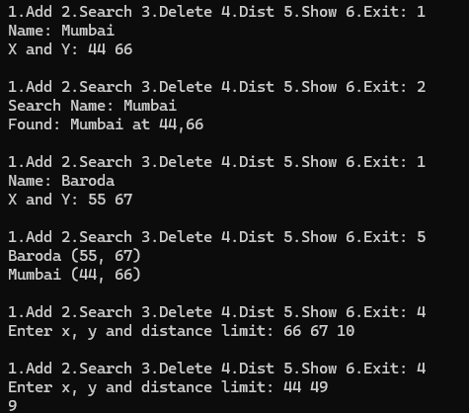
Strassen’s Matrix Multiplication
#include <stdio.h>
#define MAX 10

void inputMatrix(int A[MAX][MAX],int n)
{
for(int i=0;i<n;i++)
for(int j=0;j<n;j++)
scanf("%d",&A[i][j]);
}

void printMatrix(int A[MAX][MAX],int n)
{
for(int i=0;i<n;i++)
{
for(int j=0;j<n;j++)
printf("%d ",A[i][j]);
printf("\n");
}
}

void addMatrix(int A[MAX][MAX], int B[MAX][MAX], int C[MAX][MAX], int n)
{
for(int i=0;i<n;i++)
for(int j=0;j<n;j++)
C[i][j] = A[i][j] + B[i][j];
}

void subMatrix(int A[MAX][MAX], int B[MAX][MAX], int C[MAX][MAX], int n)
{
for(int i=0;i<n;i++)
for(int j=0;j<n;j++)
C[i][j] = A[i][j] - B[i][j];
}

void strassen(int A[MAX][MAX], int B[MAX][MAX], int C[MAX][MAX], int n)
{
if(n==1)
{
C[0][0] = A[0][0] * B[0][0];
return;
}

int k = n/2;

int A11[MAX][MAX],A12[MAX][MAX],A21[MAX][MAX],A22[MAX][MAX];
int B11[MAX][MAX],B12[MAX][MAX],B21[MAX][MAX],B22[MAX][MAX];

int M1[MAX][MAX],M2[MAX][MAX],M3[MAX][MAX],M4[MAX][MAX];
int M5[MAX][MAX],M6[MAX][MAX],M7[MAX][MAX];

int T1[MAX][MAX],T2[MAX][MAX];

for(int i=0;i<k;i++)
{
for(int j=0;j<k;j++)
{
A11[i][j] = A[i][j];
A12[i][j] = A[i][j+k];
A21[i][j] = A[i+k][j];
A22[i][j] = A[i+k][j+k];

B11[i][j] = B[i][j];
B12[i][j] = B[i][j+k];
B21[i][j] = B[i+k][j];
B22[i][j] = B[i+k][j+k];
}
}

addMatrix(A11,A22,T1,k);
addMatrix(B11,B22,T2,k);
strassen(T1,T2,M1,k);

addMatrix(A21,A22,T1,k);
strassen(T1,B11,M2,k);

subMatrix(B12,B22,T2,k);
strassen(A11,T2,M3,k);

subMatrix(B21,B11,T2,k);
strassen(A22,T2,M4,k);

addMatrix(A11,A12,T1,k);
strassen(T1,B22,M5,k);

subMatrix(A21,A11,T1,k);
addMatrix(B11,B12,T2,k);
strassen(T1,T2,M6,k);

subMatrix(A12,A22,T1,k);
addMatrix(B21,B22,T2,k);
strassen(T1,T2,M7,k);

for(int i=0;i<k;i++)
{
for(int j=0;j<k;j++)
{
C[i][j] = M1[i][j] + M4[i][j] - M5[i][j] + M7[i][j];
C[i][j+k] = M3[i][j] + M5[i][j];
C[i+k][j] = M2[i][j] + M4[i][j];
C[i+k][j+k] = M1[i][j] - M2[i][j] + M3[i][j] + M6[i][j];
}
}
}

int main()
{
int n;
int A[MAX][MAX], B[MAX][MAX], C[MAX][MAX];

printf("Enter size (power of 2): ");
scanf("%d",&n);

printf("Enter Matrix A:\n");
inputMatrix(A,n);

printf("Enter Matrix B:\n");
inputMatrix(B,n);

strassen(A,B,C,n);

printf("Result Matrix:\n");
printMatrix(C,n);

return 0;
}
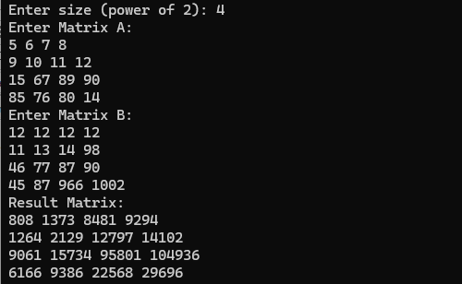

Coin Changing Algorithm
Code:
#include<stdio.h>

// Greedy Algorithm for coins works only if coins are arranged in descending order
void sortDescending(int coins[], int n)
{
for(int i = 0; i < n - 1; i++)
{
for(int j = 0; j < n - i - 1; j++)
{
if(coins[j] < coins[j + 1])
{
int temp = coins[j];
coins[j] = coins[j + 1];
coins[j + 1] = temp;
}
}
}
}

void coinChange(int coins[], int n, int amount)
{
int count[n];

for(int i = 0; i < n; i++)
{
count[i] = 0;
}

for(int i = 0; i < n; i++)
{
if(amount >= coins[i])
{
count[i] = amount / coins[i];
amount = amount % coins[i];
}
}

printf("\nCoin usage:\n");

for(int i = 0; i < n; i++)
{
if(count[i] > 0)
{
printf("%d coin(s) of %d\n", count[i], coins[i]);
}
}

if(amount != 0)
{
printf("Remaining amount cannot be formed.\n");
}
}

int main()
{
int n, amount;

printf("Enter number of coin denominations: ");
scanf("%d", &n);

int coins[n];

printf("Enter coin denominations: ");
for (int i = 0; i < n; i++) {
scanf("%d", &coins[i]);
}

// Sort coins
sortDescending(coins, n);

printf("Enter amount: ");
scanf("%d", &amount);

coinChange(coins, n, amount);

return 0;
}

Output:

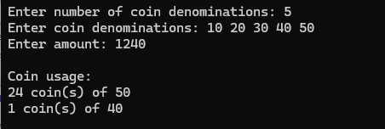

Djikstra Algorithm Code
#include <stdio.h>
#include <stdbool.h>
#include <limits.h>

#define V 9

int minDistance(int dist[], bool sptSet[]) {
int min = INT_MAX, min_index;
for (int v = 0; v < V; v++)
if (sptSet[v] == false && dist[v] <= min)
min = dist[v], min_index = v;
return min_index;
}

void printSolution(int dist[]) {
printf("Vertex \t Distance from Source\n");
for (int i = 0; i < V; i++)
printf("%d \t\t\t %d\n", i, dist[i]);
}

void dijkstra(int graph[V][V], int src) {
int dist[V];
bool sptSet[V];

for (int i = 0; i < V; i++)
dist[i] = INT_MAX, sptSet[i] = false;

dist[src] = 0;

for (int count = 0; count < V - 1; count++) {
int u = minDistance(dist, sptSet);
sptSet[u] = true;

for (int v = 0; v < V; v++)
if (!sptSet[v] && graph[u][v] && dist[u] != INT_MAX
&& dist[u] + graph[u][v] < dist[v])
dist[v] = dist[u] + graph[u][v];
}

printSolution(dist);
}

int main() {
int graph[V][V] = { { 0, 4, 0, 0, 0, 0, 0, 8, 0 },
{ 4, 0, 8, 0, 0, 0, 0, 11, 0 },
{ 0, 8, 0, 7, 0, 4, 0, 0, 2 },
{ 0, 0, 7, 0, 9, 14, 0, 0, 0 },
{ 0, 0, 0, 9, 0, 10, 0, 0, 0 },
{ 0, 0, 4, 14, 10, 0, 2, 0, 0 },
{ 0, 0, 0, 0, 0, 2, 0, 1, 6 },
{ 8, 11, 0, 0, 0, 0, 1, 0, 7 },
{ 0, 0, 2, 0, 0, 0, 6, 7, 0 } };

dijkstra(graph, 0);
return 0;
}
Output:
