JavaScript is a single-threaded language, which means it can only execute one task at a time. It is also synchronous , which means that tasks are executed in the order in which they are presented to the engine. This nature of JavaScript is the default nature of JavaScript.

This can sometimes lead to problems, such as when a long-running task blocks the execution of other tasks. However, there are a number of ways to work around these problems, such as using asynchronous programming techniques.

Asynchronous programming is a way of writing code that allows multiple tasks to be executed at the same time. This is done by using callbacks, which are functions that are called when a certain event occurs.

In JavaScript, Blocking code is code that prevents the execution of other code until it is finished. Non-blocking code, on the other hand, does not prevent the execution of other code.
Blocking code is typically used for synchronous operations, such as reading a file or waiting for a network response. Non-blocking code is typically used for asynchronous operations, such as setting a timer or listening for an event.

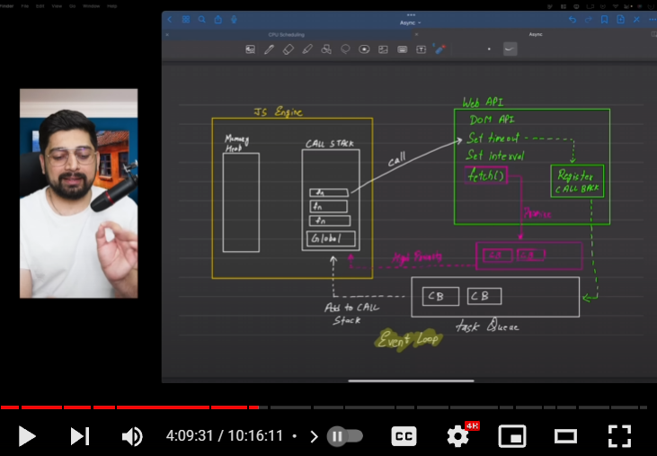

- In JavaScript, a Promise is a special object that represents the eventual completion or failure of an asynchronous operation and its resulting value. Promises are a way to work with asynchronous code more easily and to handle operations like fetching data, reading files, or making network requests.

- Promises are objects representing the eventual completion or failure of an asynchronous operation. They provide a more structured and readable way to work with asynchronous code.

>> A Promise can be in one of three states:

Pending: The initial state; the promise is neither fulfilled nor rejected.
Fulfilled: The operation completed successfully, and the promise has a resulting value.
Rejected: The operation failed, and the promise has a reason for the failure.

>> Promises have two main components:

Producer: The code that generates the promise. This code might represent an asynchronous operation, like fetching data from a server.
Consumer: The code that wants to use the result of the asynchronous operation. It can attach callbacks to the promise to be executed when the promise is fulfilled or rejected.

Here's a basic example of a Promise in JavaScript:

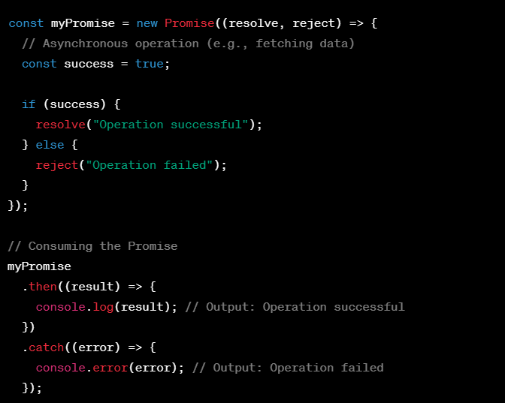

In the example above:
The Promise constructor takes a function with resolve and reject parameters. These functions are called based on the success or failure of the asynchronous operation.
The then method is used to handle the fulfillment of the promise, and the catch method is used to handle any errors.

Promises provide a cleaner and more structured way to deal with asynchronous code compared to traditional callback patterns. They are widely used in modern JavaScript development and are a fundamental part of the language.

In a JavaScript Promise, resolve and reject are two functions provided by the Promise constructor that are used to control the state of the promise.

resolve function:

The resolve function is used when the asynchronous operation represented by the promise is successfully completed.

It takes one argument, which is the value that the promise will be resolved with.
Once resolve is called, the promise transitions from the "pending" state to the "fulfilled" state, and any attached then handlers are invoked with the resolved value.

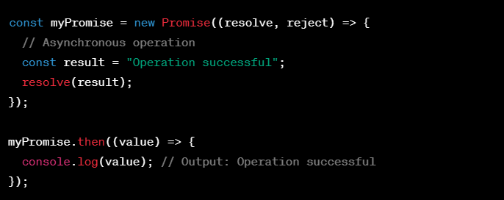

reject function:

The reject function is used when the asynchronous operation fails or encounters an error.

It takes one argument, which is typically an error object or a reason for the rejection.
Once reject is called, the promise transitions from the "pending" state to the "rejected" state, and any attached catch or then handlers with a rejection callback are invoked.

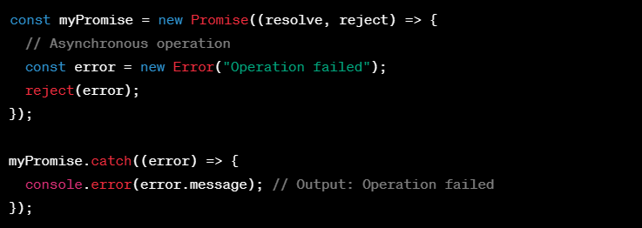

** In summary, resolve is used to fulfill the promise with a successful result, and reject is used to reject the promise with an error or failure. The usage of these functions allows you to handle the outcome of asynchronous operations in a structured manner using Promises. **

