Flow Chart:
New Connection:
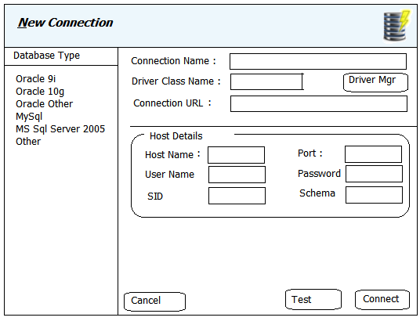
Click on “New Connection” from Menu
Open Connection Dialog

