|  |  |  |
| --- | --- | --- |
|  | GOVERNMENT OF KARNATAKA | Form No: |
| Department of Technical Education | Revision: |
| Shree Vidyadhiraj Polytechnic, Kumta (370) -581362 |  |
| E-Mail: -svpkumta@gmail.com | Date: |

**Capstone project**

**Format- 1**

**Capstone project Scope Document**

**Capstone project Scope Document**

The capstone project scope clearly describes what the capstone project will deliver and outlines all the work required for completing the capstone project.

________________________________________________________________________________________________________________

Capstone project Title: Student Database Management System

**Group Members:**

* Anant Bhat
* Anusha Achari
* Navya Hebbar
* Suhas Shetti

**Problem Statement:**

Design and develop a **STUDENT DATABASE MANAGEMENT SYSTEM** which allows staff members to maintain student marks,attendance & personal information

**Objectives:**

The goal of the Student Database Management System is to create a centralized, user-friendly, where staff members can easily access,update,delete & maintain records. This platform aims to maintain student, staff’s, course, department details in online.

* **Centralized Record Management: Develop a centralized database to store and manage student, staff, course, and department details in a structured and organized manner, ensure efficient retrieval of information for authorized users.**
* Access Control and Security:Implement access control mechanisms to ensure that only authorized staff members can access, update, and delete records.Incorporate robust security measures to protect sensitive data.
* Record Maintenance:Enable staff members to easily update and maintain records through a simple and efficient interface.Provide functionalities for adding new records, updating existing information, and deleting outdated records.

**Capstone project description:**

* The Student Database Management System aims to develop a comprehensive College Management System that enables users to maintain student marks,attendance & personal information.
* It consists of a website that allows users to browse through different department information , their availability.
* Once the student record is inserted , the staff members have the option to update and delete.

**Capstone project Deliverables:**

* The Student Database Management System project deliverables include a fully functional software application with features such as maintaining student marks, attendance, student personal information ,staff details, course details & department information.
* For Maintenance and support documentation will be included.

Key milestones:

* Project Planning and Analysis
* Design and Development
* Testing and Quality Assurance
* Deployment and Implementation
* Maintenance and Support

Constraints:

* Limited budget
* Limited time
* Limited resources
* User adoption
* Integration with existing systems
* Security and compliance.

Estimated Capstone project Duration:

* The estimated duration of Student Database Management System Capstone project may range from 3 to 4 months, depending on the scope and complexity of the project.

Estimated Capstone project cost: 329550/INR

Date: Signature of the student

Signature of the cohort owner

|  |  |  |
| --- | --- | --- |
|  | GOVERNMENT OF KARNATAKA | Form No: |
| Department of Technical Education | Revision: |
| Shree Vidyadhiraj Polytechnic, Kumta (370) -581362 |  |
| E-Mail: -svpkumta@gmail.com | Date: |

**Capstone project**

**Format- 2**

**Work Breakdown Structure**

**Capstone project Name:** Student Database Management System

**Capstone project Members:**

* Anant Bhat
* Anusha Achari
* Navya Hebbar
* Suhas Shetti

**Capstone project Objective(s):**

* The goal of the College Management System is to create a centralized, user-friendly, where staff members can easily access,update,delete & maintainrecords. This platform aims to maintain student, staff’s, course, departmentdetails in online.
* The system should be easy to use for both the Staffs and the Students, and should provide a seamless browsing experience.

**Work Breakdown Structure - Deliverables**

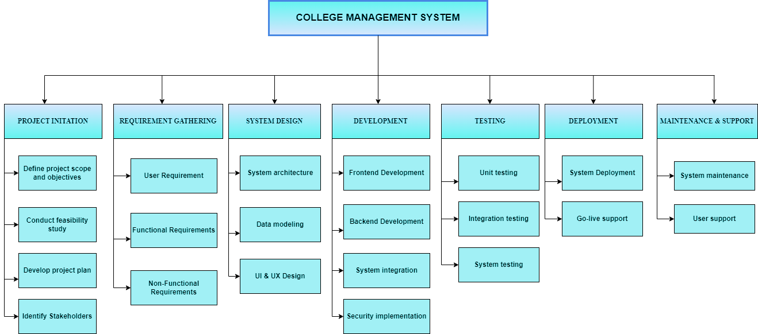

Date:

Signature of the student

Signature of the cohort owner

|  |  |  |
| --- | --- | --- |
|  | GOVERNMENT OF KARNATAKA | Form No: |
| Department of Technical Education | Revision: |
| Shree Vidyadhiraj Polytechnic, Kumta (370) -581362 |  |
| E-Mail: -svpkumta@gmail.com | Date: |

**Capstone project**

**Format- 3**

**Time - line Schedule**

Capstone project Name: Student Database Management System

Capstone project Members: Anant Bhat,Anusha Achari,Navya Hebbar,Suhas Shetti

Gantt Chart:

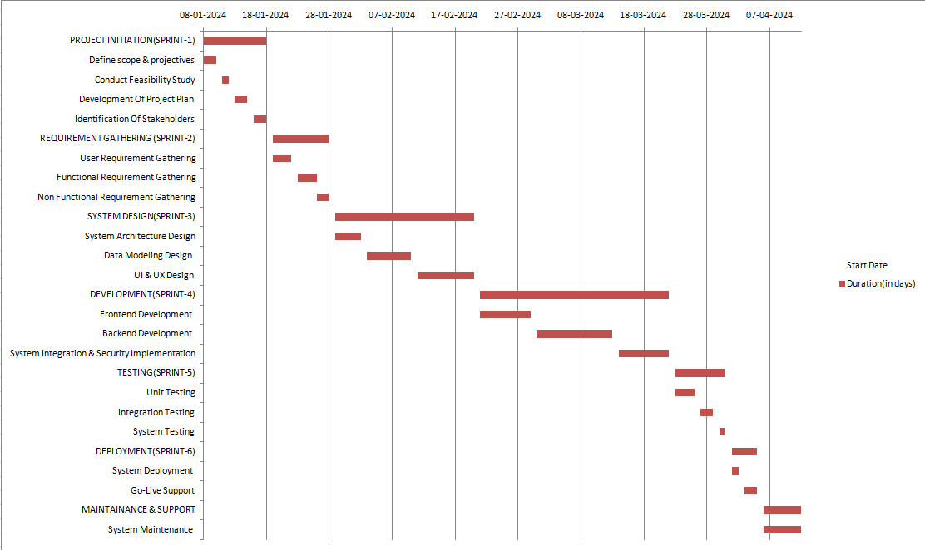

Date: Signature of the student

Signature of the cohort owner

|  |  |  |
| --- | --- | --- |
|  | GOVERNMENT OF KARNATAKA | Form No: |
| Department of Technical Education | Revision: |
| Shree Vidyadhiraj Polytechnic, Kumta (370) -581362 |  |
| E-Mail: -svpkumta@gmail.com | Date: |

**Capstone project**

**Format- 4**

**Cost Breakdown Structure**

Capstone project Name: Student Database Management System

Capstone project Members:

* Anant Bhat
* Anusha Achari
* Navya Hebbar
* Suhas Shetti

**Total Developer:**4

**Duration of Project:** 4 Months

**Total labour required for project with per month salary:**

Dev1 – 10,000/INR

Dev2 – 10,000/INR

Dev3 – 10,000/INR

Dev4 – 10,000/INR

**The project will be completed in 4 months so total labour cost:**

Total labour cost =**1,20,000/INR**

**Estimated Cost of material**

**Internet required for the development of the project**

500 x 4 = 2,000/INR

**Miscellaneous cost required for the project**

2,500 x 4 = 10,000/INR

**Total estimated cost of material is:**

= 10,000 + 2000

**= 12,000/INR**

**Contingency Amount**

**Amount to mitigate possible risk in future, which 20% of developer salary**

20% of 120,000

**= 24,000/INR**

**Final Check**

**Subtotal = Salary + Material Cost + Contingency Amount**

**= 1,20,000 + 12,000+ 24,000**

**= 1,56,000/INR**

**Total cost with company profit:**

**1,56,000+ 30% = 2,02,800/INR**

Date:

Signature of the student

Signature of the cohort owner

|  |  |  |
| --- | --- | --- |
|  | GOVERNMENT OF KARNATAKA | Form No: |
| Department of Technical Education | Revision: |
| Shree Vidyadhiraj Polytechnic, Kumta (370) -581362 |  |
| E-Mail: -svpkumta@gmail.com | Date: |

**Capstone project**

**Format- 5**

**Risk Analysis Report**

**Capstone project Name:** Student Database Management System

**Capstone project Members:**

* Anant Bhat
* Anusha Achari
* Navya Hebbar
* Suhas Shetti

**Risk Analysis:**

**Technical Risks:**

* **Data Security: Unauthorized access, data breaches, and system vulnerabilities could compromise sensitive student and staff information.**
* **System Integration: Challenges in integrating the College Management System with existing systems, leading to data inconsistencies and operational disruptions.**
* **System Availability: System outages and performance issues could disrupt critical college operations and impact student learning.**
* **Technology Obsolescence: Rapidly evolving technology may render the College Management System outdated and require costly upgrades.**

**Implementation Risks:**

* **Project Delays: Budget overruns, resource limitations, and technical challenges could delay implementation and impact operational timelines.**
* **User Resistance: Difficulty adapting to the new system and lack of proper training could lead to user resistance and decreased adoption.**
* **Change Management: Failure to manage the change process effectively could lead to employee dissatisfaction and productivity loss.**

**Data-Related Risks:**

* **Data Accuracy & Integrity: Inaccurate or incomplete data entry, system errors, and inadequate data migration practices could compromise data accuracy and reliability.**
* **Data Privacy: Improper data collection, storage, and usage practices could violate student and staff privacy rights and attract regulatory scrutiny.**
* **Data Loss & Recovery: Accidental data loss, system failures, and lack of robust data backup and recovery plans could lead to permanent data loss.**

**Financial & Resource Risks:**

1. **Budget Overruns: Implementation costs exceeding initial estimates due to unforeseen challenges or changes in requirements.**
2. **Resource Scarcity: Insufficient personnel or skills within the college to properly manage and maintain the College Management System.**
3. **Vendor Dependence: Overreliance on external vendors for College Management System support and maintenance, leading to increased costs and vulnerability to price hikes.**

**Operational & Process Risks:**

1. **Workflow Disruption: The new system disrupting existing workflows and operational processes, leading to inefficiency and confusion.**
2. **Loss of Institutional Knowledge: System migration leading to the loss of historical data and institutional knowledge.**
3. **Compliance Issues: Failure to comply with relevant data privacy and security regulations.**

**Stakeholder & Reputation Risks:**

1. **Student &Staff Dissatisfaction: Negative user experience with the new system could damage student and staff morale and negatively impact the college's reputation.**
2. **Negative Publicity: Data breaches, system outages, or privacy violations could lead to negative press coverage and damage the college's reputation.**
3. **Reduced Enrollment: Negative perception of the College Management System could lead to decreased enrollment numbers and affect the college's financial stability.**

Date: Signature of the student

Signature of the cohort owner

|  |  |  |
| --- | --- | --- |
|  | GOVERNMENT OF KARNATAKA | Form No: |
| Department of Technical Education | Revision: |
| Shree Vidyadhiraj Polytechnic, Kumta (370) -581362 |  |
| E-Mail: -svpkumta@gmail.com | Date: |

**Capstone project**

**Identification of Methodology**

Capstone project Name: FoodFly (Online Food Delivery System)

Capstone project Members:

* Anant Bhat
* Anusha Achari
* Navya Hebbar
* Suhas Shetti

The **Student Database Management System**is a web application that enables staff members tomaintain student marks,attendance & personal information The development team used the agile methodology for the development of this project.

**Agile methodology** is an iterative and incremental project management approach that is widely used for software development projects. The agile methodology involves breaking down the project into small and manageable parts, known as sprints. Each sprint has a defined duration and is focused on delivering a specific set of features. The agile methodology used for the student management system project involved the following steps:

1. **Sprint Planning:**  
   The first step in the agile methodology was to plan the sprint. A sprint is a fixed duration of time during which a set of features is developed. The sprint planning involved identifying the features to be developed during the sprint, defining the scope, and estimating the effort required to complete the features.
2. **Sprint Execution:**  
   The second step in the agile methodology was to execute the sprint. The sprint execution involved developing the features identified during the sprint planning. The development was done using the Java full stack development, which involves using Spring Boot, Thymeleaf, MySQL, Amazon EC2.
3. **Daily Stand-Up Meetings:**The third step in the agile methodology was to hold daily stand-up meetings. These meetings were used to discuss the progress made during the sprint, identify any roadblocks, and plan the tasks for the next day. The daily stand-up meetings ensured that the development team was on track and any issues could be addressed promptly.
4. **Sprint Review:**  
   The fourth step in the agile methodology was to conduct a sprint review. The sprint review involved reviewing the features developed during the sprint and seeking feedback from stakeholders. The feedback obtained during the sprint review was used to refine the features developed during the sprint and ensure that the project was on track.
5. **Sprint Retrospective:**  
   The final step in the agile methodology was to conduct a sprint retrospective. The sprint retrospective involved reflecting on the sprint and identifying areas for improvement. The feedback obtained during the sprint retrospective was used to improve the development process for the next sprint.

**Advantages of Agile Methodology:**  
The use of agile methodology for the Student Management System project provided several advantages. These advantages include:

* Flexibility: The agile methodology allowed the development team to be flexible and adapt to changes during the development process.
* Collaboration: The daily stand-up meetings and sprint review allowed for better collaboration between the development team and stakeholders.
* Faster Time-to-Market: The iterative and incremental development approach enabled the development team to deliver features faster, resulting in a faster time-to-market.
* Continuous Improvement: The sprint retrospective allowed for continuous improvement of the development process, resulting in a more efficient and effective development process.
* Customer Satisfaction: Continuous customer involvement throughout the development process ensures that the final product meets customer expectations.

**Conclusion:**  
The use of agile methodology for the Student Management System project enabled the development team to deliver a functional and efficient system. The methodology involved sprint planning, sprint execution, daily stand-up meetings, sprint review, and sprint retrospective. The agile methodology enabled the development team to deliver the project in an efficient and effective manner, with continuous feedback and improvement throughout the development process.

Date:

Signature of the student

Signature of the cohort owner