**Department of Technical Education**

**Capstone project**

**Format- 2**

**Work Breakdown Structure**

**Capstone project Title**: **College Management System**

**Group Members:** Suhas Shetti **,** Anant Bhat **,** Navya Hebbar **,** Anusha Achari

**Capstone Project Objectives:**

* The goal of the College Management System is to create a centralized, user- friendly, where staff members can easily access, update, delete & maintain records. This platform aims to maintain student, staff’s, course, department details in online.
* The system should be easy to use for both the Staffs and the Students, and should provide a seamless browsing experience.

**Work Breakdown Structure – Deliverables :**

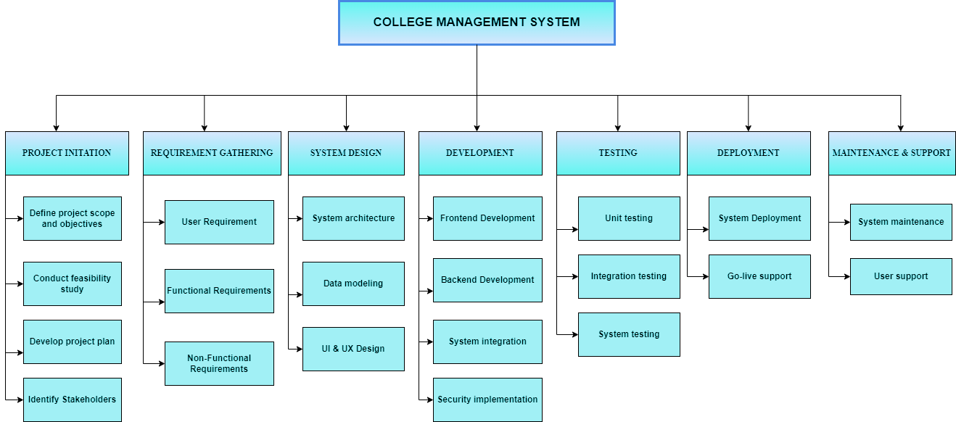

Date

Signature of the student

Signature of the cohort owner