Auto recovery contains some recovered files that haven't been opened.
Count of toss_decision by toss_decision
Count of id
K
1.095
Count of season
17
Count of winner by winner
winner
Mumbai Indians
Chennai Super …
Kolkata Knight …
Royal Challenge…
Delhi Capitals
Punjab Kings
Rajasthan Royals
Sunrisers Hyder…
Deccan Chargers
Gujarat Titans
Lucknow Super …
Gujarat Lions
Pune Warriors
Rising Pune Sup…
Royal Challenge…
Kochi Tuskers K…
NA
Count of winner
18
(64.29%)
(3
…
)
704
toss_de…
field
bat
60
70
80
season
Count of id
2009
2007/08
2015
2017
2009/10
2014
2016
2018
2019
2020/21
2021
2024
2011
2012
2022
2023
2013
391 Count of id by season
0 100
Count of winner
^{Count of id by venue}Auto recovery contains some recovered files that haven't been opened.
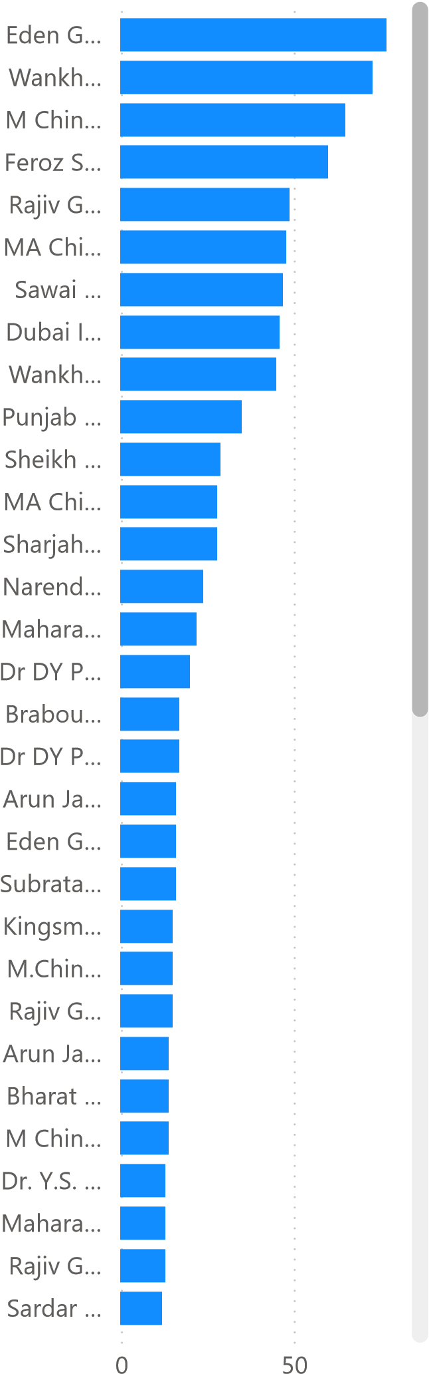
Count of Toss_Match_Win by Venue season
(55.…)
(4
…
)
41
33
Toss_Matc…
No
Yes
Toss_Match_Win
 Barabati Stadium 2007/08
 Dr. Y.S. Rajasekhara Re… 2009
 Eden Gardens 2009/10
 Feroz Shah Kotla 2011
 Himachal Pradesh Crick…  2012  M Chinnaswamy Stadium 2013  MA Chidambaram Stadi… 2014
 Punjab Cricket Associati…
 Rajiv Gandhi Internatio…
 h d
v
enue
Count of id
Sum of batsman_runs by batterAuto recovery contains some recovered files that haven't been opened.
Sum of is_wicket by bowler
RD Gaik…
KR May…
YBK Jais…
H Klaasen
Atharva …
F du Ple…
P Simra…
AM Rah…
A Mano…
V Kohli
HH Pan…
JC Buttler
bowl
er
AR Patel
10
(87…)
(7.…)
252
Bound…
Other
Four
Six
Count of Boundary_Type by Boundary_Type
21
batter
0 20 0
Sum of batsman_runs | Sum of is_wicket
batting_team bowler  Chennai Super…  A Badoni
batter
Strike_Rate
A Manohar
92.31
Abdul Samad
44.44
Abhishek Sharma
85.71
AK Markram
75.00
AM Rahane
125.00
Atharva Taide
200.00
DJ Hooda
150.00
DP Conway
66.67
F du Plessis
100.00
GJ Maxwell
175.00
Total
113.89
season

2007/08

2009

2009/10

2011

2012

2013

2014
 Gujarat Titans A Mishra
 Kolkata Knight…  A Nortje
 Lucknow Supe… A Zampa
 Mumbai Indians Abhishek Sharma
 Punjab Kings  AD Russell
 Rajasthan Roy  AJ Hosein

