ENVIRONMENTAL MONITORING

DHT11 SENSOR

The **DHT11**is a commonly used **Temperature and humidity sensor.** The sensor comes with a dedicated NTC to measure temperature and an 8-bit microcontroller to output the values of temperature and humidity as serial data. The sensor is also factory calibrated and hence easy to interface with other microcontrollers.

 

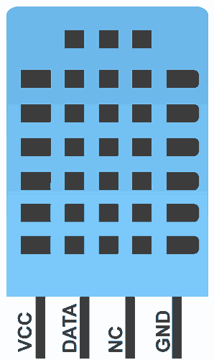

Pin diagram of DHT11:

DHT11 is a 4-pin sensor, these pins are VCC, DATA, GND and one pin is not in use shown .

**Pin Description:**

| **Pin No.** | **Pin Name** | **Pin Description** |
| --- | --- | --- |
| 1 | VCC | Power supply 3.3 to 5.5 Volt DC |
| 2 | DATA | Digital output pin |
| 3 | NC | Not in use |
| 4 | GND | Ground |

CIRCUIT DIAGRAM OF DHT11:

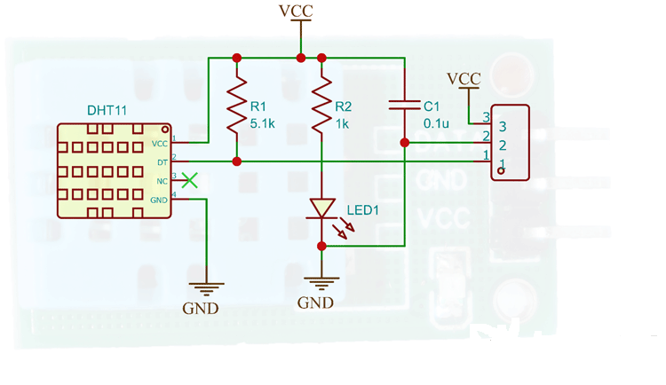

When the temperature changes, the resistance of the NTC also changes. This change in resistance is measured and the temperature is calculated from it. We have already discussed [how to use the NTC thermistor with Arduino](https://circuitdigest.com/microcontroller-projects/interfacing-Thermistor-with-arduino).

The humidity sensing component consists of a moisture-holding substrate sandwiched in between two electrodes. When the substrate absorbs water content, the resistance between the two electrodes decreases. The change in resistance between the two electrodes is proportional to the relative humidity. Higher relative humidity decreases the resistance between the electrodes, while lower relative humidity increases the resistance between the electrodes. This change in resistance is measured with the onboard MCU’s ADC and the relative humidity is calculated.

FEATURES:

DHT11 temperature-humidity sensor

1. 3 to 5V power and I/O.

2. 2.5mA max current use during conversion (while requesting data)

3. Good for 20-80% humidity readings with 5% accuracy.

4. Good for 0-50 °C temperature readings +-2 °C accuracy.

5. No more than 1 Hz sampling rate (once every second)

6. Body size 15.5mm x 12mm x 5.5mm.

BLOCK DIAGRAM:

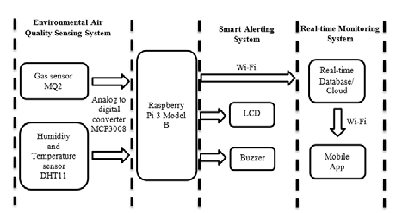

The environmental monitoring system has a humidity and temperature sensor DHT11 which is connected to the raspberry pi3 converter MCP3008.Real time monitoring can be possible through smart alerting system .The output can be viewed through a web browser or mobile app.

CIRCUIT DIAGRAM

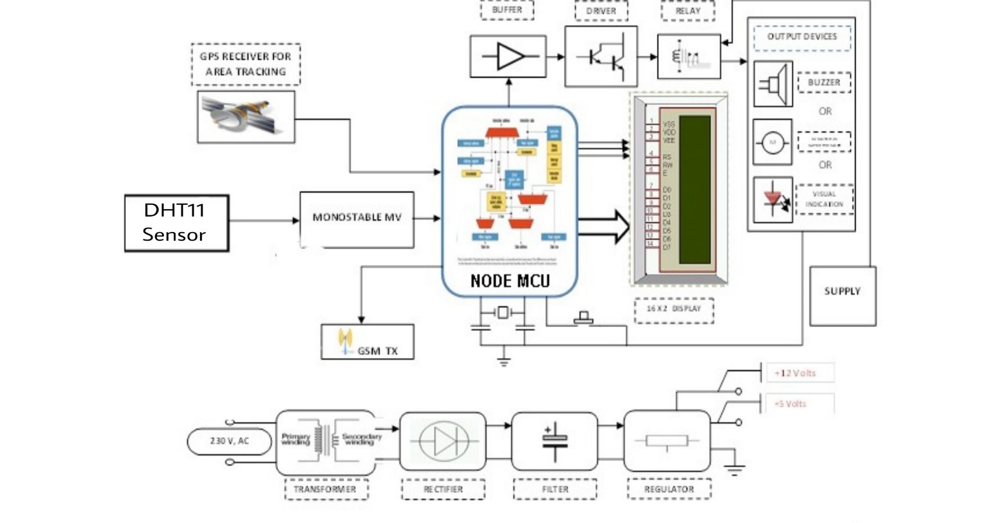

APPLICATIONS:

* Measure temperature and humidity
* Local Weather station
* Automatic climate control
* Environment monitoring