Simple Linear Regression:
Simple Linear Regression is used to predict the dependent variable (Y) based on one independent variable (X).
The equation of simple linear regression is:
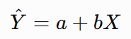
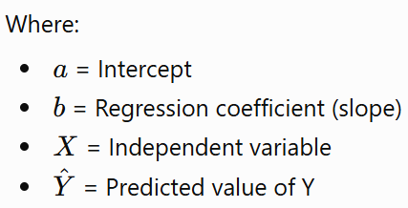
The formulas are:
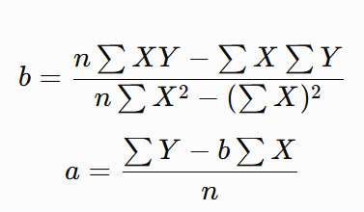
Problem 1:
The following table shows the number of hours students studied and the marks obtained in an examination. Calculate the regression equation and predict the marks for a student who studies for 6 hours.
Student | Study Hours (X) | Marks (Y)
1 | 1 | 35
2 | 2 | 40
3 | 3 | 50
4 | 4 | 55
5 | 5 | 65

Solution:
X | Y | X² | XY
1 | 35 | 1 | 35
2 | 40 | 4 | 80
3 | 50 | 9 | 150
4 | 55 | 16 | 220
5 | 65 | 25 | 325
15 | 245 | 55 | 810
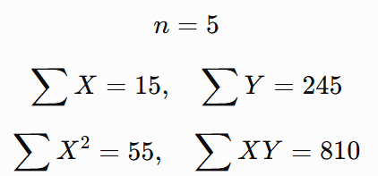

Calculate the Slope (b)
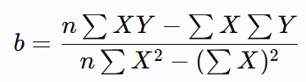
Substitute the values:
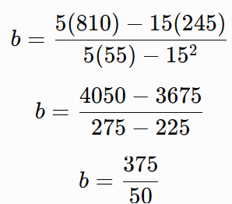
Calculate the Intercept (a)
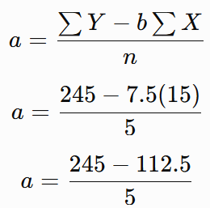
Predict Marks for 6 Hours
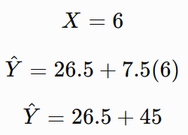
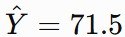
Regression Equation
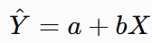
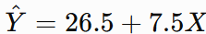

For every additional hour of study, the predicted examination marks increase by approximately 7.5 marks.
Problem 2:
The following table shows the advertising expenditure and corresponding sales of a company. Calculate the regression equation and predict sales when the advertising expenditure is ₹12,000.
Month | Advertising Expenditure (X) | Sales (Y)
1 | 2 | 20
2 | 4 | 25
3 | 6 | 35
4 | 8 | 40
5 | 10 | 50

Solution:
Construct the Calculation Table
X | Y | X² | XY
2 | 20 | 4 | 40
4 | 25 | 16 | 100
6 | 35 | 36 | 210
8 | 40 | 64 | 320
10 | 50 | 100 | 500
30 | 170 | 220 | 1170

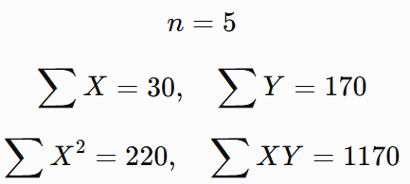
Calculate the Slope (b) Calculate the Intercept (a)
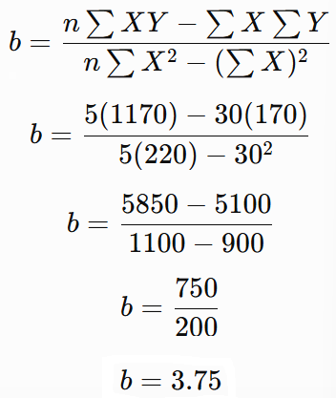
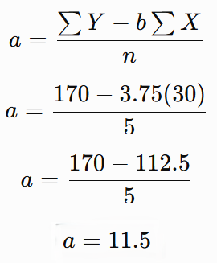

Regression Equation
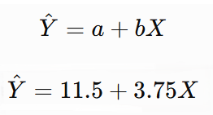
Predict Sales for ₹12,000 Advertising Expenditure
Since X is measured in thousands of rupees:
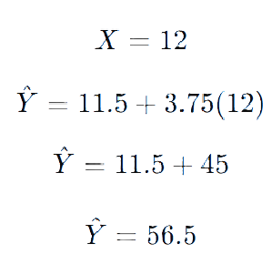

Multiple linear regression

Multiple Linear Regression is used to predict a dependent variable (Y) using two or more independent variables.
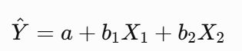
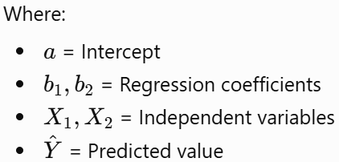

Problem1:
The following table shows the study hours, attendance percentage and examination marks of students. Calculate the multiple linear regression equation and predict the marks for a student who studies for 6 hours and has 85% attendance.
Student | Study Hours (X₁) | Attendance (X₂) | Marks (Y)
1 | 1 | 60 | 65
2 | 2 | 70 | 80
3 | 3 | 60 | 75
4 | 4 | 80 | 100
5 | 5 | 70 | 95

Solution:
Regression Equation
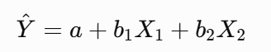
The coefficients are calculated using the least squares method.
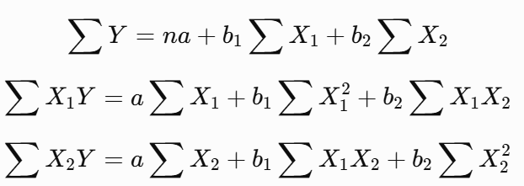
X₁ | X₂ | Y | X₁² | X₂² | X₁X₂ | X₁Y | X₂Y
1 | 60 | 65 | 1 | 3600 | 60 | 65 | 3900
2 | 70 | 80 | 4 | 4900 | 140 | 160 | 5600
3 | 60 | 75 | 9 | 3600 | 180 | 225 | 4500
4 | 80 | 100 | 16 | 6400 | 320 | 400 | 8000
5 | 70 | 95 | 25 | 4900 | 350 | 475 | 6650
15 | 340 | 415 | 55 | 23400 | 1050 | 1325 | 28650

Substituting the calculated sums:
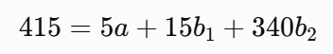
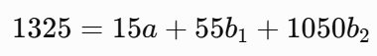
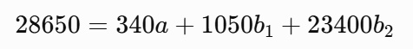
Solving these equations:
Regression Equation
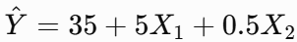
Prediction
- Study Hours = 6
- Attendance = 85%
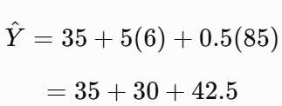
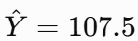

The model estimates the marks based on study hours and attendance. The predicted value is an extrapolation beyond the observed marks range, so it should be interpreted cautiously.
Problem 2:
The following table shows the advertising expenditure, social media promotion expenditure and sales of a company.Calculate the multiple linear regression equation and predict sales when advertising expenditure is ₹6,000 and social media expenditure is ₹4,000.Assume all expenditure and sales values are measured in thousands of rupees.
Month | Advertising (X₁) | Social Media (X₂) | Sales (Y)
1 | 1 | 1 | 17
2 | 2 | 1 | 19
3 | 1 | 2 | 20
4 | 3 | 2 | 23
5 | 2 | 3 | 24
6 | 4 | 3 | 27

Solution:
X₁ | X₂ | Y | X₁² | X₂² | X₁X₂ | X₁Y | X₂Y
1 | 1 | 17 | 1 | 1 | 1 | 17 | 17
2 | 1 | 19 | 4 | 1 | 2 | 38 | 19
1 | 2 | 20 | 1 | 4 | 2 | 20 | 40
3 | 2 | 23 | 9 | 4 | 6 | 69 | 46
2 | 3 | 24 | 4 | 9 | 6 | 48 | 72
4 | 3 | 27 | 16 | 9 | 12 | 108 | 81
13 | 12 | 130 | 35 | 28 | 29 | 300 | 275
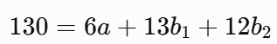
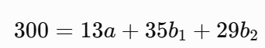
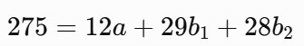
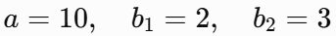
Regression Equation
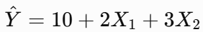

Advertising expenditure = ₹6,000 → X1=6
Social media expenditure = ₹4,000 → X2=4
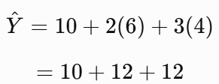
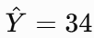
Since Y is measured in thousands of rupees:
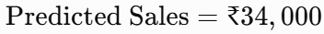
The model estimates sales using both advertising expenditure and social media expenditure.

RIDGE REGRESSION
Ridge Regression is a regularized version of linear regression that is used to reduce overfitting and handle multicollinearity among input features. It adds a penalty term (L2 regularization) to the ordinary least squares cost function.
Mathematical Equation
The linear regression equation is:
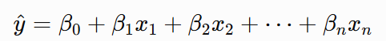
Ridge Regression minimizes:
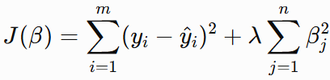

Symbol | Meaning
$y_{i}$ | Actual output
${\hat{y}}_{i}$ | Predicted output
$β_{j}$ | Model coefficients
$λ$ | Regularization parameter
$m$ | Number of samples
$n$ | Number of features

Effect of Regularization
Lambda ($λ$) | Effect
0 | Equivalent to ordinary linear regression
Small value | Slightly reduces coefficient magnitudes
Large value | Strongly shrinks coefficients
Very large value | May cause underfitting
Ridge regression shrinks coefficients toward zero but generally does not make them exactly zero.

Feature | Linear Regression | Ridge Regression
Regularization | No | Yes (L2)
Cost function | Sum of squared errors | SSE + penalty
Overfitting | Can occur | Can be reduced
Multicollinearity | Can cause unstable coefficients | Helps stabilize coefficients
Coefficients | Unrestricted by penalty | Shrunk toward zero
Feature selection | No inherent feature selection | No inherent exact feature selection
Complexity | Simple | Includes hyperparameter tuning

Problem1:
A real-estate company wants to predict house prices based on house area. Using the given dataset, calculate the regression equation using (a) Linear Regression and (b) Ridge Regression with $λ=1$. Predict the price of a 500 sq.ft. house and compare the two models. Explain why the Ridge coefficient differs from the Linear Regression coefficient.
The following data are collected:
House | Area $X$(100 sq.ft.) | Price $Y$(₹ lakh)
1 | 1 | 2
2 | 2 | 4
3 | 3 | 5
4 | 4 | 8

Solution:
Prepare the data
Area $X$ | Price $Y$ | $X^{2}$ | $XY$
1 | 2 | 1 | 2
2 | 4 | 4 | 8
3 | 5 | 9 | 15
4 | 8 | 16 | 32
Σ = 10 | Σ = 19 | Σ = 30 | Σ = 57

Linear Regression:
intercept is: coefficient is:
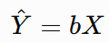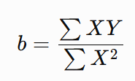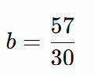
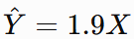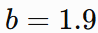

Prediction for 500 sq.ft.
Since $X$is measured in units of 100 sq.ft.:
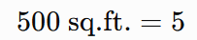
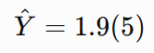
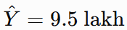

Ridge Regression
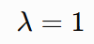
The Ridge coefficient is:
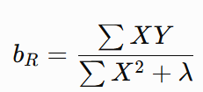
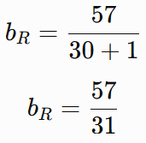
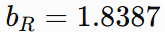
The Ridge equation is:
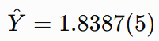
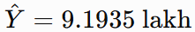
Comparison:
Parameter | Linear Regression | Ridge Regression
Application | House price prediction | House price prediction
$λ$ | 0 | 1
$\sum{}X^{2}$ | 30 | 30
$\sum{}XY$ | 57 | 57
Coefficient | 1.9000 | 1.8387
Regression equation | $\hat{Y}=1.9X$ | $\hat{Y}=1.8387X$
Area | 500 sq.ft. | 500 sq.ft.
Predicted price | ₹9.50 lakh | ₹9.1935 lakh
Coefficient magnitude | Higher | Lower
Regularization | No | Yes
Effect on coefficient | No shrinkage | Shrinks toward zero

For the same house-price dataset:
The Ridge coefficient is smaller because Ridge adds an L2 penalty:
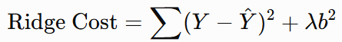

- Linear Regression: predicts ₹9.50 lakh
- Ridge Regression: predicts ₹9.19 lakh
Difference:
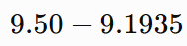
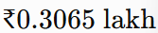
approximately ₹30,650.

- The important point is not that Ridge always gives a lower prediction. The important point is that:
- Ridge Regression reduces the magnitude of regression coefficients by adding an L2 regularization penalty.
- This becomes particularly useful in real applications such as house-price prediction, sales forecasting, medical prediction, and energy-demand prediction, where several input variables may be correlated.

Problem2:
A retail company wants to predict daily sales based on advertising expenditure. The following data are collected:
Advertising Expenditure (X) |  | Sales (Y)
1 |  | 2
2 |  | 3
3 |  | 5
4 |  | 6
Assume the regression line passes through the origin.
a) Calculate the regression equation using Linear Regression.
b) Calculate the regression equation using Ridge Regression with $λ=1$.
c) Predict sales when advertising expenditure is 5 units using both models. Compare the regression coefficients and predicted values.
Solution:
Parameter | Linear Regression | Ridge Regression
Application | Sales prediction | Sales prediction
Regularization ($λ$) | 0 | 1
$\sum{}XY$ | 47 | 47
$\sum{}X^{2}$ | 30 | 30
Coefficient | 1.5667 | 1.5161
Regression equation | $\hat{Y}=1.5667X$ | $\hat{Y}=1.5161X$
Advertising expenditure | 5 | 5
Predicted sales | 7.8335 | 7.5805
Coefficient magnitude | Higher | Lower

Problem3:
An electricity company wants to predict daily electricity consumption based on the number of operating industrial machines. The following data are collected:
Number of Machines (X) | Electricity Consumption (Y)
1 | 3
2 | 8
3 | 15
4 | 20

Assume that the regression line passes through the origin.
a) Calculate the regression equation using Linear Regression.
b) Calculate the regression equation using Ridge Regression with $λ=20$.
c) Predict electricity consumption when the number of machines is 5 using both models. Compare the slopes and predictions.
Solution:

Parameter | Linear Regression | Ridge Regression
Application | Electricity consumption | Electricity consumption
Regularization ($λ$) | 0 | 20
$\sum{}XY$ | 144 | 144
$\sum{}X^{2}$ | 30 | 30
Slope | 4.80 | 2.88
Regression equation | $\hat{Y}=4.8X$ | $\hat{Y}=2.88X$
Number of machines | 5 | 5
Predicted consumption | 24 | 14.4
Slope reduction | — | 40%
Regularization | No | L2 penalty

