Logistic Regression
Logistic Regression is a supervised machine learning algorithm mainly used for classification problems.
Unlike linear regression, which predicts a continuous numerical value, logistic regression predicts the probability that an observation belongs to a particular class.
Suppose we want to predict whether a student will Pass (1) or Fail (0) based on study hours.
The model first calculates a linear combination:
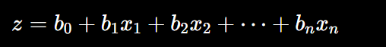
Then it converts this value into a probability using the Sigmoid (Logistic) function:
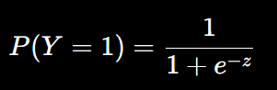
The probability lies between 0 and 1.
For example:
- Probability = 0.85 → Class 1
- Probability = 0.25 → Class 0
Usually, 0.5 is used as the classification threshold.
Multinomial Logistic Regression
Used when there are three or more classes without a natural order.
Example: Predicting the type of transport:
- Bus
- Train
- Car
There is no meaningful order such as Bus < Train < Car.
The model estimates a probability for each class, and the class with the highest probability is selected.

Example:
Suppose we want to predict a student's performance based on the number of hours studied.
Student | Study Hours | Performance
A | 1 | Poor
B | 2 | Poor
C | 3 | Average
D | 4 | Average
E | 5 | Good
F | 6 | Good

Step 1: Linear equation
Logistic regression first calculates:
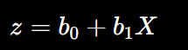
z=−5+1.2X
For a student studying 4 hours:
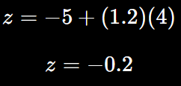
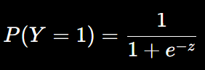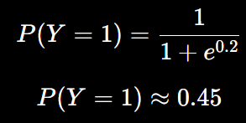
So the probability of Pass = 45%.
Using a threshold of 0.5:
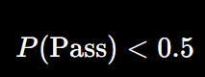
Therefore:
Prediction = Fail
What happens if the student studies 5 hours?
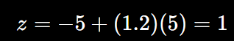
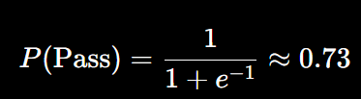
So:
Probability of Pass = 73%
0.73>0.5 Prediction = Pass

