

Electricity pricing
Consumer simulator and price selector  Implementation and validation |  | Research checkpoint  27 October 2026

Contents

Executive summary 2
At a glance 2
Introduction 2
Key findings 3
Context and conditions 3
Patterns in the evidence 6
Implications 8
Recommendations 9
Conclusion 9
Appendix 10
Notes 10
Source records 11

Executive summary
We implemented a closed-loop electricity-pricing simulator for 717 Norwegian spot-contract households. A frozen Transformer ensemble predicts household consumption, and a Deep Q-Network (DQN) selects a shared hourly price for 48 hours. Among the three upgraded-simulator fits, the best validation policy, DQN seed 2026, reduced the combined cost by 3.60% versus market tracking and 5.38% versus the validation-selected constant policy. [1, 2]
Its pricing varied meaningfully: 9.68 changes per 48-hour episode, with a mean absolute hourly change of 0.163 NOK/kWh. Relative to market tracking, it produced 2.25% fewer overload region-hours and 5.88% less accumulated overload. The benefit was modest and did not eliminate overload under severe scarcity.

At a glance
- Consumer model: configuration C, two frozen Transformers using 24-hour histories, with response seeds 42 and 7; their household predictions are averaged before feedback.
- Price selector: standard SB3 DQN with policy seed 2026; a 20,857-feature observation feeds 256 and 128 ReLU units and 21 price actions.
- Evidence: 29 January origins multiplied by three capacity scenarios, giving 87 overlapping 48-hour validation cases. Final retrospective follow-up evaluation is still running at this report snapshot.

Introduction
The research question is whether a learned, varying price schedule can reduce constructed regional demand stress while limiting household energy and charge impacts. NO1 and NO5 are separate capacity pools; all households receive one common selected price. Current pricing models consumption only. It includes no allocation, forced consumption floor, deferred-demand queue or recovery rule.
Policy seed 2026 is a descriptive validation winner; seed 42 remains the predeclared representative. The upgraded three-seed mean cost is 0.03253 versus market’s 0.03248, or 0.16% higher. Reliable improvement across seeds and reserved dynamics remains unestablished.

Key findings
The implementation separates data preparation, consumer prediction, pricing, scoring and observation-only telemetry. All policies below use the same upgraded consumer ensemble and the same reward definitions. This makes the policy comparison consistent within that simulator. [1–5]

Context and conditions
The consumer model used by the winning policy
Configuration C pretrains general consumption on all 1,136 households with prices disabled, then fine-tunes price-aware forecasts on the 717 spot-contract households. Both frozen ensemble members use the architecture below. Reserved consumer seed 2026 is distinct from the winning DQN policy seed 2026. [3, 4]
Component | Exact implementation
Historical input | 24 hours × 12 features per household
Input projection | Linear 12 → 64
Temporal encoder | 2 Transformer encoder layers; width 64; 4 attention heads
Feed-forward block | Width 128; GELU; dropout 0.10 during training
Position and pooling | Fixed sinusoidal positions; final historical token
Prediction head | 131 → 64 → 1; SiLU then Softplus
Head context | 64 encoded features + 59 static features + price + price change + 6 target-calendar features
Output | One nonnegative next-hour household kWh prediction
Parameters | 76,289 per consumer model; two frozen members
History contains demand, price, temperature, two hour channels, weekday/annual sine and cosine, log demand, price change and its availability flag. Hour encoding is (1 − cos θ)/2 and (1 + sin θ)/2. Static features encode region, dwelling, heating, water heating, EV ownership and unknown categories.
Both models see the same histories and price. Average each household’s predictions before advancing the shared history; persist origin temperature. Saved demand scales and price/temperature statistics are fitted on training data only. [3, 4]
The price selector and training protocol
The best observed policy is new_seed2026/best.zip, trained against the frozen C-seed-42/C-seed-7 consumer ensemble. It is standard Stable-Baselines3 DQN with MultiInputPolicy. Its feature extractor flattens the observation groups; the price selector itself is an MLP, not a Transformer. [1, 5]
Setting | Value
Q network | 20,857 → 256 ReLU → 128 ReLU → 21 Q values
Parameter count | 5,375,253 per Q network; target network has the same structure
Actions | 0.05, 0.10, 0.20, …, 2.00 NOK/kWh
Episode | 48 hourly decisions; 24-hour starting histories
Discount and reward scale | Gamma 1; reward scale 100
Learning rate | Linear 0.0001 → 0.00001 over consumed slot time
Replay and warm-up | 3,000 CPU transitions; learning starts at decision 2,400
Batch and updates | Batch 64; one update every 4 decisions
Target and clipping | Target update every 1,000 decisions; gradient norm clipped at 10
Exploration | Epsilon 1 → 0.05 over first 30% of slot time
Execution | macOS GPU via MPS; float32; 4 supporting CPU threads
Best checkpoint | 128,064 decisions and 31,416 gradient updates
The observation contains every household’s demand history, regional price/temperature histories, historical calendar, known episode calendar and market-price schedules, a release mask, modeled regional reference schedules, household energy/charge accounts and scenario context. Fixed household order and saved preprocessing are reused. At reset, only day-one market/reference information is visible; day two is released at the second midnight.
Six paired fits used old/new dynamics for seeds 42, 7 and 2026, with 100 minutes allocated per fit. Actual consumed training time was 9 hours 50 minutes, covering 867,312 decisions. Setup and final evaluation have separate timers. Validation checks every 29 origins × three scenarios, and the minimum validation-cost checkpoint is retained. Source, data and weight fingerprints protect checkpoint compatibility.
What each baseline means
- Market tracking. At each hour, take the household-count-weighted mean of recorded NO1/NO5 prices, then round and clip it to the common action grid. This produces one feasible shared price schedule, rather than two regional tariffs.
- Selected constant. Enumerate all 21 fixed prices and choose the lowest mean validation-cost price separately for each scarcity scenario. Mild/moderate select 1.20 and severe selects 1.30 NOK/kWh. The chosen price stays unchanged for all 48 hours.
- Capacity rule. Preview regional requests at the grid-projected market price. Raise that price by max(z − 1, 0) × 1.95, where z is the larger regional demand/capacity ratio; clip and round to the action grid. This rule is fixed rather than learned.
- One-hour greedy. Simulate all 21 actions and choose the best immediate configured reward. It does not plan the complete 48-hour energy/charge outcome. Terminal household penalties enter its decision only at the final hour. In this validation run it chose the minimum throughout.
- Constant minimum. Charge 0.05 NOK/kWh for all 48 hours. This diagnostic tests an inexpensive constant schedule.
- Constant maximum. Charge 2.00 NOK/kWh throughout. This tests the high-price extreme and its household charge trade-off.
- Episode constant oracle. For each complete 48-hour case, enumerate the modeled outcomes of all constant prices and retrospectively select the best one. It is an offline comparator within the constant-price family, not a deployable learned policy.
Reward and reference
A policy-independent reference branch uses recorded regional prices from the same origin and is shared across compared policies. Cost combines state-weighted regional stress, household energy deviation beyond 5% and household charge increase beyond 5%. Grid weights are computed before acting and rise from 1 to 5 as the preceding demand/capacity ratio rises from 80% to 100%. Energy and charge weights remain one; the normalization is fixed at seven. Exact formulas are in the appendix.
Grid penalties are charged hourly; household penalties are charged at hour 48. Episode reward equals −100 × total cost exactly. There is no reward for switching, diversity, price jumps or demand flattening. A varying schedule is therefore observed behavior, not a directly rewarded action-count target.

Patterns in the evidence
Price changes across the same validation cases
All monetary prices and price changes below are in NOK/kWh. “Hourly change” is the mean absolute difference across the 47 within-episode transitions, including unchanged hours; it excludes the initial transition from historical regional prices. “Jump on change” averages only transitions where the price actually changed. [1, 2]
Policy | Mean price | Changes per 48 hours | Hourly change | Jump on change
DQN seed 2026 | 1.197 | 9.68 | 0.163 | 0.793
Market tracking | 1.390 | 14.17 | 0.039 | 0.128
Selected constant | 1.233 | 0.00 | 0.000 | 0.000
Capacity rule | 1.416 | 15.94 | 0.044 | 0.129
One hour greedy | 0.050 | 0.00 | 0.000 | 0.000
Constant minimum | 0.050 | 0.00 | 0.000 | 0.000
Constant maximum | 2.000 | 0.00 | 0.000 | 0.000
Episode constant oracle | 1.375 | 0.00 | 0.000 | 0.000
The DQN changed price in all 87 cases, using an average of 7.82 distinct prices per episode and 16 grid prices overall. Its range spanned 0.05–2.00 NOK/kWh. It switched less frequently than market tracking, but its jumps were larger: 0.793 versus 0.128 NOK/kWh when a change occurred. The largest DQN jump was 1.95 NOK/kWh.
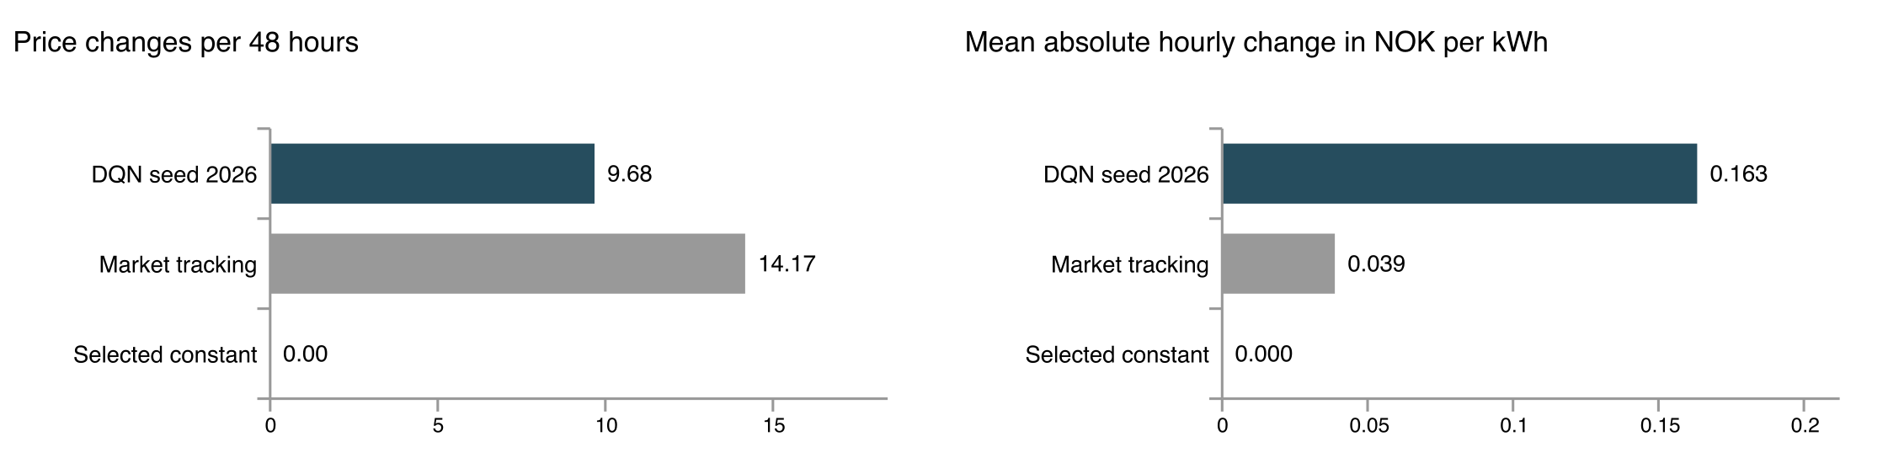
Figure 1 Price variation of the selected policy and the principal practical baselines. A constant policy has zero within-episode changes.
DQN used a 13.90% lower mean price and less modeled overload than market tracking. Its benefit did not depend on maximum pricing throughout; switching alone is not established as the cause.
Grid stress and overall performance
Overload counts each region-hour separately: 8,352 region-hours. Excess kWh is accumulated demand above capacity per case. Mild/moderate/severe limits use measured-training 95th/90th/75th percentiles. Cost includes all three objectives.
Policy | Mean cost | Hours overloaded | Excess kWh per case | Worst overload
DQN seed 2026 | 0.03131 | 13.03% | 777.96 | 28.56%
Market tracking | 0.03248 | 13.33% | 826.55 | 28.18%
Selected constant | 0.03309 | 13.31% | 826.92 | 29.32%
Capacity rule | 0.03607 | 13.25% | 827.04 | 27.78%
One hour greedy | 0.05226 | 18.09% | 1446.09 | 37.44%
Constant minimum | 0.05226 | 18.09% | 1446.09 | 37.44%
Constant maximum | 0.13604 | 11.83% | 677.16 | 25.80%
Episode constant oracle | 0.03126 | 12.94% | 784.64 | 28.16%
Versus market, cost fell 3.60%, overload region-hours fell from 1,113 to 1,088 (2.25%), and excess energy fell 5.88%. Paired hours show 74 overload hours avoided and 49 introduced, a net reduction of 25.
Scarcity | NO1 limit kW | NO5 limit kW | Market overload hours | DQN overload hours | DQN cases within limits
Mild | 1297.64 | 674.38 | 0.00% | 0.00% | 29/29
Moderate | 1166.39 | 609.01 | 0.79% | 0.86% | 22/29
Severe | 952.18 | 509.16 | 39.19% | 38.22% | 0/29
Severe overload fell from 39.19% to 38.22%; moderate overload worsened slightly. Every severe case still overloaded. Worst overload was 28.56% above capacity, versus market’s 28.18%, and the mean case peak of combined regional demand was 0.33% higher. Continuous capacity compliance was not achieved.
Constant maximum produced less physical overload than DQN, but its full cost was 0.13604 because the objective also protects households. The episode constant oracle had slightly lower cost than DQN (0.03126 versus 0.03131). DQN therefore beat the practical selected-constant policy by 5.38%, but did not establish a switching advantage over the oracle.
How the price schedule changed modeled demand
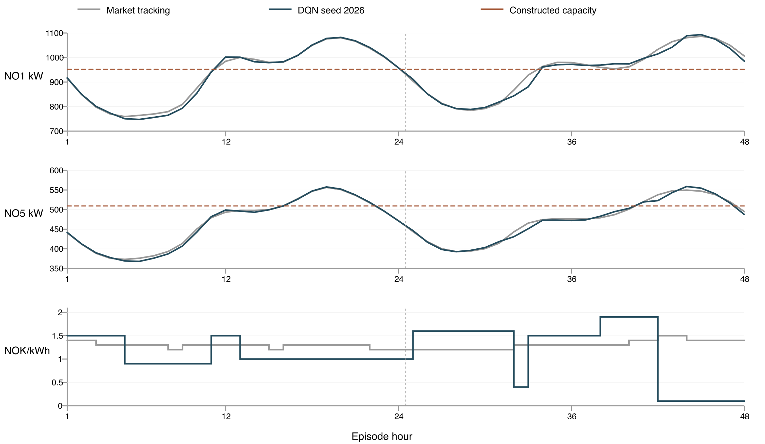
Figure 2 Middle validation origin, 16 January 2022, severe scarcity. Regional demand follows the frozen consumer ensemble; the bottom panel shows the corresponding shared prices. The vertical dotted line marks the second midnight. This illustrative case was selected by chronological position, not by its improvement.

Implications
The learned schedule altered the consumer model’s subsequent requests and reduced the integrated amount above capacity across the full validation set. Its weighted grid-cost term fell from 0.22570 to 0.21823, a 3.31% reduction. Total modeled energy differed from the recorded-price reference by only −0.34%, while mean absolute household energy deviation was 0.71%. The benefit was therefore not accompanied by large aggregate energy suppression in this validation result.
These are controlled comparisons inside one learned simulator. Their direction and magnitude depend on the consumer model; observational price/consumption training cannot identify causal elasticity. A lower combined cost also does not imply lower peaks, fewer overloads in every scenario or real voltage/frequency stability. The three-seed mean remains approximately tied with market pricing, and reserved-dynamics follow-up is pending.

Recommendations
The implementation provides a bounded research checkpoint: a consumer simulator, a price selector, explicit reward accounting and inspectable household trajectories. The next stage should address remaining scarcity while preserving the distinction between requested demand and delivered service.
- Complete the frozen comparison. Finish evaluation on the previously examined February–March origins under common upgraded dynamics, reserved consumer seed 2026 and the price-free control. Report every policy seed and paired uncertainty. Keep validation-selected performance distinct from follow-up evidence.
- Test regional resource allocation. Compare FCFS in seeded assumed order, proportional allocation and cumulative fair priority under the same fixed price schedules. Keep NO1/NO5 budgets separate. Evaluate unserved energy, essential-service feasibility and household fairness explicitly rather than absorbing shortages into an unexplained reward.
- Validate consumer behaviour under curtailment. Record requested and allocated energy separately. Do not feed curtailed delivery into the frozen consumer model as though it were a measured voluntary response. Until outage-response data or another validated behaviour model is available, describe any curtailed-history forecasts as stress tests, not accurate consumer adaptation.

Conclusion
The best observed DQN learned a genuinely varying price schedule and achieved a modest modeled reduction in grid stress while improving the combined objective relative to market tracking and a practical fixed-price policy. The evidence supports continuing the research, with the best-seed and simulator limitations stated explicitly.
The next research step is to test allocation of resources under the remaining regional capacity shortages, and verify how consumer behaviour should be represented after allocation. Pricing can reduce some requested demand stress; a separately evaluated allocator must determine delivery when requests still exceed capacity. This report does not claim that the current consumer model already predicts real reactions to curtailment.

Appendix

Notes
Exact reward definitions
Let B(x) = (x / (1 + x))² and [x]₊ = max(x, 0). For each region, z = regional hourly power / constructed capacity.
g(z) = 0.5 × {B([z − 0.90]₊ / 0.10) + B([z − 1]₊ / 0.10)}.
u = clip((preceding z − 0.80) / 0.20, 0, 1); w = 1 + 4u²(3 − 2u).
Energy cost = household mean of B([|E − E0| / max(E0, 10⁻⁶) − 0.05]₊ / 0.05).
d = max(|A0|, 0.01 × training median price × E0, 10⁻⁶). Charge cost = household mean of B([(A − A0) / d − 0.05]₊ / 0.05).
C = {mean over 48 hours and two regions of w × g(z) + energy cost + charge cost} / 7. Total reward = −100C; gamma = 1. E and E0 are episode kWh; A and A0 are modeled NOK charges. The fixed normalization bounds cost in [0, 1].
All six completed fits
Training simulator | Policy seed | Best validation cost | Final decisions | Initial policy stayed best
Old | 42 | 0.05101 | 162,096 | No
New | 42 | 0.03408 | 140,880 | No
Old | 7 | 0.05549 | 148,176 | No
New | 7 | 0.03220 | 139,440 | No
Old | 2026 | 0.05547 | 138,624 | Yes
New | 2026 | 0.03131 | 138,096 | No
Old/new costs use different dynamics and are not directly comparable. Upgraded seeds average 0.03253: 0.16% above market and 1.69% below selected constant. Seed 42 remains the predeclared representative; seed 2026 is highlighted descriptively.
Overlapping windows are not independent. Final uncertainty uses 5,000 paired block resamples with seven-day primary and three-/fourteen-day sensitivity, averaging policy seeds/scenarios within day. Follow-up results remain pending.

Source records
Evidence snapshot: 27 October 2026 at 13:08 IST. Current pipeline stage at capture: follow-up evaluation under old dynamics. January metrics are complete and immutable; the final pricing comparison and report have not yet been produced. All numeric tables above were recalculated from saved hourly trajectories.
- [1] Winning policy: runs/pricing_checkpoint_v1/new_seed2026/best.json and best.zip.
- [2] Baselines and grid enumeration: runs/pricing_checkpoint_v1/validation/new/baselines.json.
- [3] Consumer code: response_v2/model.py and data.py; pricing_v2/engine.py. C-seed-42 and C-seed-7 weights: runs/response_refinement_v2/.
- [4] Consumer study: runs/response_refinement_v2/selection.json, evaluation.json and REPORT.md. Its 48-hour RMSE improved from 0.87736 to 0.85876 kWh (2.12%); this is forecast evidence, not causal price validation.
- [5] Pricing code: pricing_v2/environment.py, objective.py and train.py; shared DQN settings: dqn/train.py.
- [6] Provenance and checks: runs/pricing_checkpoint_v1/settings.json, selection.json, fit_summaries.json and preflight.json.
Paths are relative to norway_energy_crisis/. Full source/checkpoint SHA-256 fingerprints are saved with the experiment. The suite ran 103 tests with two sandbox GPU skips. Separate full-cohort MPS checks passed inference parity within 0.000002 kWh, learner recovery and 48-hour price-free invariance.
Evidence boundaries. Training covers October 2020–December 2021; validation is January 2022, with February–March retrospective follow-up. Each history/target stays inside its partition. The 717-household contract assignment is based on later survey answers assumed stable retrospectively. Weather is regional reanalysis persisted at each origin. Capacities are measured-training quantiles used as constructed limits, not observed feeder ratings. Historical demand under actual tariffs is measured; alternative-price demand is predicted. Spot-energy charges exclude full retail bills and supplier profit.
The reviewed paper 1812.09567v1 motivated history-dependent demand states; its simulated backlog and minimum-consumption rules were not transferred. Neither the validation improvement nor a future allocation simulation should be described as causal demand-response validation.
Next stage: test resource allocation and validate the representation of consumer behaviour when allocated supply differs from requested consumption.

