Functional Requirements Document
360° Feedback & Evaluation Platform
(working name — to be finalized before launch)
Field | Details
Prepared for | Mahesh Puttaswamy
Prepared by | Stixis AI Solutions Pvt Ltd — Business Analysis Team
Document version | v0.2 — Draft for Approval
Date | 07 August 2026
Source | Requirements captured from stakeholder call recording (07 Aug 2026)
Status | Pending client / stakeholder approval before development starts

1. Purpose & Background
Stixis is evaluating a new internal and commercial product: a single, configurable platform that captures structured feedback across every relationship in a business — employees, managers, teams, clients, products, services, and proposals. Rather than building separate tools for HR reviews, customer satisfaction, and proposal quality tracking, the platform consolidates all of these into one system with a shared feedback-link mechanism, a common admin structure, and per-organization data isolation.
This document translates the requirements discussed on the stakeholder call into a functional specification, so that scope, roles, and flows can be reviewed and approved before development begins.

1.1 Objectives
- Provide one platform to collect 360° feedback: employee ↔ manager, team ↔ team, and department ↔ department.
- Allow feedback collection from external parties — clients, customers, and prospects — via a simple emailed link (no login required for respondents).
- Support both single-recipient and bulk/cohort feedback campaigns (e.g., a 25-person cohort).
- Capture structured feedback on proposals and SOWs submitted to prospects, covering technical quality, estimation accuracy, infrastructure, and delivery.
- Support multiple client organizations on one platform (multi-tenant), each with isolated data, so the product can be sold to external clients such as Gilbarco.
- Provide a two-tier admin model (Super Admin, Client Admin) so new organizations can be onboarded in a controlled way.
- Let a client organization either self-register through the portal (subject to Super Admin approval) or be registered directly by the Super Admin (auto-approved).
- Let each client organization upload its own company logo, applied consistently across its dashboard, email templates, and feedback forms.
- Maintain a full audit log of key actions across the platform for traceability and compliance.
- Support responsive web design (RWD) so the platform is usable on desktop, tablet, and mobile.
- Be usable internally at Stixis from day one, and packaged for external sale later.

1.2 Out of Scope (for this phase)
- Final product naming and branding — to be decided separately.
- Billing / subscription management for external SaaS customers — assumed to be a later phase.
- Deep integrations with third-party CRMs (e.g., auto-pulling proposal data from an external system) — not discussed on the call, flagged as an open question in Section 7.

2. User Roles & Access Model
The platform uses a two-tier administrative hierarchy — Super Admin and Client Admin — plus organization-level roles beneath each Client Admin. A client organization can join the platform in one of two ways: by self-registering through the portal, or by being registered directly by the Super Admin. This is illustrated in Diagram 1.
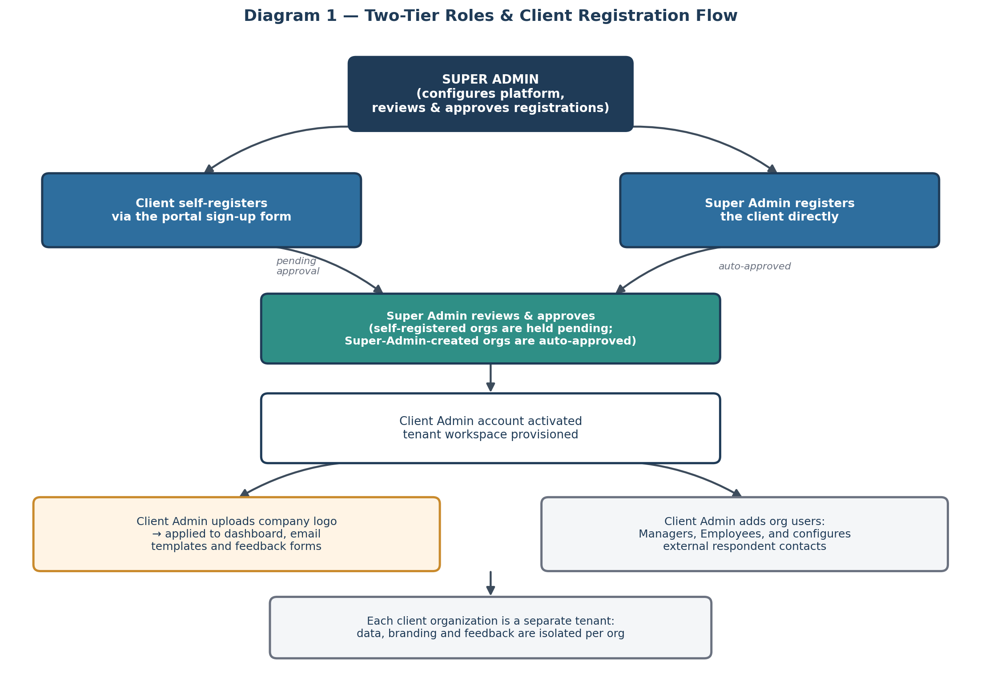
Diagram 1 — Two-tier roles and client registration flow
Role | Description | Key Permissions
Super Admin | Stixis-level platform owner. Highest level of access — no intermediate Admin tier. | Configure global platform settings; review and approve/reject self-registered client organizations; register client organizations directly (auto-approved); suspend organizations; view platform-wide analytics and the full audit log; manage the internal proposal/prospect module.
Client Admin | The primary administrator within a client organization (e.g., Gilbarco's coordinator). Created either via self-registration (pending Super Admin approval) or directly by the Super Admin (auto-approved). | Upload company logo and branding; add managers/employees/users for their org; create feedback campaigns; configure email templates; view org-level dashboards and org-level audit log. Cannot see other organizations' data.
Manager | A team lead within a client organization. | Give feedback on employees; receive upward feedback from employees; trigger product/service feedback requests to clients.
Employee / Team Member | A regular staff user. | Give feedback on managers and peers; receive feedback.
External Respondent | Client contact, customer, or prospect — no platform login. | Access a single, client-branded feedback form via a unique emailed link; submit a rating and comments.

Note: registration approval logic — self-registered organizations are held in a "pending" state until the Super Admin reviews and approves them; organizations created directly by the Super Admin are provisioned immediately (auto-approved) since they are already vetted.

3. Functional Modules

3.1 Module A — Internal 360° Feedback
Captures feedback within an organization: manager-to-employee, employee-to-manager (upward feedback), and peer/cross-team feedback.
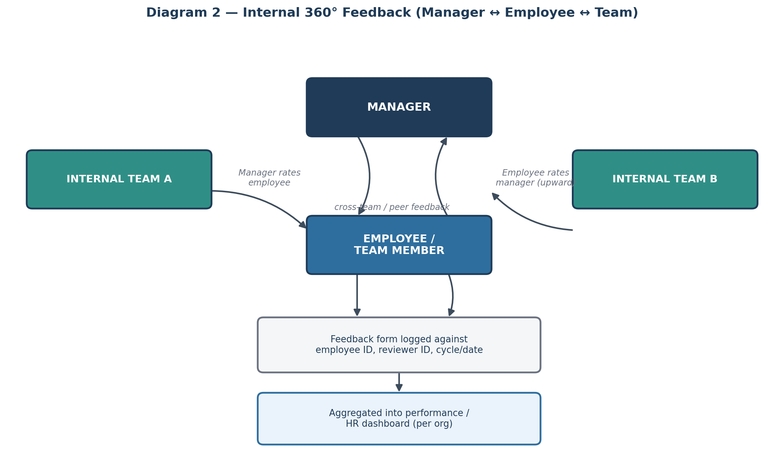
Diagram 2 — Internal 360° feedback flow

Key features
- Manager can rate one or more direct reports on defined criteria (configurable per org).
- Employee can submit upward feedback on their manager.
- Peer-to-peer and cross-team feedback supported.
- Feedback is tagged with reviewer, reviewee, and review cycle/date for trend reporting.
- Aggregated results roll up into an org-level performance dashboard.

3.2 Module B — Client / Product / Service Feedback
Captures feedback from external parties (clients, customers, prospects) on products, services, or individual staff performance, triggered by an emailed link.
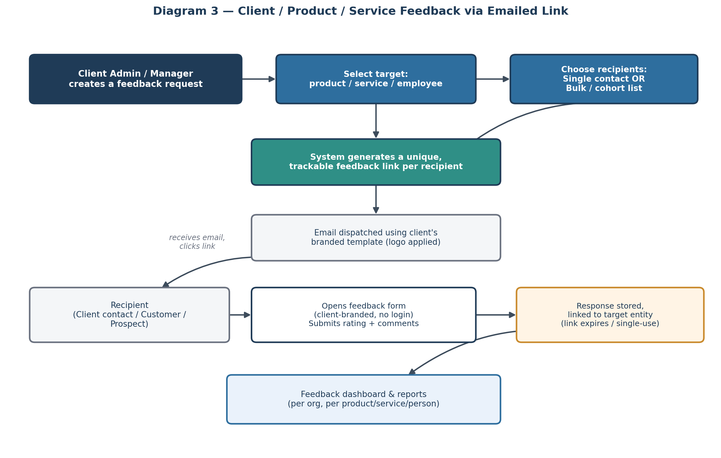
Diagram 3 — Client / product / service feedback via emailed link

Key features
- A Client Admin or Manager creates a feedback request and selects a target: a product, a service, or an employee.
- Recipient list can be a single contact or a bulk/cohort list (e.g., 25 people in "cohort 1").
- System generates a unique, trackable link per recipient — single-use or expiring, to prevent duplicate or stale submissions.
- Email is sent either one-to-one or as a mass send to the full recipient list, using the client organization's uploaded logo and branding.
- Respondent clicks the link and completes a client-branded feedback form without needing to log in or create an account.
- Responses are stored against the specific target (product, service, or person) and roll up into reports.

3.3 Module C — Prospect / Proposal (SOW) Feedback
Captures structured feedback from prospects after Stixis submits a proposal or Statement of Work, so proposal quality and estimation accuracy can be tracked and improved over time.
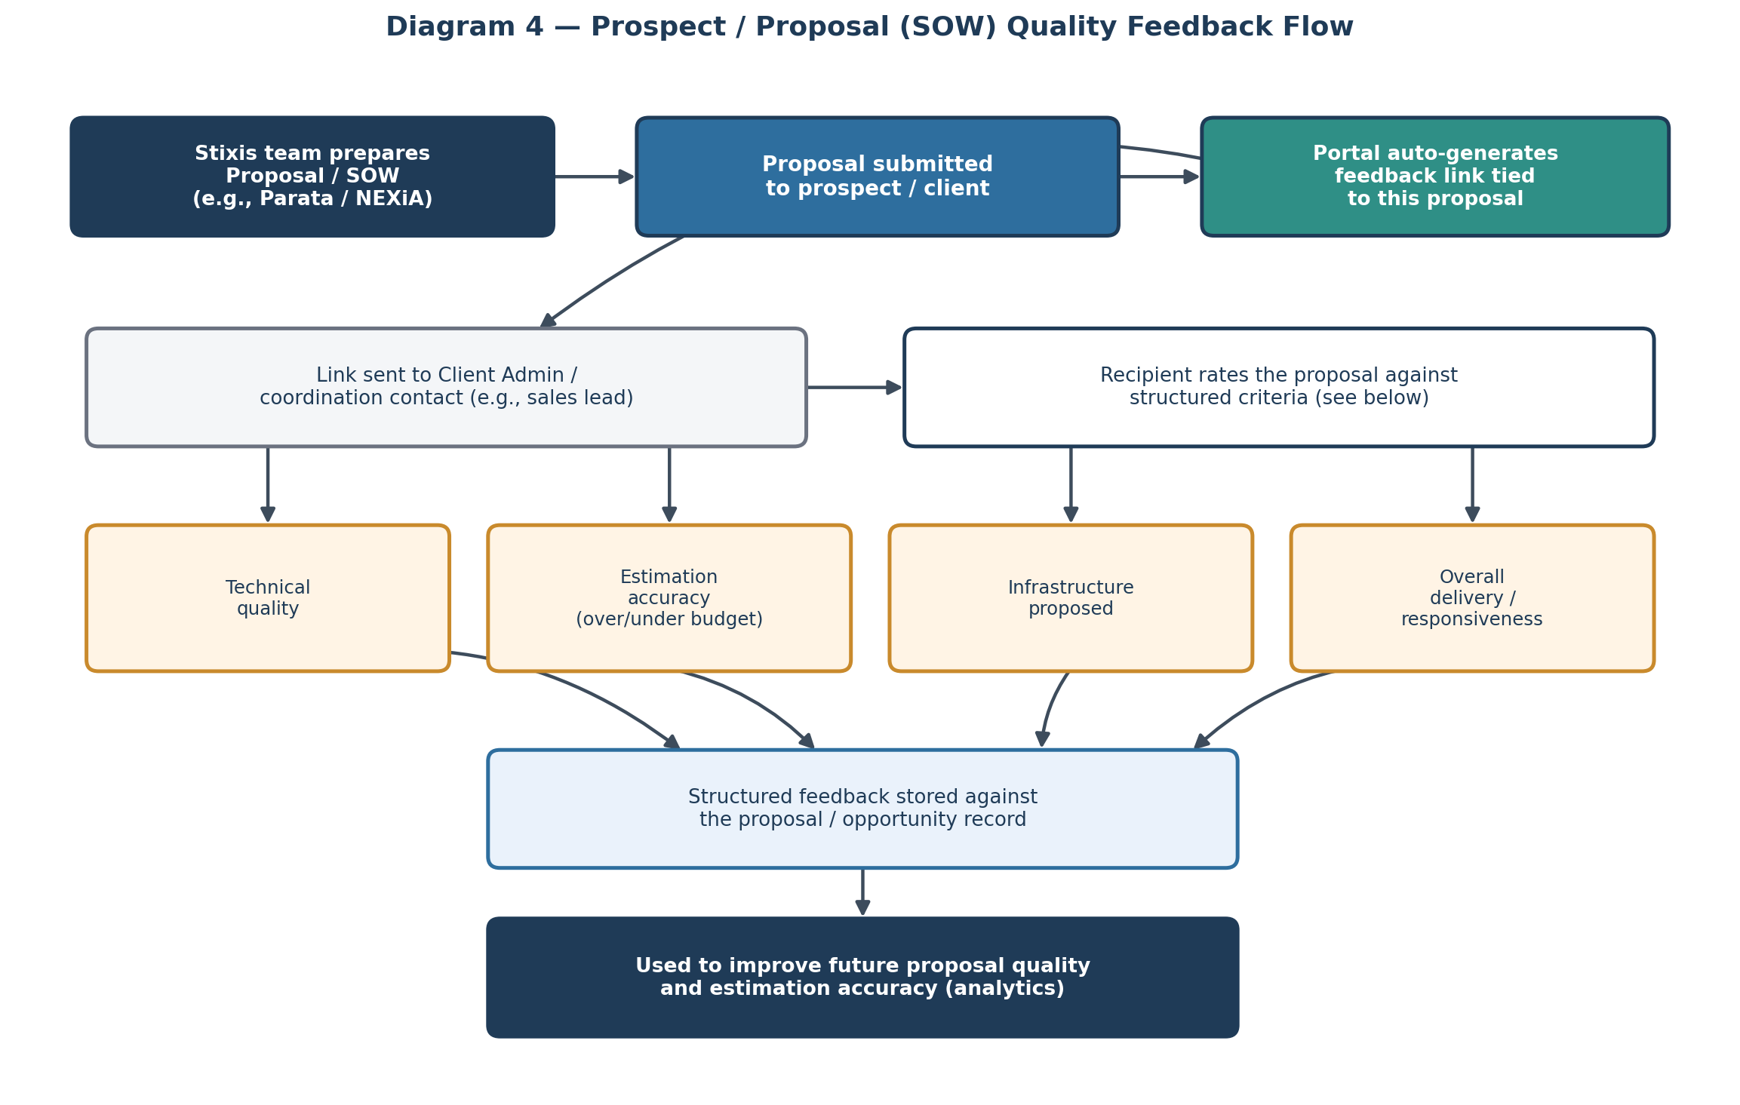
Diagram 4 — Prospect / proposal (SOW) quality feedback flow

Key features
- Once a proposal/SOW is submitted to a prospect (e.g., the Parata/NEXiA proposal), the portal generates a feedback link tied to that specific proposal.
- The link is sent to the prospect's coordination contact (e.g., a sales lead such as Agni in the example discussed).
- Respondent rates the proposal against structured criteria: technical quality, estimation accuracy (over/under budget), infrastructure proposed, and overall delivery/responsiveness.
- Feedback is stored against the proposal/opportunity record, enabling analytics on proposal quality over time and across proposal authors.

3.4 Module D — Platform Administration
- Organization (tenant) onboarding: self-registration by the client, or direct registration by the Super Admin.
- Approval workflow for self-registered organizations (Super Admin reviews and approves/rejects).
- User management within each organization (add/remove managers, employees, external respondent contacts).
- Configurable feedback form builder (criteria, rating scale, free-text comments) per feedback type.
- Email template management for feedback invitations (single-send and bulk-send).
- Dashboards and exportable reports at both the Super Admin (cross-org) and Client Admin (single-org) level.

3.5 Module E — Branding / White-Labeling
Each client organization can upload its own company logo once, and have it applied consistently everywhere its users and respondents interact with the platform.

Key features
- Client Admin uploads a company logo (with recommended format/size guidance shown at upload time).
- Logo is automatically applied to: the organization's dashboard header, all outgoing email templates, and all feedback forms generated for that organization.
- Branding is tenant-scoped — one organization's logo is never shown to another organization's users or respondents.
- Logo can be replaced at any time by the Client Admin; changes apply platform-wide for that org going forward (not retroactively to already-sent emails).

3.6 Module F — Audit Log
A system-wide audit trail records key actions for traceability, accountability, and compliance.

Key features
- Logged events include: organization registration/approval, user creation/removal, role changes, feedback campaign creation, bulk email sends, logo/branding changes, and login activity for admin-level roles.
- Each entry captures: actor (who), action (what), target entity, timestamp, and where relevant, IP address.
- Super Admin can view the audit log across all organizations; Client Admin can view the audit log scoped to their own organization only.
- Audit log entries are read-only and cannot be edited or deleted by any user role.

4. End-to-End Flow Summary
- An organization is onboarded either by self-registering through the portal (held pending Super Admin approval) or by being registered directly by the Super Admin (auto-approved); the tenant workspace is then provisioned.
- Client Admin uploads the organization's logo and sets up users (managers, employees) and external respondent contacts.
- A feedback campaign is created — internal (Module A), external (Module B), or proposal-linked (Module C).
- The system generates one or more unique feedback links and dispatches them by email, individually or in bulk.
- Recipients complete the feedback form without logging in.
- Responses are stored against the correct target entity and surfaced in dashboards/reports at the appropriate admin level.

5. Non-Functional Considerations
Area | Requirement
Multi-tenancy | Each client organization's users, feedback data, branding, and reports must be logically isolated from other organizations.
Link security | Feedback links should be unique per recipient, and should expire or become single-use after submission to prevent tampering or duplicate responses.
No-login respondent experience | External respondents (clients, customers, prospects) must be able to submit feedback via link only — no account creation required.
Email delivery | Must support both transactional single-send and bulk/cohort send, with delivery tracking (sent, opened, submitted), rendered with the sending organization's branding.
Configurability | Feedback criteria and rating scales should be configurable per organization rather than hardcoded, to support resale to different client types.
Branding | Each organization can upload one company logo, applied consistently to its dashboard, email templates, and feedback forms.
Audit logging | Key actions (registration, approval, user management, campaigns, branding changes, admin logins) must be recorded in a read-only audit trail, scoped by role.
Responsive design (RWD) | All user-facing surfaces — admin dashboards, campaign creation, and the respondent feedback form — must render and function correctly across desktop, tablet, and mobile screen sizes.
Reporting | Role-based dashboards: Super Admin sees cross-org summaries; Client Admin sees only their organization's data.

6. Suggested Phasing
Given the breadth of scope, a phased build is recommended so early value can be validated before full investment:
- Phase 1 — Platform foundation: Super Admin / Client Admin roles, self-registration + direct provisioning, branding (logo), audit log, RWD.
- Phase 2 — Module A (Internal 360° feedback) and Module D (dashboards, configurable forms).
- Phase 3 — Module B (Client/product/service feedback via emailed links, single + bulk send).
- Phase 4 — Module C (Prospect/proposal feedback), tied into Stixis's own proposal workflow first, then generalized for resale.

7. Open Questions for Stakeholder Review
The following points were not fully specified on the call and need confirmation before development starts:
- Should a self-registered organization get any limited/trial access while its approval is pending, or is it fully blocked until the Super Admin approves it?
- What rating scale should be used by default (e.g., 1–5 stars, 1–10, Likert scale), and can this vary by organization or feedback type?
- Should feedback responses be anonymous to the reviewee in the internal 360° module, or always attributable?
- Is integration with an external CRM or proposal-tracking tool required for Module C, or will proposals be logged manually within the platform?
- What is the expected pricing/packaging model for external resale (per seat, per organization, per feedback campaign)? This affects whether usage limits need to be built in early.
- Logo upload specifications — accepted file formats, maximum file size, and recommended dimensions — to be confirmed for Module E.
- Audit log retention period — how long should audit entries be retained, and is export (e.g., to CSV) required for compliance purposes?
- Final product name — required before UI copy, email templates, and branding can be finalized.

8. Approval
Please review the scope, roles, and flows above. On sign-off, this document will form the baseline for UI mockups and technical design.

Name | Role | Decision (Approved / Changes Requested) | Date
 | Mahesh Puttaswamy
 | Stixis Project Lead

