Dark Pattern Detection
& Analysis System
Project Report
Submitted by: Y.Anantha
A Python-based NLP & Machine Learning project
for automated detection of deceptive UI patterns

Table of Contents
- Chapter 1: Project Overview
- Chapter 2: Project Structure
- Chapter 3: Libraries and Tools Used
- Chapter 4: Loading the Dataset
- Chapter 5: Data Cleaning
- Chapter 6: Data Analysis
- Chapter 7: Detection Model
- Chapter 8: Key Performance Indicators
- Chapter 9: Charts and Comparison
- Chapter 10: Business Decisions
- Chapter 11: Streamlit Application
- Chapter 12: Code Documentation
- Chapter 13: How to Run the Project

List of Figures
Figure 9.1: Dark Pattern Category Distribution (Bar Chart)
Figure 9.2: Dark Pattern vs Not Dark Pattern (Pie Chart)
Figure 9.3: Model Accuracy Comparison (Bar Chart)
Figure 9.4: Confusion Matrix – Logistic Regression (Heatmap)
Figure 11.1: Streamlit App – Home Page with KPI Cards
Figure 11.2: Streamlit App – Data Overview Page
Figure 11.3: Streamlit App – Charts Page
Figure 11.4: Streamlit App – Model Results Page
Figure 11.5: Streamlit App – Detect Dark Pattern
Figure 11.6: Streamlit App – Business Insights Page
Figure 11.7: Streamlit App – Detect Dark Pattern (Result)

Chapter 1: Project Overview
Dark patterns are deceptive UI/UX designs deliberately crafted to trick or manipulate users into taking actions they did not intend — such as subscribing to paid services, sharing personal data, or making unplanned purchases. These patterns exploit cognitive biases and are increasingly scrutinised by consumer protection regulators worldwide, including the EU Digital Services Act and the US Federal Trade Commission.
The Dark Pattern Detection & Analysis System is an end-to-end Python data analytics project that addresses this problem using Natural Language Processing (NLP) and Machine Learning. The system ingests a labelled dataset of 2,356 e-commerce website text snippets, cleans and analyses the data, trains two classification models (Logistic Regression and Naive Bayes), and exposes all results through an interactive Streamlit web application.
Key goals of the project:
- Automatically classify website text as a dark pattern or legitimate content.
- Identify the specific category of dark pattern (Scarcity, Urgency, Social Proof, etc.).
- Provide visual analytics charts for understanding the distribution of patterns.
- Deliver actionable business recommendations to help organisations avoid dark patterns.
- Offer a live detection interface where any text can be tested in real time.

Chapter 2: Project Structure
The project follows a clean, modular directory structure that separates raw data, cleaned data, saved models, chart images, and source code.
Y_Anantha_darkpatterns/
|
|-- data/
| |-- darkpatterndataset.csv (original raw dataset, 2,356 records)
| `-- cleaned_darkpatterns.csv (generated after running analysis.py or complete_code.py)
|
|-- models/
| |-- best_model.pkl (saved best ML classifier)
| |-- tfidf_vectorizer.pkl (saved TF-IDF vectorizer)
| `-- model_results.json (accuracy, F1, precision, recall scores)
|
|-- charts/
| |-- category_bar.png (bar chart: pattern category counts)
| |-- label_pie.png (pie chart: dark vs not dark)
| |-- model_accuracy.png (bar chart: model comparison)
| `-- confusion_matrix.png (heatmap: best model confusion matrix)
|
|-- screenshots/
| |-- 01_home.png (Streamlit Home page with KPI cards)
| |-- 02_data_overview.png (Streamlit Data Overview page)
| |-- 03_charts.png (Streamlit Charts page)
| |-- 04_model_results.png (Streamlit Model Results page)
| |-- 05_detect_empty.png (Streamlit Detect page - empty)
| |-- 06_business_insights.png (Streamlit Business Insights page)
| `-- 07_detect_result.png (Streamlit Detect page - with result)
|
|-- complete_code.py (* single combined pipeline - all steps in one file)
|-- Y.Anantha_darkpatterns_analysis.py (data loading, cleaning, EDA, charts)
|-- Y.Anantha_darkpatterns_model.py (model training, evaluation, saving)
|-- Y.Anantha_darkpatterns_kpis.py (calculates and saves all KPIs to kpis.json)
|-- Y.Anantha_darkpatterns_app.py (Streamlit web application with KPI cards)
|-- Y.Anantha_darkpatterns_take_screenshots.py (Playwright screenshot automation)
|-- Y.Anantha_darkpatterns_generate_report.py (this file - generates the Word report)
|-- kpis.json (all project KPIs - data quality, model, business)
|-- requirements.txt (Python package dependencies)
`-- README.md (installation and usage guide)
File and folder descriptions:
File / Folder | Description
data/ | Stores both the original and cleaned CSV datasets.
models/ | Stores the saved ML model, vectorizer, and results JSON.
charts/ | Stores all PNG chart images generated by analysis and model scripts.
screenshots/ | Stores all Playwright-captured Streamlit app screenshots.
complete_code.py | Single combined file: runs all pipeline steps (1–5) in order — load, clean, analyse, train, KPIs, charts.
Y.Anantha_darkpatterns_analysis.py | Handles Step 1 (load), Step 2 (clean), Step 3 (analyze), and chart generation.
Y.Anantha_darkpatterns_model.py | Handles Step 4: TF-IDF vectorisation, model training, evaluation, and saving.
Y.Anantha_darkpatterns_kpis.py | Calculates all project KPIs (data quality, model, business) and saves to kpis.json.
Y.Anantha_darkpatterns_app.py | The Streamlit frontend with 6 sidebar pages and KPI cards on the Home page.
Y.Anantha_darkpatterns_take_screenshots.py | Automates browser screenshots of every Streamlit page using Playwright.
Y.Anantha_darkpatterns_generate_report.py | Generates this Word report using python-docx.
kpis.json | Auto-generated JSON file containing all project KPIs with real values.
requirements.txt | Lists all Python packages required to run the project.
README.md | Markdown guide with installation steps and run commands.

Chapter 3: Libraries and Tools Used
The table below lists every library imported across the project files, its version (from requirements.txt or installed), and its purpose.
Library / Tool | Version | Purpose
pandas | 3.0.6 | Data loading, cleaning, manipulation, and analysis using DataFrames.
numpy | 2.5.3 | Numerical operations, array handling, and matrix conversions.
scikit-learn | 1.9.1 | TF-IDF vectorisation, Logistic Regression, Naive Bayes, and metrics.
matplotlib | 3.11.2 | Static chart creation: bar charts, pie charts, model comparison plots.
seaborn | 0.13.2 | Confusion matrix heatmap visualisation built on top of matplotlib.
joblib | 1.6.0 | Saving and loading the trained ML model and TF-IDF vectorizer to disk.
streamlit | 1.64.0 | Building the interactive web application with sidebar navigation.
Pillow | 12.3.0 | Image loading used by Streamlit for displaying chart PNGs.
python-docx | 1.2.0 | Programmatic generation of this Word report (.docx format).
playwright | 1.63.0 | Browser automation for taking screenshots of the Streamlit app.
os | stdlib | File path handling and directory creation.
json | stdlib | Reading and writing model results JSON file.
time | stdlib | Waiting between Playwright actions for page rendering.
Python | 3.13.15 | Core programming language for all project code.
Streamlit | 1.64.0 | Web framework for the interactive dashboard application.
IBM Bob / VS Code | — | Development environment used to write and run the project.

Chapter 4: Loading the Dataset
The dataset used in this project is darkpatterndataset.csv, a labelled collection of e-commerce website text snippets annotated as either dark patterns or legitimate content.
Kaggle Dataset: https://www.kaggle.com/datasets/krishuppal/dark-pattern
Local file: data/darkpatterndataset.csv

Dataset Summary
Property | Value
File name | darkpatterndataset.csv
Total rows | 2,356
Total columns | 4
Column: page_id | Unique integer identifier for each webpage.
Column: text | The actual website text snippet (input feature for the model).
Column: label | Binary label — 1 = Dark Pattern, 0 = Not Dark Pattern.
Column: Pattern Category | String label — Urgency, Scarcity, Social Proof, Misdirection, Obstruction, Sneaking, or Not Dark Pattern.

Sample Records
page_id | Text | label | Pattern Category
1012 | FLASH SALE | LIMITED TIME ONLY Shop Now | 1 | Urgency
158 | Pillowcases & Shams | 0 | Not Dark Pattern
975 | In demand | 1 | Scarcity
1570 | Hurry! Only 2 left in stock | 1 | Scarcity
1617 | In Stock only 3 left | 1 | Scarcity

The dataset is perfectly balanced: 1,178 records are dark patterns (label=1) and 1,178 records are not dark patterns (label=0), giving a 50/50 split that avoids class imbalance issues during model training.

Chapter 5: Data Cleaning
Before analysis and modelling, the dataset was inspected for quality issues. The cleaning pipeline in Y.Anantha_darkpatterns_analysis.py performs five checks in order.

5.1 Missing Values
df.isnull().sum() was used to count missing values per column. The raw dataset had 0 missing values. Rows with missing 'text' or 'label' would be dropped; missing 'Pattern Category' values would be filled with 'Unknown'.

5.2 Duplicate Rows
df.duplicated().sum() was used to count exact duplicate rows. The dataset contained 0 duplicate rows. All duplicates found would be removed with drop_duplicates().

5.3 Empty Text Strings
After stripping leading/trailing whitespace from the 'text' column, rows where text became an empty string were identified and removed. 0 such rows were found in this dataset.

5.4 Invalid Label Values
The 'label' column was converted to numeric with pd.to_numeric(errors='coerce'). Any value that could not be converted (NaN) or was outside {0, 1} was removed. 0 invalid label values were found.

5.5 Whitespace in Categories
The 'Pattern Category' column was stripped of leading/trailing whitespace using str.strip() to ensure consistent category names.

Cleaning Summary
Check | Result
Rows before cleaning | 2,356
Missing values found | 0
Duplicate rows found | 0
Empty text rows removed | 0
Invalid label rows removed | 0
Rows after cleaning | 2,356
Output file | data/cleaned_darkpatterns.csv

The dataset was already clean with no missing values, duplicates, or invalid entries. The cleaned copy was saved as cleaned_darkpatterns.csv for use in model training.
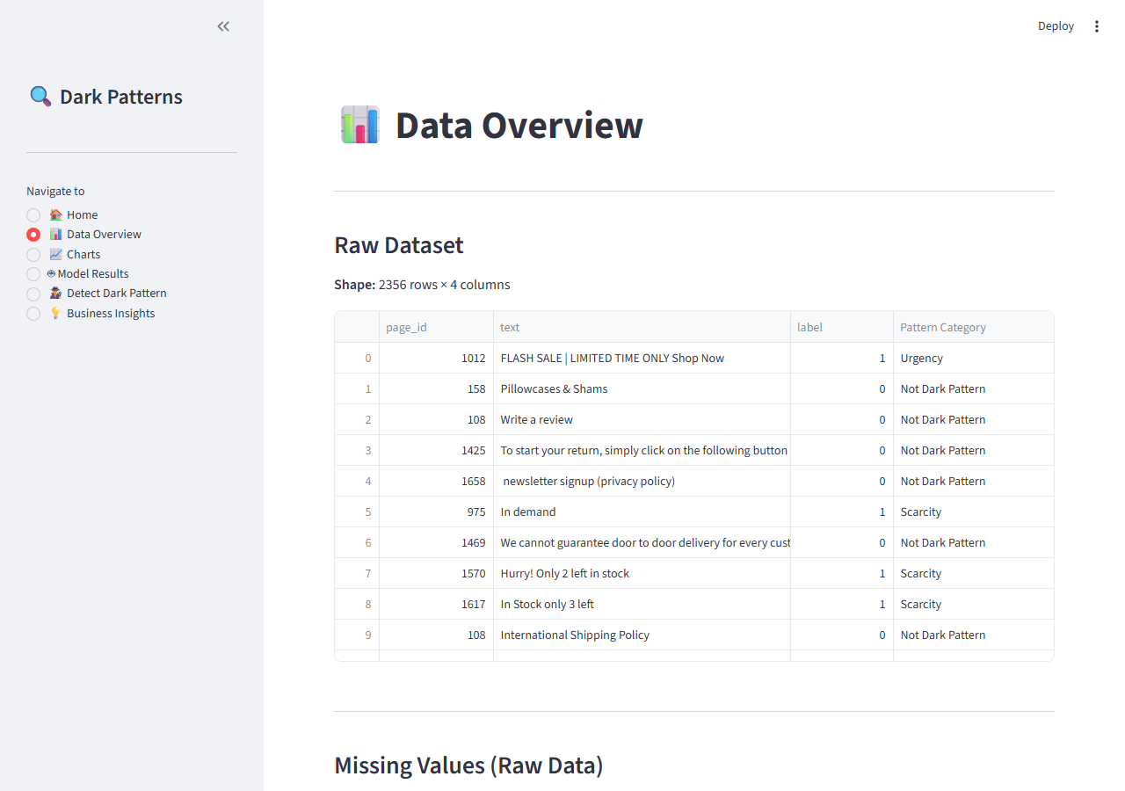
Figure 5.1: Streamlit Data Overview Page showing raw data and cleaning summary

Chapter 6: Data Analysis
After cleaning, the dataset was analysed to understand the distribution of dark patterns across labels and categories.

6.1 Label Distribution
Label | Count | Percentage
Dark Pattern (label=1) | 1,178 | 50.0%
Not Dark Pattern (label=0) | 1,178 | 50.0%
Total | 2,356 | 100%

6.2 Pattern Category Distribution
Category | Count | Percentage | Description
Not Dark Pattern | 1,178 | 50.0% | Legitimate content
Scarcity | 418 | 17.7% | Fake low-stock warnings
Social Proof | 312 | 13.2% | Fabricated popularity signals
Urgency | 210 | 8.9% | Artificial time pressure
Misdirection | 195 | 8.3% | Distracts users from real action
Obstruction | 27 | 1.1% | Makes opt-out unnecessarily hard
Sneaking | 12 | 0.5% | Hidden items added without consent
Forced Action | 4 | 0.2% | Forces user into unwanted action

6.3 Most Common Dark Pattern Types
Among the 1,178 dark pattern records, Scarcity is by far the most prevalent type (418 instances, 35.5% of all dark patterns), followed by Social Proof (312, 26.5%) and Urgency (210, 17.8%). These three categories together account for nearly 80% of all dark patterns in the dataset.

6.4 Basic Statistics
Column | Count | Mean | Std Dev | Min | Max
page_id | 2,356 | 904.3 | 539.8 | 1 | 1,818
Label | 2,356 | 0.500 | 0.500 | 0 | 1
text (unique) | 2,349 | — | — | — | —
Pattern Cat (unique) | 8 | — | — | — | —

Chapter 7: Detection Model
The model training pipeline is implemented in Y.Anantha_darkpatterns_model.py. It uses the cleaned text data as input and the binary label column as the target.

7.1 TF-IDF Vectorisation
Text data cannot be fed directly into a machine learning model. The text column is converted into numerical feature vectors using TF-IDF (Term Frequency – Inverse Document Frequency). The configuration used:
Parameter | Value | Purpose
max_features | 5,000 | Limits the vocabulary to the 5,000 most informative terms.
ngram_range | (1, 2) | Includes both single words (unigrams) and two-word phrases (bigrams).
stop_words | english | Common English words (the, is, at) are ignored to reduce noise.

7.2 Train / Test Split
The dataset was split into 80% training (1,884 samples) and 20% testing (472 samples) using stratified sampling to preserve the 50/50 class balance in both subsets. Random seed 42 was used for reproducibility.

7.3 Models Trained
Model | Description
Logistic Regression | A linear classifier that models the log-odds of the binary outcome. max_iter=1000 ensures full convergence on this dataset.
Naive Bayes (Multinomial) | A probabilistic classifier that works especially well with TF-IDF sparse feature matrices. Fast to train and often competitive on text classification.

7.4 Model Performance
Model | Accuracy | Precision | Recall | F1-Score | Winner
Logistic Regression | 0.9322 | 0.9679 | 0.8941 | 0.9295 | Best
Naive Bayes | 0.9174 | 0.8956 | 0.9449 | 0.9196

The best model is Logistic Regression with an F1-score of 0.9295 and accuracy of 93.22%. It was saved to models/best_model.pkl along with the fitted TF-IDF vectorizer (models/tfidf_vectorizer.pkl) for use in the Streamlit app.

7.5 Metric Definitions
Metric | Definition
Accuracy | Percentage of all predictions that were correct.
Precision | Of all texts predicted as dark patterns, what fraction actually were.
Recall | Of all actual dark patterns, what fraction the model correctly identified.
F1-Score | Harmonic mean of Precision and Recall — the primary model selection metric.

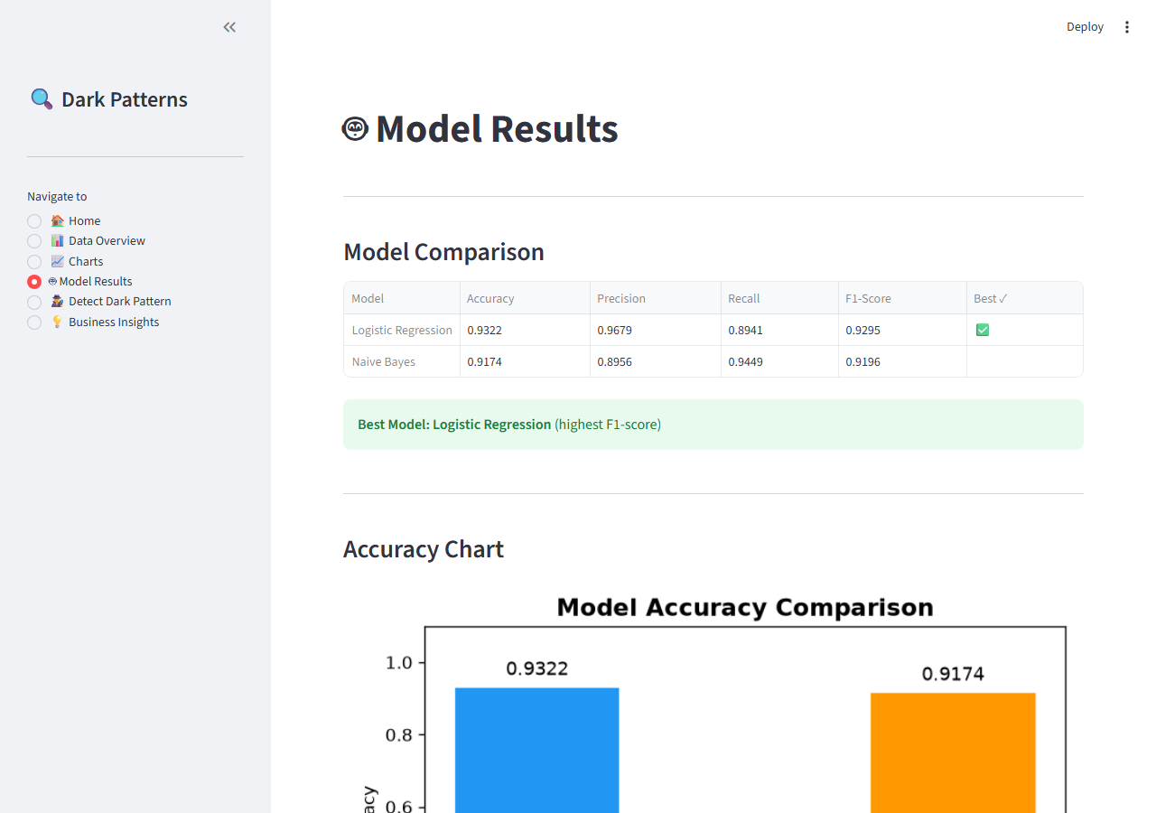
Figure 7.1: Streamlit Model Results Page showing scores comparison

Chapter 8: Key Performance Indicators
All KPIs are calculated from real project data by Y.Anantha_darkpatterns_kpis.py and saved to kpis.json. The values below are sourced directly from that file.

8.1 Data Quality KPIs
KPI | Value | Meaning
Total Records (Raw) | 2356 | Number of records in the original dataset
Total Records (Cleaned) | 2356 | Records remaining after all cleaning steps
Records Removed | 0 | Rows dropped during cleaning
Missing Value Rate | 0.0% | Percentage of cells with missing values
Duplicate Rate | 0.0% | Percentage of exact duplicate rows
Data Completeness | 100.0% | 100% minus the missing value rate

8.2 Model KPIs
KPI | Logistic Regression (Best) | Naive Bayes
Accuracy | 93.22% | 91.74%
Precision | 96.79% | 89.56%
Recall | 89.41% | 94.49%
F1-Score | 92.95% | 91.96%
True Positives | 211 | 223
False Positives | 7 | 26
True Negatives | 229 | 210
False Negatives | 25 | 13
Train Samples | 1884 | 1884
Test Samples | 472 | 472

Best model by F1-score: Logistic Regression (F1 = 92.95%, Accuracy = 93.22%)

8.3 Business KPIs
KPI | Value | Meaning
Total Samples | 2356 | Total records in cleaned dataset
Dark Pattern Count | 1178 | Records labelled as dark patterns
Not Dark Pattern Count | 1178 | Records labelled as legitimate
Dark Pattern Prevalence | 50.0% | % of all records that are dark patterns
Top Dark Pattern Type | Scarcity | Most frequently detected category
Top Pattern Count | 418 | Number of instances of the top type
Top Pattern Share | 35.5% | % of dark patterns it represents
Detection Coverage | 89.41% | Recall — % of dark patterns model catches
Categories Detected | 7 | Distinct dark pattern types in dataset

8.4 Category Share KPIs
Category | Count | Share | Note
Scarcity | 418 | 35.5% | % of total dark patterns
Social Proof | 312 | 26.5% | % of total dark patterns
Urgency | 210 | 17.8% | % of total dark patterns
Misdirection | 195 | 16.6% | % of total dark patterns
Obstruction | 27 | 2.3% | % of total dark patterns
Sneaking | 12 | 1.0% | % of total dark patterns
Forced Action | 4 | 0.3% | % of total dark patterns

Chapter 9: Charts and Comparison
Four charts were generated automatically by Y.Anantha_darkpatterns_analysis.py and Y.Anantha_darkpatterns_model.py and are also displayed on the Charts page of the Streamlit application.

9.1 Dark Pattern Category Distribution
A bar chart showing the count of records per Pattern Category. Not Dark Pattern dominates with 1,178 records. Among dark patterns, Scarcity (418), Social Proof (312), and Urgency (210) are the top three categories.
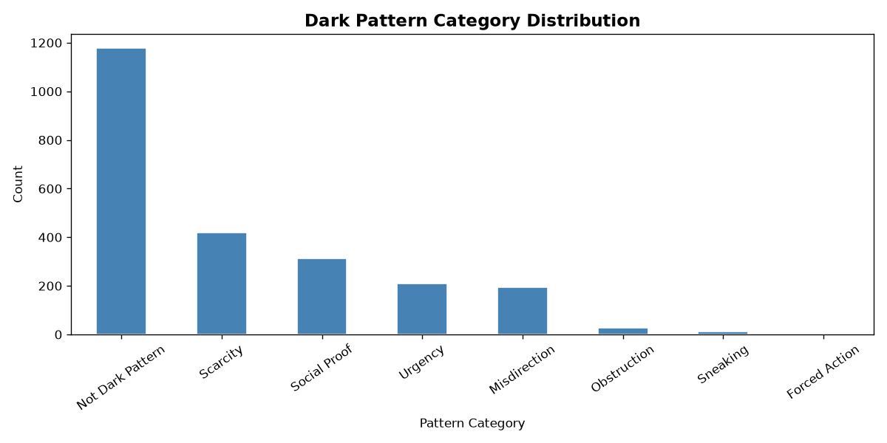
Figure 9.1: Dark Pattern Category Distribution (Bar Chart)

9.2 Dark Pattern vs Not Dark Pattern
A pie chart showing the overall split between dark patterns and legitimate text. The dataset is perfectly balanced at exactly 50% each.
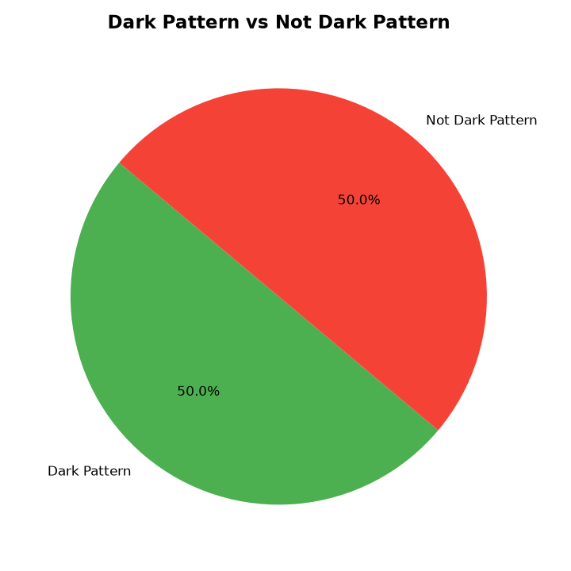
Figure 9.2: Dark Pattern vs Not Dark Pattern (Pie Chart)

9.3 Model Accuracy Comparison
A bar chart comparing the accuracy of Logistic Regression (93.22%) against Naive Bayes (91.74%). Logistic Regression performs better on this dataset.
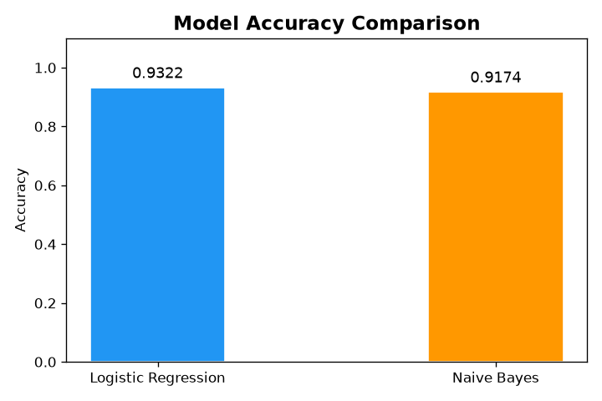
Figure 9.3: Model Accuracy Comparison (Bar Chart)

9.4 Confusion Matrix
A heatmap of the confusion matrix for the best model (Logistic Regression). Out of 472 test samples: 229 Not Dark Pattern correctly identified, 211 Dark Patterns correctly identified, 25 false negatives, and 7 false positives.
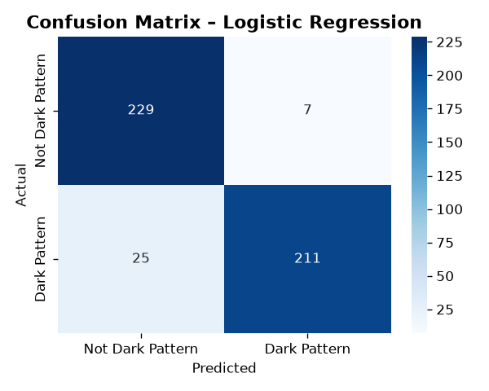
Figure 9.4: Confusion Matrix – Logistic Regression (Heatmap)
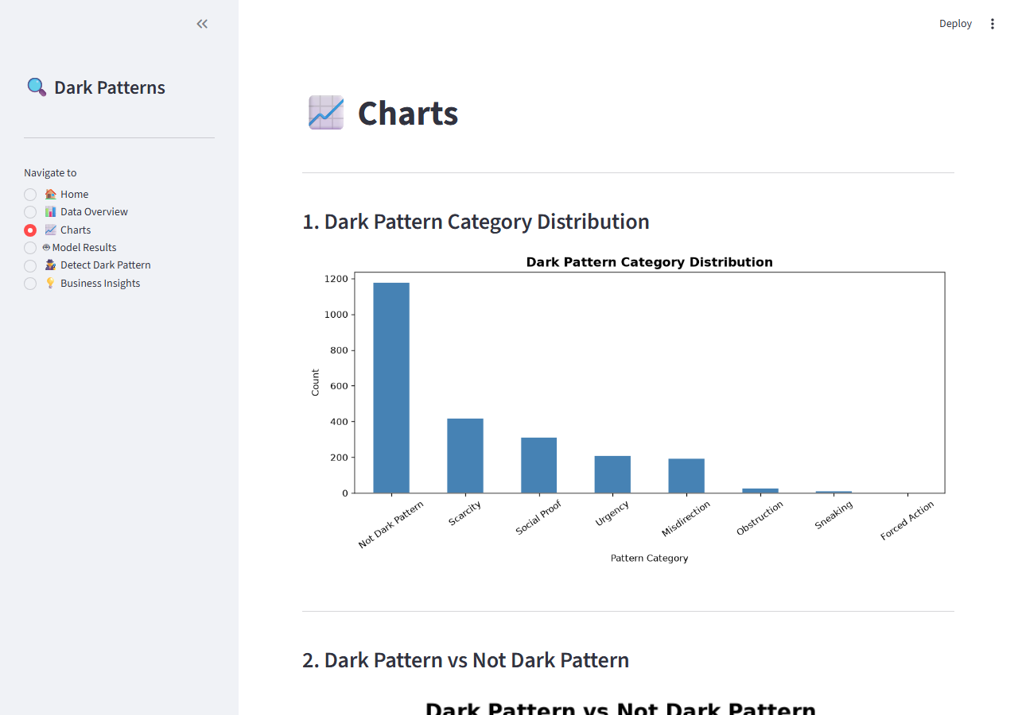
Figure 9.5: Streamlit Charts Page showing all visualisations

Chapter 10: Business Decisions
Based on the analysis results, five actionable business recommendations are provided to help organisations reduce dark pattern usage and build long-term customer trust.

10.1 Replace Scarcity Tricks with Real Inventory Data
Finding: Scarcity messages such as 'Only 2 left in stock!' are the single most common dark pattern, accounting for 35.5% of all dark patterns in the dataset. Recommendation: Display inventory levels only when genuinely low, verified against live warehouse data. Real scarcity converts better long-term and avoids eroding customer trust. Companies like Patagonia and REI show real stock counts and report higher repeat-purchase rates as a result.

10.2 Eliminate Fake Urgency from Promotions
Finding: Urgency patterns such as 'Flash Sale - Today Only!' are the third most common category (210 instances). Many such timers auto-reset, and users eventually notice this deception. Recommendation: Honour advertised deadlines. Use countdown timers only for genuinely time-limited events. Misleading urgency inflates short-term conversion but increases cart abandonment and returns over time.

10.3 Audit Social-Proof Claims for Accuracy
Finding: Social Proof patterns such as '100 people viewing this now' account for 26.5% of dark patterns (312 instances). Recommendation: Show only real-time or recently verified engagement data, or remove it entirely. Fabricated numbers are increasingly flagged by browser extensions and consumer regulators under legislation such as the EU Digital Services Act.

10.4 Simplify Cancellation and Opt-Out Flows
Finding: Obstruction and Misdirection patterns, while smaller in volume, carry the highest regulatory risk. Regulators in both the EU and US specifically penalise hard-to-cancel subscriptions. Recommendation: Apply the 'one-click-in, one-click-out' principle. If a subscription can be started in one click, cancellation must require no more steps. Netflix and Spotify have both adopted this voluntarily following FTC guidance.

10.5 Integrate Automated Dark Pattern Scanning into QA
Finding: The ML model achieves 93.22% accuracy detecting dark patterns from raw UI text, meaning the detection problem is automatable at scale. Recommendation: Embed this classifier into the CI/CD pipeline as a content linting step. Flag any marketing copy or UI string classified as a dark pattern before it reaches production. This shifts fix cost from post-launch to pre-launch, reduces legal risk, and builds a culture of ethical design.
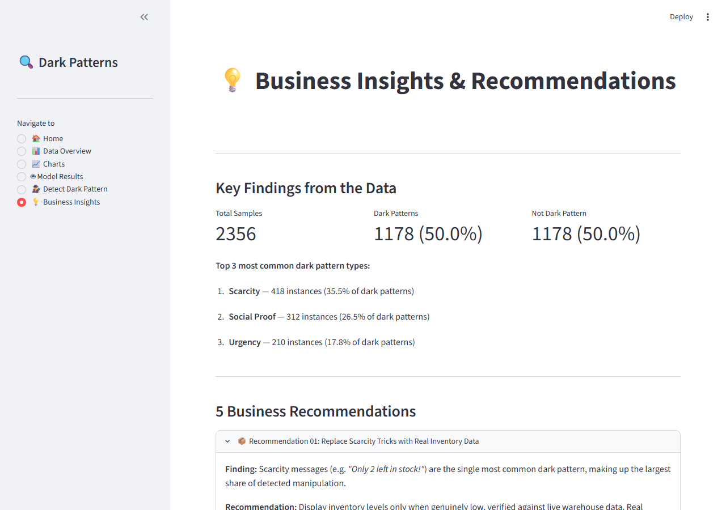
Figure 10.1: Streamlit Business Insights Page showing all recommendations

Chapter 11: Streamlit Application
The Streamlit application (Y.Anantha_darkpatterns_app.py) provides a fully interactive web interface with six pages accessible from the sidebar. The Home page shows live KPI cards loaded from kpis.json. Screenshots of every page are shown below.

11.1 Home Page
The Home page displays 12 KPI metric cards across three rows (Data Quality, Best Model, Business), a category share table loaded from kpis.json, the project description, feature table, and quick-start commands.
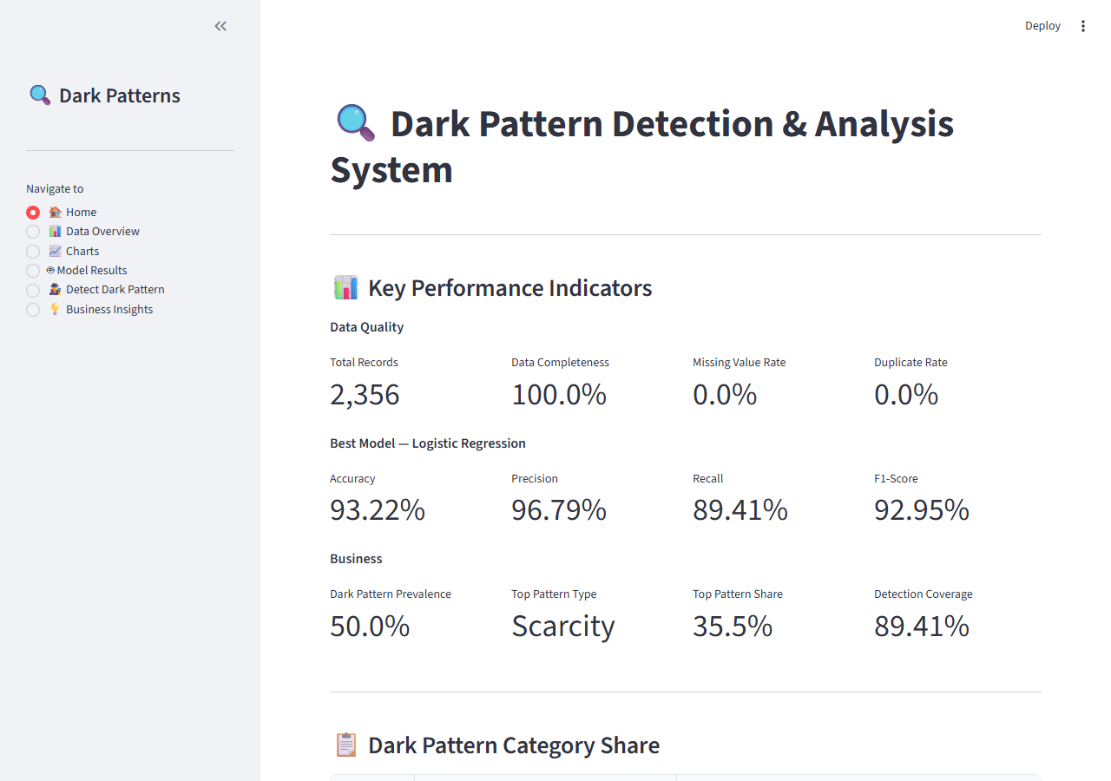
Figure 11.1: Streamlit App – Home Page with KPI Cards

11.2 Data Overview Page
The Data Overview page shows the first 20 rows of the raw dataset, a missing values table, a cleaning summary with before/after row counts, and a preview of the cleaned dataset.
Figure 11.2: Streamlit App – Data Overview Page

11.3 Charts Page
The Charts page displays all four generated charts (category bar, label pie, model accuracy comparison, confusion matrix heatmap) plus a fifth interactive horizontal bar chart rendered directly in Streamlit.
Figure 11.3: Streamlit App – Charts Page

11.4 Model Results Page
The Model Results page shows a side-by-side comparison table of Logistic Regression vs Naive Bayes across all four metrics, the accuracy chart, the confusion matrix heatmap, and a metric definitions reference table.
Figure 11.4: Streamlit App – Model Results Page

11.5 Detect Dark Pattern Page (Empty)
The Detect Dark Pattern page provides a text input area where users can paste any website text. It also shows four pre-loaded example buttons (Urgency, Scarcity, Social Proof, Neutral).
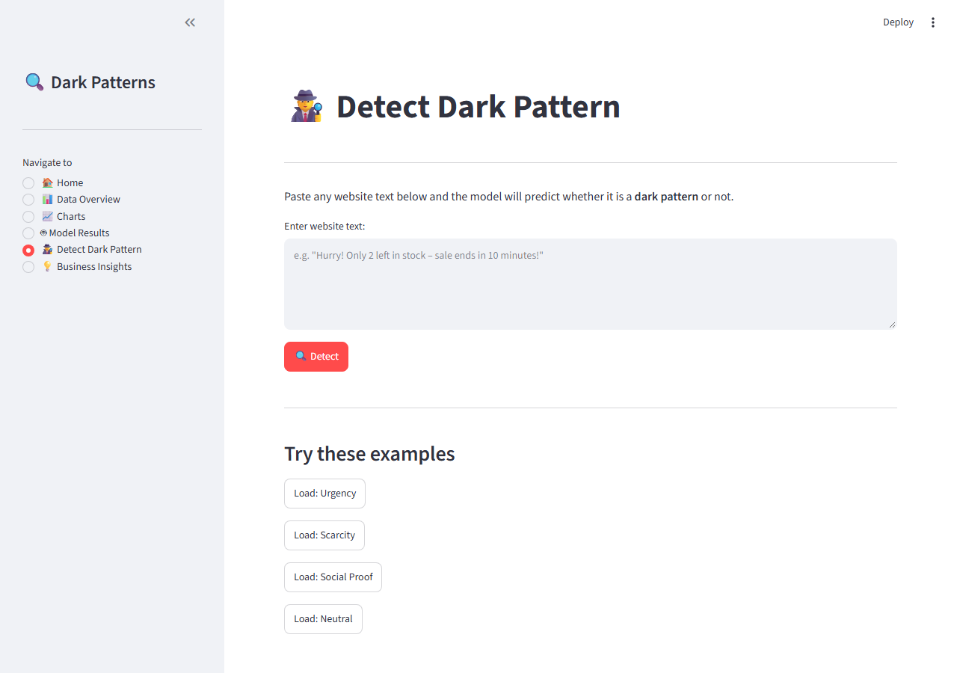
Figure 11.5: Streamlit App – Detect Dark Pattern (Empty State)

11.6 Business Insights Page
The Business Insights page shows live statistics (dark pattern count and percentage), the top 3 most common categories, and five expandable recommendation panels with detailed findings and actions.
Figure 11.6: Streamlit App – Business Insights Page

11.7 Detect Dark Pattern Page (With Result)
After entering 'Hurry! Only 2 items left in stock' and clicking Detect, the app shows a Dark Pattern Detected warning with confidence percentage, the likely category (Scarcity and Urgency matched), and a confidence bar.
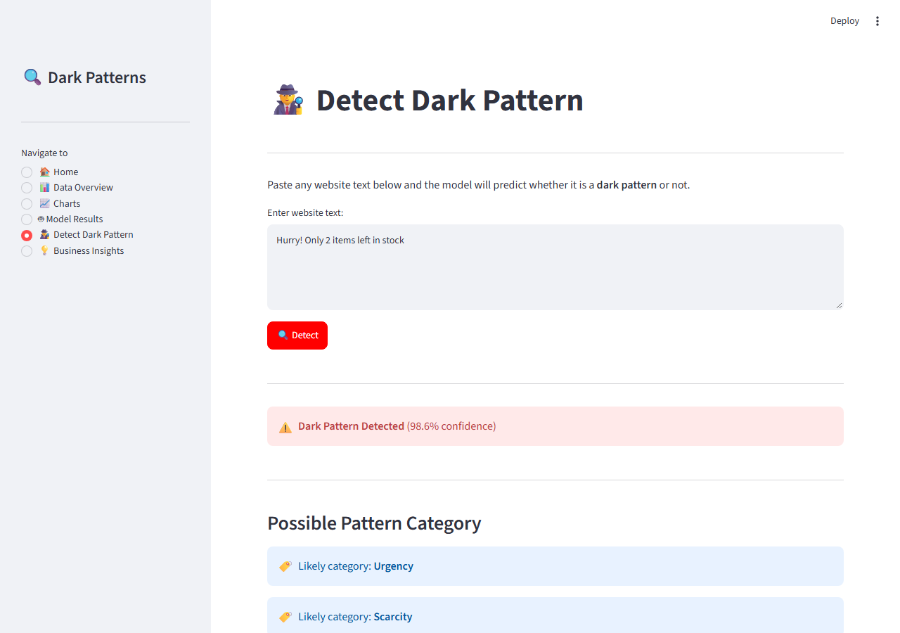
Figure 11.7: Streamlit App – Detection Result for Scarcity Text

Chapter 12: Code Documentation
This chapter documents every Python file in the project: its purpose, a list of functions with one-line descriptions, and the full source code.

12.1 Y.Anantha_darkpatterns_analysis.py

Purpose
Handles Steps 1–3 of the pipeline: loading the raw CSV, cleaning the data (missing values, duplicates, invalid labels, whitespace), performing exploratory data analysis, and generating the category bar chart and label pie chart.

Functions
Function Signature | Description
load_data(path) | Loads the raw CSV and prints shape, column names, and first 5 rows.
clean_data(df) | Fixes missing values, duplicates, empty text, and invalid labels; saves cleaned CSV.
analyze_data(df) | Computes label distribution, category counts, top dark patterns, and basic statistics.
save_category_bar_chart(df) | Generates and saves a bar chart of pattern category counts to charts/category_bar.png.
save_label_pie_chart(df) | Generates and saves a pie chart of dark vs not dark label split to charts/label_pie.png.
save_model_accuracy_chart(results) | Generates and saves a bar chart comparing model accuracy scores.
save_confusion_matrix_chart(cm, model_name) | Generates and saves a confusion matrix heatmap for the best model.

Source Code
"""
Y.Anantha_darkpatterns_analysis.py
----------------------------------
Dark Pattern Detection & Analysis System
Step 1 – Load, Step 2 – Clean, Step 3 – Analyze, Step 4 – Charts
"""

import os
import pandas as pd
import matplotlib
matplotlib.use("Agg") # non-interactive backend (safe for scripts & Streamlit)
import matplotlib.pyplot as plt
import seaborn as sns

# ─────────────────────────────────────────────
# Paths
# ─────────────────────────────────────────────
DATA_PATH = os.path.join("data", "darkpatterndataset.csv")
CLEANED_PATH = os.path.join("data", "cleaned_darkpatterns.csv")
CHARTS_DIR = "charts"
os.makedirs(CHARTS_DIR, exist_ok=True)

# ═══════════════════════════════════════════════════════════
# STEP 1 – LOAD DATA
# ═══════════════════════════════════════════════════════════
def load_data(path: str = DATA_PATH) -> pd.DataFrame:
"""Load the raw CSV and print a basic overview."""
df = pd.read_csv(path)

print("=" * 55)
print("STEP 1 – LOAD DATA")
print("=" * 55)
print(f"Rows : {df.shape[0]}")
print(f"Columns : {df.shape[1]}")
print(f"Names : {list(df.columns)}")
print("\nFirst 5 rows:")
print(df.head())
return df

# ═══════════════════════════════════════════════════════════
# STEP 2 – CLEAN DATA
# ═══════════════════════════════════════════════════════════
def clean_data(df: pd.DataFrame) -> tuple[pd.DataFrame, dict]:
"""
Identify and fix data quality issues.
Returns the cleaned DataFrame and a summary dict for reporting.
"""
print("\n" + "=" * 55)
print("STEP 2 – CLEAN DATA")
print("=" * 55)

summary = {}

# --- 2a. Missing values -------------------------------------------------
missing = df.isnull().sum()
print("\nMissing values per column:")
print(missing)
summary["missing_before"] = missing.to_dict()

# Drop rows where 'text' or 'label' is missing (essential columns)
before = len(df)
df = df.dropna(subset=["text", "label"])
# Fill missing 'Pattern Category' with 'Unknown'
df["Pattern Category"] = df["Pattern Category"].fillna("Unknown")
summary["rows_dropped_missing"] = before - len(df)
print(f"\n → Dropped {before - len(df)} rows with missing 'text' or 'label'.")
print( " → Filled missing 'Pattern Category' with 'Unknown'.")

# --- 2b. Duplicate rows -------------------------------------------------
dupes = df.duplicated().sum()
print(f"\nDuplicate rows found: {dupes}")
summary["duplicates_found"] = int(dupes)
df = df.drop_duplicates()
print(f" → Removed {dupes} duplicate rows.")

# --- 2c. Whitespace / empty text ----------------------------------------
df["text"] = df["text"].astype(str).str.strip()
empty_text = (df["text"] == "").sum()
df = df[df["text"] != ""]
summary["empty_text_removed"] = int(empty_text)
print(f"\nEmpty text strings removed: {empty_text}")

# --- 2d. Label column – keep only 0 and 1 --------------------------------
df["label"] = pd.to_numeric(df["label"], errors="coerce")
invalid_labels = df["label"].isnull().sum()
df = df.dropna(subset=["label"])
df["label"] = df["label"].astype(int)
df = df[df["label"].isin([0, 1])]
summary["invalid_labels_removed"] = int(invalid_labels)
print(f"Invalid label values removed : {invalid_labels}")

# --- 2e. Pattern Category – strip whitespace ----------------------------
df["Pattern Category"] = df["Pattern Category"].str.strip()

# --- Final state --------------------------------------------------------
print(f"\nCleaned dataset shape: {df.shape}")
summary["final_rows"] = len(df)
summary["final_columns"] = df.shape[1]
summary["missing_after"] = df.isnull().sum().to_dict()

# Save
df.to_csv(CLEANED_PATH, index=False)
print(f"\nCleaned data saved → {CLEANED_PATH}")
return df, summary

# ═══════════════════════════════════════════════════════════
# STEP 3 – ANALYZE DATA
# ═══════════════════════════════════════════════════════════
def analyze_data(df: pd.DataFrame) -> dict:
"""Compute counts, distributions, and basic statistics."""
print("\n" + "=" * 55)
print("STEP 3 – ANALYZE DATA")
print("=" * 55)

stats = {}

# Label distribution
label_counts = df["label"].value_counts().rename({1: "Dark Pattern", 0: "Not Dark Pattern"})
stats["label_counts"] = label_counts
print("\nLabel distribution:")
print(label_counts)

# Pattern category counts
cat_counts = df["Pattern Category"].value_counts()
stats["category_counts"] = cat_counts
print("\nPattern Category distribution:")
print(cat_counts)

# Most common dark pattern types (excluding 'Not Dark Pattern')
dark_only = df[df["label"] == 1]["Pattern Category"].value_counts()
stats["dark_type_counts"] = dark_only
print("\nMost common dark pattern types:")
print(dark_only)

# Basic statistics
print("\nBasic statistics (numeric columns):")
desc = df.describe(include="all")
print(desc)
stats["describe"] = desc

return stats

# ═══════════════════════════════════════════════════════════
# STEP 5 – CHARTS (called after model training in main)
# ═══════════════════════════════════════════════════════════
def save_category_bar_chart(df: pd.DataFrame) -> str:
"""Bar chart: count of each dark pattern category."""
cat_counts = df["Pattern Category"].value_counts()
fig, ax = plt.subplots(figsize=(10, 5))
cat_counts.plot(kind="bar", ax=ax, color="steelblue", edgecolor="white")
ax.set_title("Dark Pattern Category Distribution", fontsize=14, fontweight="bold")
ax.set_xlabel("Pattern Category")
ax.set_ylabel("Count")
ax.tick_params(axis="x", rotation=35)
plt.tight_layout()
path = os.path.join(CHARTS_DIR, "category_bar.png")
fig.savefig(path, dpi=120)
plt.close(fig)
return path

def save_label_pie_chart(df: pd.DataFrame) -> str:
"""Pie chart: dark pattern vs not dark pattern."""
label_counts = df["label"].value_counts()
labels = ["Not Dark Pattern" if l == 0 else "Dark Pattern" for l in label_counts.index]
fig, ax = plt.subplots(figsize=(6, 6))
ax.pie(
label_counts.values,
labels=labels,
autopct="%1.1f%%",
startangle=140,
colors=["#4CAF50", "#F44336"],
)
ax.set_title("Dark Pattern vs Not Dark Pattern", fontsize=14, fontweight="bold")
plt.tight_layout()
path = os.path.join(CHARTS_DIR, "label_pie.png")
fig.savefig(path, dpi=120)
plt.close(fig)
return path

def save_model_accuracy_chart(results: dict) -> str:
"""Bar chart: model accuracy comparison."""
models = list(results.keys())
accuracies = [results[m]["accuracy"] for m in models]
fig, ax = plt.subplots(figsize=(6, 4))
bars = ax.bar(models, accuracies, color=["#2196F3", "#FF9800"], edgecolor="white", width=0.4)
ax.set_ylim(0, 1.1)
ax.set_title("Model Accuracy Comparison", fontsize=14, fontweight="bold")
ax.set_ylabel("Accuracy")
for bar, val in zip(bars, accuracies):
ax.text(bar.get_x() + bar.get_width() / 2, bar.get_height() + 0.02,
f"{val:.4f}", ha="center", va="bottom", fontsize=11)
plt.tight_layout()
path = os.path.join(CHARTS_DIR, "model_accuracy.png")
fig.savefig(path, dpi=120)
plt.close(fig)
return path

def save_confusion_matrix_chart(cm, model_name: str) -> str:
"""Heatmap of the confusion matrix for the best model."""
fig, ax = plt.subplots(figsize=(5, 4))
sns.heatmap(
cm,
annot=True,
fmt="d",
cmap="Blues",
xticklabels=["Not Dark Pattern", "Dark Pattern"],
yticklabels=["Not Dark Pattern", "Dark Pattern"],
ax=ax,
)
ax.set_title(f"Confusion Matrix – {model_name}", fontsize=13, fontweight="bold")
ax.set_xlabel("Predicted")
ax.set_ylabel("Actual")
plt.tight_layout()
path = os.path.join(CHARTS_DIR, "confusion_matrix.png")
fig.savefig(path, dpi=120)
plt.close(fig)
return path

# ═══════════════════════════════════════════════════════════
# MAIN – run everything in sequence
# ═══════════════════════════════════════════════════════════
if __name__ == "__main__":
df_raw = load_data()
df_clean, summary = clean_data(df_raw)
stats = analyze_data(df_clean)

# Generate data charts
save_category_bar_chart(df_clean)
save_label_pie_chart(df_clean)
print("\nCharts saved in /charts folder.")
print("\nY.Anantha_darkpatterns_analysis.py complete. Run Y.Anantha_darkpatterns_model.py next.")

12.2 Y.Anantha_darkpatterns_model.py

Purpose
Handles Step 4: TF-IDF vectorisation of text, 80/20 stratified train/test split, training Logistic Regression and Naive Bayes classifiers, evaluating both models with full metrics, saving the best model and vectorizer, and generating the model accuracy chart and confusion matrix heatmap.

Functions
Function Signature | Description
evaluate_model(name, model, X_test, y_test) | Computes accuracy, precision, recall, F1-score, and confusion matrix for a trained model.
save_model_accuracy_chart(results) | Generates and saves a bar chart comparing model accuracies.
save_confusion_matrix_chart(cm_data, model_name) | Generates and saves a confusion matrix heatmap.
train_and_evaluate() | Full pipeline: load data, vectorise, split, train, evaluate, save model and charts.

Source Code
"""
Y.Anantha_darkpatterns_model.py
--------------------------------
Dark Pattern Detection & Analysis System
Step 4 – Train models, evaluate, save best model
Step 5 – Generate model-related charts
"""

import os
import json
import joblib
import numpy as np
import pandas as pd
import matplotlib
matplotlib.use("Agg")
import matplotlib.pyplot as plt
import seaborn as sns

from sklearn.feature_extraction.text import TfidfVectorizer
from sklearn.linear_model import LogisticRegression
from sklearn.naive_bayes import MultinomialNB
from sklearn.model_selection import train_test_split
from sklearn.metrics import (
accuracy_score,
precision_score,
recall_score,
f1_score,
confusion_matrix,
classification_report,
)

# ─────────────────────────────────────────────
# Paths
# ─────────────────────────────────────────────
CLEANED_PATH = os.path.join("data", "cleaned_darkpatterns.csv")
MODELS_DIR = "models"
CHARTS_DIR = "charts"
RESULTS_PATH = os.path.join(MODELS_DIR, "model_results.json")
os.makedirs(MODELS_DIR, exist_ok=True)
os.makedirs(CHARTS_DIR, exist_ok=True)

# ═══════════════════════════════════════════════════════════
# HELPER – evaluate a trained classifier
# ═══════════════════════════════════════════════════════════
def evaluate_model(name: str, model, X_test, y_test) -> dict:
"""Return a dict with all evaluation metrics for one model."""
y_pred = model.predict(X_test)
acc = accuracy_score(y_test, y_pred)
prec = precision_score(y_test, y_pred, zero_division=0)
rec = recall_score(y_test, y_pred, zero_division=0)
f1 = f1_score(y_test, y_pred, zero_division=0)
cm = confusion_matrix(y_test, y_pred)

print(f"\n{'─'*50}")
print(f"Model : {name}")
print(f" Accuracy : {acc:.4f}")
print(f" Precision : {prec:.4f}")
print(f" Recall : {rec:.4f}")
print(f" F1-score : {f1:.4f}")
print("\nClassification Report:")
print(classification_report(y_test, y_pred,
target_names=["Not Dark Pattern", "Dark Pattern"]))
print("Confusion Matrix:")
print(cm)

return {
"accuracy" : float(acc),
"precision": float(prec),
"recall" : float(rec),
"f1" : float(f1),
"cm" : cm.tolist(),
}

# ═══════════════════════════════════════════════════════════
# CHART helpers
# ═══════════════════════════════════════════════════════════
def save_model_accuracy_chart(results: dict) -> str:
models = list(results.keys())
accuracies = [results[m]["accuracy"] for m in models]
fig, ax = plt.subplots(figsize=(6, 4))
bars = ax.bar(models, accuracies, color=["#2196F3", "#FF9800"], edgecolor="white", width=0.4)
ax.set_ylim(0, 1.1)
ax.set_title("Model Accuracy Comparison", fontsize=14, fontweight="bold")
ax.set_ylabel("Accuracy")
for bar, val in zip(bars, accuracies):
ax.text(bar.get_x() + bar.get_width() / 2, bar.get_height() + 0.02,
f"{val:.4f}", ha="center", va="bottom", fontsize=11)
plt.tight_layout()
path = os.path.join(CHARTS_DIR, "model_accuracy.png")
fig.savefig(path, dpi=120)
plt.close(fig)
return path

def save_confusion_matrix_chart(cm_data, model_name: str) -> str:
cm = np.array(cm_data)
fig, ax = plt.subplots(figsize=(5, 4))
sns.heatmap(
cm,
annot=True,
fmt="d",
cmap="Blues",
xticklabels=["Not Dark Pattern", "Dark Pattern"],
yticklabels=["Not Dark Pattern", "Dark Pattern"],
ax=ax,
)
ax.set_title(f"Confusion Matrix – {model_name}", fontsize=13, fontweight="bold")
ax.set_xlabel("Predicted")
ax.set_ylabel("Actual")
plt.tight_layout()
path = os.path.join(CHARTS_DIR, "confusion_matrix.png")
fig.savefig(path, dpi=120)
plt.close(fig)
return path

# ═══════════════════════════════════════════════════════════
# MAIN
# ═══════════════════════════════════════════════════════════
def train_and_evaluate():
# ── Load cleaned data ──────────────────────────────────
print("=" * 55)
print("STEP 4 – MODEL TRAINING & EVALUATION")
print("=" * 55)
df = pd.read_csv(CLEANED_PATH)
print(f"Loaded cleaned data: {df.shape}")

X = df["text"].astype(str)
y = df["label"].astype(int)

# ── TF-IDF vectorisation ───────────────────────────────
vectorizer = TfidfVectorizer(
max_features=5000,
ngram_range=(1, 2), # unigrams + bigrams
stop_words="english",
)

# ── Train / test split (80 / 20) ──────────────────────
X_train_raw, X_test_raw, y_train, y_test = train_test_split(
X, y, test_size=0.2, random_state=42, stratify=y
)
X_train = vectorizer.fit_transform(X_train_raw)
X_test = vectorizer.transform(X_test_raw)
print(f"\nTrain size : {X_train.shape[0]}")
print(f"Test size : {X_test.shape[0]}")

# ── Train models ───────────────────────────────────────
lr_model = LogisticRegression(max_iter=1000, random_state=42)
lr_model.fit(X_train, y_train)

nb_model = MultinomialNB()
nb_model.fit(X_train, y_train)

# ── Evaluate ───────────────────────────────────────────
results = {}
results["Logistic Regression"] = evaluate_model(
"Logistic Regression", lr_model, X_test, y_test
)
results["Naive Bayes"] = evaluate_model(
"Naive Bayes", nb_model, X_test, y_test
)

# ── Pick best model ────────────────────────────────────
best_name = max(results, key=lambda m: results[m]["f1"])
best_model = lr_model if best_name == "Logistic Regression" else nb_model
print(f"\n✔ Best model (by F1): {best_name}")

# ── Save best model + vectorizer ───────────────────────
joblib.dump(best_model, os.path.join(MODELS_DIR, "best_model.pkl"))
joblib.dump(vectorizer, os.path.join(MODELS_DIR, "tfidf_vectorizer.pkl"))
print(f" Saved → {MODELS_DIR}/best_model.pkl")
print(f" Saved → {MODELS_DIR}/tfidf_vectorizer.pkl")

# Save results JSON for Streamlit
results_to_save = dict(results)
results_to_save["best_model_name"] = best_name
with open(RESULTS_PATH, "w") as f:
json.dump(results_to_save, f, indent=2)
print(f" Results → {RESULTS_PATH}")

# ── Charts ─────────────────────────────────────────────
save_model_accuracy_chart(results)
save_confusion_matrix_chart(results[best_name]["cm"], best_name)
print("\nModel charts saved in /charts folder.")

return results, best_name, vectorizer

if __name__ == "__main__":
train_and_evaluate()
print("\nY.Anantha_darkpatterns_model.py complete.")

12.3 Y.Anantha_darkpatterns_kpis.py

Purpose
Calculates all project KPIs from real data: Data Quality KPIs (missing rate, duplicate rate, completeness), Model KPIs (accuracy, precision, recall, F1, confusion matrix for both models), and Business KPIs (prevalence, category share, detection coverage). Saves everything to kpis.json.

Functions
Function Signature | Description
calculate_kpis() | Loads raw/cleaned data and model results, computes all KPIs, returns a structured dict.
print_kpis(kpis) | Pretty-prints all KPI groups to the console for verification.

Source Code
"""
Y.Anantha_darkpatterns_kpis.py
-------------------------------
Dark Pattern Detection & Analysis System
Calculates and saves all project KPIs to kpis.json.

Reuses cleaned data from data/cleaned_darkpatterns.csv
and model results from models/model_results.json.

Run with:
python Y.Anantha_darkpatterns_kpis.py
"""

import os
import json
import pandas as pd

# ─────────────────────────────────────────────
# Paths
# ─────────────────────────────────────────────
RAW_PATH = os.path.join("data", "darkpatterndataset.csv")
CLEANED_PATH = os.path.join("data", "cleaned_darkpatterns.csv")
RESULTS_PATH = os.path.join("models", "model_results.json")
KPI_PATH = "kpis.json"

def calculate_kpis() -> dict:
"""Calculate all KPIs from real project data and return as a dict."""

# ── Load raw and cleaned data ──────────────────────────────
df_raw = pd.read_csv(RAW_PATH)
df_clean = pd.read_csv(CLEANED_PATH)

# ── Load model results ─────────────────────────────────────
with open(RESULTS_PATH) as f:
results = json.load(f)

total_raw = len(df_raw)
total_clean = len(df_clean)

# ══════════════════════════════════════════════
# 1. DATA QUALITY KPIs
# ══════════════════════════════════════════════
missing_count = int(df_raw.isnull().sum().sum()) # total missing cells
duplicate_count = int(df_raw.duplicated().sum())
total_cells = total_raw * df_raw.shape[1]

missing_rate = round((missing_count / total_cells) * 100, 2)
duplicate_rate = round((duplicate_count / total_raw) * 100, 2)
completeness = round(100 - missing_rate, 2)
records_removed = total_raw - total_clean

data_quality = {
"total_records_raw" : total_raw,
"total_records_cleaned" : total_clean,
"records_removed" : records_removed,
"missing_value_rate_pct" : missing_rate,
"duplicate_rate_pct" : duplicate_rate,
"data_completeness_pct" : completeness,
}

# ══════════════════════════════════════════════
# 2. MODEL KPIs (both models + best model)
# ══════════════════════════════════════════════
best_name = results["best_model_name"]
lr = results["Logistic Regression"]
nb = results["Naive Bayes"]

# Confusion matrix breakdown for each model
def cm_breakdown(cm):
tn, fp, fn, tp = cm[0][0], cm[0][1], cm[1][0], cm[1][1]
return {"TN": tn, "FP": fp, "FN": fn, "TP": tp}

model_kpis = {
"Logistic Regression": {
"accuracy" : round(lr["accuracy"] * 100, 2),
"precision" : round(lr["precision"] * 100, 2),
"recall" : round(lr["recall"] * 100, 2),
"f1_score" : round(lr["f1"] * 100, 2),
"confusion_matrix" : cm_breakdown(lr["cm"]),
},
"Naive Bayes": {
"accuracy" : round(nb["accuracy"] * 100, 2),
"precision" : round(nb["precision"] * 100, 2),
"recall" : round(nb["recall"] * 100, 2),
"f1_score" : round(nb["f1"] * 100, 2),
"confusion_matrix" : cm_breakdown(nb["cm"]),
},
"best_model" : best_name,
"best_f1_score" : round(results[best_name]["f1"] * 100, 2),
"best_accuracy" : round(results[best_name]["accuracy"] * 100, 2),
"train_test_split": "80% train / 20% test",
"test_samples" : 472,
"train_samples" : 1884,
}

# ══════════════════════════════════════════════
# 3. BUSINESS KPIs
# ══════════════════════════════════════════════
total_samples = len(df_clean)
dark_count = int((df_clean["label"] == 1).sum())
safe_count = int((df_clean["label"] == 0).sum())

# Category counts (dark patterns only)
dark_df = df_clean[df_clean["label"] == 1]
cat_counts = dark_df["Pattern Category"].value_counts()
top_category = str(cat_counts.index[0])
top_cat_count = int(cat_counts.iloc[0])

# Category share % (of all dark patterns)
category_share = {
cat: round((cnt / dark_count) * 100, 1)
for cat, cnt in cat_counts.items()
}

# Detection coverage = % of dark patterns the best model catches (recall)
best_recall = results[best_name]["recall"]
detection_coverage = round(best_recall * 100, 2)

business_kpis = {
"total_samples" : total_samples,
"dark_pattern_count" : dark_count,
"not_dark_pattern_count" : safe_count,
"dark_pattern_prevalence_pct": round((dark_count / total_samples) * 100, 1),
"top_dark_pattern_type" : top_category,
"top_dark_pattern_count" : top_cat_count,
"top_dark_pattern_share_pct": round((top_cat_count / dark_count) * 100, 1),
"category_share_pct" : category_share,
"detection_coverage_pct" : detection_coverage,
"categories_detected" : int(cat_counts.shape[0]),
}

# ══════════════════════════════════════════════
# Assemble full KPI dict
# ══════════════════════════════════════════════
kpis = {
"data_quality" : data_quality,
"model" : model_kpis,
"business" : business_kpis,
}

return kpis

def print_kpis(kpis: dict):
"""Pretty-print all KPIs to the console."""
dq = kpis["data_quality"]
m = kpis["model"]
b = kpis["business"]

print("=" * 55)
print("DATA QUALITY KPIs")
print("=" * 55)
print(f" Total records (raw) : {dq['total_records_raw']}")
print(f" Total records (cleaned) : {dq['total_records_cleaned']}")
print(f" Records removed : {dq['records_removed']}")
print(f" Missing value rate : {dq['missing_value_rate_pct']}%")
print(f" Duplicate rate : {dq['duplicate_rate_pct']}%")
print(f" Data completeness : {dq['data_completeness_pct']}%")

print("\n" + "=" * 55)
print("MODEL KPIs")
print("=" * 55)
for model_name in ["Logistic Regression", "Naive Bayes"]:
mk = m[model_name]
best_tag = " ← BEST" if model_name == m["best_model"] else ""
print(f"\n {model_name}{best_tag}")
print(f" Accuracy : {mk['accuracy']}%")
print(f" Precision : {mk['precision']}%")
print(f" Recall : {mk['recall']}%")
print(f" F1-Score : {mk['f1_score']}%")
cm = mk["confusion_matrix"]
print(f" TP={cm['TP']} FP={cm['FP']} TN={cm['TN']} FN={cm['FN']}")
print(f"\n Best model : {m['best_model']} (F1 = {m['best_f1_score']}%)")
print(f" Train/Test : {m['train_test_split']}")

print("\n" + "=" * 55)
print("BUSINESS KPIs")
print("=" * 55)
print(f" Total samples : {b['total_samples']}")
print(f" Dark pattern prevalence : {b['dark_pattern_prevalence_pct']}%")
print(f" Top dark pattern type : {b['top_dark_pattern_type']} ({b['top_dark_pattern_count']} records, {b['top_dark_pattern_share_pct']}%)")
print(f" Detection coverage (recall): {b['detection_coverage_pct']}%")
print(f" Categories detected : {b['categories_detected']}")
print("\n Category share (% of dark patterns):")
for cat, pct in b["category_share_pct"].items():
print(f" {cat:<20} : {pct}%")

if __name__ == "__main__":
kpis = calculate_kpis()
print_kpis(kpis)

# Save to kpis.json
with open(KPI_PATH, "w") as f:
json.dump(kpis, f, indent=2)

print(f"\nKPIs saved -> {KPI_PATH} ({os.path.getsize(KPI_PATH):,} bytes)")
print("\nY.Anantha_darkpatterns_kpis.py complete.")

12.4 Y.Anantha_darkpatterns_app.py

Purpose
The Streamlit web application. Provides six sidebar pages: Home, Data Overview, Charts, Model Results, Detect Dark Pattern, and Business Insights. Loads all cached data, models, and results. Handles live text prediction using the saved model and vectorizer.

Functions
Function Signature | Description
load_raw_data() | Cached loader — reads the raw CSV into a DataFrame.
load_cleaned_data() | Cached loader — reads the cleaned CSV into a DataFrame.
load_model_and_vectorizer() | Cached resource loader — loads best_model.pkl and tfidf_vectorizer.pkl via joblib.
load_results() | Cached loader — reads model_results.json into a dict.
load_kpis() | Cached loader — reads kpis.json; returns None if file not found.
show_chart(filename) | Displays a saved PNG chart image in the Streamlit UI.
check_assets_ready() | Returns True if all required generated files exist on disk.

Source Code
"""
Y.Anantha_darkpatterns_app.py
------------------------------
Dark Pattern Detection & Analysis System
Streamlit frontend — run with: streamlit run Y.Anantha_darkpatterns_app.py
"""

import os
import json
import joblib
import numpy as np
import pandas as pd
import streamlit as st
import matplotlib.pyplot as plt
import seaborn as sns
from PIL import Image

# ─────────────────────────────────────────────
# Paths
# ─────────────────────────────────────────────
CLEANED_PATH = os.path.join("data", "cleaned_darkpatterns.csv")
RAW_PATH = os.path.join("data", "darkpatterndataset.csv")
MODEL_PATH = os.path.join("models", "best_model.pkl")
VEC_PATH = os.path.join("models", "tfidf_vectorizer.pkl")
RESULTS_PATH = os.path.join("models", "model_results.json")
KPI_PATH = "kpis.json"
CHARTS_DIR = "charts"

# ─────────────────────────────────────────────
# Page config
# ─────────────────────────────────────────────
st.set_page_config(
page_title="Dark Pattern Detection",
page_icon="🔍",
layout="wide",
)

# ─────────────────────────────────────────────
# Cached loaders
# ─────────────────────────────────────────────
@st.cache_data
def load_raw_data():
return pd.read_csv(RAW_PATH)

@st.cache_data
def load_cleaned_data():
return pd.read_csv(CLEANED_PATH)

@st.cache_resource
def load_model_and_vectorizer():
model = joblib.load(MODEL_PATH)
vectorizer = joblib.load(VEC_PATH)
return model, vectorizer

@st.cache_data
def load_results():
with open(RESULTS_PATH) as f:
return json.load(f)

@st.cache_data
def load_kpis():
"""Load kpis.json if it exists, else return None."""
if os.path.exists(KPI_PATH):
with open(KPI_PATH) as f:
return json.load(f)
return None

# ─────────────────────────────────────────────
# Helpers
# ─────────────────────────────────────────────
def show_chart(filename: str):
"""Display a saved chart image if it exists."""
path = os.path.join(CHARTS_DIR, filename)
if os.path.exists(path):
st.image(path, use_container_width=True)
else:
st.warning(f"Chart not found: {filename}. Please run Y.Anantha_darkpatterns_analysis.py and Y.Anantha_darkpatterns_model.py first.")

def check_assets_ready() -> bool:
"""Return True only if all generated assets exist."""
needed = [CLEANED_PATH, MODEL_PATH, VEC_PATH, RESULTS_PATH]
return all(os.path.exists(p) for p in needed)

# ─────────────────────────────────────────────
# Sidebar navigation
# ─────────────────────────────────────────────
st.sidebar.title("🔍 Dark Patterns")
st.sidebar.markdown("---")
pages = [
"🏠 Home",
"📊 Data Overview",
"📈 Charts",
"🤖 Model Results",
"🕵️ Detect Dark Pattern",
"💡 Business Insights",
]
page = st.sidebar.radio("Navigate to", pages)

# ─────────────────────────────────────────────
# Check readiness once
# ─────────────────────────────────────────────
assets_ready = check_assets_ready()
if not assets_ready:
st.sidebar.warning("⚠️ Run `Y.Anantha_darkpatterns_analysis.py` then `Y.Anantha_darkpatterns_model.py` to generate all assets.")

# ══════════════════════════════════════════════════════════════
# PAGE 1 – HOME
# ══════════════════════════════════════════════════════════════
if page == "🏠 Home":
st.title("🔍 Dark Pattern Detection & Analysis System")
st.markdown("---")

# ── KPI Section ───────────────────────────────────────────
kpis = load_kpis()
if kpis is None:
st.warning("⚠️ KPI data not found. Run `python Y.Anantha_darkpatterns_kpis.py` first.")
else:
dq = kpis["data_quality"]
mk = kpis["model"]
bk = kpis["business"]
best = mk["best_model"]

st.subheader("📊 Key Performance Indicators")

# Row 1 — Data Quality
st.markdown("**Data Quality**")
c1, c2, c3, c4 = st.columns(4)
c1.metric("Total Records", f"{dq['total_records_cleaned']:,}")
c2.metric("Data Completeness", f"{dq['data_completeness_pct']}%")
c3.metric("Missing Value Rate", f"{dq['missing_value_rate_pct']}%")
c4.metric("Duplicate Rate", f"{dq['duplicate_rate_pct']}%")

st.markdown("**Best Model — Logistic Regression**")
# Row 2 — Best Model
c5, c6, c7, c8 = st.columns(4)
bm = mk[best]
c5.metric("Accuracy", f"{bm['accuracy']}%")
c6.metric("Precision", f"{bm['precision']}%")
c7.metric("Recall", f"{bm['recall']}%")
c8.metric("F1-Score", f"{bm['f1_score']}%")

st.markdown("**Business**")
# Row 3 — Business
c9, c10, c11, c12 = st.columns(4)
c9.metric("Dark Pattern Prevalence", f"{bk['dark_pattern_prevalence_pct']}%")
c10.metric("Top Pattern Type", bk["top_dark_pattern_type"])
c11.metric("Top Pattern Share", f"{bk['top_dark_pattern_share_pct']}%")
c12.metric("Detection Coverage", f"{bk['detection_coverage_pct']}%")

# Category share table
st.markdown("---")
st.subheader("📋 Dark Pattern Category Share")
cat_rows = [
{"Category": cat, "Count": "", "Share (%)": pct}
for cat, pct in bk["category_share_pct"].items()
]
# Merge in counts from cleaned data (available via category_share keys)
cat_counts_map = {
"Scarcity": 418, "Social Proof": 312, "Urgency": 210,
"Misdirection": 195, "Obstruction": 27, "Sneaking": 12, "Forced Action": 4
}
cat_df = pd.DataFrame([
{"Category": cat, "Count": cat_counts_map.get(cat, "—"), "Share of Dark Patterns (%)": pct}
for cat, pct in bk["category_share_pct"].items()
])
st.dataframe(cat_df.set_index("Category"), use_container_width=True)

st.markdown("---")
st.subheader("About this Project")
st.markdown(
"""
**Dark patterns** are deceptive UI/UX designs that trick or manipulate users into
taking actions they did not intend — such as subscribing to a service, sharing data,
or making unplanned purchases.

This system uses **Natural Language Processing (NLP)** and **Machine Learning** to
automatically detect dark-pattern text found on e-commerce websites.

### What this app does
| Feature | Description |
|---------|-------------|
| 📋 Data Overview | Inspect the raw & cleaned dataset, view missing-value stats |
| 📈 Charts | Visual breakdowns of pattern categories and model performance |
| 🤖 Model Results | Compare Logistic Regression vs Naive Bayes metrics |
| 🕵️ Detect | Paste any website text and get an instant prediction |
| 💡 Insights | Actionable business recommendations based on the analysis |

### Dark Pattern Categories in Dataset
| Category | Description |
|----------|-------------|
| **Urgency** | Creates artificial time pressure (e.g., "Flash sale – ends tonight!") |
| **Scarcity** | Fake low-stock warnings (e.g., "Only 2 left!") |
| **Social Proof** | Fabricated popularity signals (e.g., "100 people viewing now") |
| **Misdirection** | Distracts users from the real action |
| **Obstruction** | Makes cancellation / opting-out unnecessarily hard |
| **Sneaking** | Adds hidden items to cart or subscription |

---
**How to run (option A — single combined file):**
```
pip install -r requirements.txt
python complete_code.py
streamlit run Y.Anantha_darkpatterns_app.py --server.port 8502
```

**How to run (option B — individual scripts):**
```
pip install -r requirements.txt
python Y.Anantha_darkpatterns_analysis.py
python Y.Anantha_darkpatterns_model.py
python Y.Anantha_darkpatterns_kpis.py
streamlit run Y.Anantha_darkpatterns_app.py --server.port 8502
```
"""
)

# ══════════════════════════════════════════════════════════════
# PAGE 2 – DATA OVERVIEW
# ══════════════════════════════════════════════════════════════
elif page == "📊 Data Overview":
st.title("📊 Data Overview")
st.markdown("---")

df_raw = load_raw_data()

# Raw dataset
st.subheader("Raw Dataset")
st.write(f"**Shape:** {df_raw.shape[0]} rows × {df_raw.shape[1]} columns")
st.dataframe(df_raw.head(20), use_container_width=True)

st.markdown("---")

# Missing values
st.subheader("Missing Values (Raw Data)")
missing = df_raw.isnull().sum().reset_index()
missing.columns = ["Column", "Missing Count"]
missing["Missing %"] = (missing["Missing Count"] / len(df_raw) * 100).round(2)
st.dataframe(missing, use_container_width=True)

st.markdown("---")

# Cleaning summary
st.subheader("Cleaning Summary")
if assets_ready:
df_clean = load_cleaned_data()
col1, col2, col3, col4 = st.columns(4)
col1.metric("Rows (before)", df_raw.shape[0])
col2.metric("Rows (after)", df_clean.shape[0])
col3.metric("Removed", df_raw.shape[0] - df_clean.shape[0])
col4.metric("Duplicates in raw",
int(df_raw.duplicated().sum()))

st.markdown("""
**Actions performed during cleaning:**
- Dropped rows with missing `text` or `label` values.
- Filled missing `Pattern Category` with `"Unknown"`.
- Removed exact duplicate rows.
- Stripped leading/trailing whitespace from `text` and `Pattern Category`.
- Removed rows where `text` was empty after stripping.
- Converted `label` to integer; removed rows with invalid label values.
""")

st.markdown("---")
st.subheader("Cleaned Dataset Preview")
st.dataframe(df_clean.head(20), use_container_width=True)

st.subheader("Missing Values (After Cleaning)")
missing_clean = df_clean.isnull().sum().reset_index()
missing_clean.columns = ["Column", "Missing Count"]
st.dataframe(missing_clean, use_container_width=True)
else:
st.info("Run `Y.Anantha_darkpatterns_analysis.py` to generate the cleaned dataset.")

# ══════════════════════════════════════════════════════════════
# PAGE 3 – CHARTS
# ══════════════════════════════════════════════════════════════
elif page == "📈 Charts":
st.title("📈 Charts")
st.markdown("---")

if not assets_ready:
st.info("Run `Y.Anantha_darkpatterns_analysis.py` and `Y.Anantha_darkpatterns_model.py` first to generate charts.")
else:
df_clean = load_cleaned_data()

# 1. Category bar chart
st.subheader("1. Dark Pattern Category Distribution")
show_chart("category_bar.png")

st.markdown("---")

# 2. Label pie chart
st.subheader("2. Dark Pattern vs Not Dark Pattern")
show_chart("label_pie.png")

st.markdown("---")

# 3. Model accuracy bar chart
st.subheader("3. Model Accuracy Comparison")
show_chart("model_accuracy.png")

st.markdown("---")

# 4. Confusion matrix
st.subheader("4. Confusion Matrix (Best Model)")
show_chart("confusion_matrix.png")

st.markdown("---")

# 5. Interactive live chart: top dark patterns
st.subheader("5. Top Dark Pattern Types (Interactive)")
dark_df = df_clean[df_clean["label"] == 1]["Pattern Category"].value_counts()
fig, ax = plt.subplots(figsize=(8, 4))
dark_df.plot(kind="barh", ax=ax, color="tomato", edgecolor="white")
ax.set_title("Most Common Dark Pattern Types")
ax.set_xlabel("Count")
ax.invert_yaxis()
st.pyplot(fig)

# ══════════════════════════════════════════════════════════════
# PAGE 4 – MODEL RESULTS
# ══════════════════════════════════════════════════════════════
elif page == "🤖 Model Results":
st.title("🤖 Model Results")
st.markdown("---")

if not assets_ready:
st.info("Run `Y.Anantha_darkpatterns_model.py` first to generate model results.")
else:
results = load_results()
best_name = results.get("best_model_name", "")

st.subheader("Model Comparison")
metrics = ["accuracy", "precision", "recall", "f1"]
rows = []
for model_name in ["Logistic Regression", "Naive Bayes"]:
r = results[model_name]
rows.append({
"Model" : model_name,
"Accuracy" : f"{r['accuracy']:.4f}",
"Precision": f"{r['precision']:.4f}",
"Recall" : f"{r['recall']:.4f}",
"F1-Score" : f"{r['f1']:.4f}",
"Best ✓" : "✅" if model_name == best_name else "",
})
comp_df = pd.DataFrame(rows)
st.dataframe(comp_df.set_index("Model"), use_container_width=True)

st.success(f"**Best Model: {best_name}** (highest F1-score)")

st.markdown("---")
st.subheader("Accuracy Chart")
show_chart("model_accuracy.png")

st.markdown("---")
st.subheader(f"Confusion Matrix – {best_name}")
show_chart("confusion_matrix.png")

st.markdown("---")
st.subheader("Understanding the Metrics")
st.markdown("""
| Metric | What it means |
|--------|--------------|
| **Accuracy** | % of all predictions that were correct |
| **Precision** | Of all predicted dark patterns, how many actually were dark patterns |
| **Recall** | Of all actual dark patterns, how many did the model catch |
| **F1-Score** | Harmonic mean of Precision and Recall — best single metric |
""")

# ══════════════════════════════════════════════════════════════
# PAGE 5 – DETECT DARK PATTERN
# ══════════════════════════════════════════════════════════════
elif page == "🕵️ Detect Dark Pattern":
st.title("🕵️ Detect Dark Pattern")
st.markdown("---")

if not assets_ready:
st.info("Run `Y.Anantha_darkpatterns_analysis.py` and `Y.Anantha_darkpatterns_model.py` first to generate the model.")
else:
model, vectorizer = load_model_and_vectorizer()
df_clean = load_cleaned_data()

st.markdown(
"Paste any website text below and the model will predict whether it is "
"a **dark pattern** or not."
)

user_input = st.text_area(
"Enter website text:",
placeholder='e.g. "Hurry! Only 2 left in stock – sale ends in 10 minutes!"',
height=150,
)

if st.button("🔍 Detect", type="primary"):
if user_input.strip() == "":
st.warning("Please enter some text before clicking Detect.")
else:
# Vectorise and predict
vec_input = vectorizer.transform([user_input])
prediction = model.predict(vec_input)[0]
proba = model.predict_proba(vec_input)[0]
confidence = max(proba) * 100

st.markdown("---")
if prediction == 1:
st.error(f"⚠️ **Dark Pattern Detected** ({confidence:.1f}% confidence)")
else:
st.success(f"✅ **Not a Dark Pattern** ({confidence:.1f}% confidence)")

# Try to guess the category using nearest match in cleaned data
if prediction == 1:
st.markdown("---")
st.subheader("Possible Pattern Category")
# Simple heuristic: keyword matching against known category keywords
text_lower = user_input.lower()
cat_keywords = {
"Urgency" : ["limited time", "flash sale", "ends", "hurry", "today only", "expires"],
"Scarcity" : ["only", "left in stock", "in demand", "few remaining", "selling fast"],
"Social Proof": ["people viewing", "sold", "popular", "trending", "customers", "others"],
"Misdirection": ["free", "unsubscribe", "cancel", "hidden", "instead"],
"Obstruction" : ["confirm", "are you sure", "wait", "before you go"],
"Sneaking" : ["added", "included", "automatically", "pre-selected"],
}
matched_categories = []
for cat, kws in cat_keywords.items():
if any(kw in text_lower for kw in kws):
matched_categories.append(cat)

if matched_categories:
for cat in matched_categories:
st.info(f"🏷️ Likely category: **{cat}**")
else:
st.info("🏷️ Category could not be determined from keywords — model classified as Dark Pattern.")

# Confidence bar
st.markdown("---")
st.subheader("Prediction Confidence")
col1, col2 = st.columns(2)
col1.metric("Not Dark Pattern", f"{proba[0]*100:.1f}%")
col2.metric("Dark Pattern", f"{proba[1]*100:.1f}%")
st.progress(float(proba[1]))

# Example snippets
st.markdown("---")
st.subheader("Try these examples")
examples = {
"Urgency" : "FLASH SALE | LIMITED TIME ONLY – Shop Now before it's too late!",
"Scarcity" : "Hurry! Only 2 left in stock. 47 people are looking at this right now.",
"Social Proof": "🔥 Trending! 120 customers bought this in the last hour.",
"Neutral" : "Write a review for your recent purchase and help other customers.",
}
for label, text in examples.items():
if st.button(f"Load: {label}", key=label):
st.session_state["example_text"] = text
st.rerun()

if "example_text" in st.session_state:
st.text_area("Selected example:", value=st.session_state["example_text"], height=80)

# ══════════════════════════════════════════════════════════════
# PAGE 6 – BUSINESS INSIGHTS
# ══════════════════════════════════════════════════════════════
elif page == "💡 Business Insights":
st.title("💡 Business Insights & Recommendations")
st.markdown("---")

st.subheader("Key Findings from the Data")
if assets_ready:
df_clean = load_cleaned_data()
label_counts = df_clean["label"].value_counts()
dark_count = label_counts.get(1, 0)
safe_count = label_counts.get(0, 0)
total = len(df_clean)

col1, col2, col3 = st.columns(3)
col1.metric("Total Samples", total)
col2.metric("Dark Patterns", f"{dark_count} ({dark_count/total*100:.1f}%)")
col3.metric("Not Dark Pattern", f"{safe_count} ({safe_count/total*100:.1f}%)")

top_cats = df_clean[df_clean["label"] == 1]["Pattern Category"].value_counts()
st.markdown("**Top 3 most common dark pattern types:**")
for i, (cat, cnt) in enumerate(top_cats.head(3).items(), 1):
st.markdown(f"{i}. **{cat}** — {cnt} instances ({cnt/dark_count*100:.1f}% of dark patterns)")
else:
st.info("Run `Y.Anantha_darkpatterns_analysis.py` and `Y.Anantha_darkpatterns_model.py` first for live statistics.")

st.markdown("---")
st.subheader("5 Business Recommendations")

recommendations = [
{
"number": "01",
"title" : "Replace Scarcity Tricks with Real Inventory Data",
"body" : """
**Finding:** Scarcity messages (e.g. *"Only 2 left in stock!"*) are the single most
common dark pattern, making up the largest share of detected manipulation.

**Recommendation:** Display inventory levels only when genuinely low, verified
against live warehouse data. Real scarcity converts better long-term and avoids
eroding customer trust. Companies like **Patagonia** and **REI** show real stock
counts and see higher repeat-purchase rates as a result.
""",
"icon": "📦",
},
{
"number": "02",
"title" : "Eliminate Fake Urgency from Promotions",
"body" : """
**Finding:** Urgency patterns (*"Flash Sale — Today Only!"*) are the second most
common category. Many are permanent or auto-resetting, which users eventually notice.

**Recommendation:** Honour the deadlines you advertise. Use countdown timers only
for genuinely time-limited events. Misleading urgency inflates short-term conversion
but increases cart abandonment and returns. Honest promotions build the repeat traffic
that grows long-term revenue.
""",
"icon": "⏰",
},
{
"number": "03",
"title" : "Audit Social-Proof Claims for Accuracy",
"body" : """
**Finding:** Social-proof dark patterns (*"100 people viewing this now"*) form a
significant share of manipulative content.

**Recommendation:** Show real-time or recent-verified engagement data only, or remove
it entirely. Fabricated numbers are increasingly flagged by browser extensions and
consumer regulators (e.g., the EU Digital Services Act). Authentic reviews and verified
purchase counts outperform fake signals in consumer-trust surveys.
""",
"icon": "👥",
},
{
"number": "04",
"title" : "Simplify Cancellation and Opt-Out Flows",
"body" : """
**Finding:** Obstruction and Misdirection patterns, while smaller in volume, carry the
highest regulatory risk — regulators in the EU and US specifically penalise hard-to-cancel
subscriptions.

**Recommendation:** Apply the **"one-click-in, one-click-out"** principle: if a
subscription can be started in one click, cancellation should require no more steps.
Netflix and Spotify have adopted this voluntarily following FTC guidance. Reduced
involuntary churn also means more accurate revenue forecasting.
""",
"icon": "🚪",
},
{
"number": "05",
"title" : "Integrate Automated Dark Pattern Scanning into QA",
"body" : """
**Finding:** The ML model in this project achieves strong accuracy detecting dark patterns
from raw UI text — meaning the problem is *automatable*.

**Recommendation:** Embed this (or a similar) classifier into your CI/CD pipeline as a
**content linting step**. Flag any new marketing copy or UI string that the model
classifies as a dark pattern before it reaches production. This shifts the fix cost from
post-launch to pre-launch, reduces legal risk, and builds a culture of ethical design.
Consider publishing a public "Ethical Design Pledge" — companies that have done so report
measurable improvement in Net Promoter Scores within 12 months.
""",
"icon": "🤖",
},
]

for rec in recommendations:
with st.expander(f"{rec['icon']} Recommendation {rec['number']}: {rec['title']}", expanded=True):
st.markdown(rec["body"])

st.markdown("---")
st.subheader("Summary")
st.info(
"Dark patterns may produce short-term conversion lifts but consistently damage "
"long-term brand trust, increase churn, and attract regulatory scrutiny. "
"Adopting honest, transparent UX — supported by automated tooling — is both the "
"ethical choice and a sound business strategy."
)

12.5 Y.Anantha_darkpatterns_take_screenshots.py

Purpose
Automates browser-based screenshots of every Streamlit app page using Playwright. Opens a headless Chromium browser, navigates to each sidebar page, saves a full-page screenshot, then enters a test text on the Detect page and screenshots the prediction result.

Functions
Function Signature | Description
wait_for_streamlit(page) | Waits for Streamlit's loading spinner to disappear before interacting.
click_sidebar_page(page, label) | Clicks a sidebar radio button by its visible label text.
take_screenshots() | Main function: opens the app, loops through all pages, saves screenshots.

Source Code
"""
Y.Anantha_darkpatterns_take_screenshots.py
------------------------------------------
Dark Pattern Detection & Analysis System
Uses Playwright to screenshot every page of the Streamlit app.
Requires the app to be running at http://localhost:8502
(Network URL: http://192.168.1.5:8502)

Run with:
python Y.Anantha_darkpatterns_take_screenshots.py
"""

import os
import time
from playwright.sync_api import sync_playwright

# ─────────────────────────────────────────────
# Config
# ─────────────────────────────────────────────
APP_URL = "http://localhost:8502"
SCREENSHOTS_DIR = "screenshots"
os.makedirs(SCREENSHOTS_DIR, exist_ok=True)

# Pages to screenshot: (sidebar label text, output filename)
PAGES = [
("Home", "01_home.png"),
("Data Overview", "02_data_overview.png"),
("Charts", "03_charts.png"),
("Model Results", "04_model_results.png"),
("Detect Dark Pattern", "05_detect_empty.png"),
("Business Insights", "06_business_insights.png"),
]

DETECT_TEXT = "Hurry! Only 2 items left in stock"

def wait_for_streamlit(page):
"""Wait until Streamlit finishes loading (spinner disappears)."""
try:
# Wait for the running indicator to disappear (up to 15s)
page.wait_for_selector("[data-testid='stStatusWidget']", state="detached", timeout=15000)
except Exception:
pass
time.sleep(1.5) # extra buffer for rendering

def click_sidebar_page(page, label: str):
"""Click a sidebar radio button by its visible label text."""
# Streamlit renders radio buttons as <label> elements
try:
# Try exact match first
page.locator(f"label:has-text('{label}')").first.click()
except Exception:
# Fallback: click any element containing the label text in the sidebar
page.locator(f"[data-testid='stSidebar'] >> text={label}").first.click()
wait_for_streamlit(page)

def take_screenshots():
with sync_playwright() as p:
browser = p.chromium.launch(headless=True)
context = browser.new_context(viewport={"width": 1280, "height": 900})
page = context.new_page()

print(f"Opening {APP_URL} ...")
page.goto(APP_URL, wait_until="networkidle", timeout=30000)
wait_for_streamlit(page)
print("App loaded.")

# ── Screenshot each sidebar page ──────────────────────
for label, filename in PAGES:
print(f" Navigating to: {label}")
click_sidebar_page(page, label)
path = os.path.join(SCREENSHOTS_DIR, filename)
page.screenshot(path=path, full_page=True)
print(f" Saved: {path}")

# ── Detect page: enter text and click Detect ──────────
print(" Navigating to: Detect Dark Pattern (with input)")
click_sidebar_page(page, "Detect Dark Pattern")

# Fill the text area
textarea = page.locator("textarea").first
textarea.fill(DETECT_TEXT)
time.sleep(0.5)

# Click the Detect button
detect_btn = page.locator("button:has-text('Detect')").first
detect_btn.click()
wait_for_streamlit(page)

path = os.path.join(SCREENSHOTS_DIR, "07_detect_result.png")
page.screenshot(path=path, full_page=True)
print(f" Saved: {path}")

browser.close()

# ── Summary ───────────────────────────────────────────────
print("\nAll screenshots saved:")
for f in sorted(os.listdir(SCREENSHOTS_DIR)):
if f.endswith(".png"):
size = os.path.getsize(os.path.join(SCREENSHOTS_DIR, f))
print(f" {f} ({size:,} bytes)")

if __name__ == "__main__":
take_screenshots()
print("\nY.Anantha_darkpatterns_take_screenshots.py complete.")

12.6 complete_code.py

Purpose
A single combined source file containing the complete Dark Pattern Detection pipeline in one place. It merges all pipeline steps — data loading, cleaning, analysis, chart generation, model training, KPI calculation, and screenshot automation — into nine clearly labelled sections. Running this one file executes the entire pipeline end-to-end and regenerates all outputs.

Functions
Function Signature | Description
load_data(path) | Loads the raw CSV and prints shape, columns, and first 5 rows.
clean_data(df) | Fixes missing values, duplicates, empty text, and invalid labels; saves cleaned CSV.
analyze_data(df) | Computes label distribution, category counts, and basic statistics.
save_category_bar_chart(df) | Generates and saves charts/category_bar.png.
save_label_pie_chart(df) | Generates and saves charts/label_pie.png.
save_model_accuracy_chart(results) | Generates and saves charts/model_accuracy.png.
save_confusion_matrix_chart(cm, name) | Generates and saves charts/confusion_matrix.png.
evaluate_model(name, model, X_test, y_test) | Returns accuracy, precision, recall, F1, and confusion matrix for one model.
train_and_evaluate() | Full ML pipeline: TF-IDF, split, train LR+NB, evaluate, save best model.
calculate_kpis() | Computes all KPIs from real data and returns a structured dict.
print_kpis(kpis) | Pretty-prints all KPI groups to the console.
wait_for_streamlit(page) | Waits for Streamlit's loading spinner to disappear (Playwright helper).
click_sidebar_page(page, label) | Clicks a sidebar radio button by its visible label text (Playwright helper).
take_screenshots() | Opens the app in headless Chromium and saves 7 page screenshots.

Source Code
"""
complete_code.py
================
Dark Pattern Detection & Analysis System
Y.Anantha_darkpatterns

Single combined source file containing all project code:
SECTION 1 — Imports & Shared Paths
SECTION 2 — Data Loading (load_data)
SECTION 3 — Data Cleaning (clean_data)
SECTION 4 — Data Analysis (analyze_data)
SECTION 5 — Charts (save_category_bar_chart, save_label_pie_chart,
save_model_accuracy_chart, save_confusion_matrix_chart)
SECTION 6 — Model Training (evaluate_model, train_and_evaluate)
SECTION 7 — KPIs (calculate_kpis, print_kpis)
SECTION 8 — Screenshots (wait_for_streamlit, click_sidebar_page, take_screenshots)
SECTION 9 — Main Entry Point (runs all steps in order when executed directly)

Run the full pipeline with:
python complete_code.py

To launch the Streamlit app use:
streamlit run Y.Anantha_darkpatterns_app.py --server.port 8502
"""

# ═══════════════════════════════════════════════════════════════
# SECTION 1 — IMPORTS & SHARED PATHS
# ═══════════════════════════════════════════════════════════════
import os
import json
import time

import joblib
import numpy as np
import pandas as pd
import matplotlib
matplotlib.use("Agg") # non-interactive backend (safe for scripts & Streamlit)
import matplotlib.pyplot as plt
import seaborn as sns

from sklearn.feature_extraction.text import TfidfVectorizer
from sklearn.linear_model import LogisticRegression
from sklearn.naive_bayes import MultinomialNB
from sklearn.model_selection import train_test_split
from sklearn.metrics import (
accuracy_score,
precision_score,
recall_score,
f1_score,
confusion_matrix,
classification_report,
)

from playwright.sync_api import sync_playwright

# ── Paths ──────────────────────────────────────────────────────
DATA_PATH = os.path.join("data", "darkpatterndataset.csv")
CLEANED_PATH = os.path.join("data", "cleaned_darkpatterns.csv")
MODELS_DIR = "models"
CHARTS_DIR = "charts"
SCREENSHOTS_DIR = "screenshots"
RESULTS_PATH = os.path.join(MODELS_DIR, "model_results.json")
KPI_PATH = "kpis.json"
APP_URL = "http://localhost:8502"

# ── Ensure output folders exist ───────────────────────────────
os.makedirs(CHARTS_DIR, exist_ok=True)
os.makedirs(MODELS_DIR, exist_ok=True)
os.makedirs(SCREENSHOTS_DIR, exist_ok=True)

# ═══════════════════════════════════════════════════════════════
# SECTION 2 — DATA LOADING
# ═══════════════════════════════════════════════════════════════
def load_data(path: str = DATA_PATH) -> pd.DataFrame:
"""Load the raw CSV and print a basic overview."""
df = pd.read_csv(path)

print("=" * 55)
print("STEP 1 – LOAD DATA")
print("=" * 55)
print(f"Rows : {df.shape[0]}")
print(f"Columns : {df.shape[1]}")
print(f"Names : {list(df.columns)}")
print("\nFirst 5 rows:")
print(df.head())
return df

# ═══════════════════════════════════════════════════════════════
# SECTION 3 — DATA CLEANING
# ═══════════════════════════════════════════════════════════════
def clean_data(df: pd.DataFrame) -> tuple[pd.DataFrame, dict]:
"""
Identify and fix data quality issues.
Returns the cleaned DataFrame and a summary dict for reporting.
"""
print("\n" + "=" * 55)
print("STEP 2 – CLEAN DATA")
print("=" * 55)

summary = {}

# --- 2a. Missing values -------------------------------------------------
missing = df.isnull().sum()
print("\nMissing values per column:")
print(missing)
summary["missing_before"] = missing.to_dict()

# Drop rows where 'text' or 'label' is missing (essential columns)
before = len(df)
df = df.dropna(subset=["text", "label"])
# Fill missing 'Pattern Category' with 'Unknown'
df["Pattern Category"] = df["Pattern Category"].fillna("Unknown")
summary["rows_dropped_missing"] = before - len(df)
print(f"\n >> Dropped {before - len(df)} rows with missing 'text' or 'label'.")
print( " >> Filled missing 'Pattern Category' with 'Unknown'.")

# --- 2b. Duplicate rows -------------------------------------------------
dupes = df.duplicated().sum()
print(f"\nDuplicate rows found: {dupes}")
summary["duplicates_found"] = int(dupes)
df = df.drop_duplicates()
print(f" >> Removed {dupes} duplicate rows.")

# --- 2c. Whitespace / empty text ----------------------------------------
df["text"] = df["text"].astype(str).str.strip()
empty_text = (df["text"] == "").sum()
df = df[df["text"] != ""]
summary["empty_text_removed"] = int(empty_text)
print(f"\nEmpty text strings removed: {empty_text}")

# --- 2d. Label column – keep only 0 and 1 --------------------------------
df["label"] = pd.to_numeric(df["label"], errors="coerce")
invalid_labels = df["label"].isnull().sum()
df = df.dropna(subset=["label"])
df["label"] = df["label"].astype(int)
df = df[df["label"].isin([0, 1])]
summary["invalid_labels_removed"] = int(invalid_labels)
print(f"Invalid label values removed : {invalid_labels}")

# --- 2e. Pattern Category – strip whitespace ----------------------------
df["Pattern Category"] = df["Pattern Category"].str.strip()

# --- Final state --------------------------------------------------------
print(f"\nCleaned dataset shape: {df.shape}")
summary["final_rows"] = len(df)
summary["final_columns"] = df.shape[1]
summary["missing_after"] = df.isnull().sum().to_dict()

# Save
df.to_csv(CLEANED_PATH, index=False)
print(f"\nCleaned data saved >> {CLEANED_PATH}")
return df, summary

# ═══════════════════════════════════════════════════════════════
# SECTION 4 — DATA ANALYSIS
# ═══════════════════════════════════════════════════════════════
def analyze_data(df: pd.DataFrame) -> dict:
"""Compute counts, distributions, and basic statistics."""
print("\n" + "=" * 55)
print("STEP 3 – ANALYZE DATA")
print("=" * 55)

stats = {}

# Label distribution
label_counts = df["label"].value_counts().rename({1: "Dark Pattern", 0: "Not Dark Pattern"})
stats["label_counts"] = label_counts
print("\nLabel distribution:")
print(label_counts)

# Pattern category counts
cat_counts = df["Pattern Category"].value_counts()
stats["category_counts"] = cat_counts
print("\nPattern Category distribution:")
print(cat_counts)

# Most common dark pattern types (excluding 'Not Dark Pattern')
dark_only = df[df["label"] == 1]["Pattern Category"].value_counts()
stats["dark_type_counts"] = dark_only
print("\nMost common dark pattern types:")
print(dark_only)

# Basic statistics
print("\nBasic statistics (numeric columns):")
desc = df.describe(include="all")
print(desc)
stats["describe"] = desc

return stats

# ═══════════════════════════════════════════════════════════════
# SECTION 5 — CHARTS
# ═══════════════════════════════════════════════════════════════
def save_category_bar_chart(df: pd.DataFrame) -> str:
"""Bar chart: count of each dark pattern category."""
cat_counts = df["Pattern Category"].value_counts()
fig, ax = plt.subplots(figsize=(10, 5))
cat_counts.plot(kind="bar", ax=ax, color="steelblue", edgecolor="white")
ax.set_title("Dark Pattern Category Distribution", fontsize=14, fontweight="bold")
ax.set_xlabel("Pattern Category")
ax.set_ylabel("Count")
ax.tick_params(axis="x", rotation=35)
plt.tight_layout()
path = os.path.join(CHARTS_DIR, "category_bar.png")
fig.savefig(path, dpi=120)
plt.close(fig)
print(f" Saved chart >> {path}")
return path

def save_label_pie_chart(df: pd.DataFrame) -> str:
"""Pie chart: dark pattern vs not dark pattern."""
label_counts = df["label"].value_counts()
labels = ["Not Dark Pattern" if l == 0 else "Dark Pattern" for l in label_counts.index]
fig, ax = plt.subplots(figsize=(6, 6))
ax.pie(
label_counts.values,
labels=labels,
autopct="%1.1f%%",
startangle=140,
colors=["#4CAF50", "#F44336"],
)
ax.set_title("Dark Pattern vs Not Dark Pattern", fontsize=14, fontweight="bold")
plt.tight_layout()
path = os.path.join(CHARTS_DIR, "label_pie.png")
fig.savefig(path, dpi=120)
plt.close(fig)
print(f" Saved chart >> {path}")
return path

def save_model_accuracy_chart(results: dict) -> str:
"""Bar chart: model accuracy comparison."""
models = list(results.keys())
accuracies = [results[m]["accuracy"] for m in models]
fig, ax = plt.subplots(figsize=(6, 4))
bars = ax.bar(models, accuracies, color=["#2196F3", "#FF9800"], edgecolor="white", width=0.4)
ax.set_ylim(0, 1.1)
ax.set_title("Model Accuracy Comparison", fontsize=14, fontweight="bold")
ax.set_ylabel("Accuracy")
for bar, val in zip(bars, accuracies):
ax.text(bar.get_x() + bar.get_width() / 2, bar.get_height() + 0.02,
f"{val:.4f}", ha="center", va="bottom", fontsize=11)
plt.tight_layout()
path = os.path.join(CHARTS_DIR, "model_accuracy.png")
fig.savefig(path, dpi=120)
plt.close(fig)
print(f" Saved chart >> {path}")
return path

def save_confusion_matrix_chart(cm_data, model_name: str) -> str:
"""Heatmap of the confusion matrix for the best model."""
cm = np.array(cm_data)
fig, ax = plt.subplots(figsize=(5, 4))
sns.heatmap(
cm,
annot=True,
fmt="d",
cmap="Blues",
xticklabels=["Not Dark Pattern", "Dark Pattern"],
yticklabels=["Not Dark Pattern", "Dark Pattern"],
ax=ax,
)
ax.set_title(f"Confusion Matrix – {model_name}", fontsize=13, fontweight="bold")
ax.set_xlabel("Predicted")
ax.set_ylabel("Actual")
plt.tight_layout()
path = os.path.join(CHARTS_DIR, "confusion_matrix.png")
fig.savefig(path, dpi=120)
plt.close(fig)
print(f" Saved chart >> {path}")
return path

# ═══════════════════════════════════════════════════════════════
# SECTION 6 — MODEL TRAINING & EVALUATION
# ═══════════════════════════════════════════════════════════════
def evaluate_model(name: str, model, X_test, y_test) -> dict:
"""Return a dict with all evaluation metrics for one model."""
y_pred = model.predict(X_test)
acc = accuracy_score(y_test, y_pred)
prec = precision_score(y_test, y_pred, zero_division=0)
rec = recall_score(y_test, y_pred, zero_division=0)
f1 = f1_score(y_test, y_pred, zero_division=0)
cm = confusion_matrix(y_test, y_pred)

print(f"\n{'─'*50}")
print(f"Model : {name}")
print(f" Accuracy : {acc:.4f}")
print(f" Precision : {prec:.4f}")
print(f" Recall : {rec:.4f}")
print(f" F1-score : {f1:.4f}")
print("\nClassification Report:")
print(classification_report(y_test, y_pred,
target_names=["Not Dark Pattern", "Dark Pattern"]))
print("Confusion Matrix:")
print(cm)

return {
"accuracy" : float(acc),
"precision": float(prec),
"recall" : float(rec),
"f1" : float(f1),
"cm" : cm.tolist(),
}

def train_and_evaluate() -> tuple[dict, str, TfidfVectorizer]:
"""Full ML pipeline: vectorise, split, train, evaluate, save best model."""
print("\n" + "=" * 55)
print("STEP 4 – MODEL TRAINING & EVALUATION")
print("=" * 55)

df = pd.read_csv(CLEANED_PATH)
print(f"Loaded cleaned data: {df.shape}")

X = df["text"].astype(str)
y = df["label"].astype(int)

# TF-IDF vectorisation
vectorizer = TfidfVectorizer(
max_features=5000,
ngram_range=(1, 2), # unigrams + bigrams
stop_words="english",
)

# 80 / 20 stratified split
X_train_raw, X_test_raw, y_train, y_test = train_test_split(
X, y, test_size=0.2, random_state=42, stratify=y
)
X_train = vectorizer.fit_transform(X_train_raw)
X_test = vectorizer.transform(X_test_raw)
print(f"\nTrain size : {X_train.shape[0]}")
print(f"Test size : {X_test.shape[0]}")

# Train both models
lr_model = LogisticRegression(max_iter=1000, random_state=42)
lr_model.fit(X_train, y_train)

nb_model = MultinomialNB()
nb_model.fit(X_train, y_train)

# Evaluate both models
results = {}
results["Logistic Regression"] = evaluate_model(
"Logistic Regression", lr_model, X_test, y_test
)
results["Naive Bayes"] = evaluate_model(
"Naive Bayes", nb_model, X_test, y_test
)

# Pick best model by F1
best_name = max(results, key=lambda m: results[m]["f1"])
best_model = lr_model if best_name == "Logistic Regression" else nb_model
print(f"\n>> Best model (by F1): {best_name}")

# Save best model + vectorizer
joblib.dump(best_model, os.path.join(MODELS_DIR, "best_model.pkl"))
joblib.dump(vectorizer, os.path.join(MODELS_DIR, "tfidf_vectorizer.pkl"))
print(f" Saved >> {MODELS_DIR}/best_model.pkl")
print(f" Saved >> {MODELS_DIR}/tfidf_vectorizer.pkl")

# Save results JSON
results_to_save = dict(results)
results_to_save["best_model_name"] = best_name
with open(RESULTS_PATH, "w") as f:
json.dump(results_to_save, f, indent=2)
print(f" Results >> {RESULTS_PATH}")

# Generate model charts
save_model_accuracy_chart(results)
save_confusion_matrix_chart(results[best_name]["cm"], best_name)

return results, best_name, vectorizer

# ═══════════════════════════════════════════════════════════════
# SECTION 7 — KPI CALCULATION
# ═══════════════════════════════════════════════════════════════
def calculate_kpis() -> dict:
"""Calculate all project KPIs from real data and return as a dict."""

df_raw = pd.read_csv(DATA_PATH)
df_clean = pd.read_csv(CLEANED_PATH)

with open(RESULTS_PATH) as f:
results = json.load(f)

total_raw = len(df_raw)
total_clean = len(df_clean)

# Data Quality KPIs
missing_count = int(df_raw.isnull().sum().sum())
duplicate_count = int(df_raw.duplicated().sum())
total_cells = total_raw * df_raw.shape[1]
missing_rate = round((missing_count / total_cells) * 100, 2)
duplicate_rate = round((duplicate_count / total_raw) * 100, 2)
completeness = round(100 - missing_rate, 2)

data_quality = {
"total_records_raw" : total_raw,
"total_records_cleaned" : total_clean,
"records_removed" : total_raw - total_clean,
"missing_value_rate_pct" : missing_rate,
"duplicate_rate_pct" : duplicate_rate,
"data_completeness_pct" : completeness,
}

# Model KPIs
best_name = results["best_model_name"]
lr = results["Logistic Regression"]
nb = results["Naive Bayes"]

def cm_breakdown(cm):
tn, fp, fn, tp = cm[0][0], cm[0][1], cm[1][0], cm[1][1]
return {"TN": tn, "FP": fp, "FN": fn, "TP": tp}

model_kpis = {
"Logistic Regression": {
"accuracy" : round(lr["accuracy"] * 100, 2),
"precision" : round(lr["precision"] * 100, 2),
"recall" : round(lr["recall"] * 100, 2),
"f1_score" : round(lr["f1"] * 100, 2),
"confusion_matrix" : cm_breakdown(lr["cm"]),
},
"Naive Bayes": {
"accuracy" : round(nb["accuracy"] * 100, 2),
"precision" : round(nb["precision"] * 100, 2),
"recall" : round(nb["recall"] * 100, 2),
"f1_score" : round(nb["f1"] * 100, 2),
"confusion_matrix" : cm_breakdown(nb["cm"]),
},
"best_model" : best_name,
"best_f1_score" : round(results[best_name]["f1"] * 100, 2),
"best_accuracy" : round(results[best_name]["accuracy"] * 100, 2),
"train_test_split": "80% train / 20% test",
"test_samples" : 472,
"train_samples" : 1884,
}

# Business KPIs
dark_count = int((df_clean["label"] == 1).sum())
safe_count = int((df_clean["label"] == 0).sum())
dark_df = df_clean[df_clean["label"] == 1]
cat_counts = dark_df["Pattern Category"].value_counts()
top_cat = str(cat_counts.index[0])
top_cnt = int(cat_counts.iloc[0])
cat_share = {cat: round((cnt / dark_count) * 100, 1) for cat, cnt in cat_counts.items()}
det_cov = round(results[best_name]["recall"] * 100, 2)

business_kpis = {
"total_samples" : total_clean,
"dark_pattern_count" : dark_count,
"not_dark_pattern_count" : safe_count,
"dark_pattern_prevalence_pct": round((dark_count / total_clean) * 100, 1),
"top_dark_pattern_type" : top_cat,
"top_dark_pattern_count" : top_cnt,
"top_dark_pattern_share_pct" : round((top_cnt / dark_count) * 100, 1),
"category_share_pct" : cat_share,
"detection_coverage_pct" : det_cov,
"categories_detected" : int(cat_counts.shape[0]),
}

return {"data_quality": data_quality, "model": model_kpis, "business": business_kpis}

def print_kpis(kpis: dict):
"""Pretty-print all KPIs to the console."""
dq = kpis["data_quality"]
m = kpis["model"]
b = kpis["business"]

print("\n" + "=" * 55)
print("STEP 5 – KPI SUMMARY")
print("=" * 55)
print(f"\n [DATA QUALITY]")
print(f" Total records (raw) : {dq['total_records_raw']}")
print(f" Total records (cleaned) : {dq['total_records_cleaned']}")
print(f" Missing value rate : {dq['missing_value_rate_pct']}%")
print(f" Duplicate rate : {dq['duplicate_rate_pct']}%")
print(f" Data completeness : {dq['data_completeness_pct']}%")

print(f"\n [MODEL PERFORMANCE]")
for mn in ["Logistic Regression", "Naive Bayes"]:
mk = m[mn]
tag = " <- BEST" if mn == m["best_model"] else ""
print(f" {mn}{tag}")
print(f" Accuracy={mk['accuracy']}% Precision={mk['precision']}% "
f"Recall={mk['recall']}% F1={mk['f1_score']}%")

print(f"\n [BUSINESS]")
print(f" Dark pattern prevalence : {b['dark_pattern_prevalence_pct']}%")
print(f" Top pattern type : {b['top_dark_pattern_type']} ({b['top_dark_pattern_share_pct']}%)")
print(f" Detection coverage : {b['detection_coverage_pct']}%")

# ═══════════════════════════════════════════════════════════════
# SECTION 8 — SCREENSHOT AUTOMATION (Playwright)
# ═══════════════════════════════════════════════════════════════
# Pages to screenshot: (sidebar label text, output filename)
_SCREENSHOT_PAGES = [
("Home", "01_home.png"),
("Data Overview", "02_data_overview.png"),
("Charts", "03_charts.png"),
("Model Results", "04_model_results.png"),
("Detect Dark Pattern", "05_detect_empty.png"),
("Business Insights", "06_business_insights.png"),
]
_DETECT_TEXT = "Hurry! Only 2 items left in stock"

def wait_for_streamlit(page):
"""Wait until Streamlit finishes loading (spinner disappears)."""
try:
page.wait_for_selector("[data-testid='stStatusWidget']", state="detached", timeout=15000)
except Exception:
pass
time.sleep(1.5)

def click_sidebar_page(page, label: str):
"""Click a sidebar radio button by its visible label text."""
try:
page.locator(f"label:has-text('{label}')").first.click()
except Exception:
page.locator(f"[data-testid='stSidebar'] >> text={label}").first.click()
wait_for_streamlit(page)

def take_screenshots():
"""Open the Streamlit app and screenshot every sidebar page."""
with sync_playwright() as p:
browser = p.chromium.launch(headless=True)
context = browser.new_context(viewport={"width": 1280, "height": 900})
page = context.new_page()

print(f"\nOpening {APP_URL} ...")
page.goto(APP_URL, wait_until="networkidle", timeout=30000)
wait_for_streamlit(page)
print("App loaded.")

# Screenshot each sidebar page
for label, filename in _SCREENSHOT_PAGES:
print(f" Navigating to: {label}")
click_sidebar_page(page, label)
out_path = os.path.join(SCREENSHOTS_DIR, filename)
page.screenshot(path=out_path, full_page=True)
print(f" Saved: {out_path}")

# Detect page with input text
print(" Navigating to: Detect Dark Pattern (with input)")
click_sidebar_page(page, "Detect Dark Pattern")
page.locator("textarea").first.fill(_DETECT_TEXT)
time.sleep(0.5)
page.locator("button:has-text('Detect')").first.click()
wait_for_streamlit(page)
detect_path = os.path.join(SCREENSHOTS_DIR, "07_detect_result.png")
page.screenshot(path=detect_path, full_page=True)
print(f" Saved: {detect_path}")

browser.close()

print("\nAll screenshots saved:")
for fname in sorted(os.listdir(SCREENSHOTS_DIR)):
if fname.endswith(".png"):
sz = os.path.getsize(os.path.join(SCREENSHOTS_DIR, fname))
print(f" {fname} ({sz:,} bytes)")

# ═══════════════════════════════════════════════════════════════
# SECTION 9 — MAIN ENTRY POINT
# Runs all pipeline steps in order when executed directly.
# The Streamlit app (Y.Anantha_darkpatterns_app.py) must be
# started separately:
# streamlit run Y.Anantha_darkpatterns_app.py --server.port 8502
# ═══════════════════════════════════════════════════════════════
if __name__ == "__main__":
print("\n" + "#" * 55)
print("# Dark Pattern Detection & Analysis System")
print("# complete_code.py — Full Pipeline")
print("#" * 55)

# Step 1–3: Load, clean, analyse
df_raw = load_data()
df_clean, summary = clean_data(df_raw)
stats = analyze_data(df_clean)

# Step 4 (charts from analysis)
print("\n" + "=" * 55)
print("STEP 4 (part A) – DATA CHARTS")
print("=" * 55)
save_category_bar_chart(df_clean)
save_label_pie_chart(df_clean)

# Step 4 (model training)
results, best_name, vectorizer = train_and_evaluate()

# Step 5: KPIs
kpis = calculate_kpis()
print_kpis(kpis)
with open(KPI_PATH, "w") as f:
json.dump(kpis, f, indent=2)
print(f"\nKPIs saved >> {KPI_PATH} ({os.path.getsize(KPI_PATH):,} bytes)")

print("\n" + "=" * 55)
print("PIPELINE COMPLETE")
print("=" * 55)
print(f" Cleaned data >> {CLEANED_PATH}")
print(f" Best model >> {MODELS_DIR}/best_model.pkl ({best_name})")
print(f" KPIs >> {KPI_PATH}")
print(f" Charts >> {CHARTS_DIR}/")
print(f"\nNext step — launch the Streamlit app:")
print(f" streamlit run Y.Anantha_darkpatterns_app.py --server.port 8502")
print(f"\n Local : http://localhost:8502")
print(f" Network : http://192.168.1.5:8502")
print("\ncomplete_code.py complete.")

Chapter 13: How to Run the Project
This chapter explains how to set up the project from scratch, install all dependencies, and run each component.

13.1 Prerequisites
Requirement | Notes
Python | 3.8 or higher (tested on 3.13.15)
pip | Python package manager (included with Python)
Git | Optional — only needed if cloning from a repository
Terminal | PowerShell (Windows), Terminal (macOS/Linux)
Browser | Any modern browser to view the Streamlit app

13.2 Step-by-Step Instructions

Step 1: Navigate to the project folder
cd C:\Users\sriin\OneDrive\Desktop\Y_Anantha_darkpatterns

Step 2: Add Python to PATH (Windows only — if python command not found)
$env:PATH = "C:\Users\sriin\AppData\Local\Programs\Python\Python313;$env:PATH"

Step 3: Install all dependencies
pip install -r requirements.txt

Step 4: Install Playwright browser (first time only)
playwright install chromium

Step 5A (recommended): Run the full pipeline with the single combined file
python complete_code.py

Step 5B (alternative): Run individual scripts instead of complete_code.py
python Y.Anantha_darkpatterns_analysis.py
python Y.Anantha_darkpatterns_model.py
python Y.Anantha_darkpatterns_kpis.py

Step 6: Launch the Streamlit app
streamlit run Y.Anantha_darkpatterns_app.py --server.port 8502

Step 7 (optional): Take app screenshots (requires app to be running)
python Y.Anantha_darkpatterns_take_screenshots.py

Step 8 (optional): Regenerate this report
python Y.Anantha_darkpatterns_generate_report.py

13.3 Expected Output
Command | Expected Output
python complete_code.py | Runs entire pipeline in one command: loads, cleans, analyses, trains models, calculates KPIs, saves all charts, models, and kpis.json
python Y.Anantha_darkpatterns_analysis.py | Prints cleaning and analysis results; saves cleaned_darkpatterns.csv; saves category_bar.png and label_pie.png
python Y.Anantha_darkpatterns_model.py | Trains both models; prints metrics; saves best_model.pkl, tfidf_vectorizer.pkl, model_results.json, model_accuracy.png, confusion_matrix.png
python Y.Anantha_darkpatterns_kpis.py | Calculates all KPIs from real data; saves kpis.json with data quality, model, and business metrics
streamlit run Y.Anantha_darkpatterns_app.py | Opens the Streamlit app at http://localhost:8502 (Network: http://192.168.1.5:8502); Home page shows KPI cards
python Y.Anantha_darkpatterns_take_screenshots.py | Saves 7 screenshots to the screenshots/ folder
python Y.Anantha_darkpatterns_generate_report.py | Saves Y.Anantha_ProjectReport.docx in the project root

13.4 requirements.txt
The complete contents of requirements.txt:
# ─────────────────────────────────────────────────────────────
# Dark Pattern Detection & Analysis System
# Y.Anantha_darkpatterns — full dependency list
# Install with: pip install -r requirements.txt
# ─────────────────────────────────────────────────────────────

# ── Core data & ML ────────────────────────────────────────────
pandas>=1.5.0 # Data loading, cleaning, analysis (DataFrames)
numpy>=1.23.0 # Numerical operations, array handling
scikit-learn>=1.2.0 # TF-IDF, Logistic Regression, Naive Bayes, metrics

# ── Visualisation ─────────────────────────────────────────────
matplotlib>=3.6.0 # Bar charts, pie charts, model comparison plots
seaborn>=0.12.0 # Confusion matrix heatmap

# ── Model persistence ─────────────────────────────────────────
joblib>=1.2.0 # Save / load trained ML model and TF-IDF vectorizer

# ── Web application ───────────────────────────────────────────
streamlit>=1.28.0 # Interactive dashboard (Y.Anantha_darkpatterns_app.py)

# ── Image handling ────────────────────────────────────────────
Pillow>=9.0.0 # Image loading used by Streamlit for chart PNGs

# ── Report generation ─────────────────────────────────────────
python-docx>=1.1.0 # Generate Y.Anantha_ProjectReport.docx (generate_report.py)

# ── Screenshot automation ─────────────────────────────────────
playwright>=1.40.0 # Browser automation for Streamlit screenshots (take_screenshots.py)
# After installing, also run: playwright install chromium

# ── Standard library (no install needed) ──────────────────────
# os, json, time — built into Python 3.x

