CLOUD COMPUTING ASSIGNMENT 1

DOCKER

Name: Anantha Krishnan S

Roll No: AM.EN.U4CSE20208

Docker Installation

Command used : docker run -d -p 80:80 docker/getting-started

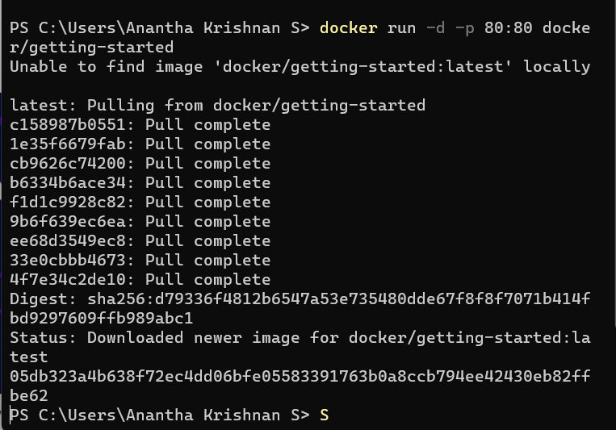

Starting docker

Command used: docker pull docker/getting-started

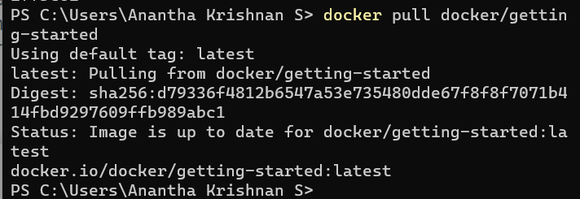

Docker Commands:

1. Docker Search

Searching for a MySQL docker using the search command docker search MySQL

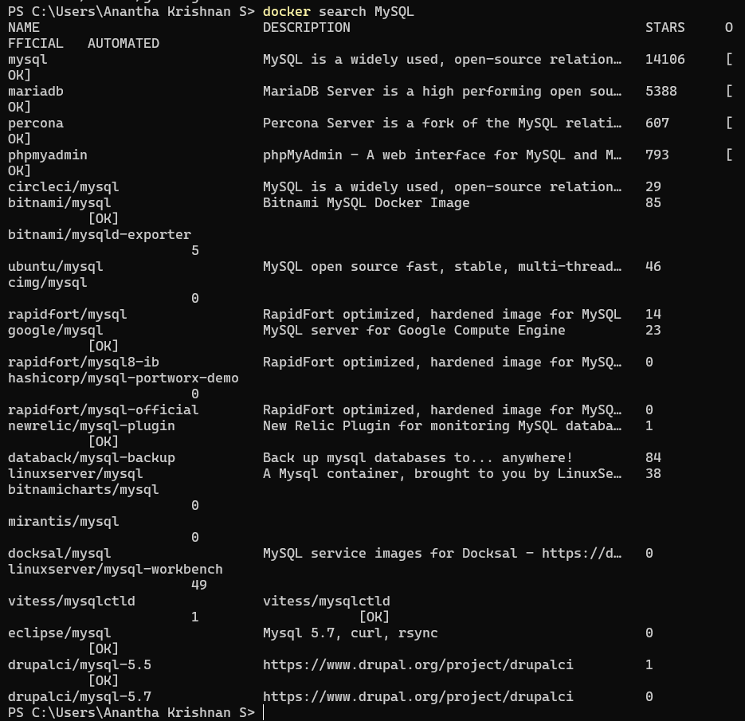

1. Docker pull

This is used to download the images that are available in the docker repository. This allows us to use the downloaded images to setup containers. Here , I am downloading the latest image for MySQL

Command: docker pull mysql

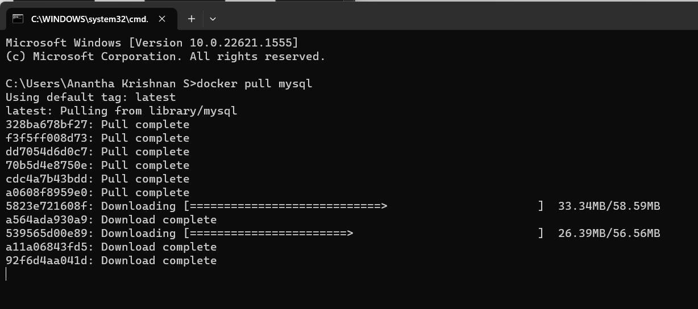

1. Docker images

This will list all the local images I have set up so far

Command: docker images

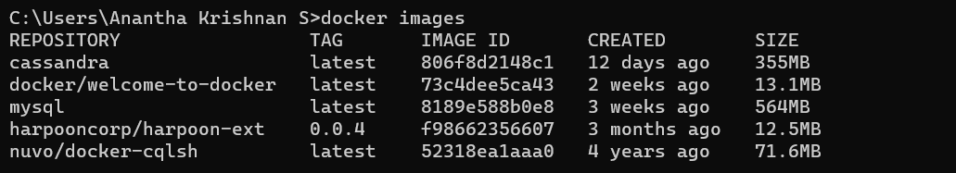

1. Docker ps

This will list all the images that docker is currently running. Command: docker ps

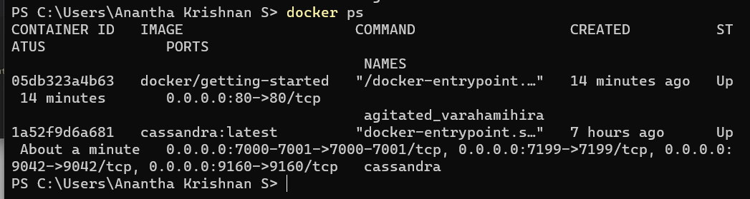

1. Docker stop

This is used to stop a specific docker container as demonstrated in the screenshot below

Command: docker stop



1. Docker restart We can use this command to restart a recently closed or closed process as docker will maintain

