[Anantha Sridhar Vedula](mailto:anantha1@umd.edu)

**Requirement Analysis Individual Exercise**

1. **Context model (use a UML class diagram)**

**Answer:**

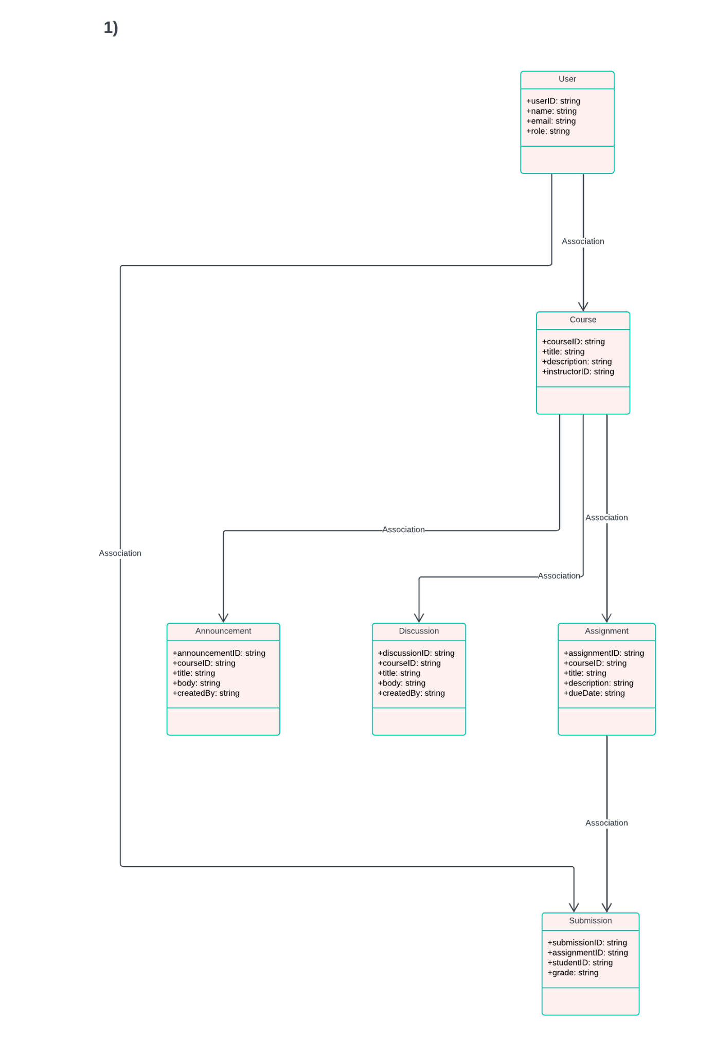

1. **Use case diagram (use a UML Use Case diagram)**

**Answer:**

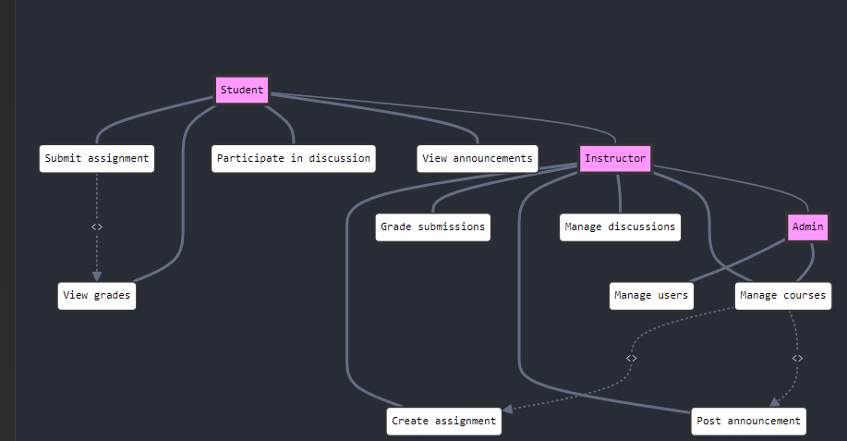

1. **Description of one of the use cases (of your choice) in textual format (use the template provided in the slides)**

**Answer:**

**Use Case Name: Submit Assignment**

**Actors: Student (Primary) and ELMS/Canvas system (Secondary)**

**Preconditions:**

**The student is logged into the ELMS/Canvas system.**

**The student is enrolled in the course and the assignment is active and available for**

**submission.**

**Postconditions:**

**Success Postconditions: The student successfully uploads and submits the**

**assignment for grading.**

**Failure Postconditions: The student fails to submit the assignment due to system**

**errors or invalid file format, or the submission is incomplete.**

**Trigger: The student initiates the assignment submission process by selecting the**

**assignment and clicking the "Submit Assignment" button.**

**Basic Flow:**

**1. Student navigates to the course page in ELMS/Canvas.**

**2. Student selects the assignment to submit.**

**3. ELMS/Canvas system displays the assignment submission interface.**

**4. Student clicks the "Submit Assignment" button.**

**5. ELMS/Canvas system displays the file upload option.**

**6. Student selects the assignment file from their device and clicks "Upload."**

**7. ELMS/Canvas system checks the file format and size for validity.**

**8. Student clicks the "Submit" button after uploading the file.**

**9. ELMS/Canvas system validates the submission and stores the uploaded file.**

**10. ELMS/Canvas system displays a confirmation message, including the submission**

**time and file details.**

**11. Student receives a notification or email confirming the successful submission.**

**Alternate Flows:**

**5.a: The student clicks "Cancel" and decides not to submit the assignment, returning**

**to the assignment page.**

**7.a: If the file format or size is invalid, the system displays an error message, and the**

**student is asked to upload a valid file.**

**Exception Flows:**

**3.a: The system detects that the assignment is no longer available for submission**

**(e.g., past the due date).**

**3.b: ELMS/Canvas system displays an error message and prevents submission.**

**7.b: The system detects file format or size issues.**

**7.c: The system displays an error message, requesting the student to upload the**

**correct file format or size.**

**9.a: The system experiences an internal error while submitting the file.**

**9.b: ELMS/Canvas system displays a system error message and asks the student to try**

**again later or contact support.**

1. **Description of the same use case in graphical form (use a UML activity diagram)**

**Answer:**

**https://drive.google.com/file/d/1GGz5gd2_x6s-PJotJZg-P5GOLM8isGxd/view?usp=sharing**

