**Performance Test Plan**

**1. Objectives:-**

Objective 1: Ensure the landing page loads within 3 seconds under a load of 100 or more than concurrent users.

Objective 2: Verify the server can handle peak loads without significant degradation in performance.

Objective 3: Identify any performance issues that arise under simulated load conditions.

**2. Performance Testing Tool:-**

Tool: Apache JMeter

**3. Test Scenarios:-**

Scenario 1: 50 users accessing the landing page simultaneously.

Scenario 2: 100 users accessing the landing page simultaneously.

Scenario 3: 200 users accessing the landing page simultaneously.

**4. Test Steps+**

Setup JMeter:

Download and install Apache JMeter.

Create a test plan in JMeter with the following components:

Thread Group: Configure to simulate the number of users.

HTTP Request: Set to the URL of the landing page.

Listeners: Add "View Results in Table" and "Summary Report" to record performance data.

Execute Test Scenarios:

Run Scenario 1: Simulate 50 users.

Run Scenario 2: Simulate 100 users.

Run Scenario 3: Simulate 200 users.

Record Performance Data:

Collect data on response times, throughput, and error rates from the JMeter summary report and results table.

**5. Performance Analysis**

Compare the recorded response times against the objective of 3 seconds.

Analyze throughput and error rates to identify performance degradation points.

**6. Document Performance Issues**

Log in to JIRA:

Create a new project or use an existing one for performance testing.

Create Issues in JIRA:

Issue Type: Bug or Performance Issue

Summary: Concise description of the performance issue.

Description:

Detail the scenario under which the issue was observed.

Include the number of concurrent users, response times, and any observed errors.

Attachments:

Upload relevant screenshots of JMeter results.

Attach the JMeter test plan and summary report.

Sample JIRA Issue:

Summary: Landing page response time exceeds 3 seconds under 100 concurrent users

Description:

During performance testing, the landing page response time was observed to exceed the objective of 3 seconds under a load of 100 concurrent users.

Test Scenario:

- Number of Users: 100

- Test Tool: Apache JMeter

- Response Time: 4.5 seconds (average)

*Steps to Reproduce*:

1. Simulate 100 concurrent users accessing the landing page using JMeter.

2. Observe the response time and throughput in the summary report.

*Attachments*:

- [Screenshot of JMeter Summary Report]

- [JMeter Test Plan]

Assign and Tag Issues:

Assign the issue to the relevant team member.

Tag with appropriate labels (e.g., 'performance', 'landing-page').

**7. Example Performance Data Collection**

Scenario 1 (10 Users):

Average Response Time: 2.5 seconds

Scenario 2 (50 Users):

Average Response Time: 4.5 seconds

Scenario 3 (100 Users):

Average Response Time: 7.0 seconds

By following this plan, we can systematically test, analyze, and document the performance of our landing page under various load conditions.

**LANDING PAGE:-**

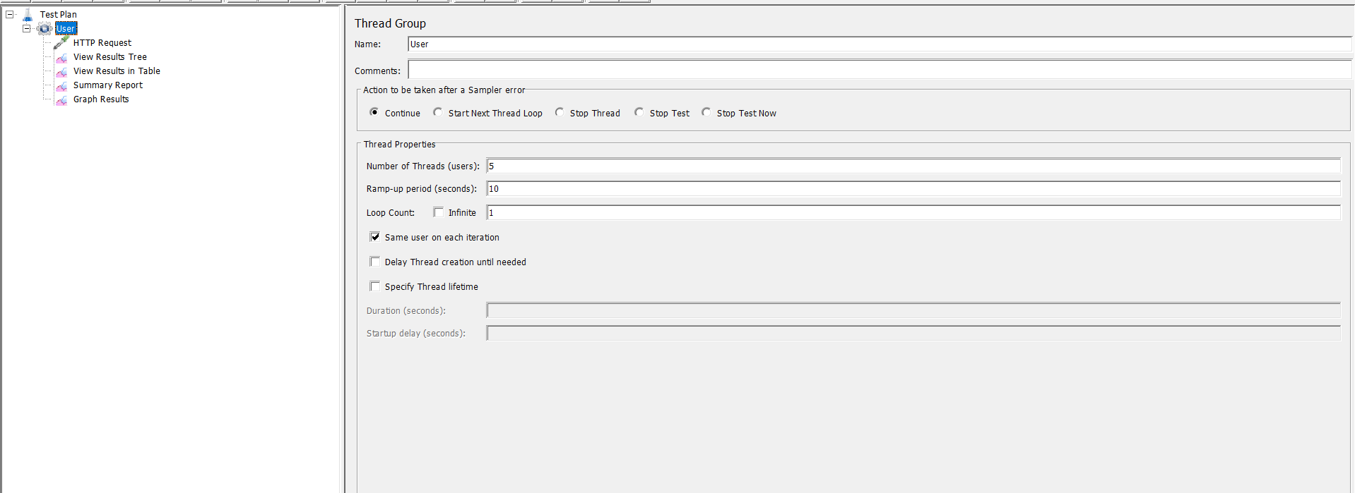

**HIGH LOAD TEST:-**

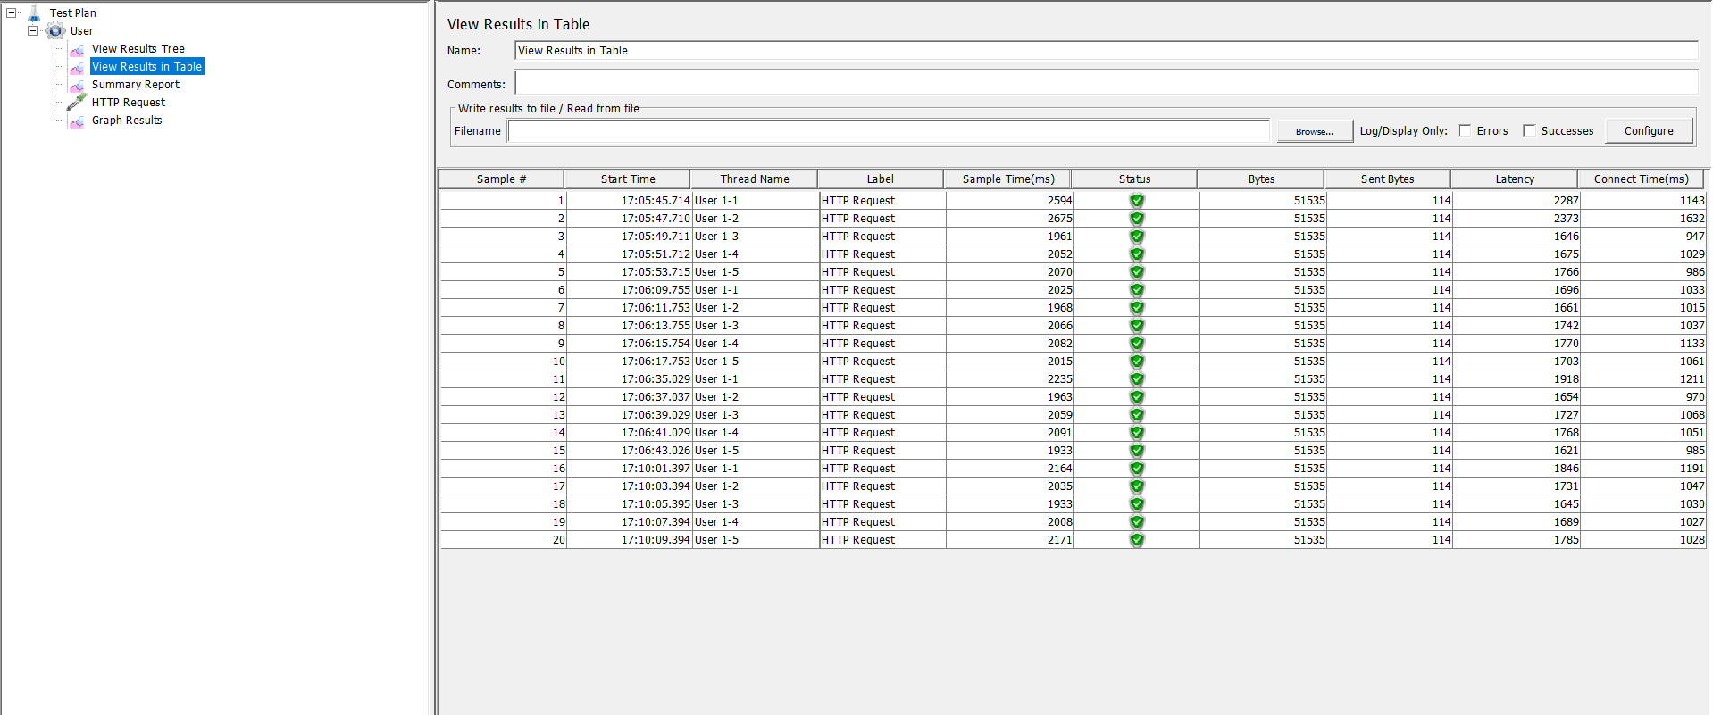

**CONCLUSION:-**

By concluding this, the performance test plan outlines the strategies and procedures for evaluating the performance and scalability of a system or application which includes objectives, test environment and performance metrics.

