**DATA SCIENCE**

**Lab Cycle-1**

**Submitted By**

**Ananthakrishnan P.M**

**S3 MCA**

**RollNo:12**

**DATA SCEINCE & MACHINE LEARNING:**

**LAB CYCLE 1**

**1. Program to Print all non-Prime Numbers in an Interval**

**Program:**

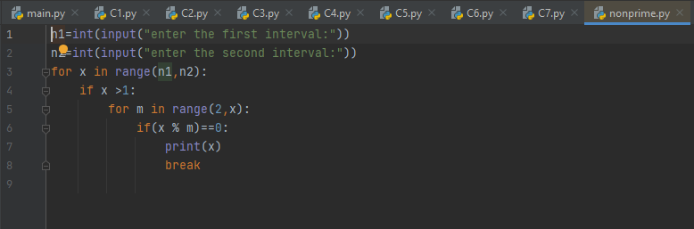

**Output**

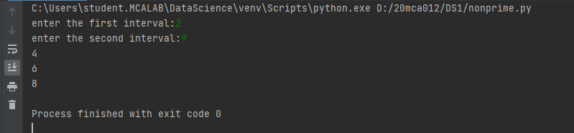

**2. Program to print the first N Fibonacci numbers.**

**Program:**

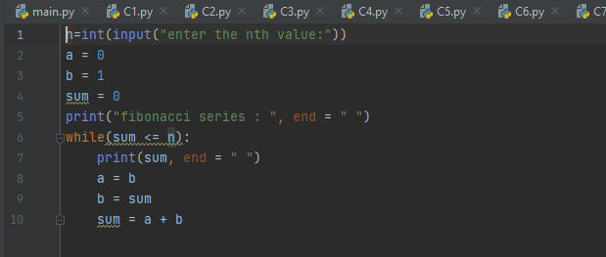

**Output:**

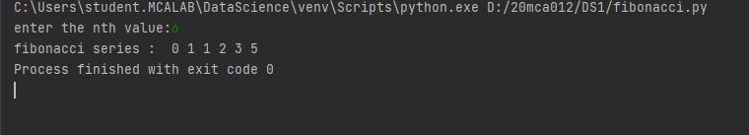

**3. Given sides of a triangle, write a program to check whether given triangle is anisosceles, equilateral or scalene.**

**Program**

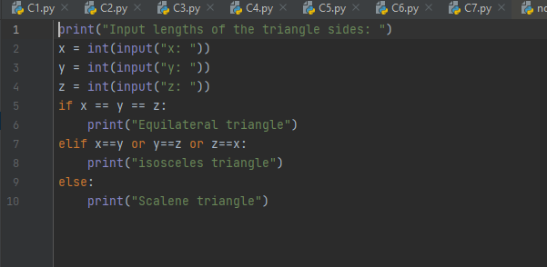

**Output**

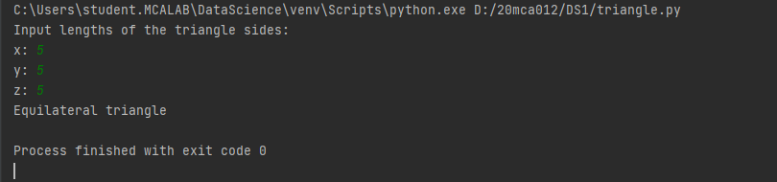

**4. Program to check whether given pair of number is coprime**

**Program**

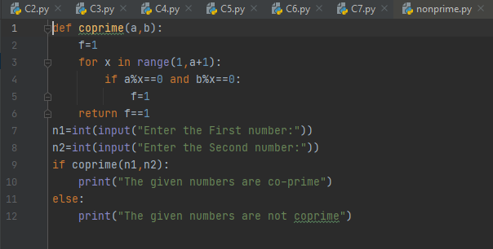

**Output:**

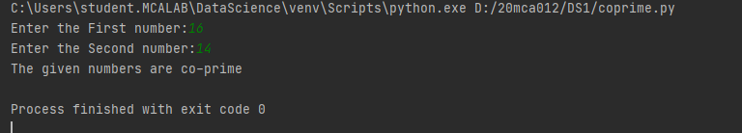

**5. Program to find the roots of a quadratic equation(rounded to 2 decimal places)**

**Program**

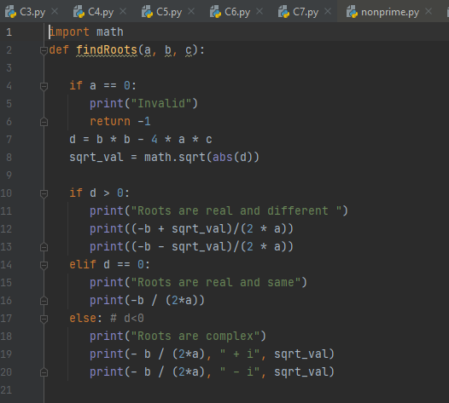

**Output**

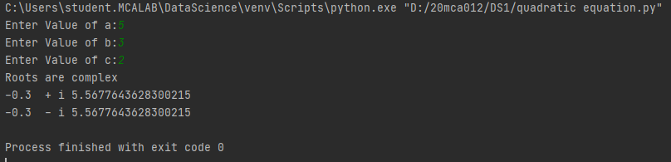

**6. Program to check whether a given number is perfect number or not(sum of factors=number)**

**Program**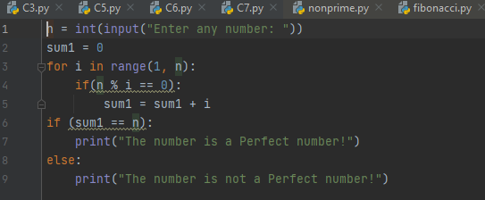

**Output**

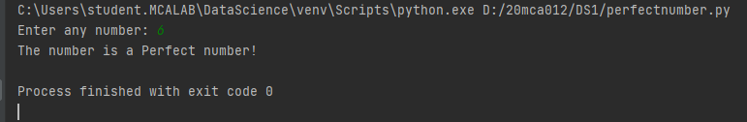

**7. Program to display amstrong numbers upto 1000**

**Program**

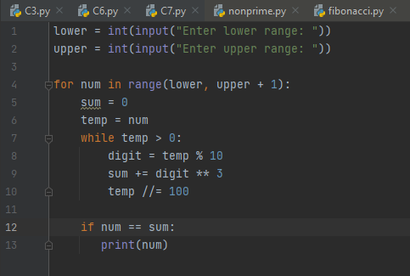

**Output**

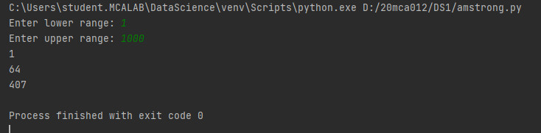

**8. Store and display the days of a week as a List, Tuple, Dictionary, Set. Also demonstrate different ways to store values in each of them. Display its type also.**

**Program**

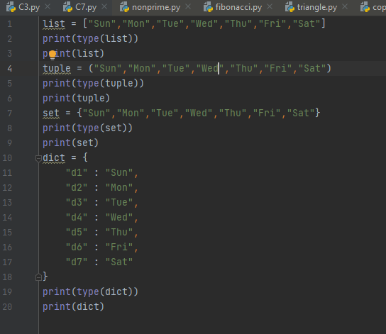

**Output**

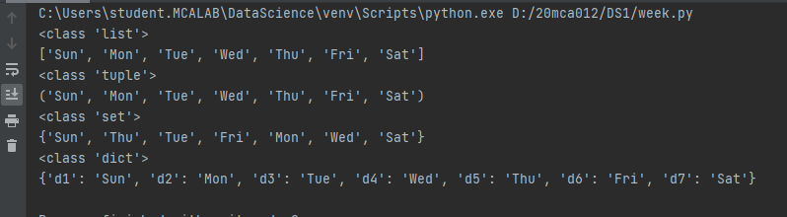

**9. Write a program to add elements of given 2 lists**

**Program**

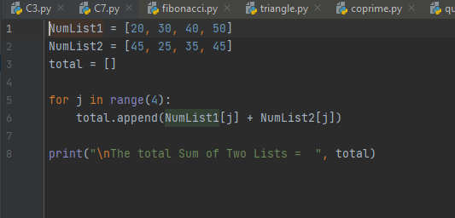

**Output**

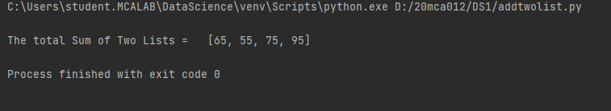

**10. Write a program to find the sum of 2 matrices using nested List.**

**Program**

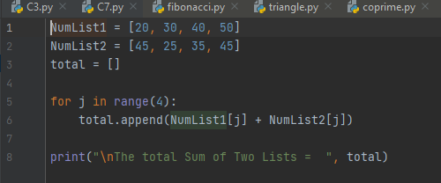

**Output**



**11. Write a program to perform bubble sort on a given set of elements.**

**Program**

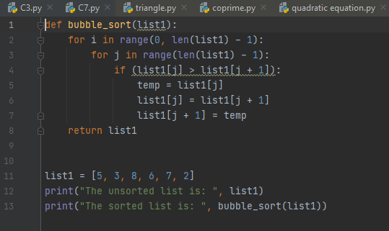

**Output**

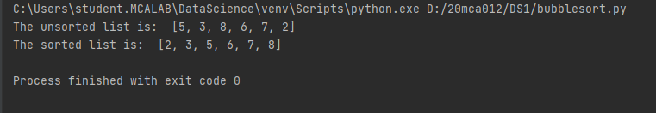

**12. Program to find the count of each vowel in a string(use dictionary)**

**Program**

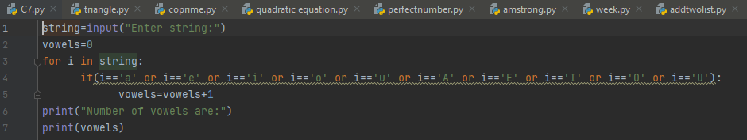

**Output**

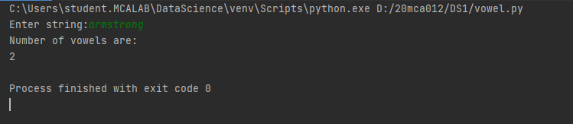

**13. Write a Python program that accept a positive number and subtract from thisnumber the sum of its digits and so on. Continues this operation until the number is positive**

**Program**

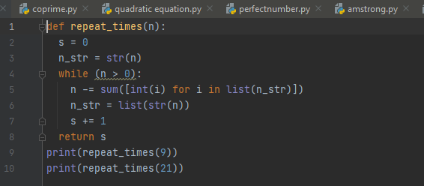

**Output**

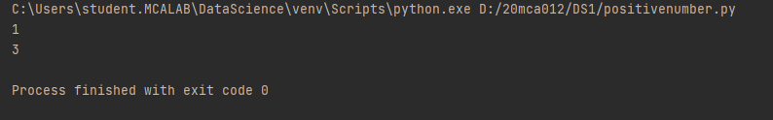

**14. Write a Python program that accepts a 10 digit mobile number, and find the digits which are absent in a given mobile number**

**Program**

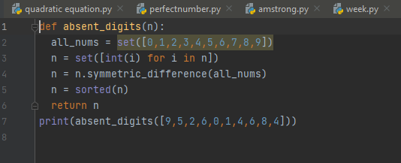

**Output**

