**FEDERAL INSTITUTE OF SCIENCE AND TECHNOLOGY (FISAT)** **®**

**HORMIS NAGAR, MOOKKANNOOR, ANGAMALY-683577**



**FOCUS ON EXCELLENCE**

**20MCA134 ADVANCED DBMS LAB**

**…………………………………………………………………..**

**LABORATORY RECORD**

**Name: ANANTHAKRISHNAN P R**

**Branch: MASTER OF COMPUTER APPLICATIONS**

**Semester: 2 Batch: A Roll No: 19**

**University Register Number: FIT24MCA-2019**

# JANUARY 2025

**FEDERAL INSTITUTE OF SCIENCE AND TECHNOLOGY (FISAT)TM**

**HORMIS NAGAR, MOOKKANNOOR, ANGAMALY-683577**



**FOCUS ON EXCELLENCE**

**CERTIFICATE**

*This is to certify that this is a Bonafide record of the Practical work done by* **ANANTHAKRISHNAN P R (FIT24MCA-2019)** *in the* **20MCA134 ADVANCED DBMS LAB** *Laboratory**towards the partial fulfilment for the award of the Master Of Computer Applications during the academic year 2024-2025.*

Signature of Staff in Charge Signature of H O D

Ms.Anju L Dr. Deepa Mary Mathews

**Date of University practical examination ……………………….**

Signature of Signature of

# Internal Examiner External Examiner

**CONTENT**

|  |  |  |  |  |
| --- | --- | --- | --- | --- |
| **Sl. No** | **Date** | **Title** | **Page No** | **Signature of Staff -In**  **-Charge** |
| 1 | 13.02.25 | Creation of a database using DDL commands including integrity constraints | 1 |  |
| 2 | 20.02.25 | Implementation of DML commands | 8 |  |
| 3 | 25.02.25 | Implementation of different types of operators in SQL . | 17 |  |
| 4 | 05.03.25 | Implementation of different types of functions with suitable examples | 20 |  |
| 5 | 11.03.25 | Implementation of different types of functions with suitable examples | 37 |  |
| 6 | 19.03.25 | Implementation of Join,Views,Set operations | 39 |  |
| 7 | 01.04.25 | PLSQL programs | 48 |  |
| 8 | 10.04.25 | Comparison between relational and nonrelational (NoSQL) databases and the configuration of NoSQL Databases. | 69 |  |
| 9 | 22.04.25 | Programs using MongoDB | 70 |  |

**Question – 1 : Creation of a database using DDL commands including integrity constraints**

Creation of a database using DDL commands including integrity

|  |  |  |
| --- | --- | --- |
| REGD.NO | NAME | BRANCH |
| 0001 | Ram | CSE |
| 0002 | Hari | MECH |
| 0003 | Pradeep | EEE |
| 0004 | Deepak | ETC |

1. Create a table called student with the following values and Write a SQL command which will show the entire STUDENT table.

CREATE TABLE STUDENT19 (REGD_NO INTEGER PRIMARY KEY ,NAME VARCHAR(20) NOT NULL,BRANCH VARCHAR(20) NOT NULL);

INSERT INTO STUDENT19 VALUES(0001,'Ram','CSE');

INSERT INTO STUDENT19 VALUES(0002,'Hari','MECH')

INSERT INTO STUDENT19 VALUES(0003,'Pradeep','EEE');

INSERT INTO STUDENT19 VALUES(0004,'Deepak','ETC');

SELECT * FROM STUDENT19;

**Output**

1. Create a table EMPLOYEE with following schema:

(Emp_no, E_name, E_address, E_ph_no, Dept_no, Dept_name,Job_id , Salary)

CREATE TABLE EMPLOYEE19(Emp_no INTEGER, E_name VARCHAR(20), E_address VARCHAR(50), E_ph_no NUMERIC(10), Dept_no INTEGER, Dept_name VARCHAR(20),Job_id VARCHAR(20) , Salary NUMERIC(10,2));

1. Add a new column; HIREDATE to the existing relation.

ALTER TABLE EMPLOYEE19 ADD HIREDATE DATE;

**Output**

1. Change the datatype of JOB_ID from varchar to integer.

ALTER TABLE EMPLOYEE19 MODIFY(Job_id INTEGER);

**Output**

1. Change the name of column/field Emp_no to E_no.

ALTER TABLE EMPLOYEE19 RENAME COLUMN Emp_no TO E_no;

**Output**

1. Modify the column width of the Employee name field of emp table.

ALTER TABLE EMPLOYEE19 MODIFY(E_name VARCHAR(30));

**Output**

1. Write a query in sql to create a table employee and department.

Employee(empno, ename, deptno, job, hiredate)

Department(deptno,dname,loc)

CREATE TABLE Employee_19(empno INTEGER, ename VARCHAR(20), deptno INTEGER, job VARCHAR(20), hiredate DATE);

CREATE TABLE Department_19(deptno INTEGER,dname VARCHAR(20),loc VARCHAR(50));

Include the following constraints on column of emp table.

1. to make the empno as primary key of the table.

ALTER TABLE Employee_19 MODIFY(empno PRIMARY KEY);

**Output**

1. To ensure that the ename column does not contain NULL values.

ALTER TABLE Employee_19 MODIFY(ename NOT NULL);

**Output**

1. the job column to have only UPPERCASE entries.

ALTER TABLE Employee_19 MODIFY(job VARCHAR(20) CHECK(job = UPPER(job)));

**Output**

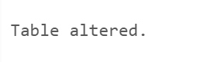

1. put the current date as default date in hire date column in case data is not supplied for the

column.

ALTER TABLE Employee_19 MODIFY(hiredate DEFAULT(CURRENT_DATE));

**Output**

Include the following constraints on column of Department table.

1. To make deptno as primary key.

ALTER TABLE Department_19 MODIFY(deptno PRIMARY KEY);

**Output**

1. To ensure dname,loc coloumns does not contain NULL values.

ALTER TABLE Department_19 MODIFY dname NOT NULL;

ALTER TABLE Department_19 MODIFY loc NOT NULL;

**Output**

1. Also enforce REFERENTIAL INTEGRITY, declare deptno field of dept table as

primary key and deptno field of emp table as foreign key.

ALTER TABLE Employee_19 ADD FOREIGN KEY (deptno) REFERENCES Department_19(deptno);

**Output**



**Question 2: Implementation of DML commands**

1. Create a table EMPLOYEE with following schema:

(Emp_no, E_name, E_address, E_ph_no, Dept_no, Dept_name,Job_id , Salary).

CREATE TABLE EMPLOYEE_19(Emp_no INTEGER, E_name VARCHAR(20), E_address VARCHAR(100), E_ph_no NUMERIC(10), Dept_no VARCHAR(5), Dept_name VARCHAR(20),Job_id VARCHAR(5) , Salary NUMERIC(6,2));

**Write SQL queries for following question:**

1. Insert aleast 5 rows in the table.

INSERT INTO EMPLOYEE_19 VALUES (10, 'John', 'Pune', '9876543210', 'D10', 'SALES', 'J01', 5000);

INSERT INTO EMPLOYEE_19 VALUES (19, 'James', 'Mumbai', '9876543219', 'D12', 'MECH', 'J02', 4500);

INSERT INTO EMPLOYEE_19 VALUES (12, 'Adam', 'Nagpur', '9876543212', 'D10', 'SALES', 'J03', 4800);

INSERT INTO EMPLOYEE_19 VALUES (13, 'Mary', 'Chennai', '9876543213', 'D12', 'MECH', 'J04', 5200);

INSERT INTO EMPLOYEE_19 VALUES (14, 'Robert', 'Delhi', '9876543214', 'D20', 'IT', 'J05', 1900);

1. Display all the information of EMP table.

SELECT * FROM EMPLOYEE_19;

**Output**

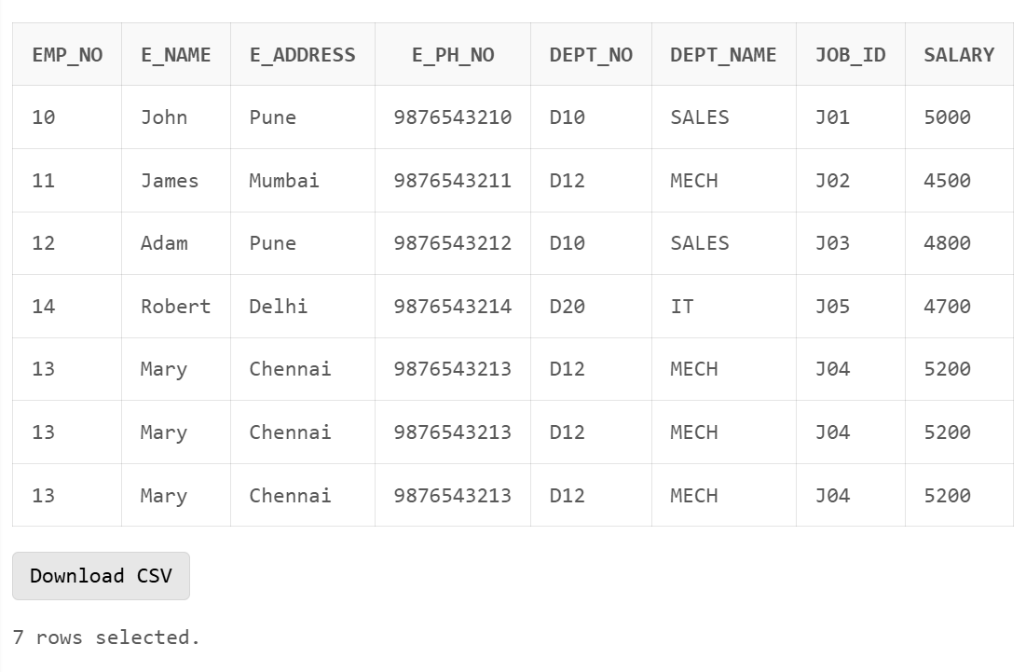

1. Display the record of each employee who works in department D10.

SELECT * FROM EMPLOYEE_19 WHERE Dept_no = 'D10';

**Output**

1. Update the city of Emp_no-12 with current city as Nagpur.

UPDATE EMPLOYEE_19 SET E_address = 'Nagpur' WHERE Emp_no = 12;

**Output**

1. Display the details of Employee who works in department MECH.

SELECT * FROM EMPLOYEE_19 WHERE Dept_name = 'MECH';

**Output**

6. Delete the email_id of employee James.

ALTER TABLE EMPLOYEE_19 ADD email_id VARCHAR(20);

UPDATE EMPLOYEE_19 SET email_id = 'james@gmail.com' WHERE E_name = 'James';

UPDATE EMPLOYEE_19 SET email_id = 'NULL' WHERE E_name = 'James';

**Output**

7. Display the complete record of employees working in SALES Department.

SELECT * FROM EMPLOYEE_19 WHERE Dept_name = 'SALES';

**Output**

8. Find out the employee id, names, salaries of all the employees

SELECT Emp_no, E_name, Salary FROM EMPLOYEE_19;

**Output**

9. Find the names of the employees who have a salary greater than or equal to 4800

SELECT E_name FROM EMPLOYEE_19

WHERE Salary >= 4800;

**Output**

**5.** **(Exercise on updating records in table)**

Create Client_master with the following fields(ClientNO, Name, Address, City, State, bal_due).

CREATE TABLE Client_master(ClientNO VARCHAR(6), Name VARCHAR(10), Address VARCHAR(20), City VARCHAR(10), State VARCHAR(10), bal_due NUMERIC(6,2));

1. Insert five records

INSERT INTO Client_master VALUES ('C121', 'John','Rk House', 'Aloor', 'THRISSUR', 6000);

INSERT INTO Client_master VALUES ('C122', 'Vinod','Mk House', 'Kattapana', 'Idukki', 5000);

INSERT INTO Client_master VALUES ('C123', 'Adam', 'HK House','Aloor', 'THRISSUR', 5700);

INSERT INTO Client_master VALUES ('C124', 'Hari','PK House', 'Aloor', 'THRISSUR', 4000);

INSERT INTO Client_master VALUES ('C125', 'Eve','JK House', 'Aloor', 'THRISSUR', 9000);

1. Find the names of clients whose bal_due> 5000

**Output**

1. Change the bal_due of ClientNO “ C123” to Rs. 5100

UPDATE Client_master SET bal_due = 5100 WHERE ClientNO = 'C123';

**Output**

1. Change the name of Client_master to Client12

ALTER TABLE Client_master RENAME TO Client12;

**Output**

1. Display the bal_due heading as “BALANCE”

SELECT bal_due AS BALANCE FROM Client12;

**Output**

**6. (Rollback and Commit commands )**

Create Teacher table with the following fields(Name, DeptNo, Date of joining, DeptName, Location,Salary)

CREATE TABLE TEACHER_19(Name VARCHAR(10) PRIMARY KEY, DeptNo VARCHAR(6), Date_of_joining DATE, DeptName VARCHAR(20), Location VARCHAR(15),Salary NUMERIC(6,2));

1. Insert five records

INSERT INTO TEACHER_19 VALUES ('John','D101','08-JAN-01', 'Mathematics', 'THRISSUR', 6000);

INSERT INTO TEACHER_19 VALUES ('Varun','D102','04-JAN-03', 'Commerce', 'Idukki', 7000);

INSERT INTO TEACHER_19 VALUES ('Vinu','D101','05-JAN-08', 'Mathematics', 'THRISSUR', 8000);

INSERT INTO TEACHER_19 VALUES ('Jenna','D103','09-JAN-06', 'English', 'Idukki', 6000);

INSERT INTO TEACHER_19 VALUES ('Eve','D104','07-JAN-05', 'Commerce', 'THRISSUR', 8000);

1. Give Increment of 25% salary for Mathematics Department.

UPDATE TEACHER_19 SET Salary = Salary + (Salary * 0.25) WHERE DeptName = 'Mathematics';

**Output**

1. Perform Rollback command

ROLLBACK;

**Output**

1. Give Increment of 15% salary for Commerce Department

UPDATE TEACHER_ SET Salary = Salary + (Salary * 0.15) WHERE DeptName = 'Commerce';

**Output**

1. Perform commit command

COMMIT;

**Output**

**7.(Exercise on order by and group by clauses)**

Create Sales table with the following fields( Sales No, Salesname, Branch, Salesamount, DOB)

CREATE TABLE Sales (SalesNo NUMBER PRIMARY KEY,Salesname VARCHAR2(50),Branch VARCHAR2(30),Salesamount NUMBER(10,2),DOB DATE);

1. Insert five records

INSERT INTO Sales VALUES (1, 'John Smith', 'North', 15000, '15-DEC-85');

INSERT INTO Sales VALUES (2, 'Sarah Johnson', 'South', 22000, '03-MAR-90');

INSERT INTO Sales VALUES (3, 'Mike Brown', 'North', 18000, '21-DEC-88');

INSERT INTO Sales VALUES (4, 'Emily Davis', 'East', 25000, '12-AUG-92');

INSERT INTO Sales VALUES (5, 'David Wilson', 'South', 19000, '30-DEC-87');

1. Calculate total salesamount in each branch

SELECT Branch,SUM(Salesamount) AS TotalSales FROM Sales GROUP BY Branch ORDER BY Branch;

**Output**

1. Calculate average salesamount in each branch .

SELECT Branch, AVG(Salesamount) AS AverageSales FROM Sales GROUP BY Branch ORDER BY Branch;

**Output**

1. Display all the salesmen, DOB who are born in the month of December as day in character format i.e. 21-Dec-09.

SELECT Salesname, TO_CHAR(DOB, 'DD-MON-YY') AS Formatted DOB FROM Sales WHERE EXTRACT(MONTH FROM DOB) = 12 ORDER BY Salesname;

**Output**

1. Display the name and DOB of salesman in alphabetical order of the month.

SELECT Salesname, TO_CHAR(DOB, 'DD-MON-YY') AS FormattedDOB FROM Sales ORDER BY TO_CHAR(DOB, 'MON'), Salesname;

**Output**

**Question - 3 : Implementation of different types of operators in SQL**

**8.** Create an Emp table with the following fields:(EmpNo, EmpName, Job, Basic, DA,

HRA,PF, GrossPay, NetPay) Hint:( PF is calculated as 10% of basic salary) (Calculate DA

as 30% of Basic and HRA as 40% of Basic).

CREATE TABLE Emp (EmpNo INT PRIMARY KEY,EmpName VARCHAR(50),Job VARCHAR(30),Basic DECIMAL(10,2),DA DECIMAL(10,2),HRA DECIMAL(10,2),PF DECIMAL(10,2),GrossPay DECIMAL(10,2),NetPay DECIMAL(10,2),Department VARCHAR(30));

1. Insert Five Records and calculate GrossPay and NetPay.

INSERT INTO Emp (EmpNo, EmpName, Job, Basic, Department)

VALUES (101, 'John Smith', 'Manager', 25000.00, 'HR');

INSERT INTO Emp (EmpNo, EmpName, Job, Basic, Department)

VALUES (102, 'Sarah Johnson', 'Developer', 18000.00, 'IT');

INSERT INTO Emp (EmpNo, EmpName, Job, Basic, Department)

VALUES (103, 'Mike Brown', 'Analyst', 15000.00, 'HR');

INSERT INTO Emp (EmpNo, EmpName, Job, Basic, Department)

VALUES (104, 'Lisa Davis', 'Designer', 9000.00, 'Creative');

INSERT INTO Emp (EmpNo, EmpName, Job, Basic, Department)

VALUES (105, 'David Wilson', 'Tester', 5000.00, 'IT');

UPDATE Emp SET

DA = Basic * 0.30,

HRA = Basic * 0.40,

PF = Basic * 0.10,

GrossPay = Basic + (Basic * 0.30) + (Basic * 0.40),

NetPay = Basic + (Basic * 0.30) + (Basic * 0.40) - (Basic * 0.10);

1. Display the employees whose Basic is lowest in each department.

SELECT Emp.* FROM Emp

INNER JOIN (

SELECT Department, MIN(Basic) as MinBasic

FROM Emp

GROUP BY Department

) dept ON Emp.Department = dept.Department AND Emp.Basic = dept.MinBasic;

**Output**

1. If NetPay is less than <Rs. 10,000 add Rs. 1200 as special allowances.

UPDATE Emp

SET NetPay = NetPay + 1200

WHERE NetPay < 10000;

**Output**

1. Display the employees whose GrossPay lies between 10,000 & 20,000.

SELECT * FROM Emp WHERE GrossPay BETWEEN 10000 AND 20000;

**Output**

1. Display all the employees who earn maximum salary Employee Table.

SELECT * FROM Emp WHERE NetPay = (SELECT MAX(NetPay) FROM Emp);

**Output**

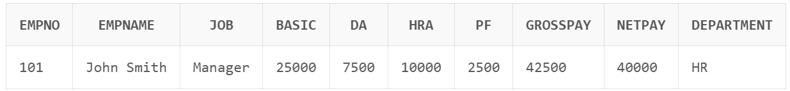

**Question – 4 : Implementation of different types of functions with suitable examples**

**9.** Create a table EMPLOYEE with following schema:

(Emp_no, E_name, E_address, E_ph_no, Dept_no, Dept_name,Job_id, Designation , Salary)

CREATE TABLE EMPLOYEE (Emp_no INT PRIMARY KEY,E_name VARCHAR(50) NOT NULL,E_address VARCHAR(100),E_ph_no VARCHAR(15),Dept_no INT,Dept_name VARCHAR(30),Job_id VARCHAR(20),Designation VARCHAR(30),Salary DECIMAL(10,2),HireDate DATE);

Write SQL statements for the following query.

1. List the E_no, E_name, Salary of all employees working for MANAGER.

SELECT Emp_no, E_name, Salary FROM EMPLOYEE WHERE Designation = 'MANAGER';

**Output**

1. Display all the details of the employee whose salary is more than the Sal of any IT PROFF.

SELECT * FROM EMPLOYEE

WHERE Salary > ANY (

SELECT Salary

FROM EMPLOYEE

WHERE Designation = 'IT PROFF'

);

**Output**

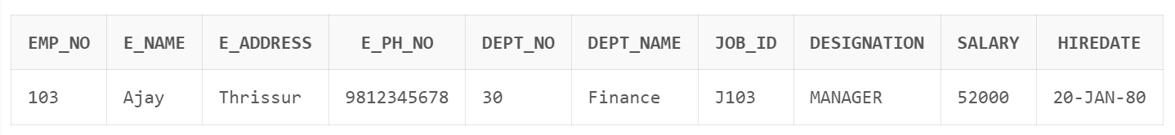

1. List the employees in the ascending order of Designations of those joined after 1981.

SELECT * FROM EMPLOYEE

WHERE EXTRACT(YEAR FROM HireDate) > 1981

ORDER BY Designation ASC;

**Output**

1. List the employees along with their Experience and Daily Salary.

SELECT

E_name,

FLOOR(MONTHS_BETWEEN(SYSDATE, HireDate)/12) AS Experience_Years,

ROUND(Salary/30, 2) AS Daily_Salary

FROM EMPLOYEE;

**Output**

1. List the employees who are either ‘CLERK’ or ‘ANALYST’.

SELECT * FROM EMPLOYEE

WHERE Designation IN ('CLERK', 'ANALYST');

**Output**

1. List the employees who joined on 1-MAY-81, 3-DEC-81, 17-DEC-81,19-JAN-80.

SELECT * FROM EMPLOYEE

WHERE HireDate IN ('01-MAY-81', '03-DEC-81', '17-DEC-81', '19-JAN-80');

**Output**

1. List the employees who are working for the Deptno 10 or 20.

SELECT * FROM EMPLOYEE WHERE Dept_no IN (10, 20);

**Output**

1. List the Enames those are starting with ‘S’.

SELECT E_name FROM EMPLOYEE WHERE E_name LIKE 'S%';

**Output**

1. Dislay the name as well as the first five characters of name(s) starting with ‘H.

SELECT

E_name,

SUBSTR(E_name, 1, 5) AS First_Five_Chars

FROM EMPLOYEE

WHERE E_name LIKE 'H%';

**Output**

1. List all the emps except ‘PRESIDENT’ & ‘MANAGR” in asc order of Salaries.

SELECT * FROM EMPLOYEE

WHERE Designation NOT IN ('PRESIDENT', 'MANAGER')

ORDER BY Salary ASC;

**Output**

**10**. Consider Employee table

**Perform the following**

1. Display all the fields of employee table.

SELECT * FROM Employee;

**Output**

1. Retrieve employee number and their salary.

SELECT EMPNO, SALARY FROM Employee;

**Output**

1. Retrieve average salary of all employee.

SELECT AVG(SALARY) AS Average_Salary FROM Employee;

**Output**

1. Retrieve number of employee.

SELECT COUNT(*) AS Total_Employees FROM Employee;

**Output**

1. Retrieve distinct number of employee.

SELECT COUNT(DISTINCT EMPNO) AS Distinct_Employees FROM Employee;

**Output**

1. Retrieve total salary of employee group by employee name and count similar names.

SELECT EMP_NAME, SUM(SALARY) AS Total_Salary, COUNT(*) AS Name_Count

FROM Employee GROUP BY EMP_NAME;

**Output**

1. Retrieve total salary of employee which is greater than >120000.

SELECT SUM(SALARY) AS Total_Salary FROM Employee

GROUP BY EMP_NAME

HAVING SUM(SALARY) > 120000;

**Output**

1. Display name of employee in descending order.

SELECT EMP_NAME FROM Employee ORDER BY EMP_NAME DESC;

**Output**

1. Display details of employee whose name is AMIT and salary greater than 50000;

SELECT * FROM Employee WHERE EMP_NAME = 'Amit' AND SALARY > 50000;

**Output**

**19.** Create a table called Employee with the following structure.

CREATE TABLE Employee (Empno NUMBER(4) PRIMARY KEY,Ename VARCHAR2(20) NOT NULL,Job VARCHAR2(20),Mgr NUMBER(4),Sal NUMBER(7,2),Deptno NUMBER(2));

1. Display lowest paid employee details under each department.

SELECT Employee.*

FROM Employee

WHERE (Employee.Deptno, Employee.Sal) IN (

SELECT Deptno, MIN(Sal)

FROM Employee

GROUP BY Deptno

)

ORDER BY Employee.Deptno;

**Output**

b) Display number of employees working in each department and their department

number.

SELECT Deptno, COUNT(*) AS Employee_Count

FROM Employee GROUP BY Deptno

ORDER BY Deptno ASC;

**Output**

c) Using built-in functions, display number of employees working in each department

and their department name from dept table. Insert deptname to dept table and insert deptname for each row, do the required thing specified above.

ALTER TABLE Employee ADD Dept_name VARCHAR2(20);

UPDATE Employee SET Dept_name = 'ADMIN' WHERE Deptno = 10;

UPDATE Employee SET Dept_name = 'RESEARCH' WHERE Deptno = 20;

UPDATE Employee SET Dept_name = 'SALES' WHERE Deptno = 30;

SELECT Deptno,Dept_name, COUNT(*) AS Employee_Count

FROM Employee

GROUP BY Deptno,Dept_name

ORDER BY Deptno ASC;

**Output**

1. List all employees which start with either B or C.

SELECT * FROM Employee WHERE Ename LIKE 'B%' OR Ename LIKE 'C%';

**Output**

e) Display only these ename of employees where the maximum salary is greater than

or equal to 5000.

SELECT Ename FROM Employee GROUP BY Ename

HAVING MAX(Sal) >= 5000;

**Output**

1. Calculate the average salary for each different job.

SELECT Job, AVG(Sal) AS Avg_Salary FROM Employee GROUP BY Job;

**Output**

1. Show the average salary of each job excluding manager.

SELECT Job, AVG(Sal) AS Avg_Salary FROM Employee WHERE Job != 'MANAGER' GROUP BY Job;

**Output**

1. Show the average salary for all departments employing more than three people.

SELECT Deptno, AVG(Sal) AS Avg_Salary FROM Employee

GROUP BY Deptno HAVING COUNT(*) > 3;

**Output**

1. How many days between day of birth to current date.

SELECT Ename,Sal AS Current_Salary,Sal * 1.15

AS Salary_After_Rise FROM Employee;

**Output**

1. List all employee names, salary and 15% rise in salary.

SELECT Employee.* FROM Employee

INNER JOIN (

SELECT Mgr, MIN(Sal) AS MinSal

FROM Employee

WHERE Mgr IS NOT NULL

GROUP BY Mgr

) mgr ON Employee.Mgr = mgr.Mgr AND Employee.Sal = mgr.MinSal;

**Output**

1. Display lowest paid emp details under each manager.

SELECT Deptno,Dept_name, AVG(Sal) AS Avg_Monthly_Salary

FROM Employee

GROUP BY Deptno,Dept_name;

**Output**

1. Display the average monthly salary bill for each deptno.

SELECT Deptno, AVG(Sal) AS Avg_Salary FROM Employee

GROUP BY Deptno

HAVING COUNT(*) > 2;

**Output**

1. Show the average salary for all departments employing more than two people.

SELECT Empno, AVG(Sal) AS Avg_Salary FROM Employee WHERE Deptno = 5

GROUP BY Empno;

**Output**

n) By using the group by clause, display the eid who belongs to deptno 05 along with

average salary.

SELECT COUNT(*) AS Employee_Count FROM Employee WHERE Deptno = 20;

**Output**

1. Count the number of employees in department 20.

SELECT MIN(Sal) AS Min_Clerk_Salary FROM Employee WHERE Job = 'CLERK';

**Output**

1. Find the minimum salary earned by clerk.

SELECT MIN(Sal) AS Min_Salary,MAX(Sal) AS Max_Salary,AVG(Sal) AS Avg_Salary FROM Employee;

**Output**

1. Find minimum, maximum, average salary of all employees.

SELECT Job,MIN(Sal) AS Min_Salary,MAX(Sal) AS Max_Salary FROM Employee

GROUP BY Job;

**Output**

1. List the employee names in descending order.

SELECT Ename FROM Employee

ORDER BY Ename DESC;

**Output**

1. List the employee id, names in ascending order by empid.

SELECT Empno, Ename

FROM Employee

ORDER BY Empno ASC;

**Output**

**Question – 5 : Implementation of different types of functions with suitable examples**

**12.** Create a table EMPLOYEE with following schema:

CREATE TABLE EMPLOYEE (Emp_no NUMBER PRIMARY KEY,E_name VARCHAR2(50),E_address VARCHAR2(100),E_ph_no VARCHAR2(15),Dept_no NUMBER,Dept_name VARCHAR2(30),Job_id VARCHAR2(20),Salary NUMERIC(10,2));

CREATE TABLE DEPARTMENT(Dept_no NUMBER,Dept_name VARCHAR2(30),LOC VARCHAR(10) );

1. Display all the dept numbers available with the dept and emp tables avoiding duplicates.

SELECT Dept_no FROM EMPLOYEE UNION SELECT Dept_no FROM DEPARTMENT ORDER BY Dept_no;

**Output**

1. Display all the dept numbers available with the dept and emp tables.

SELECT Dept_no FROM EMPLOYEE UNION ALL SELECT Dept_no FROM DEPARTMENT ORDER BY Dept_no;

**Output**

1. Display all the dept numbers available in emp and not in dept tables and vice versa.

SELECT Dept_no FROM EMPLOYEE MINUS SELECT Dept_no FROM DEPARTMENT;

SELECT Dept_no FROM DEPARTMENT MINUS SELECT Dept_no FROM EMPLOYEE;

**Output**

**Question – 6 : Implementation of Join,Views,Set operations**

**13.** Consider the following schema:

Sailors (sid, sname, rating, age)

Boats (bid, bname, color)

Reserves (sid, bid, day(date))

CREATE TABLE Sailors(sid NUMBER PRIMARY KEY,sname VARCHAR2(50),rating NUMBER,age NUMBER);

CREATE TABLE Boats(bid NUMBER PRIMARY KEY,bname VARCHAR2(50),color VARCHAR2(20));

CREATE TABLE Reserves(sid NUMBER,bid NUMBER,day DATE,PRIMARY KEY (sid, bid, day),FOREIGN KEY (sid) REFERENCES Sailors(sid),FOREIGN KEY (bid) REFERENCES Boats(bid));

1. Find all the information of sailors who have reserved boat number 101.

SELECT Sailors.* FROM Sailors

JOIN

Reserves ON Sailors.sid = Reserves.sid

WHERE Reserves.bid = 101;

**Output**

1. Find the name of boat reserved by Bob.

SELECT Boats.bname FROM Boats

JOIN

Reserves ON Boats.bid = Reserves.bid

JOIN

Sailors ON Sailors.sid = Reserves.sid

WHERE Sailors.sname = 'Bob';

**Output**

1. Find the names of sailors who have reserved a red boat, and list in order of age.

SELECT sname

FROM (

SELECT DISTINCT Sailors.sname, Sailors.age

FROM Sailors

JOIN Reserves ON Sailors.sid = Reserves.sid

JOIN Boats ON Reserves.bid = Boats.bid

WHERE Boats.color = 'red'

)

ORDER BY age;

**Output**

1. Find the names of sailors who have reserved at least one boat.

SELECT DISTINCT Sailors.sname

FROM Sailors

JOIN Reserves

ON Sailors.sid =Reserves.sid;

**Output**

1. Find the ids and names of sailors who have reserved two different boats on the same day.

SELECT DISTINCT s.sid, s.sname

FROM Sailors s

JOIN Reserves r1 ON s.sid = r1.sid

JOIN Reserves r2 ON s.sid = r2.sid

WHERE r1.bid <> r2.bid AND r1.day = r2.day;

**Output**

1. Find the ids of sailors who have reserved a red boat or a green boat.

SELECT DISTINCT Sailors.sid

FROM Sailors

JOIN Reserves ON

Sailors.sid = Reserves.sid

JOIN Boats ON

Reserves.bid = Boats.bid

WHERE Boats.color IN ('red', 'green');

**Output**

1. Find the name and the age of the youngest sailor.

SELECT sname, age FROM Sailors

WHERE age = (SELECT MIN(age) FROM Sailors);

**Output**

1. Count the number of different sailor names.

SELECT COUNT(DISTINCT sname) AS unique_names

FROM Sailors;

**Output**

1. Find the average age of sailors for each rating level.

SELECT rating, AVG(age) AS avg_age

FROM Sailors

GROUP BY rating;

**Output**

1. Find the average age of sailors for each rating level that has at least two sailors.

SELECT rating, AVG(age) AS avg_age

FROM Sailors

GROUP BY rating

HAVING COUNT(*) >= 2;

**Output**

**14.**  **Original Table:** Employees (employee_id, name, salary, department_id)

**Question:** Create a view named EmployeeDetails that displays the employee ID, name, and

salary from the Employees table.

CREATE TABLE Employees (employee_id INTEGER PRIMARY KEY,name VARCHAR(100),salary NUMERIC(10, 2),department_id INTEGER);

CREATE VIEW EmployeeDetails AS SELECT employee_id, name, salary

FROM Employees;

**Output**

**15.**  **Original Table:** Customers (customer_id, first_name, last_name, email)

**Question:** Write a SQL query to create a view called CustomerContacts that combines the

customer's first name, last name, and email address from the Customers table.

**Output**

**16. Original Tables:**

Employees (employee_id, name, salary_grade_id),

SalaryGrades (salary_grade_id, min_salary, max_salary)

CREATE TABLE SalaryGrades (salary_grade_id INTEGER PRIMARY KEY,min_salary NUMERIC(10, 2),max_salary NUMERIC(10, 2));

CREATE TABLE Employees (employee_id INTEGER PRIMARY KEY,name VARCHAR(20),salary NUMERIC(10, 2),salary_grade_id INTEGER,

FOREIGN KEY (salary_grade_id) REFERENCES SalaryGrades(salary_grade_id)

);

Create a view named EmployeeSalaries that shows the employee ID, name, and salary along with the salary grade from the Employees and SalaryGrades tables.

CREATE VIEW EmployeeSalaries AS

SELECT

Employees.employee_id,

Employees.name,

Employees.salary,

SalaryGrades.salary_grade_id AS grade

FROM Employees

JOIN SalaryGrades

ON Employees.salary BETWEEN SalaryGrades.min_salary AND SalaryGrades.max_salary;

**Output**

**17. Create tables**

Employees (employee_id , name )

Managers ( manager_id, name )

CREATE TABLE Employees (employee_id INT PRIMARY KEY,name VARCHAR(50) NOT NULL);

CREATE TABLE Managers (manager_id INT PRIMARY KEY,name VARCHAR(50) NOT

NULL);

1. Write a SQL query to retrieve the names of all employees and managers, ensuring that duplicate names are removed.

SELECT name FROM Employees

UNION

SELECT name FROM Managers;

**Output**

1. Create a query to find the common names between employees and managers.

SELECT Employees.name FROM Employees

INTERSECT

SELECT Managers.name FROM Managers;

**Output**

1. Write a query to find the names of employees who are not managers.

SELECT Employees.name

FROM Employees

WHERE Employees.name NOT IN (SELECT name FROM Managers);

**Output**

d) Write a query to find the distinct names of all employees and managers, along with their

respective roles (employee/manager).

SELECT name, 'Employee' AS role FROM Employees

UNION

SELECT name, 'Manager' AS role FROM Managers ORDER BY name;

**Output**

**Question – 18**

Write a PL/SQL program to swap the values of two numbers.

**Program Code**

DECLARE

n1 NUMBER;

n2 NUMBER;

temp NUMBER;

BEGIN

n1:=&n1;

n2:=&n2;

temp:=n1;

n1:=n2;

n2:=temp;

dbms_output.put_line('======== After Swapping =========');

dbms_output.put_line('n1='||n1);

dbms_output.put_line('n2='||n2);

END;

**Output**

**Question –19**

Write a PL/SQL program to determine the largest among three given numbers.

**Program Code**

DECLARE

n1 NUMBER;

n2 NUMBER;

n3 NUMBER;

BEGIN

    n1 := &n1;

    n2 := &n2;

    n3 := &n3;

    IF n1 > n2 AND n1 > n3

    THEN

        dbms_output.put_line('Greatest is =' || n1);

    ELSIF n2 > n1 AND n2 > n3

    THEN

        dbms_output.put_line('Greatest is =' || n2);

    ELSE

        dbms_output.put_line('Greatest is =' || n3);

    END IF;

END;

/

**Output**

**Question – 20**

Write a PL/SQL program to compute the sum of digits of a given number.

**Program Code**

DECLARE

n NUMBER;

s NUMBER;

r NUMBER;

BEGIN

n:=&n;

s:=0;

WHILE n>0 LOOP

r:= MOD(n,10);

s:=s + r;

n:=TRUNC(n / 10);

END LOOP;

dbms_output.put_line('Sum = '||s);

END;

/

**Output**

**Question – 21**

Write a PL/SQL program to display a given number in reverse order.

**Program Code**

DECLARE

n NUMBER;

rev NUMBER;

r NUMBER;

BEGIN

n:=&n;

rev:=0;

WHILE n>0 LOOP

r:= MOD(n,10);

rev:=rev * 10 + r;

n:=TRUNC(n / 10);

END LOOP;

dbms_output.put_line('Reversed Number = '||rev);

END;

/

**Output**

QUESTION 22

Write a PL/SQL program to calculate the net salary and annual salary, considering DA as 30% of basic, HRA as 10% of basic, and PF as:7% if the basic salary is less than 8000 10% if the basic salary is between 8000 and 16000.

PROGRAM CODE

DECLARE

basic_salary NUMBER := 17000;

da_percent NUMBER := 30;

hra_percent NUMBER := 10;

pf_percent_low NUMBER := 7;

pf_percent_high NUMBER := 10;

da NUMBER := basic_salary * (da_percent / 100);

hra NUMBER := basic_salary * (hra_percent / 100);

pf_percent NUMBER;

pf NUMBER;

net_salary NUMBER;

yearly_salary NUMBER;

BEGIN

IF basic_salary < 8000 THEN

pf_percent := pf_percent_low;

ELSIF basic_salary >= 8000 AND basic_salary <= 16000 THEN

pf_percent := pf_percent_high;

ELSE

pf_percent := 0;

END IF;

pf := basic_salary * (pf_percent / 100);

net_salary := basic_salary + da + hra - pf;

yearly_salary := net_salary * 12;

DBMS_OUTPUT.PUT_LINE('Net Salary: ' || net_salary); DBMS_OUTPUT.PUT_LINE('Yearly Salary: ' || yearly_salary);

END;

/

OUTPUT

SQL> @q5.sql

Net Salary: 23800

Yearly Salary: 285600

QUESTION 23

Write a PL/SQL program that accepts an account number, checks if the balance is below the minimum required balance, and deducts Rs.100/- from the balance if necessary. The program should be applied to the acct table.

PROGRAM CODE

declare

v_acct_no number ;

v_balance number;

begin

v_acct_no:=&v_acct_no;

dbms_output.put_line('account_no:'||v_acct_no);

dbms_output.put_line('minimum balance required: rs.1500/-');

select balance into v_balance from account where acct_no = v_acct_no;

if v_balance < 1500 then

update account set balance = balance - 100 where acct_no = v_acct_no;

dbms_output.put_line('changes made in account. rs.100 deducted.');

else

dbms_output.put_line('balance sufficient. no changes needed.');

end if;

end;

OUTPUT

SQL>@bal.sql

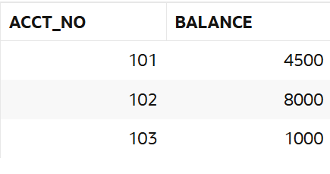

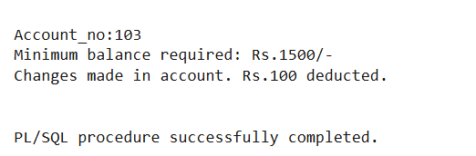

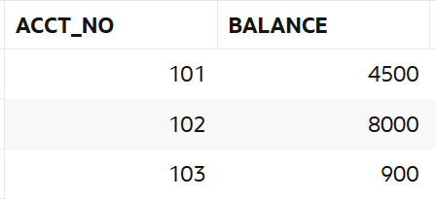

QUESTION 24

Write a PL/SQL function that computes and returns the maximum of two given values.

PROGRAM CODE

create or replace function max_two(a number, b number)

return number

as

begin

return greatest(a, b);

end;

/

declare

result number;

a number;

b number;

begin

a:=&a;

b:=&b;

result := max_two(a, b);

dbms_output.put_line('maximum of '||a|| ' and '|| b || ' is: '|| result);

end;

OUTPUT

Function created.

Statement processed.

Enter value for a: 20

Ener value for b: 45  
maximum of 25 and 45 is: 45

QUESTION 25

Write a PL/SQL function to check whether a given string is a palindrome.

PROGRAM CODE

create or replace function is_palindrome(str in varchar)

return varchar2

as

rev_str varchar(20) := '';

i integer;

begin

for i in reverse 1..length(str) loop

rev_str := rev_str || substr(str, i, 1);

end loop;

if lower(str) = lower(rev_str) then

return 'palindrome';

else

return 'not palindrome';

end if;

end;

/

declare

result varchar(20);

string varchar(20);

begin

string := '&string';

dbms_output.put_line('given string: ' || string);

result := is_palindrome(string);

dbms_output.put_line('result: ' || result);

end;

OUTPUT

Statement processed.  
Given string: civic  
Result: palindrome

QUESTION 26

Write a PL/SQL function that returns the total count of customers in the customers table.

PROGRAM CODE

create or replace function customer_count

return number

as

total number;

begin

select count(*) into total from customers;

return total;

end;

/

declare

count number;

begin

count := customer_count;

dbms_output.put_line('total customers: ' || count);

end;

/

OUTPUT

|  |  |  |  |
| --- | --- | --- | --- |
| **CUSTOMER_ID** | **FIRST_NAME** | **LAST_NAME** | **EMAIL** |
| 1 | ram | pk | ram123@gmail.com |
| 2 | raj | nath | rajss11@gmail.com |
| 3 | Albert | anto | albert97@gmail.com |

Statement processed.  
total customers: 3

QUESTION 27

Write a PL/SQL procedure to compute and display the sum of two numbers.

PROGRAM CODE

create or replace procedure sum_two(a in number, b in number)

as

total number;

begin

total := a + b;

dbms_output.put_line('sum of ' ||a|| ' and ' || b || ' =' || total);

end;

/

declare

a number;

b number;

begin

a:=&a;

b:=&b;

sum_two(a, b);

end;

/

OUTPUT

Statement processed.  
Sum of 46 and 34 = 80

QUESTION 28

Write a PL/SQL procedure to insert a student's roll number and name into the student table.

PROGRAM CODE

create or replace procedure insert_student(p_roll in number, p_name in varchar2)

as

begin

insert into student(rollno, name) values (p_roll, p_name);

dbms_output.put_line('student inserted('||p_roll || ',' || p_name || ')');

end;

/

declare

roll number;

name varchar2(20);

begin

roll:=&roll;

name:='&name';

insert_student(roll, name);

end;

OUTPUT

Statement processed.  
student inserted(4,basil)

QUESTION 29

Write a PL/SQL procedure to retrieve and display the count of instructors in a specified department.

PROGRAM CODE

create or replace procedure instructor_count(p_dept in varchar2)

as

cnt number;

begin

select count(*) into cnt from instructor where dept = p_dept;

dbms_output.put_line('instructors in ' || p_dept || ': ' || cnt);

end;

/

declare

begin

instructor_count('mca');

end;

/

OUTPUT

|  |  |  |
| --- | --- | --- |
| **FID** | **DEPT** | **FNAME** |
| 1 | btech | Ram |
| 2 | btech | basil |
| 3 | mca | ravi |
| 4 | btech | arun |

Statement processed.  
Instructors in mca: 1

QUESTION 30

Create a Customers table with attributes (CustId (Primary Key), CustName, City). Then, write a PL/SQL program using an explicit cursor to display all details from the Customers table.

PROGRAM CODE

declare

cursor cust_cursor is select * from customers;

rec customers%rowtype;

begin

open cust_cursor;

loop

fetch cust_cursor into rec;

exit when cust_cursor%notfound;

dbms_output.put_line('id: ' || rec.custid ||

', name: ' || rec.custname ||

', city: ' || rec.city);

end loop;

close cust_cursor;

end;

/

OUTPUT

ID: 1, Name: Ajay, City: Thrissur

ID: 2, Name: sam, City: Kottayam

ID: 3, Name: ram, City: Kollam

QUESTION 31

Write a PL/SQL program using an explicit cursor to display details of employees working in the MCA department.

PROGRAM CODE

declare

cursor emp_cursor is select * from instructor where dept = 'mca';

rec instructor%rowtype;

begin

open emp_cursor;

loop

fetch emp_cursor into rec;

exit when emp_cursor%notfound;

dbms_output.put_line('id: ' || rec.fid || ', name: ' || rec.fname);

end loop;

close emp_cursor;

end;

OUTPUT

ID: 3, Name: ravi

QUESTION 32

Create a table Teacher with following attributes

Teacher(T_id, T_name, Join_date, Department). Write a trigger that verifies the joining date when a new row is inserted in the ‘teacher’ table. Joining date should be greater than or equal to current date.

PROGRAM CODE

create table teacher ( t_id number primary key, t_name varchar2(20), join_date date,department varchar2(20));

create or replace trigger trg_check_join_date

before insert on teacher

for each row

begin

if :new.join_date < trunc(sysdate) then

raise_application_error(-20001, 'joining date cannot be earlier than today.');

end if;

end;

/

insert into teacher values (1, 'john', current_date, 'mca');

insert into teacher values (2, 'anu', to_date('2024-05-01', 'yyyy-mm-dd'), 'mba');

OUTPUT

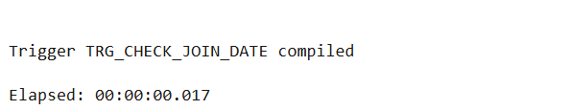

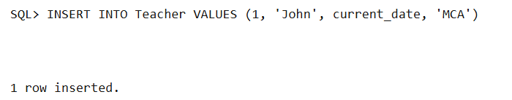

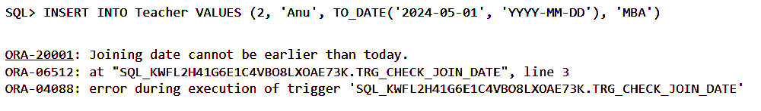

**EXPERIMENT 8**

Configuration of NoSQL database

QUESTION 33

Comparison between relational and non-relational (NoSQL) databases and the

configuration of NoSQL Databases.

OUTPUT

| **Feature** | **Relational (SQL) Databases** | **Non-Relational (NoSQL) Databases** |
| --- | --- | --- |
| **Data Model** | Structured tables with rows and columns | Flexible models: document, key-value, wide-column, graph |
| **Schema** | Fixed schema; predefined structure | Dynamic schema; allows for unstructured or semi-structured data |
| **Scalability** | Vertical scaling (adding more power to a single server) | Horizontal scaling (adding more servers to distribute the load) |
| **Query Language** | Structured Query Language (SQL) | Varies by database (e.g., MongoDB uses its own query language) |
| **Transactions** | Strong ACID compliance (Atomicity, Consistency, Isolation, Durability) | Some support for ACID; others favor BASE (Basically Available, Soft state, Eventual consistency) |
| **Examples** | MySQL, PostgreSQL, Oracle, Microsoft SQL Server | MongoDB, Cassandra, Redis, Couchbase, Neo4j |
| **Use Cases** | Complex queries, multi-row transactions, structured data | Large volumes of diverse data, real-time analytics, content management, IoT, big data applications |
| **Data Integrity** | Enforced through constraints and relationships | Application-level enforcement; less emphasis on strict data integrity |
| **Flexibility** | Less flexible; changes require altering the schema | Highly flexible; easy to add new fields or data types without affecting existing data |
| **Performance** | Optimized for complex queries and joins | Optimized for high-speed read/write operations and large-scale data handling |

**EXPERIMENT 9**

PROGRAMS USING MONGODB

QUESTION 34

Install the MongoDB and configure it.

OUTPUT

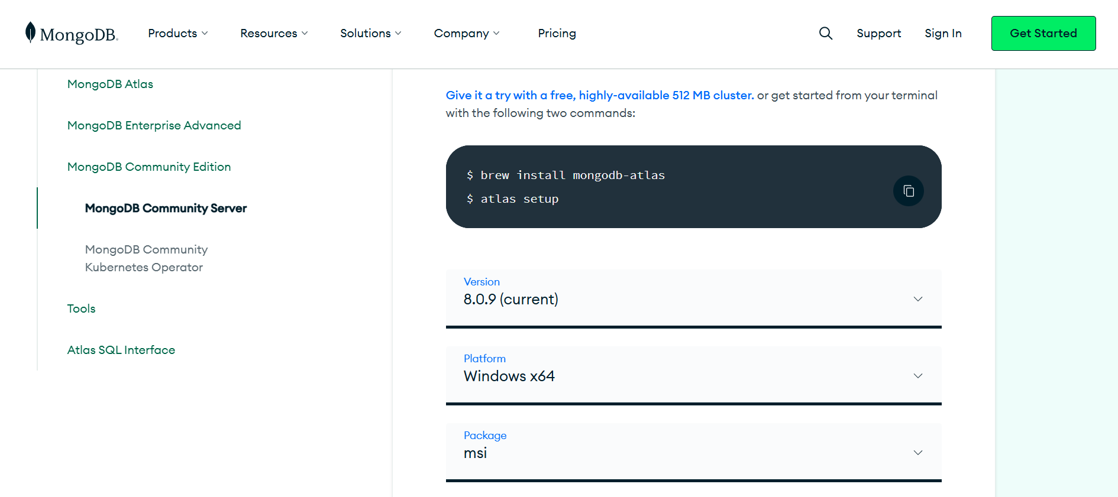

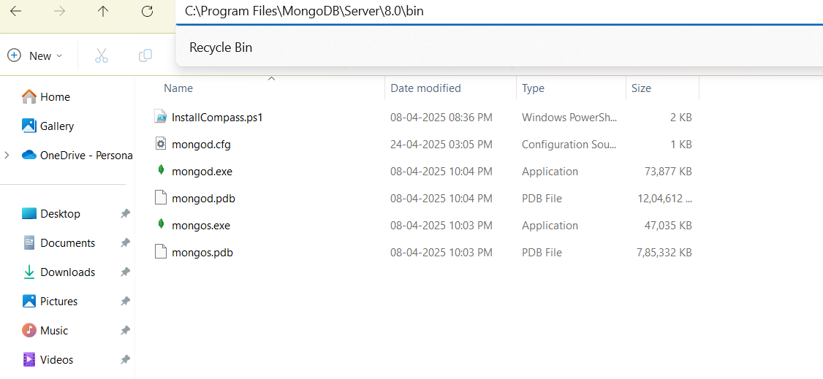

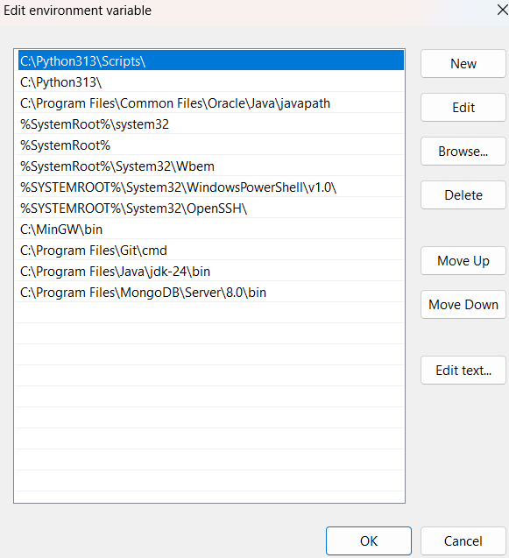

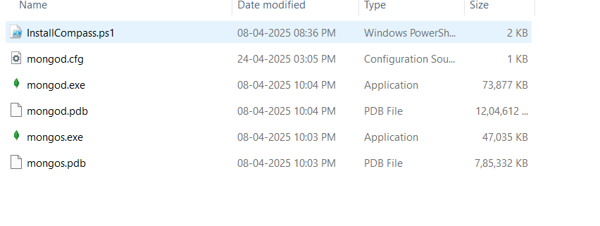

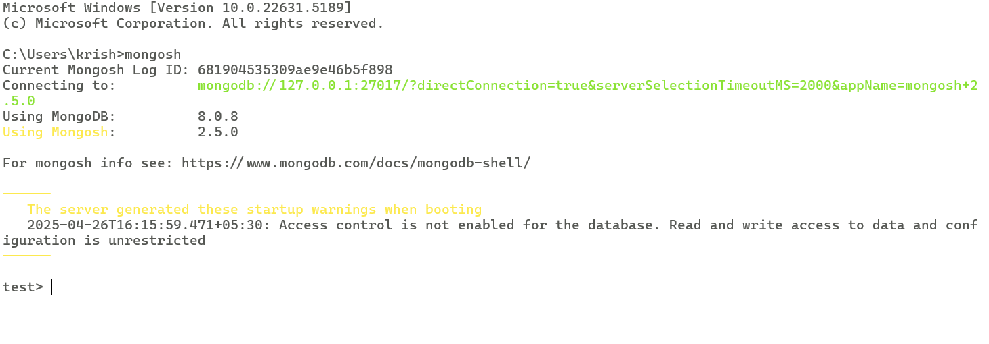

QUESTION 35

Create a collection student consists of details like rollno, name, phoneno, marks,

address, year of course etc.

PROGRAM CODE

test> use college

switched to db college

college> db.createCollection("student19")

{ ok: 1 }

college> db.student19.find()

QUESTION 36

Insert the details of the multiple students (atleast 5) in the form of documents in the

student collection.

PROGRAM CODE

college> db.student19.insertOne({rollno:1,name:"gourav",phoneno:8590451893,marks:94,address:"Kottayam",year:2024})

{

acknowledged: true,

insertedId: ObjectId('6818b16f0859ba1fbdb5f89e')

}

college> db.student19.insertOne({rollno:2,name:"abhi",phoneno:8547459618,marks:90,address:"Thrissur",year:2024})

{

acknowledged: true,

insertedId: ObjectId('6818b1d70859ba1fbdb5f89f')

}

college> db.student19.insertOne({rollno:3,name:"Sujith",phoneno:9605080027,marks:85,address:"Kollam",year:2024})

{

acknowledged: true,

insertedId: ObjectId('6818b20e0859ba1fbdb5f8a0')

}

college> db.student19.insertOne({rollno:4,name:"Abhilash",phoneno:9446491760,marks:94,address:"Kannur",year:2022})

{

acknowledged: true,

insertedId: ObjectId('6818b2520859ba1fbdb5f8a1')

}

college> db.student19.insertOne({rollno:5,name:"Alfred",phoneno:8547210352,marks:92,address:"Thrissur",year:2024})

{

acknowledged: true,

insertedId: ObjectId('6818b2830859ba1fbdb5f8a3')

}

QUESTION 37

Retrieve the fields rollno, name, phoneno, marks, city for all the documents in the

collection student.

PROGRAM CODE

college> db.student19.find()

OUTPUT

[

{

_id: ObjectId('6818b16f0859ba1fbdb5f89e'),

rollno: 1,

name: 'gourav',

phoneno: 8590451893,

marks: 94,

address: 'Kottayam',

year: 2024

},

{

_id: ObjectId('6818b1d70859ba1fbdb5f89f'),

rollno: 2,

name: 'abhi',

phoneno: 8547459618,

marks: 90,

address: 'Thrissur',

year: 2024

},

{

_id: ObjectId('6818b20e0859ba1fbdb5f8a0'),

rollno: 3,

name: 'Sujith',

phoneno: 9605080027,

marks: 85,

address: 'Kollam',

year: 2024

},

{

_id: ObjectId('6818b2520859ba1fbdb5f8a1'),

rollno: 4,

name: 'Abhilash',

phoneno: 9446491760,

marks: 94,

address: 'Kannur',

year: 2022

},

{

_id: ObjectId('6818b2830859ba1fbdb5f8a3'),

rollno: 5,

name: 'Alfred',

phoneno: 8547210352,

marks: 92,

address: 'Thrissur',

year: 2024

}

]

QUESTION 38

Display the details of students who achieved a score more than 90 and are from

‘Thrissur’.

PROGRAM CODE

college> db.student19.find({ marks: { $gt: 90 }, address: "Thrissur" })

OUTPUT

[

{

_id: ObjectId('6818b2830859ba1fbdb5f8a3'),

rollno: 5,

name: 'Alfred',

phoneno: 8547210352,

marks: 92,

address: 'Thrissur',

year: 2024

}

]

QUESTION 39

Update the phone number of Sujith in the student collection. Retrieve the updated

Information.

PROGRAM CODE

college> db.student19.updateOne({name:"Sujith"},{ $set: {phoneno:9876542130}})

college> db.student19.find({ name: "Sujith" })

OUTPUT

[

{

_id: ObjectId('6818b20e0859ba1fbdb5f8a0'),

rollno: 3,

name: 'Sujith',

phoneno: 9876542130,

marks: 85,

address: 'Kollam',

year: 2024

}]

QUESTION 40

Update the year of course in all the documents in the student collection to 2021. Also

retrieve the updated information.

PROGRAM CODE

college> db.student19.updateMany({},{$set:{year:2021}})

college> db.student19.find()

OUTPUT

[

{

_id: ObjectId('6818b16f0859ba1fbdb5f89e'),

rollno: 1,

name: 'gourav',

phoneno: 8590451893,

marks: 94,

address: 'Kottayam',

year: 2021

},

{

_id: ObjectId('6818b1d70859ba1fbdb5f89f'),

rollno: 2,

name: 'abhi',

phoneno: 8547459618,

marks: 90,

address: 'Thrissur',

year: 2021

},

{

_id: ObjectId('6818b20e0859ba1fbdb5f8a0'),

rollno: 3,

name: 'Sujith',

phoneno: 9876542130,

marks: 85,

address: 'Kollam',

year: 2021

},

{

_id: ObjectId('6818b2520859ba1fbdb5f8a1'),

rollno: 4,

name: 'Abhilash',

phoneno: 9446491760,

marks: 94,

address: 'Kannur',

year: 2021

},

{

_id: ObjectId('6818b2830859ba1fbdb5f8a3'),

rollno: 5,

name: 'Alfred',

phoneno: 8547210352,

marks: 92,

address: 'Thrissur',

year: 2021

}

]

QUESTION 41

Display the contact address of ‘Abhilash’.

PROGRAM CODE

college> db.student19.find({name:"Abhilash"},{_id:0,phoneno:1})

OUTPUT

[ { phoneno: 9446491760 } ]

QUESTION 42

Delete the details of the student whose name is ‘Abhilash’ from the student collection.

PROGRAM CODE

college> db.student19.deleteOne({ name: "Abhilash" })

QUESTION 43

Retrieve the number of students per department from the student collection.

PROGRAM CODE

college> db.student19.aggregate([{$group:{_id:"$department", count:{$sum:1}}}])

OUTPUT  
[ { _id: null, count: 5 } ]

QUESTION 44

Arrange the name of the students in ascending order along with all the columns.

PROGRAM CODE

college> db.student19.find().sort({ name: 1 })

OUTPUT

[

{

_id: ObjectId('6818b1d70859ba1fbdb5f89f'),

rollno: 2,

name: 'Abhi',

phoneno: 8547459618,

marks: 90,

address: 'Thrissur',

year: 2021

},

{

_id: ObjectId('6818b2830859ba1fbdb5f8a3'),

rollno: 5,

name: 'Alfred',

phoneno: 8547210352,

marks: 92,

address: 'Thrissur',

year: 2021

},

{

_id: ObjectId('6818b16f0859ba1fbdb5f89e'),

rollno: 1,

name: 'Gourav',

phoneno: 8590451893,

marks: 94,

address: 'Kottayam',

year: 2021

},

{

_id: ObjectId('6818b20e0859ba1fbdb5f8a0'),

rollno: 3,

name: 'Sujith',

phoneno: 9876542130,

marks: 85,

address: 'Kollam',

year: 2021

}

]

QUESTION 45

Rename city as town and add the detail of address consists of apartment no, street name

and PIN.

PROGRAM CODE

college>db.student19.updateMany({},[{$set:{town:{apartment_no:"101",street:"Gandhinagar",pin:"680001"}}}])

college> db.student19.updateMany({},{$unset:{address:""}})

college> db.student19.find({rollno:1})

OUTPUT

[ {

_id: ObjectId('6818b16f0859ba1fbdb5f89e'),

rollno: 1,

name: 'Gourav',

phoneno: 8590451893,

marks: 94,

year: 2021,

town: { apartment_no: '101', street: 'Gandhinagar', pin: '680001' }

}]

