My first MD

Timothee Bonnet

23 August 2019

Table of Contents

# Introduction

Normal, *italics*, **bold**, ***both***, *italics*

* q
* s
* s

par(mfrow=c(1,2))  
x1 <- rnorm(200)  
x2 <- x1 +rnorm(200)  
y <- 1 + x1 +rnorm(200)  
summary(lm(y ~ x2))

##   
## Call:  
## lm(formula = y ~ x2)  
##   
## Residuals:  
## Min 1Q Median 3Q Max   
## -2.7673 -0.7915 0.0556 0.8495 3.7936   
##   
## Coefficients:  
## Estimate Std. Error t value Pr(>|t|)   
## (Intercept) 1.10267 0.08488 12.99 < 2e-16 ***  
## x2 0.44278 0.05880 7.53 1.76e-12 ***  
## ---  
## Signif. codes: 0 '***' 0.001 '**' 0.01 '*' 0.05 '.' 0.1 ' ' 1  
##   
## Residual standard error: 1.2 on 198 degrees of freedom  
## Multiple R-squared: 0.2226, Adjusted R-squared: 0.2187   
## F-statistic: 56.7 on 1 and 198 DF, p-value: 1.756e-12

plot(x2, y)  
plot(x2, y)

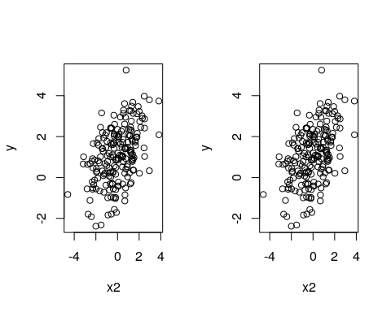

the result is -1.5112378

1 + pi

4.1415927

lm(y ~ x)

## Blabla

### subsubsection

#### subsubsubsection

##### subsubsubsubsection

###### subsubsubsubsubsection