Test

Timothee Bonnet

19 August 2019

## R Markdown

This is an R Markdown document. Markdown is a simple formatting syntax for authoring HTML, PDF, and MS Word documents. For more details on using R Markdown see <http://rmarkdown.rstudio.com>.

When you click the **Knit** button a document will be generated that includes both content as well as the output of any embedded R code chunks within the document. You can embed an R code chunk like this:

summary(cars)

## speed dist   
## Min. : 4.0 Min. : 2.00   
## 1st Qu.:12.0 1st Qu.: 26.00   
## Median :15.0 Median : 36.00   
## Mean :15.4 Mean : 42.98   
## 3rd Qu.:19.0 3rd Qu.: 56.00   
## Max. :25.0 Max. :120.00

x1 <- rnorm(200)  
x2 <- x1 +rnorm(200)  
y <- 1 + x1 +rnorm(200)  
summary(lm(y ~ x2))

##   
## Call:  
## lm(formula = y ~ x2)  
##   
## Residuals:  
## Min 1Q Median 3Q Max   
## -3.1087 -0.9835 0.1099 0.8994 2.8125   
##   
## Coefficients:  
## Estimate Std. Error t value Pr(>|t|)   
## (Intercept) 1.06903 0.08811 12.133 < 2e-16 ***  
## x2 0.51655 0.06552 7.884 2.08e-13 ***  
## ---  
## Signif. codes: 0 '***' 0.001 '**' 0.01 '*' 0.05 '.' 0.1 ' ' 1  
##   
## Residual standard error: 1.241 on 198 degrees of freedom  
## Multiple R-squared: 0.2389, Adjusted R-squared: 0.2351   
## F-statistic: 62.16 on 1 and 198 DF, p-value: 2.084e-13

## Including Plots

You can also embed plots, for example:

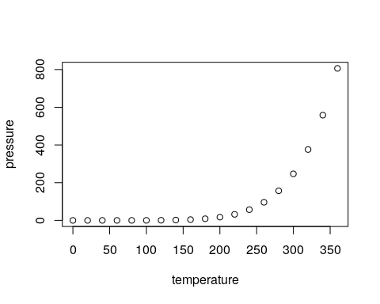

Note that the echo = FALSE parameter was added to the code chunk to prevent printing of the R code that generated the plot.

data(cars)  
knitr::kable(x = head(cars), caption = "A knitr kable table")

A knitr kable table

|  |  |
| --- | --- |
| speed | dist |
| 4 | 2 |
| 4 | 10 |
| 7 | 4 |
| 7 | 22 |
| 8 | 16 |
| 9 | 10 |

## Linear regression

### Simple

A simple regression measures total associations

summary(lm(y ~ x2))

##   
## Call:  
## lm(formula = y ~ x2)  
##   
## Residuals:  
## Min 1Q Median 3Q Max   
## -3.1087 -0.9835 0.1099 0.8994 2.8125   
##   
## Coefficients:  
## Estimate Std. Error t value Pr(>|t|)   
## (Intercept) 1.06903 0.08811 12.133 < 2e-16 ***  
## x2 0.51655 0.06552 7.884 2.08e-13 ***  
## ---  
## Signif. codes: 0 '***' 0.001 '**' 0.01 '*' 0.05 '.' 0.1 ' ' 1  
##   
## Residual standard error: 1.241 on 198 degrees of freedom  
## Multiple R-squared: 0.2389, Adjusted R-squared: 0.2351   
## F-statistic: 62.16 on 1 and 198 DF, p-value: 2.084e-13

### Multiple

A multiple regression measures direct associations, corrected for indirect associations.

summary(lm(y ~ x1+x2))

##   
## Call:  
## lm(formula = y ~ x1 + x2)  
##   
## Residuals:  
## Min 1Q Median 3Q Max   
## -2.76160 -0.64298 0.04952 0.76148 2.26397   
##   
## Coefficients:  
## Estimate Std. Error t value Pr(>|t|)   
## (Intercept) 1.01426 0.07285 13.924 <2e-16 ***  
## x1 1.06616 0.10972 9.717 <2e-16 ***  
## x2 -0.06763 0.08081 -0.837 0.404   
## ---  
## Signif. codes: 0 '***' 0.001 '**' 0.01 '*' 0.05 '.' 0.1 ' ' 1  
##   
## Residual standard error: 1.023 on 197 degrees of freedom  
## Multiple R-squared: 0.4855, Adjusted R-squared: 0.4803   
## F-statistic: 92.96 on 2 and 197 DF, p-value: < 2.2e-16

## New section

Hello $y_{i}=μ+β×x_{i}+ϵ_{i}$, have a good day

Hello

$$y_{i}=μ+β×x_{i}+ϵ_{i}$$

, have a good day

## Inline

1+pi

4.1415927