Table of Contents
Stocks with Excel support 1
Tested Environment 1
Purpose 1
How it Works 1

Stocks with Excel support

Tested Environment
Ubuntu 16.04, 12.04. LibreOffice calc

Purpose
In Internet there are lot of tools to view current stock price, its bid quantity. But there are very few website supports real time portfolio support, where the stocks can be added or sold to analyse the personal capability about correct entry level and exit level from market to book reasonable profit. If you are looking for custom portfolio management with real time stock value update in excel then this post is for you

How it Works
With the help of excel sheet managing custom portfolio, Current profit based on categorised portfolio will be possible.

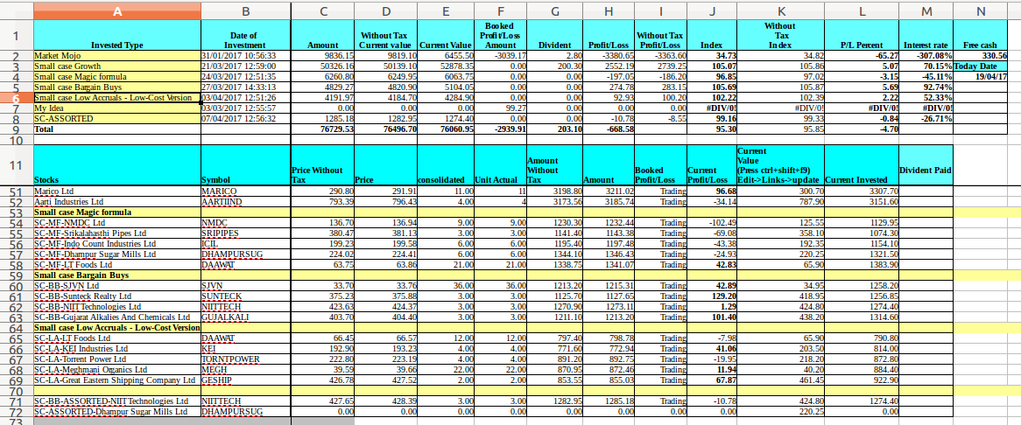
With this excel sheet (https://www.dropbox.com/s/iunlmtenrcp9avi/stocks.ods?dl=0) and a small c code to fetch stock data from internet to local file in cvs format (https://www.dropbox.com/s/vs90olny75qo584/main.c?dl=0)
Command to generate Google.csv used in the excel sheet

$ ./stocks.elf -stock_list ./list.txt >Google.csv
where list.txt file should contains like this

$ cat list.txt
539007
531082
500074
CUPID
DWARKESH
EIHAHOTELS
513361
516082
539962
SESHAPAPER
STAMPEDE
SWELECTES

