

STUDENT NAME :Anandh

STAFF NAME : Ms.Antonet Reeta J

COURSE NAME : JAVA

DATE : 4-08-2023

ACKNOWLEDGEMENT

First of all, I thank God almighty for giving us the wisdom, grace and knowledge to complete this project successfully and also for showering his choicest blessing upon us.

I express my gratitude to Ms Antonet Reeta J who co-ordinate and guided us in this project and all through this JAVA course. I take this pleasant opportunity to convey my thanks to her for her kind co-operation, necessary requirements and access to complete my project work.

I also express my gratitude to Ms JOHNCY R Technical Leader who co-ordinate and guided us in this project and all through this JAVA course. I take this pleasant opportunity to convey my thanks to him for him kind co-operation, necessary requirements and access to complete my project work.

I am thankful to all Staffs of Networkz Systems and to my friend who has given their timely support and helps to bring out our project as a successful one.

Above all I remain greatly thankful to my beloved Parents who inspired and guided us in the right path and for being the backbone of all the successful endeavours in our life.

S.Dijo Thomas
(JAVA)
INDEX

Serial No | Contents | Page  No
1 | Introduction | 4
2 | Project Name | 5
3 | Hardware and Software Requirements | 6
4 | SourceCodes | 7
5 | Screen Shots | 20
6 | Conclusion | 25

INTRODUCTION

COURSE INTRODUCTION
JAVA, also known as JAVA developer, is the creation of dynamic web applications A lot of people learn web coding because they want to
create the next Facebook or find a job in the industry. But it's also a good choice if you just want a general introduction to coding, since it's super easy to get started.
Covers Java ,OOPS,FILE HANDLING,EXCEPTION HANDLING,HTML,CSS,JAVASCRIPT,BOOSRAP,SERVLET,JSP,MYSQLdatabase and accessibility. This is a good starting point for beginners wishing to learn web development fundamentals across a number of areas.
This course is designed to start you on a path toward future studies in web development and design, no matter how little experience or technical knowledge you currently have. The web is a very big place, and if you are the typical internet user, you probably visit several websites every day, whether for business, entertainment or education.

But have you ever wondered how these websites actually work? How are they built? How do browsers, computers, and mobile devices interact with the web? What skills are necessary to build a website? With almost 1 billion websites now on the internet, the answers to these questions could be your first step toward a better understanding of the internet and developing a new set of internet skills.

INTRODUCTION:
PROJECT NAME

Car showroom website

A car is one of the most expensive purchases anyone makes, and today’s car showrooms have an important role in helping customers make that decision.
It's little wonder new car showrooms can be lavish enterprises, with double-height glazing, blazing lights and costly stone floors. And that’s before you even get into the realms of internet cafes and branded clothing!
In an increasingly segmented market, your dealership needs to cater for a range of clients and their needs. Here's how.

that just as important as how the dealership looks, is how the dealership works. Ask yourself:
How do my customers and staff use my dealership for day-to-day activities?
Can my sales team see the lot without obstruction?
Do my customers have clear routes to the service area / workshop?
Where is the guest bathroom located?
How large does the showroom need to be to accommodate the number of cars we want to display?
Given our planning volume and service growth goals, how many service bays do we need in the body shop? How many technicians?

In today’s brand-driven society, cars and lifestyle overlap – and your sales environment should reflect your customers' preferences.
Remember that the scope of a car dealership scheme is not limited to sales. After-sales service is an intrinsic element of the business model, so a service reception and a parts and workshop facility are often located on a showroom site.
At prestige marque dealerships, customers may expect access to refreshments, and wireless or internet connections in coffee bars or lounges.

HARDWARE AND SOFTWARE REQUI
Hardware Requirements

  - LAPTOP
  - RAM 8 GB
  - HARD DISK 500GB

Software Requirements
Front End:
- HTML
- CSS
- JAVA SCRIPT
- BOOSTRAP

Back End:
- JSP
DATABASE:

- MYSQL

SOURCE CODE:
Index.jsp
package project;
page contentType="text/html" pageEncoding="UTF-8"%>
<!DOCTYPE html>
<html>
<head>
<meta http-equiv="Content-Type" content="text/html; charset=UTF-8">
<title>JSP Page</title>
<link href="https://cdn.jsdelivr.net/npm/bootstrap@5.3.0-alpha3/dist/css/bootstrap.min.css" rel="stylesheet" integrity="sha384-KK94CHFLLe+nY2dmCWGMq91rCGa5gtU4mk92HdvYe+M/SXH301p5ILy+dN9+nJOZ" crossorigin="anonymous">
<script src="https://cdn.jsdelivr.net/npm/bootstrap@5.3.0-alpha3/dist/js/bootstrap.bundle.min.js" integrity="sha384-ENjdO4Dr2bkBIFxQpeoTz1HIcje39Wm4jDKdf19U8gI4ddQ3GYNS7NTKfAdVQSZe" crossorigin="anonymous"></script>
</head>
<style>
.gradient-custom {
/* fallback for old browsers */
background: #6a11cb;

/* Chrome 10-25, Safari 5.1-6 */
background: -webkit-linear-gradient(to right, rgba(106, 17, 203, 1), rgba(37, 117, 252, 1));

/* W3C, IE 10+/ Edge, Firefox 16+, Chrome 26+, Opera 12+, Safari 7+ */
background: linear-gradient(to right, rgba(106, 17, 203, 1), rgba(37, 117, 252, 1))
}
</style>
<body>
<section class="vh-100 gradient-custom">
<div class="container py-5 h-100">
<div class="row d-flex justify-content-center align-items-center h-100">
<div class="col-12 col-md-8 col-lg-6 col-xl-5">
<div class="card bg-dark text-white" style="border-radius: 1rem;">
<div class="card-body p-5 text-center">

<div class="mb-md-5 mt-md-4 pb-5">

<h2 class="fw-bold mb-2 text-uppercase">Login</h2>
<p class="text-white-50 mb-5">Please enter your login and password!</p>
<form action="index2.jsp">
<div class="form-outline form-white mb-4">
<input type="email" id="typeEmailX" class="form-control form-control-lg" name="mail" />
<label class="form-label" for="typeEmailX">Email</label>
</div>

<div class="form-outline form-white mb-4">
<input type="password" id="typePasswordX" class="form-control form-control-lg" name="pass"/>
<label class="form-label" for="typePasswordX">Password</label>
</div>

<p class="small mb-5 pb-lg-2"><a class="text-white-50" href="#!">Forgot password?</a></p>

<button class="btn btn-outline-light btn-lg px-5" type="submit">Login</button>
</form>
<div class="d-flex justify-content-center text-center mt-4 pt-1">
<a href="#!" class="text-white"><i class="fab fa-facebook-f fa-lg"></i></a>
<a href="#!" class="text-white"><i class="fab fa-twitter fa-lg mx-4 px-2"></i></a>
<a href="#!" class="text-white"><i class="fab fa-google fa-lg"></i></a>
</div>

</div>

<div>
<p class="mb-0">Don't have an account? <a href="signup.jsp" class="text-white-50 fw-bold">Sign Up</a>
</p>
</div>

</div>
</div>
</div>
</div>
</div>
</section>
</body>
</html>

Main.jsp
padding: 0;
scroll-padding-top: 1rem;
scroll-behavior: smooth;
list-style: none;
text-decoration: none;
box-sizing: border-box;
}
/*variables*/
:root{
--main-colour:#d90429;
--text-colour:#020102;
--bg-colour:#fff;
}
section{
padding: 4rem 0 2rem;

}
img{
width: 100px;
}
body{
color:var(--text-colour);
}
.nav-Container{
height: 50px;
width: 100%;
display: flex;
justify-content:left;
padding-bottom: 10px;
position: fixed;

}
/* header{
display: block;
width: 100px;
position: fixed;
top: 0;
left: 0;
z-index: 100;
} */

#menu-icon{
font: size 24px;
cursor: pointer;
color: var(--text-colour);
display: none;
bottom: 0%;
}
.logo{
font-size: 3rem;
font-weight: 700;
color:var(--text-colour);
}
.logo span{
color: var(--main-colour);
}
.navbar{
display:flex;
column-gap:2rem;
padding: 100px 300px;
width: 50%;
align-items: center;

margin-top: 0px;
}
.navbar a{
color: var(--text-colour);
font-size: 1rem;
text-transform: uppercase;
font-weight: 500;
}
.navbar a:hover,
.navbar.active{
color: var(--main-colour);
border-bottom: 3px solid var(--main-colour);
}
#search-icon{
font-size: 24px;
cursor: pointer;
color: var(--bg-colour);
}
/* .Search-Box{
position: absolute;
top: 50px;
left:1000px;
background: var(--bg-colour);
box-shadow: 4px 4px 20 px rgp(15 54 55 /10%);
border: 1px solid var(--main-colour);
border-radius: 0.5rem;
clip-path: circle(0% at 1005 0%);
}
.search-box.active{
clip-path: circle(144% at 1005 0%);
}

.search-box input{
width: 100px;
padding: 20px;
border: none;
outline: none;
background: transparent;
font-size: 1rem;
} */
.home{
max-width: 1300px;
margin: auto;
width: 100%;
min-height: 640px;
display: flex;
align-items:center;
background: url(Car-PNG-Photos\ \(1\).png);
background-repeat: no-repeat;
background-size:cover;
background-position: center;

}
.home-text{
padding-left: 20px;
}
.home-text h1{
font-size: 2.4rem;
margin-bottom: 50%;
}
.home-text span{
color: var(--main-colour);
}
.home-text p{
font-size: o.938rem;
font-weight: 300;
margin: 0.5rem 0 1.2rem;
}
.btn{
padding: 10px 22px;
background: var(--main-colour);
color: var(--bg-colour);
font-weight: 400;
}
.btn:hover{
background: #fd052f;
}
.heading{
text-align:center;
}
.heading span{
font-weight: 500;
color: var(--main-colour);
}
.heading p{
font-size: 0.938rem;
font-weight: 300;
}
.cars-container{
display: flex;
align-items: center;
flex-wrap: wrap;
gap: 2rem;
margin-top: 4rem;
}
.cars-container.box{
flex: 1 1 17;
position: relative;
height: 200px;
border-radius: 0.5rem;
overflow: hidden;

}
.box img{
width: 100%;
height: 100%;
object-fit: cover;
overflow: hidden;

}
.cars-container.box img:hover{
transform: scale(1.1);
transition: 0.5s;
}
.cars-container.box h2{
position: absolute;
bottom: 1rem;
left: 1rem;
font-weight: 400;
font-size: 1rem;
background: var(--bg-colour);
padding: 8px;
border-radius: 0.5rem;
}
.cars-container.box :hover h2{
background: var(--main-colour);
color: var(--bg-colour);
}
.about{
display: flex;
flex-wrap: wrap;
align-items: left;
gap: 1.5rem;
}
.about img{
flex: 1 1 21rem;
}
.about-text{
flex: 1 1 15rem;
text-align: center;
}
.about-text span{
font-weight: 500;
color: var(--main-colour);
}
.about-text h2{
font-size: 1.7rem;

}
.about-text p{
font-size: 0.938rem;
margin: 0.4rem 0 1.5rem;
}
.parts-container{
display: flex;
flex-wrap: wrap;
gap: 6rem;
margin-top: 5rem;
}
.parts-container.box{
flex: 1 1 17rem;
position: relative;
padding: 20px;
display: flex;
flex-direction: column;
background: #f6f6f6;
border-radius: 0.5rem;
}
.box img{
width: 100%;
height: 150px;
object-fit: contain;
object-position: center;
margin-bottom: 1rem;
}
.parts-container.box h3{
font-size: 1.1rem;
font-weight: 600;
}
.parts-container.box h3{
font-size: 1.1rem;
font-weight: 600;
}
.parts-container.box span{
font-size: 1.1rem;
font-weight: 600
color var(--main-colour);

}
.parts-container.box.bx{
color: var(--main-colour);
margin: 0.8rem 0;
}
.parts-container.box.btn{
max-width: 120px;
}
.parts-container.box.detials{
display: flex;
align-items: center;
position: absolute;
bottom: 1.8rem;
right: 1rem;
font-size: 1rem;
color: var(--text-colour);
}
.parts-container.box.detials:hover{
color: var(--main-colour);
text-decoration: underline;
}
.blog-container{
text-align: center;
background-size: auto;
display: contents;
flex-wrap:wrap;
gap: 2rem;
margin: top 2rem;
}
.box{
flex:1 1 26rem;
padding: 20px;
}
.blog-container.box:hover{
background: #f6f6f6;

}
.blog-container.box span{
font-size: 0.8rem;
color: var(--main-colour);
}
.blog-container h3{
font-size: 1.8rem;
}
.blog-container.box p{
font-size: 0.938rem;
margin: 4px 0;
}
.blog-container.box.blog.btn{
display: flex;
align-items: center;
column-gap: 4px;
color: var(--text-colour);
}
.blog-container.box.blog-btn.bx{
font-size: 50px;
}
.blog-container.box.blog-btn:hover{
color: var(--main-colour);
column-gap: 0.7rem;
transition: 0.4s;
}
.footer{
background: var(--text-colour);
color: #f6f6f6;
border-top: 2px solid var(--main-colour);
}
.footer .container{
display: flex;
justify-content: space-between;
gap:1rem;
}
.footer-container.logo{
color: var(--bg-colour);
margin-bottom: 1rem;
}
.footer-container.footer.box{
display: flex;
flex-direction: column;
}
.social{
display: flex;
align-items: center;
}
.social a{
font-size: 24px;
color: var(--bg-colour);
margin-left: 1rem;
}
.social a:hover{
color: var(--main-colour);
}
.footer-box h3{
font-size: 1.1rem;
font-weight: 400;
margin-bottom: 1rem;
}
.fotter-box a,
.footer-box p{
color: #818181;
margin-bottom: 10px;
}
.footer-box a:hover{
color: var(--main-colour);
}
.copright{
padding: 20px;
text-align: center;
color: var(--bg-colour);
background: var(--text-colour);
}
#a{
margin-left: 190px;
margin-top: 20px;
}
#x{
display: flex;
}
a{
padding: 20px;

}

</style>
<body>
<style>
#a{
margin-left: 190px;
margin-top: 20px;
}
#x{
display: flex;
}
a{
padding: 20px;

}

</head>
<style>

</style>
<div id="x">
<i class='bx bx-menu'id="menu-icon"></i>

<a href="#"class="logo">Ananth<span>Cars</span></a>
<div id="a">
Newjsp1.jsp
<%@page contentType="text/html" pageEncoding="UTF-8"%>
<!DOCTYPE html>
<html>
<head>
<style>
*{
margin-right: 0px;
padding: 0px;
box-sizing: border-box;
text-align: center;

}
body{
background-image: url(Car-PNG-HD\ \(1\).png);
background-size: cover;

}
#s{
color: aqua;

}
div{
background-color: aqua;
height: 500px;
width: 350px;
margin-left: 400;
margin-top: 100px;
opacity: 0.8;
justify-content: center;

}
.w{
margin-left: 50px;
margin-top: 30px;
width: 200p;
height: 30px;
border: none;
border: 2px solid;
}
::placeholder
{
color: blue;
}
#f
{
margin-left: 120px;
margin-top: 50px;
width: 70px;
height: 30px;
color: blue;
border-radius: 50px;
border: none;
border: 2px solid blue;
}
</style>
</head>
<body>
<div class="ananth">
<h1>Register here</h1>
<form action="reg.jsp"method="post">
<input type="text"placeholder="firstname"required class="w" name="firstname"><br>
<input type="text"placeholder="lastname"required class="w"name="lastname"><br>
<input type="text"placeholder="username"required class="w"name="username"><br>
<input type="password"placeholder="password"required class="w"name="password"><br>
<input type="email"placeholder="emailid"required class="w"name="emailid"><br>
<input type="submit"id="f" value="Register">
</form>

</div>
</body>
</html>

Newjsp2.jsp

<%@page contentType="text/html" pageEncoding="UTF-8"%>
<!DOCTYPE html>
<html>
<head>
<style>
*{
margin-right: 0px;
padding: 0px;
box-sizing: border-box;
text-align: center;

}
body{
background-image: url(Car-PNG-HD\ \(1\).png);
background-size: cover;

}
#s{
color: aqua;

}
div{
background-color: aqua;
height: 500px;
width: 350px;
margin-left: 400;
margin-top: 100px;
opacity: 0.8;
justify-content: center;

}
.w{
margin-left: 50px;
margin-top: 30px;
width: 200p;
height: 30px;
border: none;
border: 2px solid;
}
::placeholder
{
color: blue;
}
#f
{
margin-left: 120px;
margin-top: 50px;
width: 70px;
height: 30px;
color: blue;
border-radius: 50px;
border: none;
border: 2px solid blue;
}
</style>
</head>
<body>
<div class="ananth">
<h1>login Now</h1>
<form action="login.jsp">
<input type="text"placeholder="username"required class="w"name="username"<br>;
<input type="text"placeholder="password"required class="w"name="password"<br>;
<input type="submit"id="f"value="login">
<a href="newjsp3.jsp">forgot password</a>
</form>
</div>
</body>
</html>
Newjsp3.jsp

<%@page contentType="text/html" pageEncoding="UTF-8"%>
<!DOCTYPE html>
<html>
<head>
<style>
*{
margin-right: 0px;
padding: 0px;
box-sizing: border-box;
text-align: center;

}
body{
background-image: url(Car-PNG-HD\ \(1\).png);
background-size: cover;

}
#s{
color: aqua;

}
div{
background-color: aqua;
height: 500px;
width: 350px;
margin-left: 400;
margin-top: 100px;
opacity: 0.8;
justify-content: center;

}
.w{
margin-left: 50px;
margin-top: 30px;
width: 200p;
height: 30px;
border: none;
border: 2px solid;
}
::placeholder
{
color: blue;
}
#f
{
margin-left: 120px;
margin-top: 50px;
width: 70px;
height: 30px;
color: blue;
border-radius: 50px;
border: none;
border: 2px solid blue;
}
</style>
</head>
<body>
<div class="ananth">
<h1>update</h1>
<input type="text"placeholder="emailid"required class="w"name="emailid"<br>;
<input type="text"placeholder="password"required class="w"name="password"<br>;
<input type="submit"id="f"value="update">
</div>
</body>
</html>
Newjsp4.jsp

<%@page contentType="text/html" pageEncoding="UTF-8"%>
<!DOCTYPE html>
<html>
<style>
*{
margin-right: 0px;
padding: 0px;
box-sizing: border-box;
text-align: center;

}
body{
background-image: url(Car-PNG-HD\ \(1\).png);
background-size: cover;

}
#s{
color: aqua;

}
div{
background-color: aqua;
height: 500px;
width: 350px;
margin-left: 400;
margin-top: 100px;
opacity: 0.8;
justify-content: center;

}
.w{
margin-left: 50px;
margin-top: 30px;
width: 200p;
height: 30px;
border: none;
border: 2px solid;
}
::placeholder
{
color: blue;
}
#f
{
margin-left: 120px;
margin-top: 50px;
width: 70px;
height: 30px;
color: blue;
border-radius: 50px;
border: none;
border: 2px solid blue;
}
</style>
</head>
<body>
<div class="ananth">
<h1>Delete</h1>
<input type="text"placeholder="username"required class="w"name="username"<br>;
<input type="submit"id="f"value="delete">;
</body>
</html>

Reg.jsp

<%@page contentType="text/html" pageEncoding="UTF-8"%>
<%@page import= "java.sql.*"%>
<!DOCTYPE html>
<html>
<head>
<meta http-equiv="Content-Type" content="text/html; charset=UTF-8">
<title>JSP Page</title>
</head>
<body>
<%
try{
String a= request.getParameter("firstname");
String b= request.getParameter("lastname");
String c= request.getParameter("username");
String d= request.getParameter("password");
String e= request.getParameter("emailid");
String f= "insert into vijay(firstname,lastname,username,password,emailid)values('"+a+"','"+b+"','"+c+"','"+d+"','"+e+"')";
Class.forName("com.mysql.jdbc.Driver");
Connection con=DriverManager.getConnection("jdbc:mysql://localhost:3306/ananthcars?zeroDateTimeBehavior=convertToNull","root","");
Statement st=con.createStatement();
int i=st.executeUpdate(f);
if(i>0){%>

<script>
alert("successs")
window.location="newjsp2.jsp"
</script>
<% }
else{%>
<script>
alert("notsuccess")
</script>
<% } }catch(Exception e){
out.print(e);
}

%>
</body>
</html>
Update.jsp

<%@page contentType="text/html" pageEncoding="UTF-8"%>
<%@page import= "java.sql.*"%>
<!DOCTYPE html>
<html>
<head>
<meta http-equiv="Content-Type" content="text/html; charset=UTF-8">
<title>JSP Page</title>
</head>
<body>
<%
try{
String a=request.getParameter("emailid");
String b=request.getParameter("password");
String f="update emailid set password =(emailid='"+a+"'and password='"+b+"')";
Class.forName("com.mysql.jdbc.Driver");
Connection con=DriverManager.getConnection("jdbc:mysql://localhost:3306/ananthcars?zeroDateTimeBehavior=convertToNull","root","");
Statement st=con.createStatement();
int ai=st.executeUpdate(f);
if(ai>0){%>
<script>
alert("update successs")
window.location="main.jsp"
</script>
<% }
else{%>
<script>
alert("update notsuccess")
</script>
<% } }catch(Exception e){
out.print(e);
}

%>

%>
</body>
</html>

HOME PAGE:

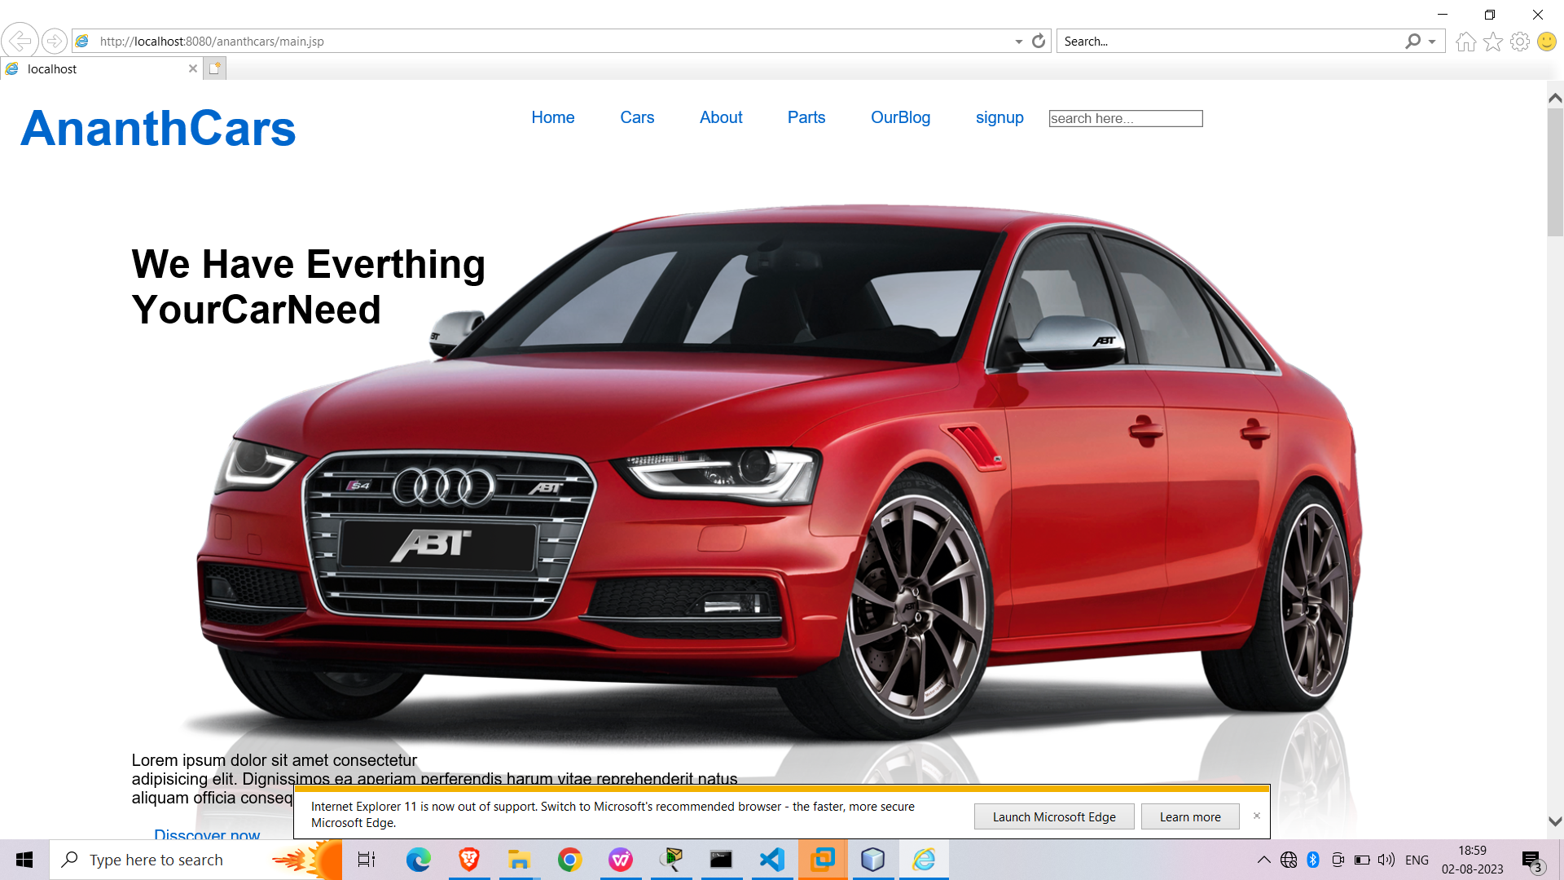
about page:

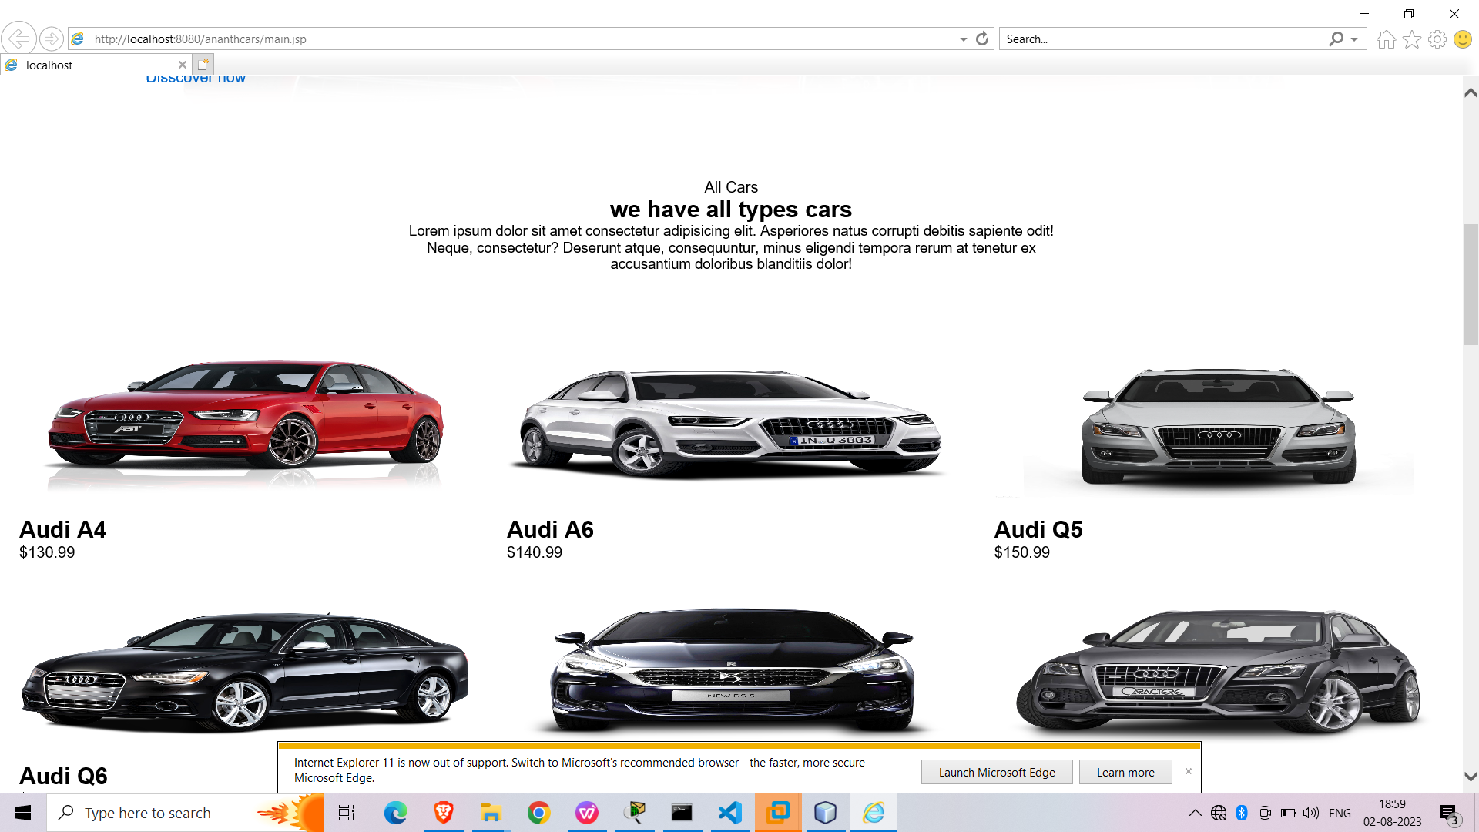

Product page:

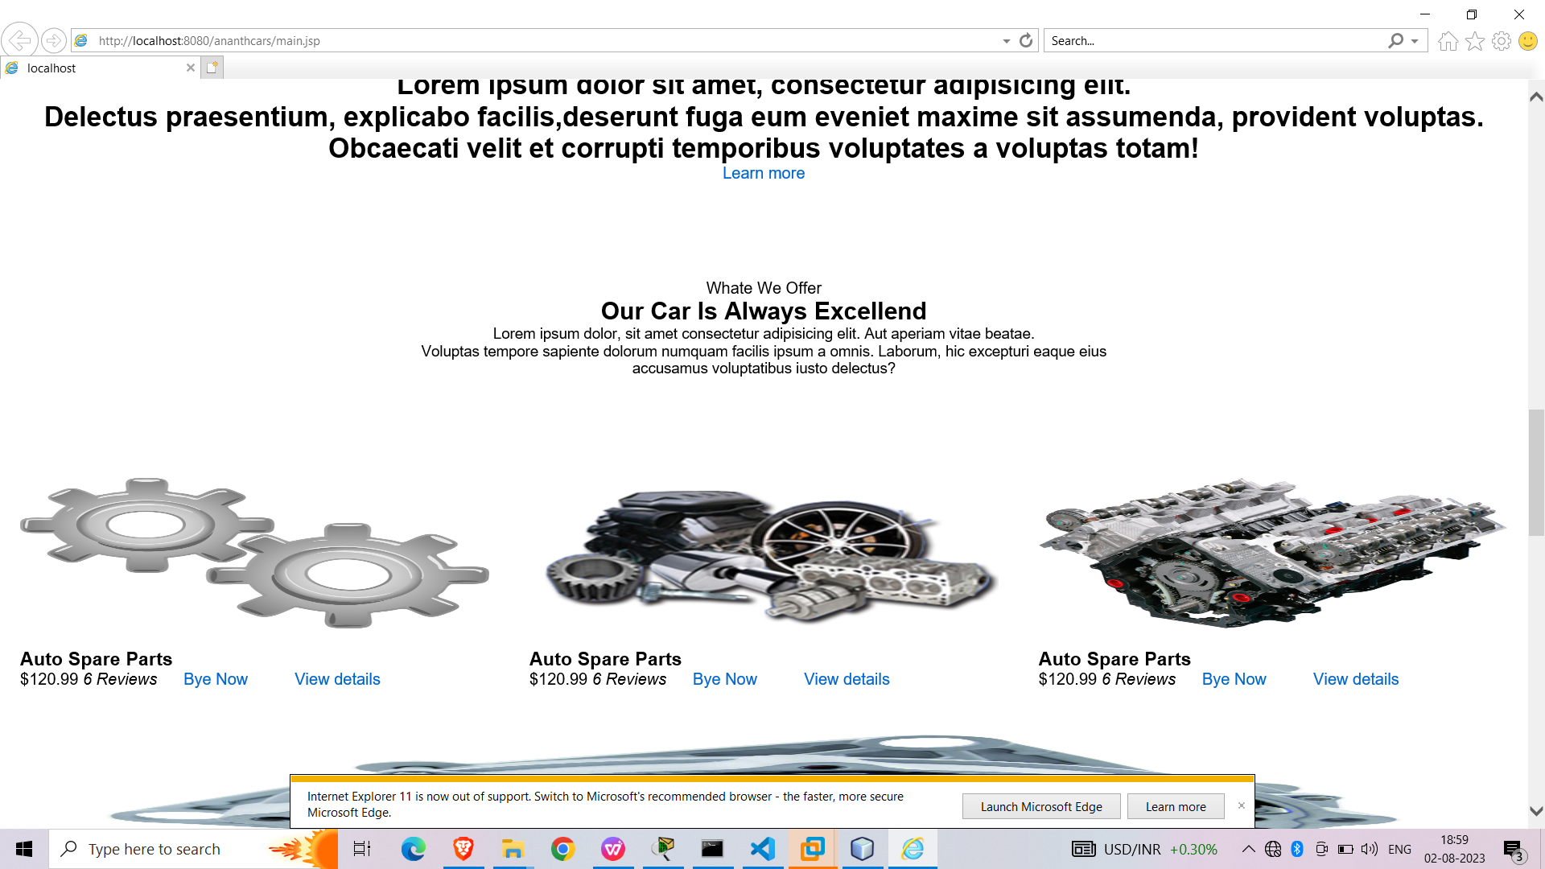

signin PAGE:
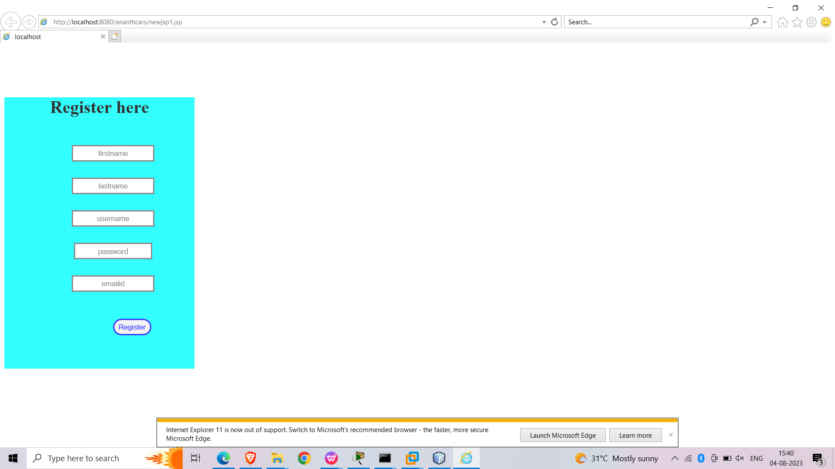

LOGIN PAGE

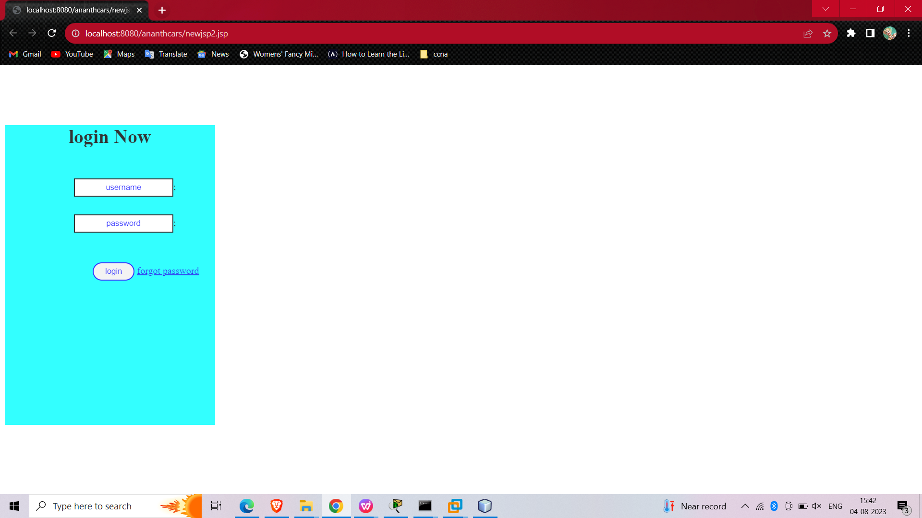
FORGOT PASSWORD PAGE:
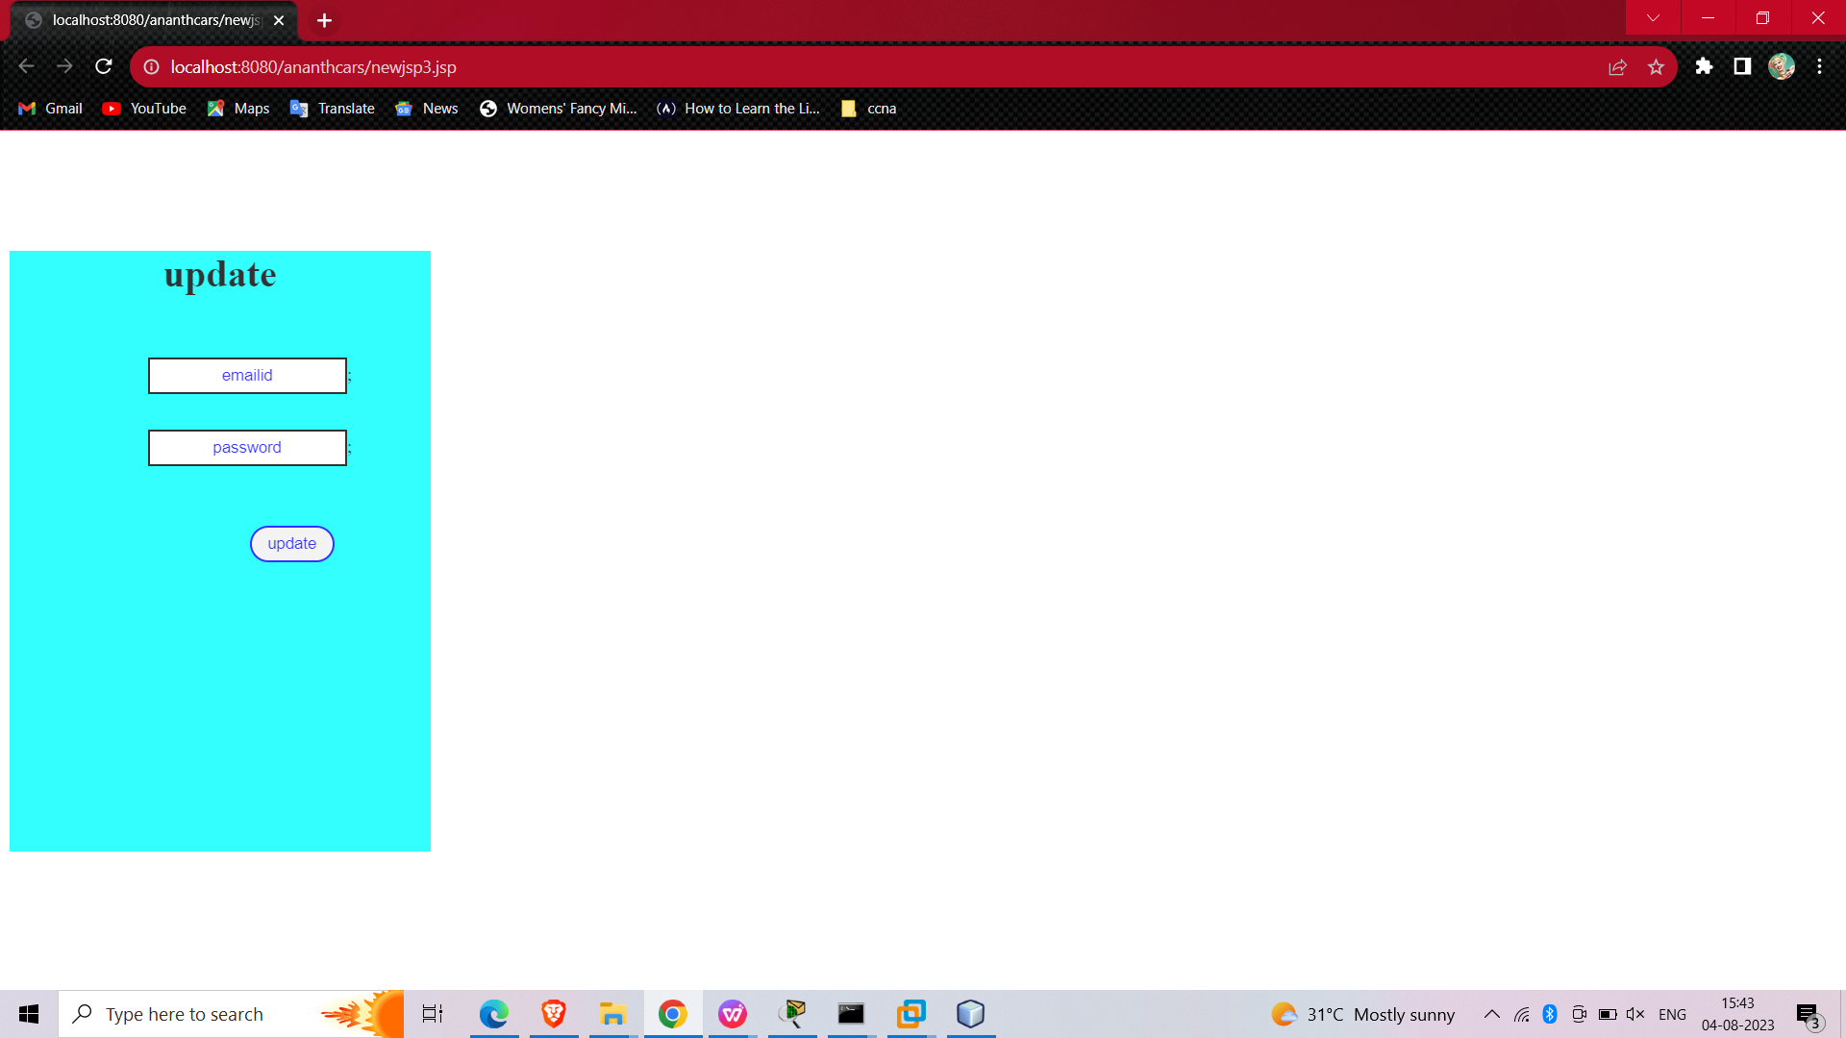

CONCLUSION:

The project was ended and executed successfully.

