**Druid-Cluster Definition/Configuration: -**

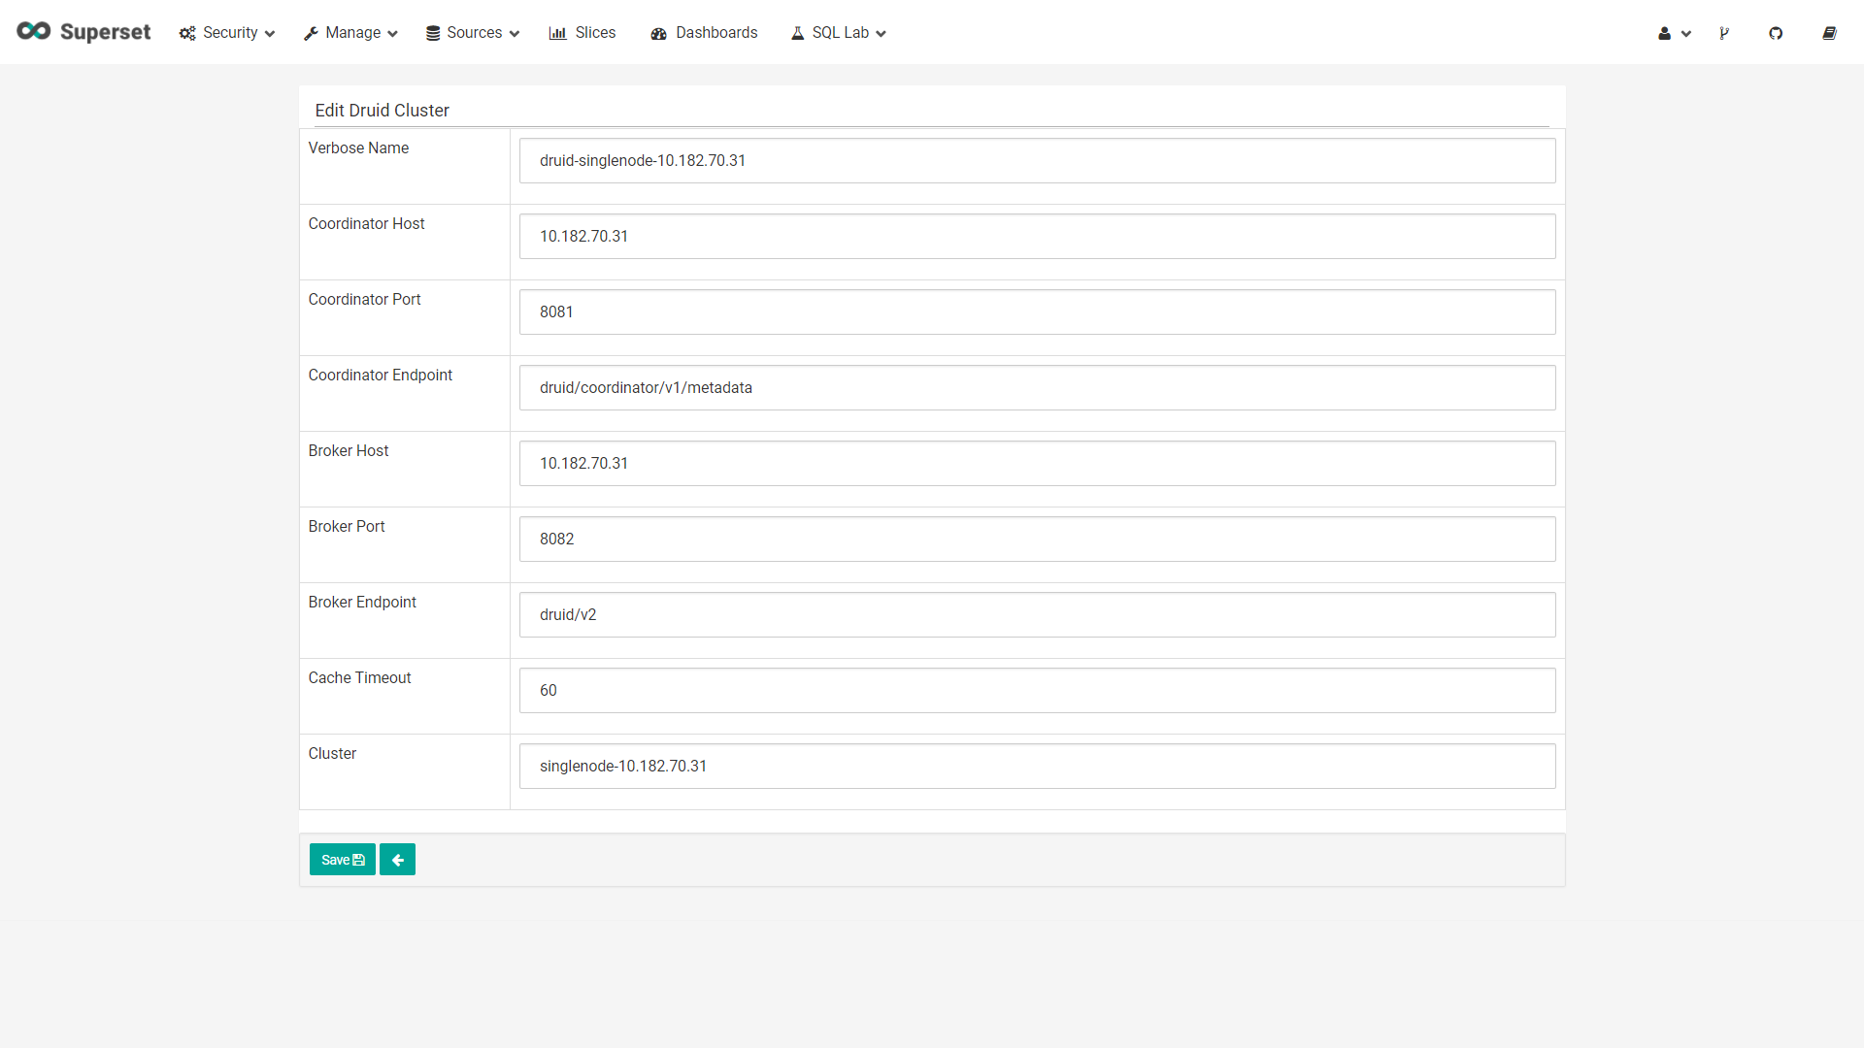

On successful addition of correct details of the Druid cluster as mentioned in the above example, users may choose

**Sources 🡪 Refresh Druid Metadata**

Option to automatically pull the details and metadata information of all of the Datasources available at the Druid cluster.

Users may click on the ‘Refresh Druid Metadata’ link again to pull the recently added Datasource’s details into the Superset portal.

All the columns, dimensions and metrics columns declared in the Druid ingestion specification json will appear as columns in the ‘Druid Columns’ tab regardless of their column type.

It is observed that the metrics columns from the metrics specification were not appearing by default in the ‘Druid Metics’ tab, which eventually lands in the ‘Druid Columns’ tab.

To fix this we have manually edit the json spec of every metric column through the edit button available against every such column. For example,

{ "name" : "QUARTER TO DATE DEBIT BEQ","type" : "doubleSum","fieldName" : "SUM OF BEGINNING PERIOD DEBIT BALANCE"}

In this above metrics json spec,

fieldname 🡪 name of the metric column druid(“name”) from the druid ingestion spec

name 🡪 verbose metric name to in the superset portal.

**Druid-Data Source Configuration: -**

**Part 1 – Druid Datasource Declaration (Auto): -**

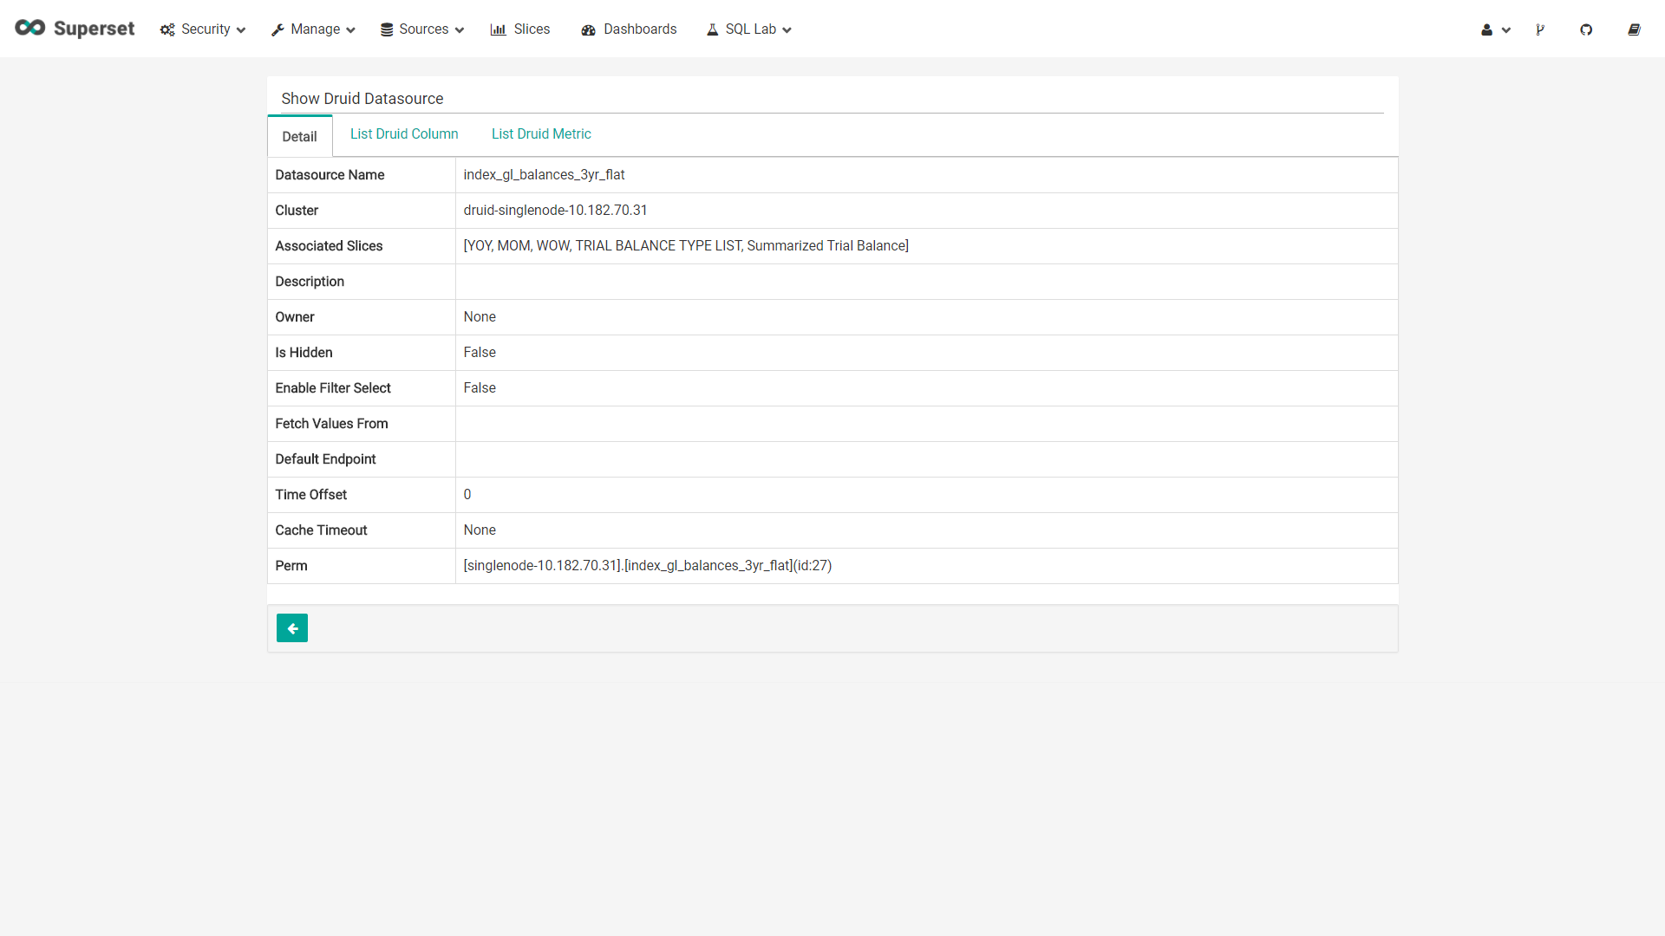

**Part 2 – Druid Column List (Auto): -**

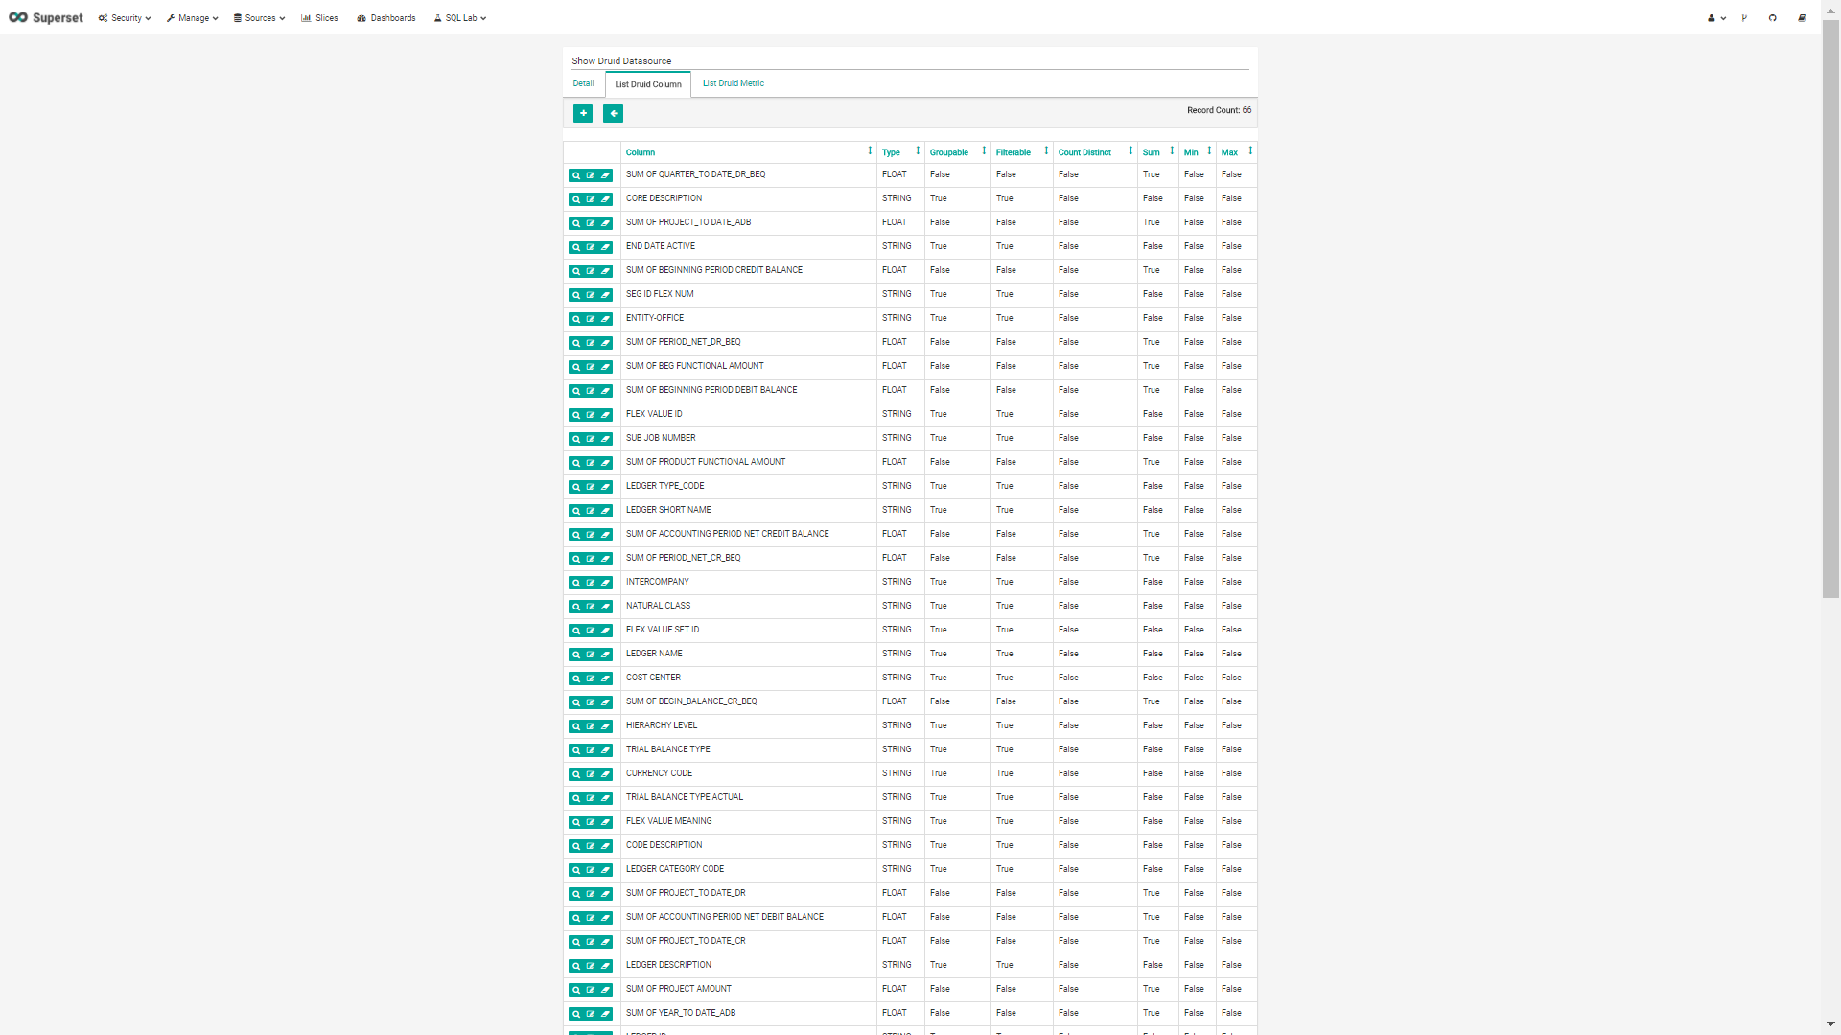

**Part 3 – Druid Metrics List (Custom):-**

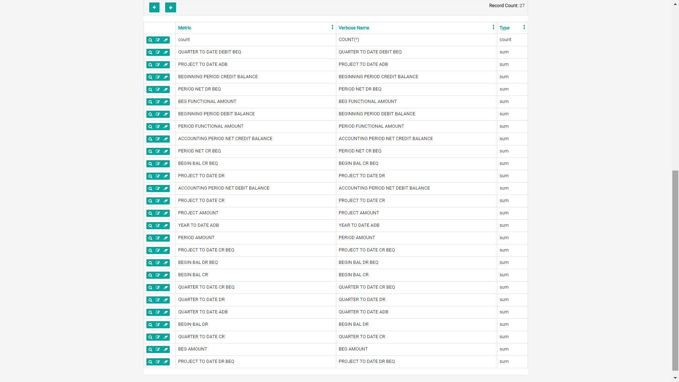

**Part 4 – Druid Metrics (Column 🡪 Metric) Edit :-**

