Contents

Data Analysis Report 1

1. Executive Summary 1

2. Objective 1

3. Data Sources and Methodology 2

Data Sources: 2

Methodology: 2

4. Analysis Scenarios and Findings 2

Scenario 1: Total Revenue by Segment 2

Scenario 2: Monthly Revenue Trend 2

Scenario 3: Segment-wise Customer Count 2

Scenario 4: Average Invoice Amount by Segment 2

Scenario 5: Revenue Contribution of High-Value Customers 3

Scenario 6: Repeat Purchases vs. Single Purchases by Segment 3

Scenario 7: Top Performing Months per Segment 3

5. Key Insights and Recommendations 3

6. Appendices 3

# Data Analysis Report

Company: Flextrus Corrugated Packaging Boxes India (P) Ltd

Analysis Period: [Specify the two-year range]

Prepared By: Ananth Ajith

Date: 30/11/2024

## 1. Executive Summary

Provide a concise summary of the analysis findings, key insights, and recommendations. Include a brief explanation of the purpose of the report.

## 2. Objective

The purpose of this analysis is to provide actionable insights into the sales performance across different customer segments. This report aims to address the following key questions:

1. What is the total revenue generated by each segment?
2. How has revenue trended on a monthly basis?
3. What is the customer count within each segment?
4. What is the average invoice amount for each segment?
5. How much revenue is contributed by high-value customers?
6. What is the distribution of repeat versus single purchases across segments?
7. Which months perform the best in terms of sales for each segment?

## 3. Data Sources and Methodology

### Data Sources:

Describe the two tables (`Sal_Reg` and `Cust_Seg`), and mention the tools used for analysis.

### Methodology:

Summarize the steps followed for data extraction, transformation, and visualization.

## 4. Analysis Scenarios and Findings

### Scenario 1: Total Revenue by Segment

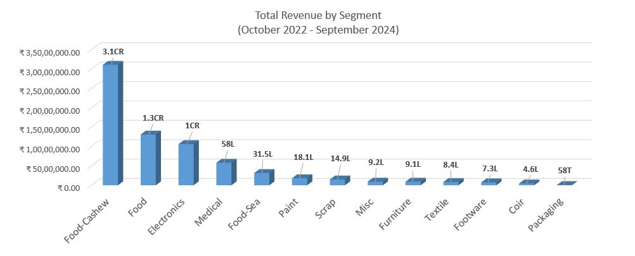

**Insights:**Among the 13 segments analyzed, the Food-Cashew segment has emerged as the highest revenue generator, contributing ₹3.1 crore. However, there is a significant disparity in revenue contribution between the Food-Cashew segment and other segments. This reliance poses a potential risk to Flextrus’s overall turnover, as any downturn in the Food-Cashew industry could have a substantial impact on the company's financial stability.

### Scenario 2: Monthly Revenue Trend

#### Monthly revenue progression from Oct-2022 to Sep-2024

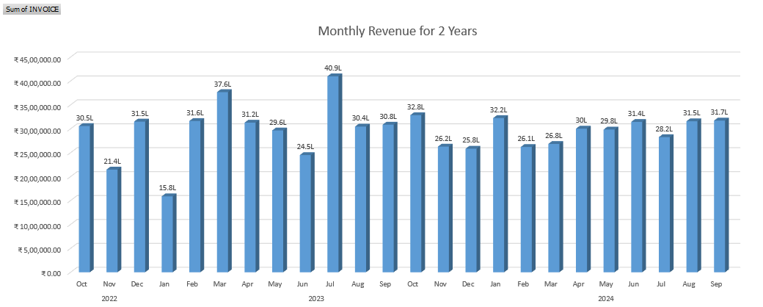

**Insights:** The monthly revenue trend over the 24-month period reveals that July 2023 recorded the highest revenue at ₹40.9 lakhs, while January 2022 reported the lowest revenue at ₹15.8 lakhs.

#### Quarterly revenue progression across 24 months

#### ( Y1 – Oct’22 to Sep-23 & Y2 – Oct’23 to Sep’24)

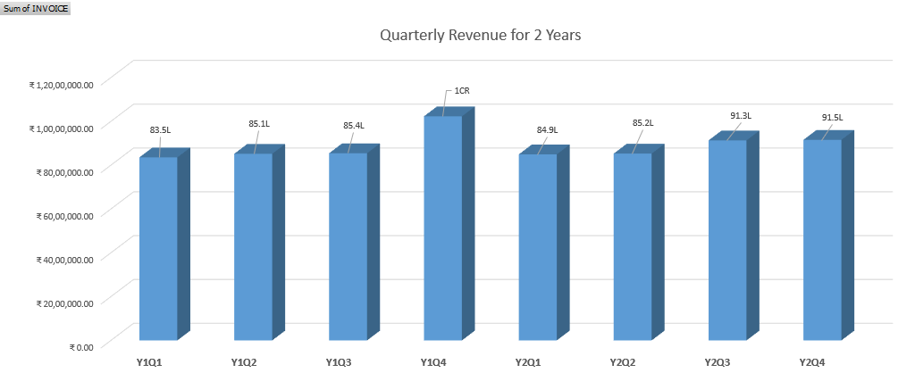

**Insights:** The revenue trend across the 8 quarters shows a stable average of ₹91.75 lakhs, with the exception of the fourth quarter of **Year 1 (Y1Q4)**, which achieved a peak revenue of **₹1 crore.** Revenue showed a significant upward trend in Year 2.

### Scenario 3: Segment-wise Customer Count

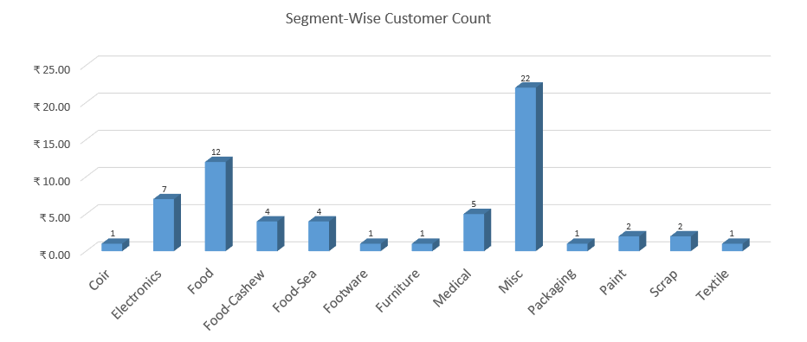

The customer distribution reveals that the majority of our customers belong to **the Misc segment (22 customers)** and the **Food segment (12 customers).** The Medical segment accounts for 5 customers, while the remaining segments have a customer count ranging between 1 and 4.

### Scenario 4: Average Invoice Amount by Segment across 2 years

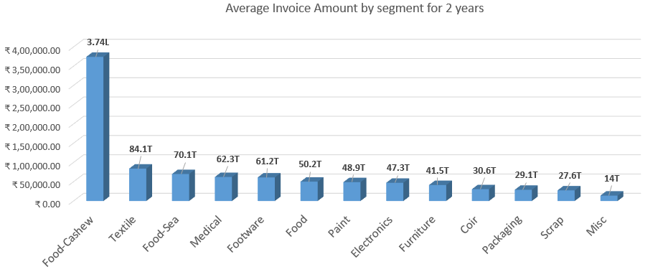

The Food-Cashew segment has the highest average invoice value at ₹3.74 lakhs, indicating a strong dependency on this segment.

### Scenario 5: Revenue Contribution of High-Value Customers in each segment

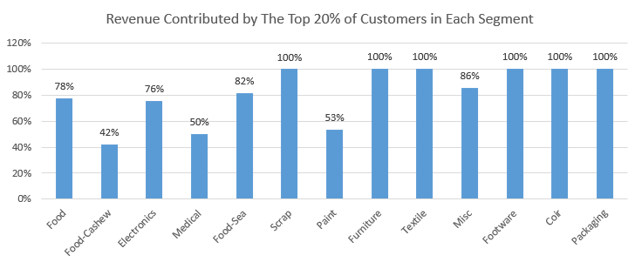

The list below captures the top performing customers in some of the selected segments:

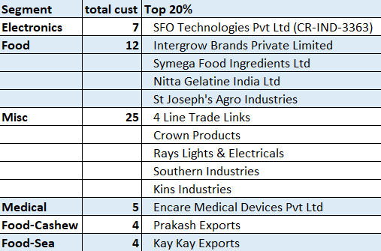

In the **Food**, **Electronics**, and **Food-Sea segments**, the top 20% of customers account for nearly 80% of the total revenue within their respective segments.

### Scenario 6 Repeat Purchases vs. Single Purchases by Segment

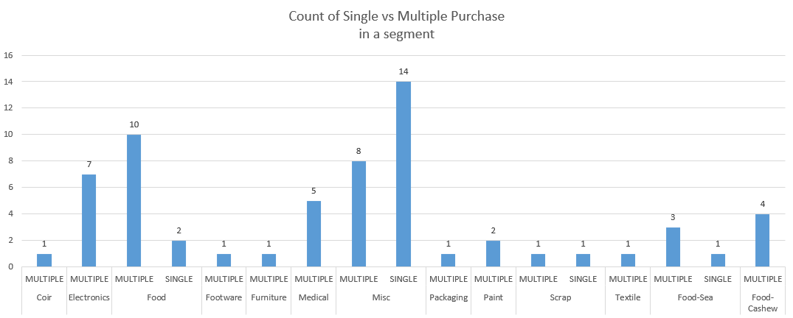

**Findings:** The Miscellaneous segment is characterized by a high number of single-purchase transactions. In contrast, the Food and Food-Cashew segments demonstrate a strong trend of repeat purchases, indicating higher customer retention and ongoing demand in these categories.

### Scenario 7: Top Performing Months per Segment

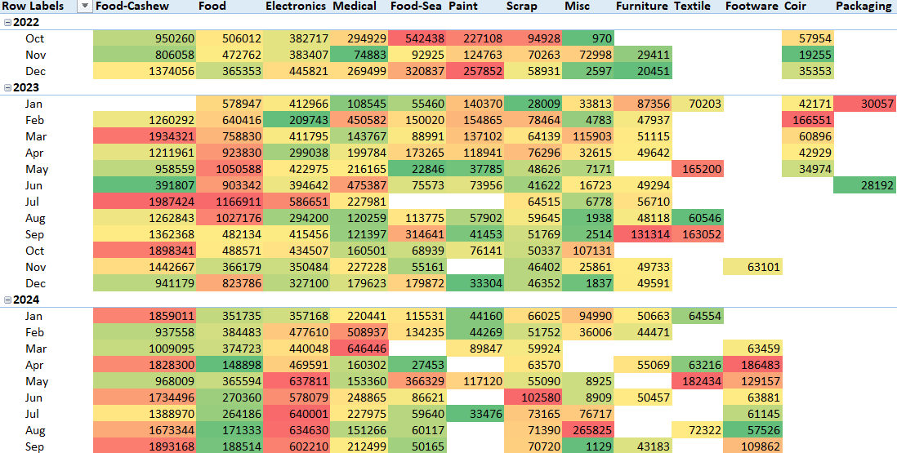

**Findings:**

* The *Food-Cashew segment* has consistently performed well throughout the months, with an upward trend observed toward the end of 2024.
* In contrast, the *Food segment*, which peaked in 2023, has experienced a significant decline, reaching its lowest performance levels in 2024.
* Meanwhile, the *Electronics segment* shows a positive growth trajectory in 2024, indicating increasing demand or improved performance in this category.

## 5. Key Insights and Recommendations

* The Food-Cashew segment dominates revenue generation, contributing ₹3.1 crore, but this heavy reliance poses a significant financial risk.
* The Misc segment has the highest customer count (22), followed by the Food segment (12). Other segments show limited customer representation.
* In the Food, Electronics, and Food-Sea segments, the top 20% of customers contribute nearly 80% of revenue, highlighting revenue concentration.
* Revenue across 8 quarters averaged ₹91.75 lakhs, with a significant growth trend in Year 2.