**CO3 PROGRAMS**

1: Work with built-in packages

**Math.py**

import math

print("The Value of pi:",math.pi)

import math as m

print("Pi is:",m.pi)

from math import pi,sqrt

print("pi:",math.pi)

print("Square Root of 125 is:",math.sqrt(125))

print("cos(90):",math.cos(90))

print("sin(90):",math.sin(30))

print("tan(90):",math.tan(45))

OUTPUT:  
The Value of pi: 3.141592653589793

Pi is: 3.141592653589793

pi: 3.141592653589793

Square Root of 125 is: 11.180339887498949

cos(90): -0.4480736161291701

sin(90): -0.9880316240928618

tan(90): 1.6197751905438615

**time.py**

import time

print("Current time in sec:",time.time())

print("Current time:",time.ctime())

print("Time after 30 sec:",time.ctime(time.time()+30))

t=time.localtime()

print("Time:",t)

print("Current Year:",t.tm_year)

print("Current month:",t.tm_mon)

print("Current day:",t.tm_mday)

print("Current Hour:",t.tm_hour)

print("Current Number of day:",t.tm_yday)

print("Current week:",t.tm_wday)

OUTPUT:  
Current time in sec: 1643470802.2988954

Current time: Sat Jan 29 21:10:02 2022

Time after 30 sec: Sat Jan 29 21:10:32 2022

Time: time.struct_time(tm_year=2022, tm_mon=1, tm_mday=29, tm_hour=21, tm_min=10, tm_sec=2, tm_wday=5, tm_yday=29, tm_isdst=0)

Current Year: 2022

Current month: 1

Current day: 29

Current Hour: 21

Current Number of day: 29

Current week: 5

**Timedate.py**

import datetime

t=datetime.time(22,56,23,34)

print(t)

print("hour:",t.hour)

print("minute:",t.minute)

print("second:",t.second)

print("micro second:",t.microsecond)

d=datetime.date.today()

print("Today:",d)

print("day:",d.day)

print("month:",d.month)

print("year:",d.year)

d1=datetime.timedelta(days=2)

d2=d1+d

print("Day after 2 days:",d2)

dt=datetime.datetime.combine(d,t)

print(dt)

OUTPUT:  
22:56:23.000034

hour: 22

minute: 56

second: 23

micro second: 34

Today: 2022-01-29

day: 29

month: 1

year: 2022

Day after 2 days: 2022-01-31

2022-01-29 22:56:23.000034

**Cal.py**

import calendar

mm=int(input("Enter the month:"))

yy=int(input("Enter the year:"))

print(calendar.month(yy,mm))

OUTPUT:  
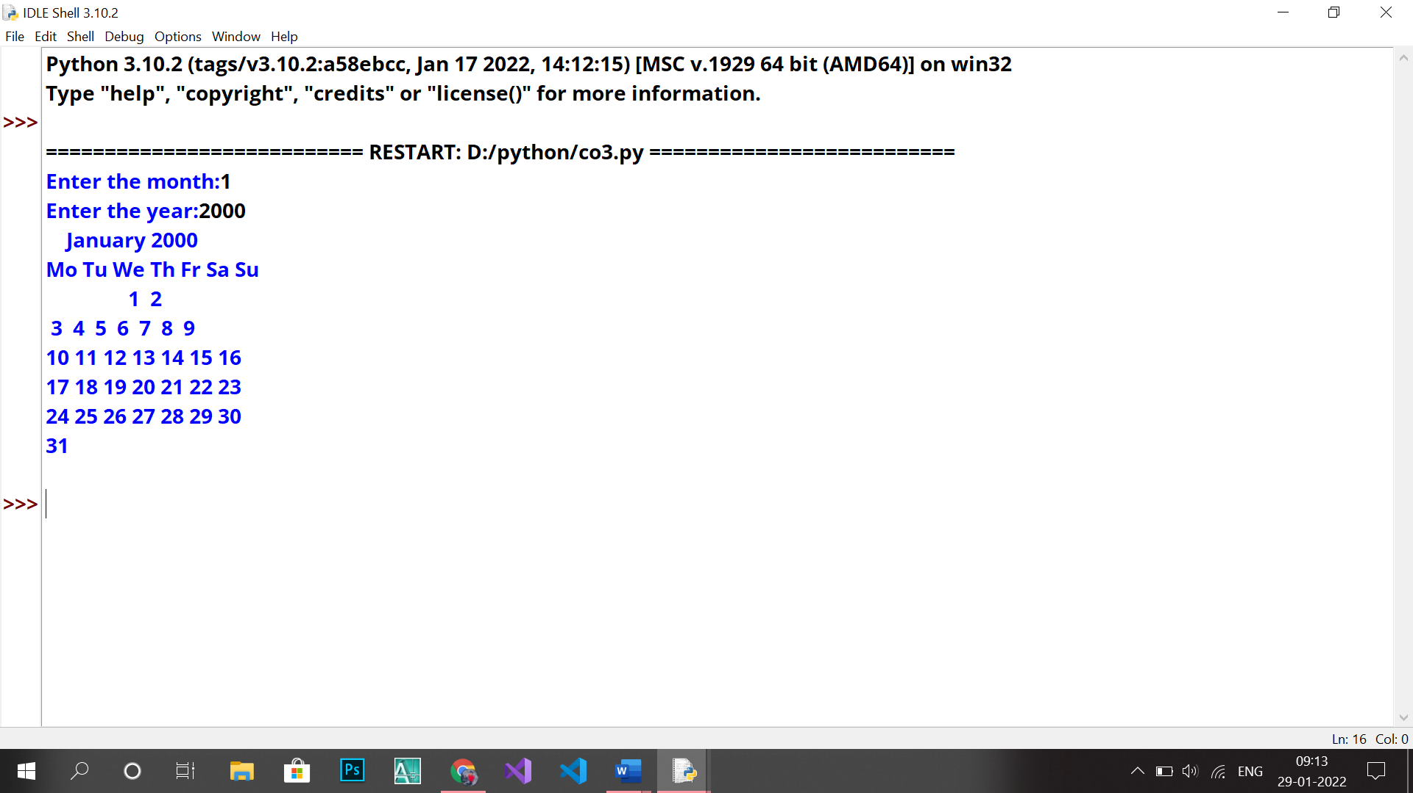

**Stati.py**

import statistics as s

print("mean of 4,6,45,86,45 is: ",s.mean([4,6,45,86,45]))

print("median of 4,6,45,86,45 is: ",s.median([4,6,45,86,45]))

print("mode of 4,6,45,86,45 is: ",s.mode([4,6,45,86,45]))

print("standard deviation of 4,6,45,86,45 is: ",s.stdev([4,6,45,86,45]))

print("variance of 4,6,45,86,45 is: ",s.variance([4,6,45,86,45]))

OUTPUT:  
mean of 4,6,45,86,45 is: 37.2

median of 4,6,45,86,45 is: 45

mode of 4,6,45,86,45 is: 45

standard deviation of 4,6,45,86,45 is: 33.83341543503996

variance of 4,6,45,86,45 is: 1144.7

**rand.py**

import random

random.seed(10)

print(random.random())

print(random.getstate())

mylist = ["Ananthu", "Manu", "Kumar"]

print(random.choice(mylist))

print(random.uniform(654, 64))

print(random.triangular(54, 70, 364))

OUTPUT:

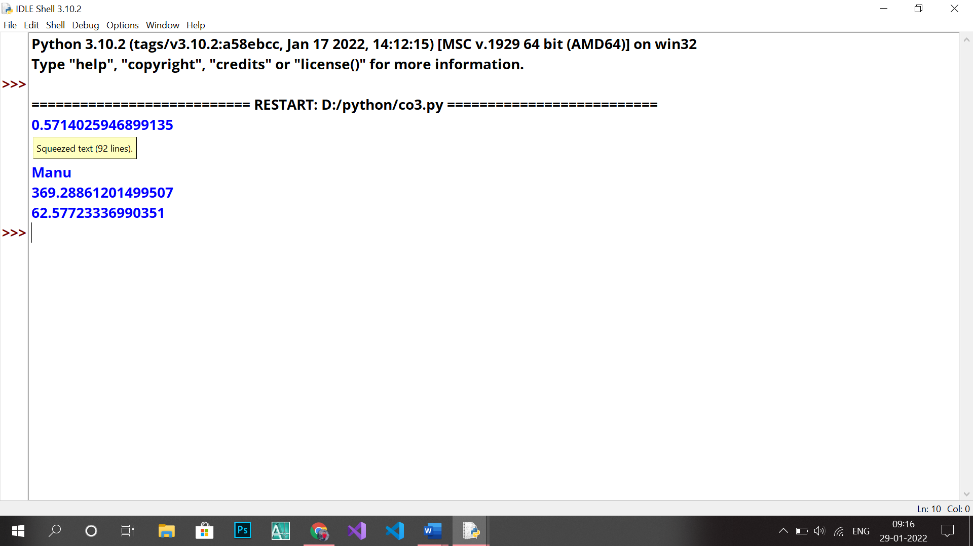

2.Create a package graphics with modules rectangle, circle and sub-package 3D-graphics with modules cuboid and sphere. Include methods to find area and perimeter of respective figures in each module. Write programs that finds area and perimeter of figures by different importing statements. (Include selective import of modules and import * statements)

**Usegrahics.py**

from graphics import rectangle

from graphics import circle

c=1

s=1

while(c>0):

print("Enter the Choice:")

print("1:Rectangle")

print("2:Circle")

print("3:Exit")

x=int(input())

if(x==1):

while(s>0):

print("Enter the Choice:")

print("1:Area")

print("2:Perimeter")

print("3:Exit")

s=int(input())

if(s==1):

l=int(input("Enter the length:"))

b=int(input("Enter the breadth"))

print("The Area is :",rectangle.area(l,b))

if(s==2):

l=int(input("Enter the length:"))

b=int(input("Enter the breadth"))

print("The Area is :",rectangle.perimeter(l,b))

if(s>2):

break

if(x==2):

while(s>0):

print("Enter the Choice:")

print("1:Area")

print("2:Perimeter")

print("3:Exit")

s=int(input())

if(s==1):

l=int(input("Enter the Radius"))

print("The Area is :",circle.area(l))

if(s==2):

l=int(input("Enter the Radius:"))

print("The Area is :",circle.perimeter(l))

if(s>2):

break

if(x>2):

break

**circle.py**

def area(r):

return(3.14*r*r)

def perimeter(l,b):

return(2*3.14*r)

**rectangle.py**

def area(l,b):

return(l*b)

def perimeter(l,b):

return((l+b)*2)

OUTPUT:

