1: Create the table Loans and insert tuples in it.

create table loans(accno int,cust_name varchar(50),loan_amount number,instalments int,int_rate number(10,2),start_date date,interest int);

Output:

table created.

insert into loans values(&acno,'&name',&loan,&inta,&rate,'&date',&inter);

2: Display the details of all the loans

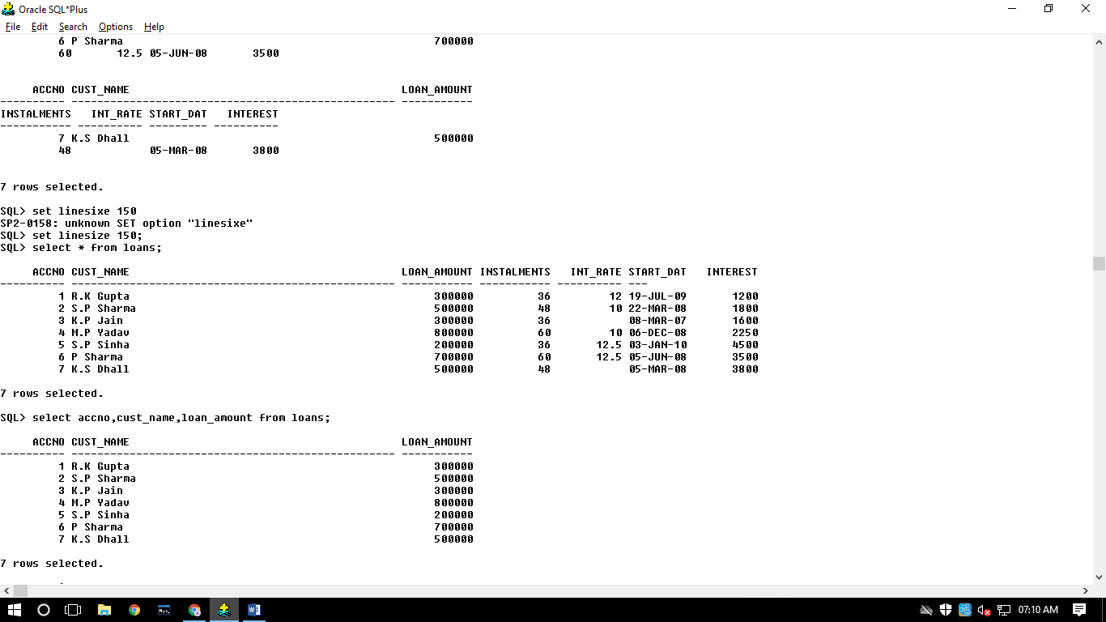

3: Display the AccNo, Cust_Name, and Loan_Amount of all the loans.



4: Display the details of all the loans with less than 40 instalments.

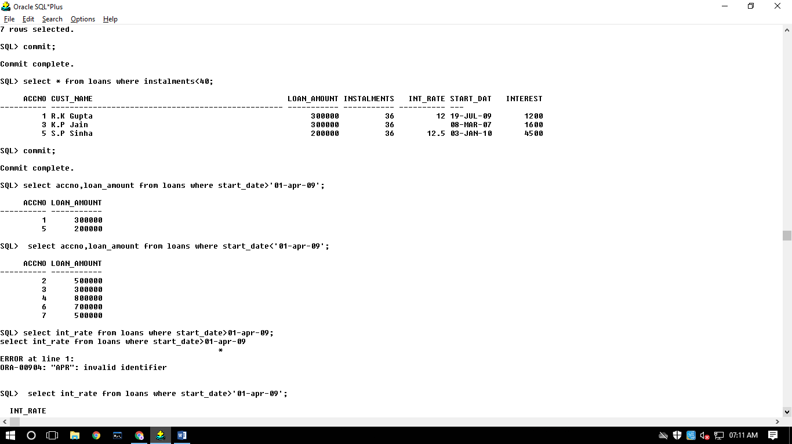

5: Display the AccNo and Loan_Amount of all the loans started before 01-04-2009. 

6: Display the Int_Rate of all the loans started after 01-04-2009.

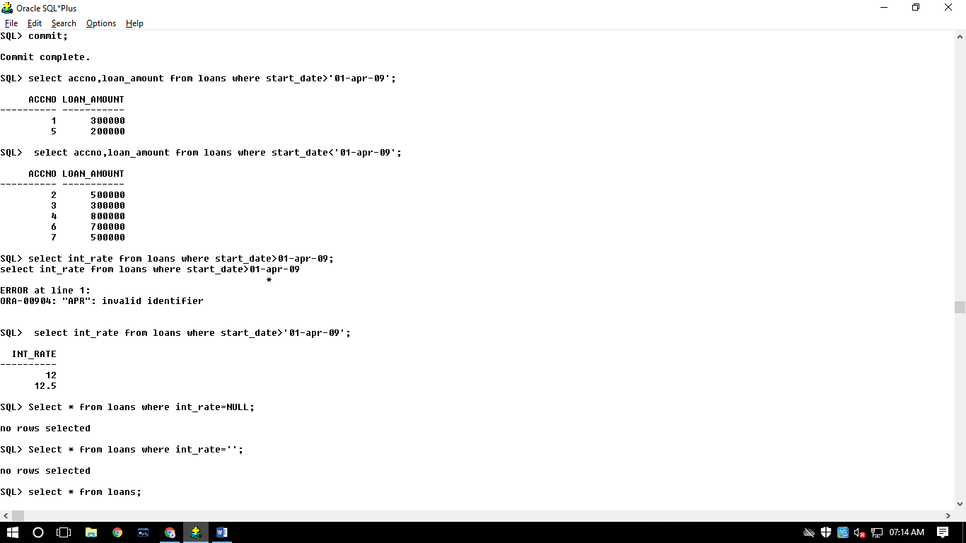

7: Display the details of all the loans whose rate of interest is NULL.

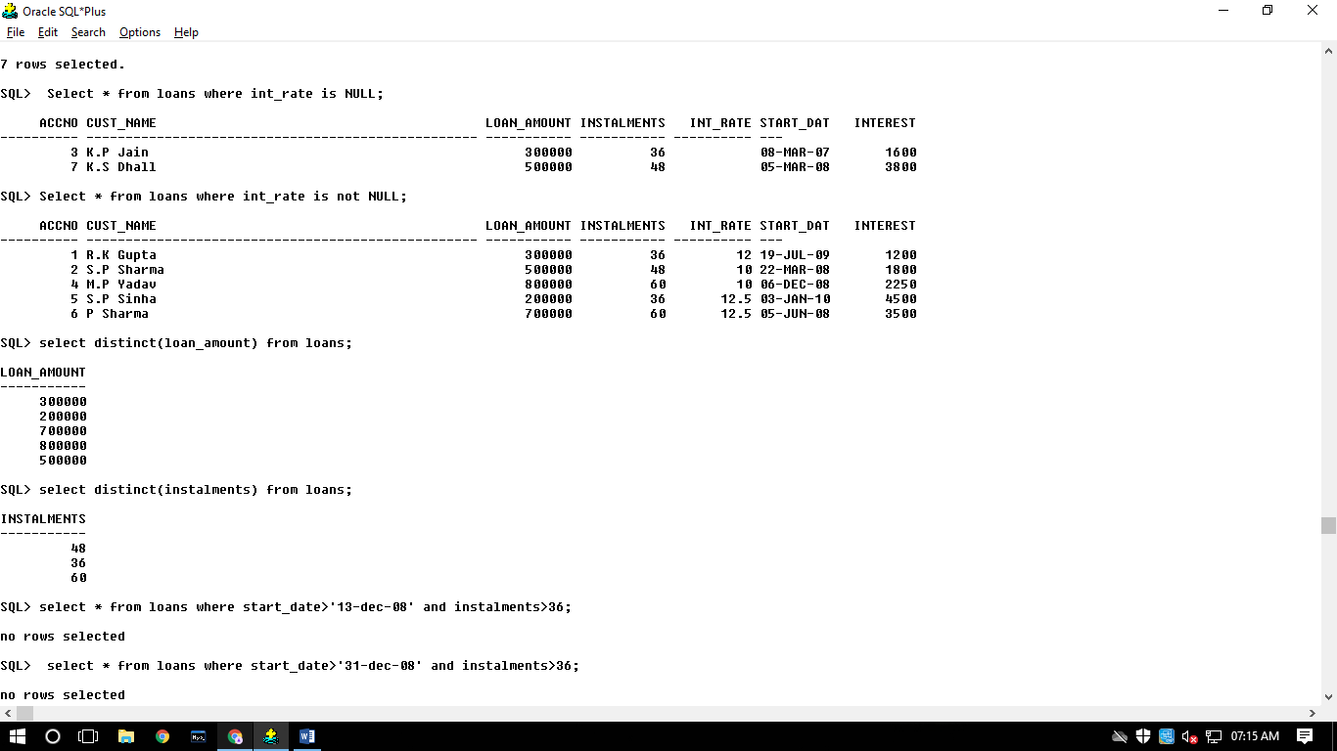

8: Display the details of all the loans whose rate of interest is not NULL.



9: Display the amounts of various loans from the table LOANS. A loan amount should appear only once.



10: )Display the number of installments of various loans from the table LOANS. An instalment should appear only once.



11: )Display the details of all the loans started after 31-12-2008 for which the number of instalments are more than 36.

select * from loans where start_date>'31-dec-08' and instalments>36;

no rows selected

12: Display the Cust_Name and Loan_Amount for all the loans which do not have number of instalments 36.

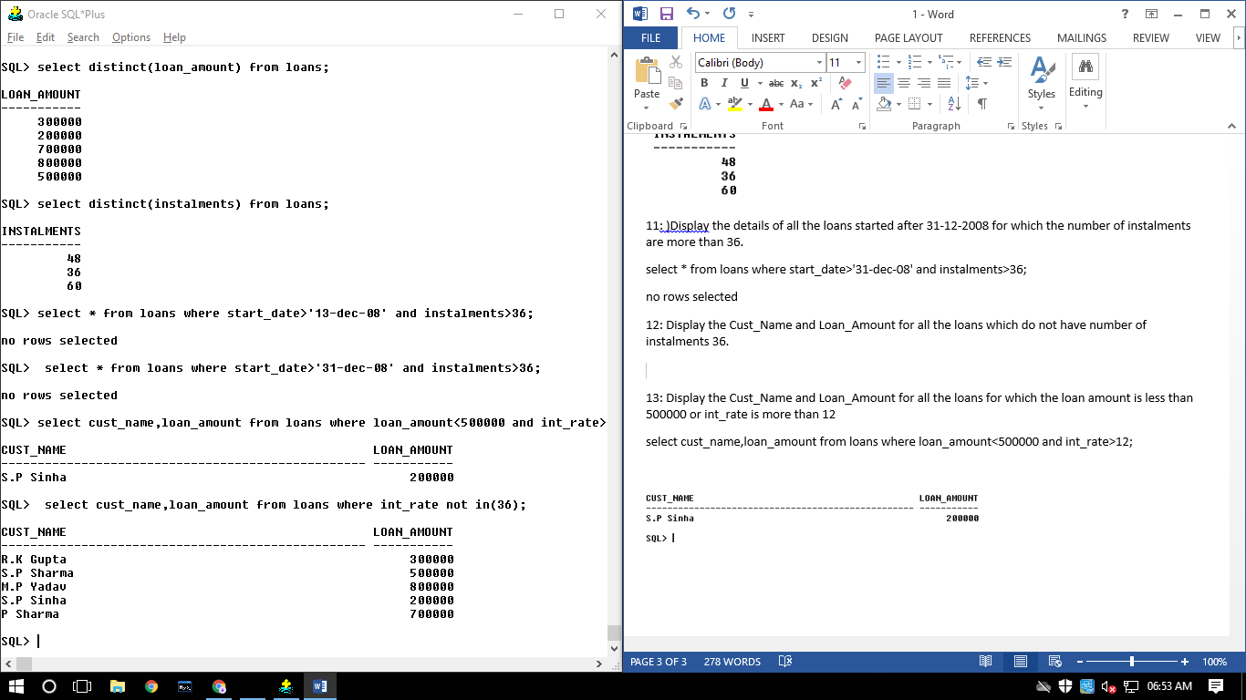

13: Display the Cust_Name and Loan_Amount for all the loans for which the loan amount is less than 500000 and int_rate is more than 12

select cust_name,loan_amount from loans where loan_amount<500000 and int_rate>12;

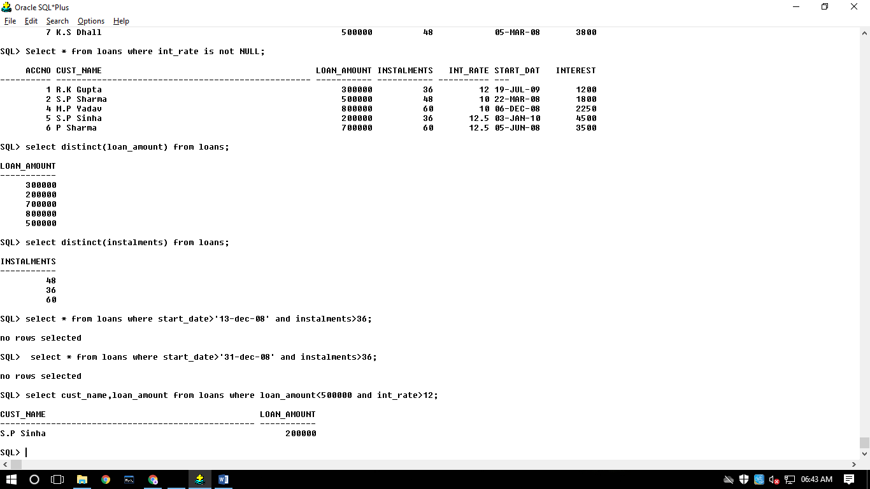

14: Display the details of all the loans whose Loan_Amount is in the range 400000 to 500000.

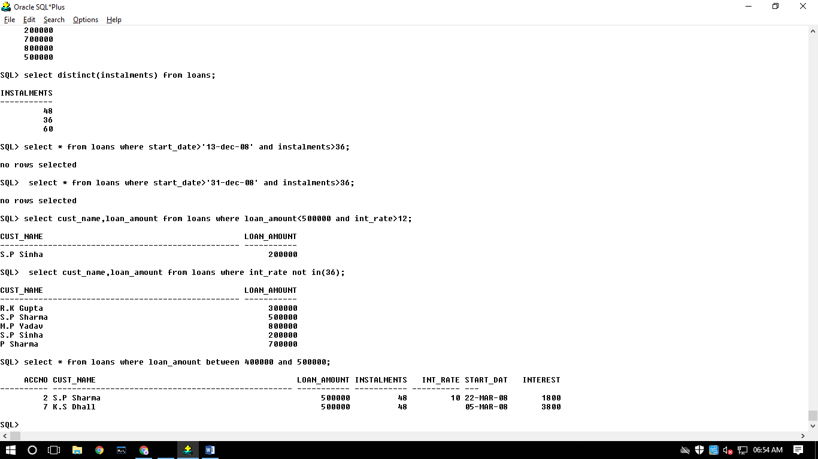

15:Display the details of all the loans whose rate of interest is in the range 11% to 12%.

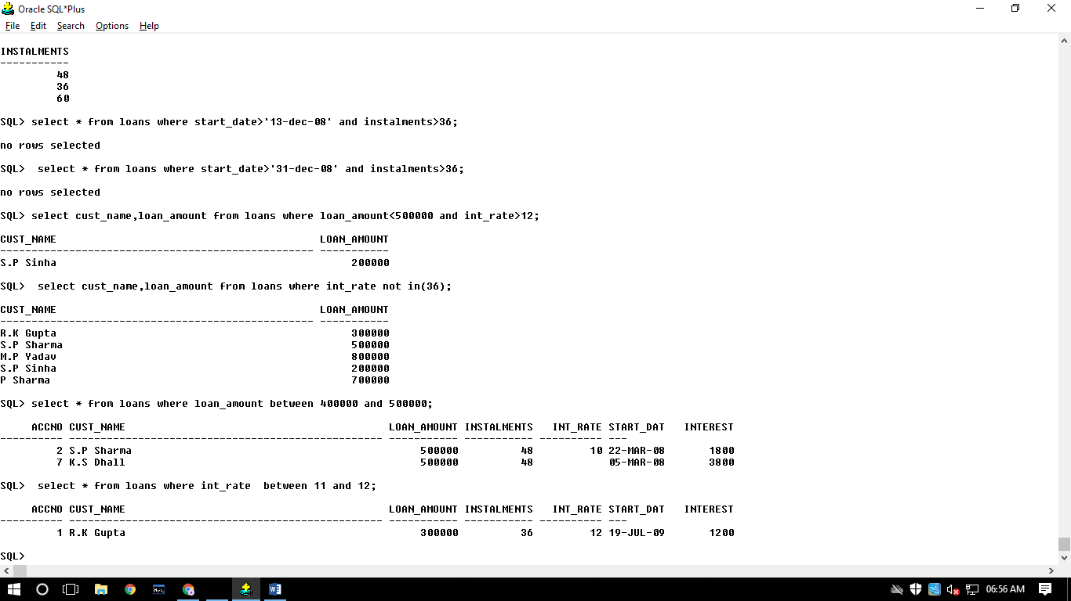

16: Display the Cust_Name and Loan_Amount for all the loans for which the number of installments are 24, 36, or 48. (Using IN operator)

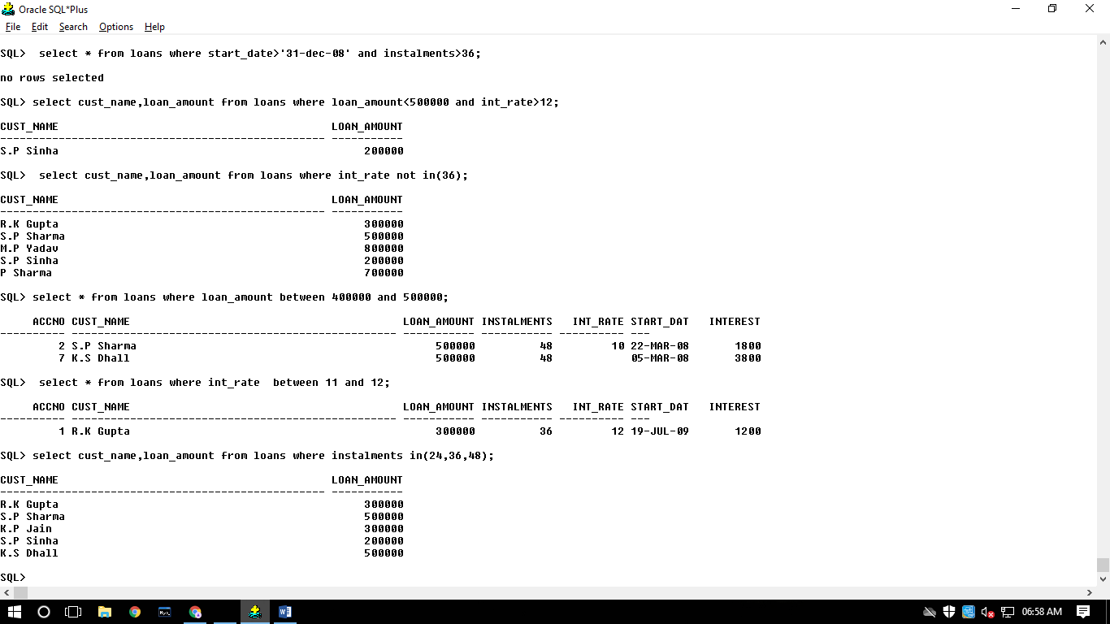

17: Display the AccNo, Cust_Name, and Loan_Amount for all the loans for which the Cust_Name ends with 'Sharma'.

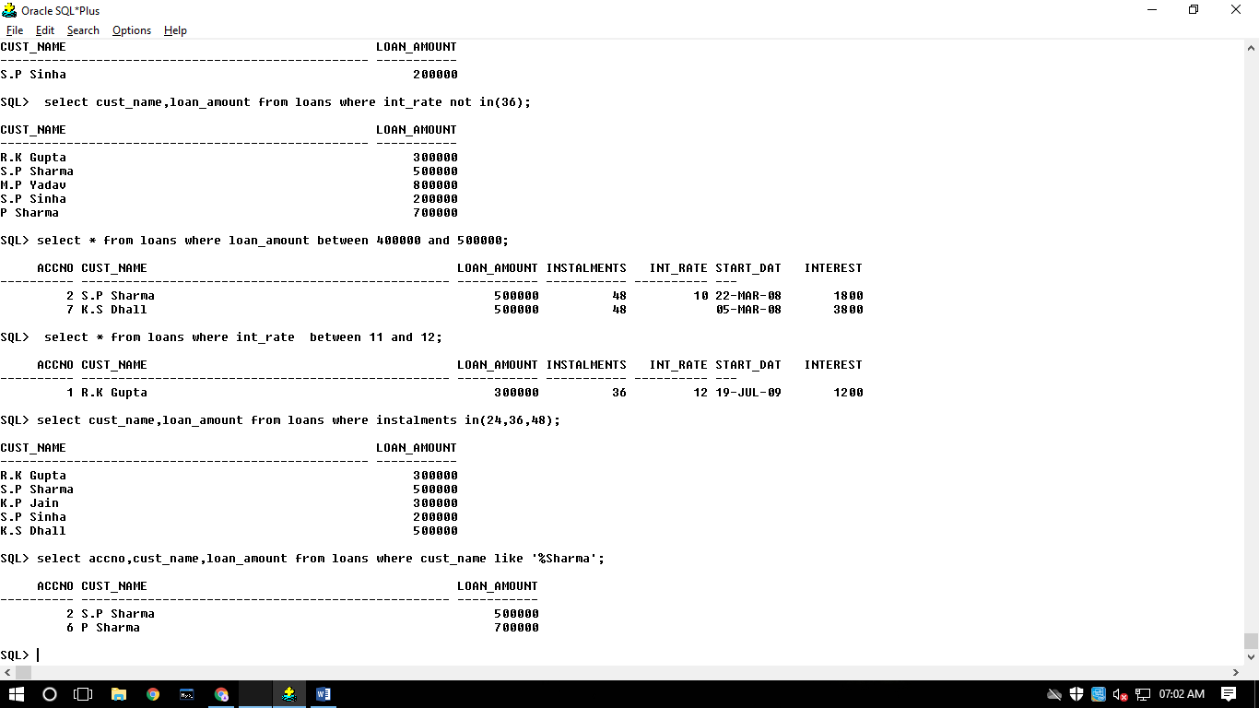

18: Display the AccNo, Cust_Name, and Loan_Amount for all the loans for which the Cust_Name ends with 'a'.

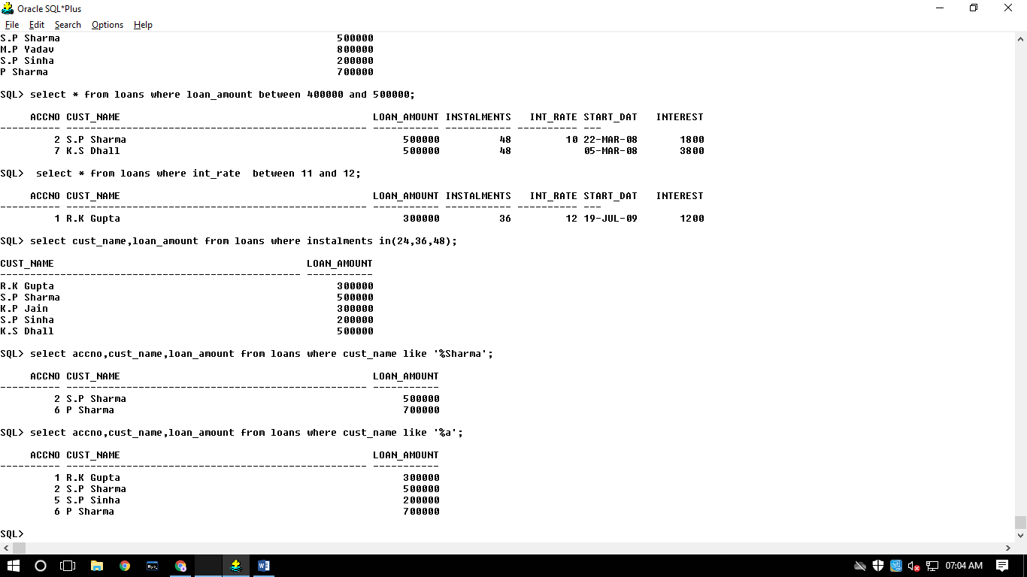

19: Display the AccNo, Cust_Name, and Loan_Amount for all the loans for which the Cust_Name contains 'a'.

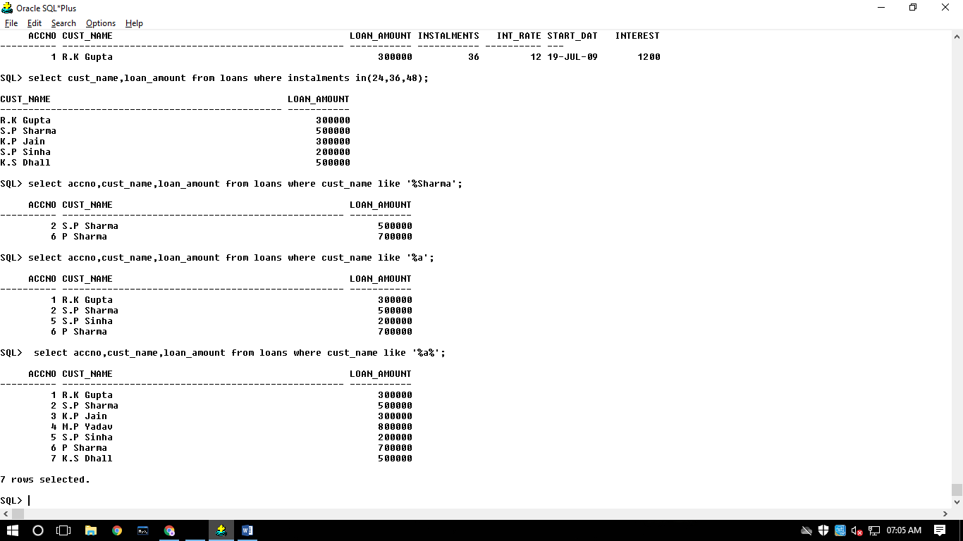

20: Display the AccNo, Cust_Name, and Loan_Amount for all the loans for which the Cust_Name does not contain 'P'

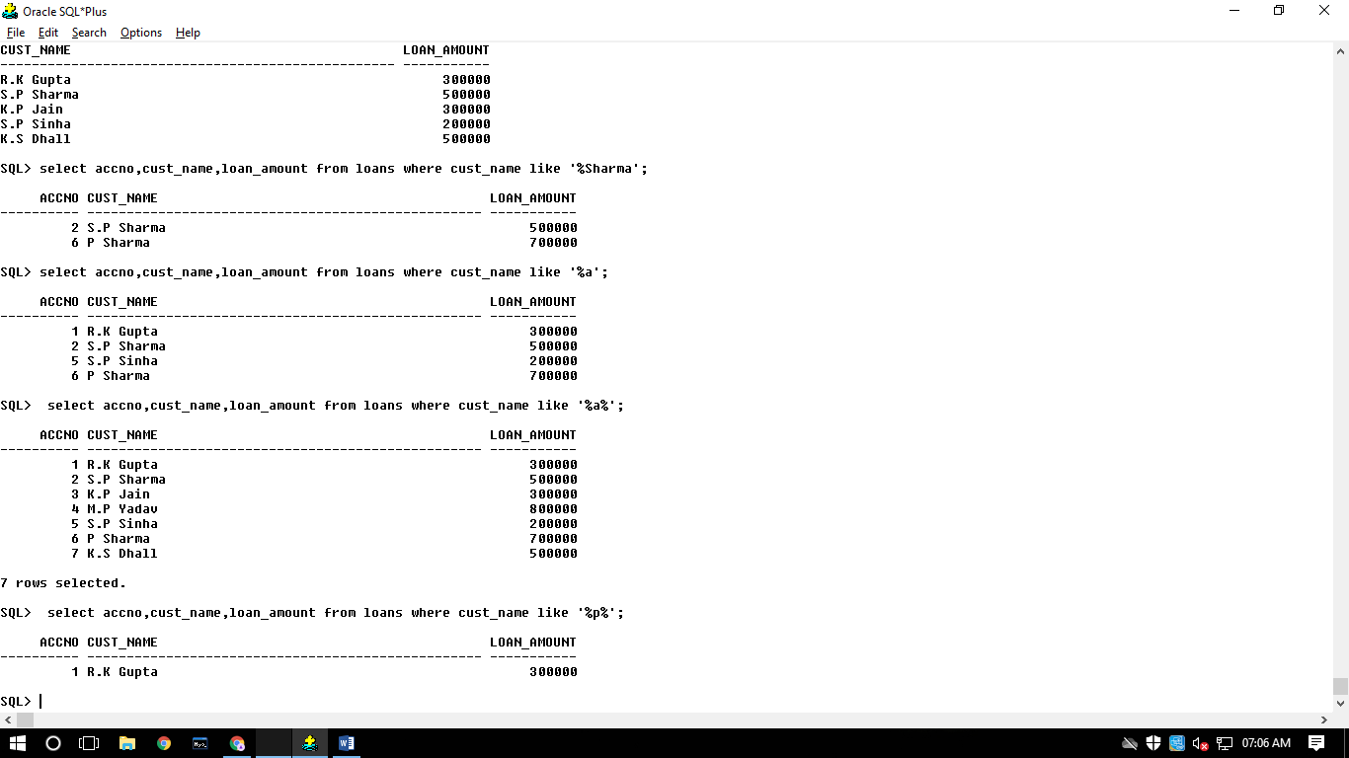

21: Display the AccNo, Cust_Name, and Loan_Amount for all the loans for which the Cust_Name contains 'a' as the second last character.

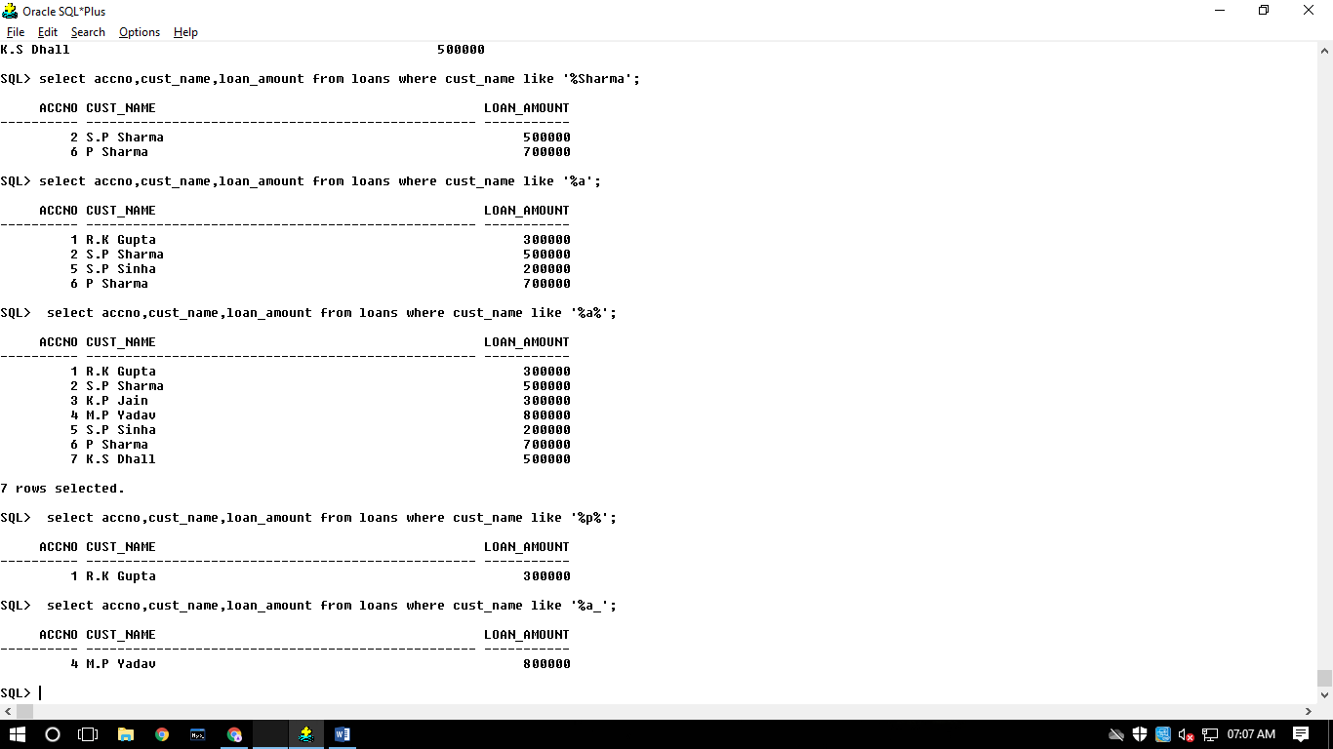

22: Display the details of all the loans in the ascending order of their Loan_Amount.

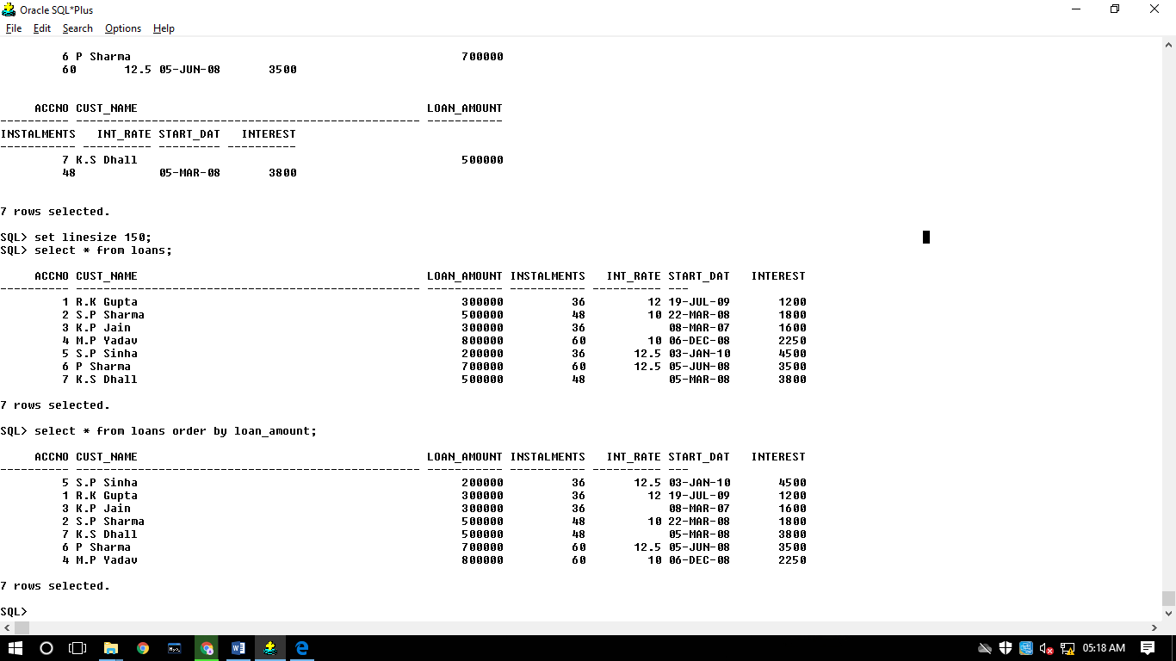

23: Display the details of all the loans in the descending order of their Start_Date.

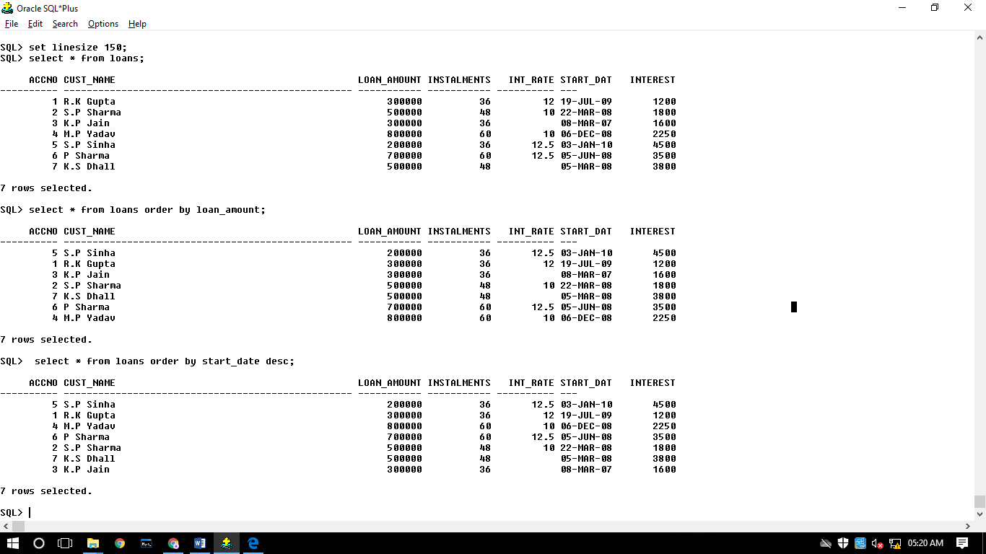

24:

25:Put the interest rate 11.50% for all the loans for which interest rate is NULL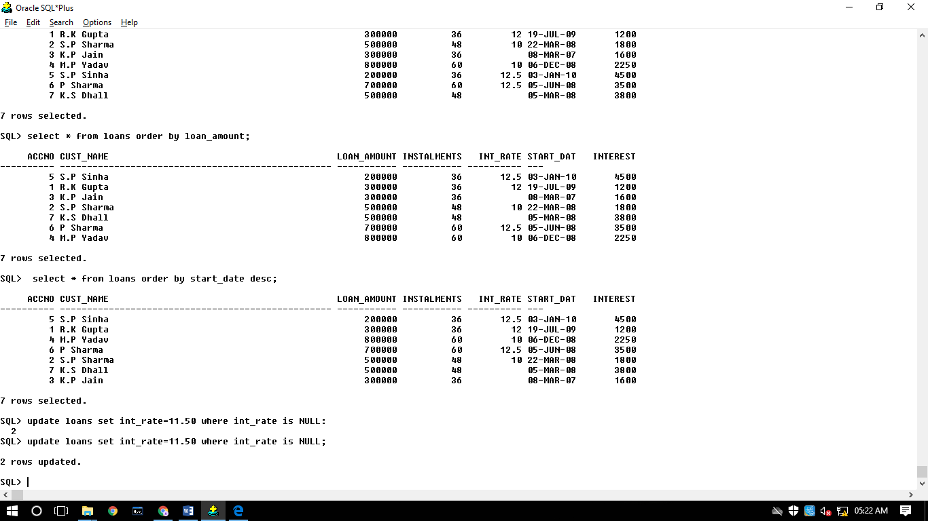

26: Increase the interest rate by 0.5% for all the loans for which the loan amount is more than 400000.

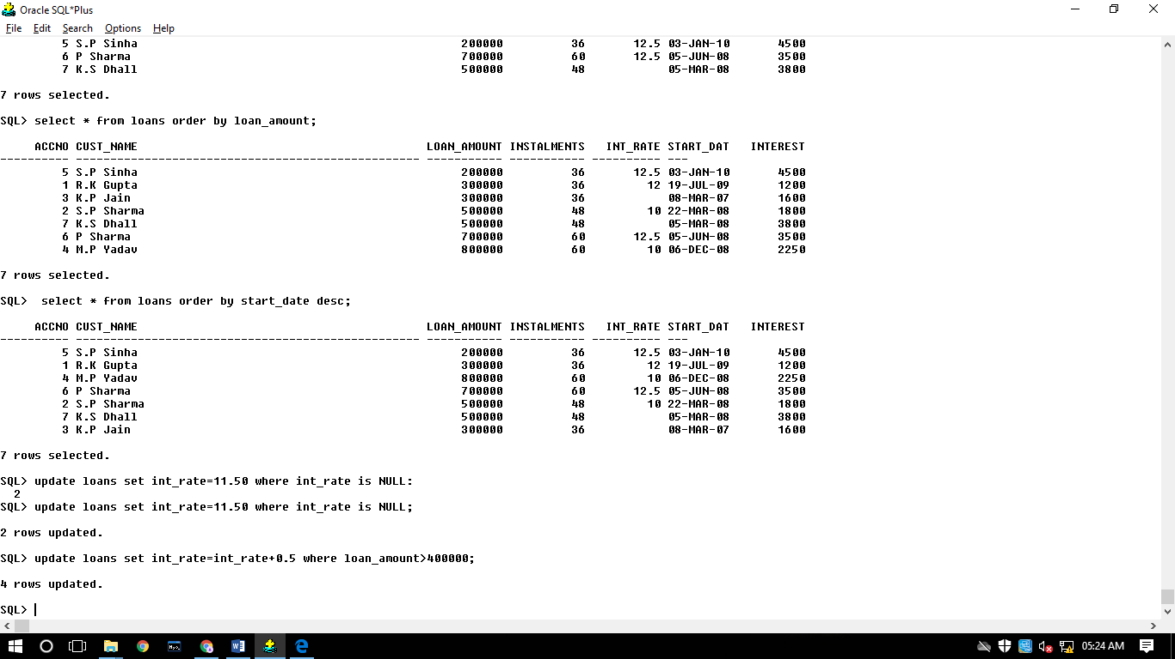

27: For each loan replace Interest with (Loan_Amount*Int_Rate*Instalments)/ 12*100.

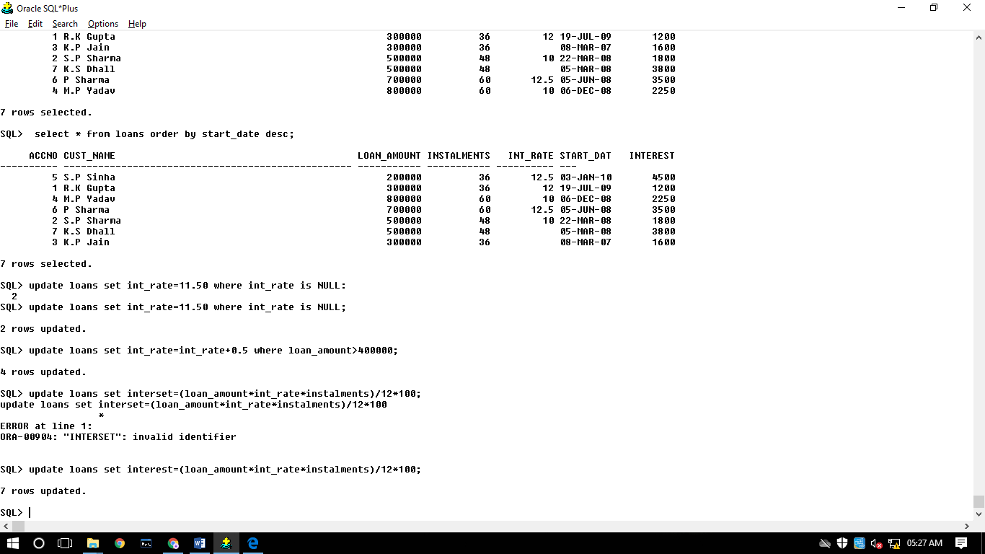

28: Delete the records of all the loans of 'K.P. Jain'

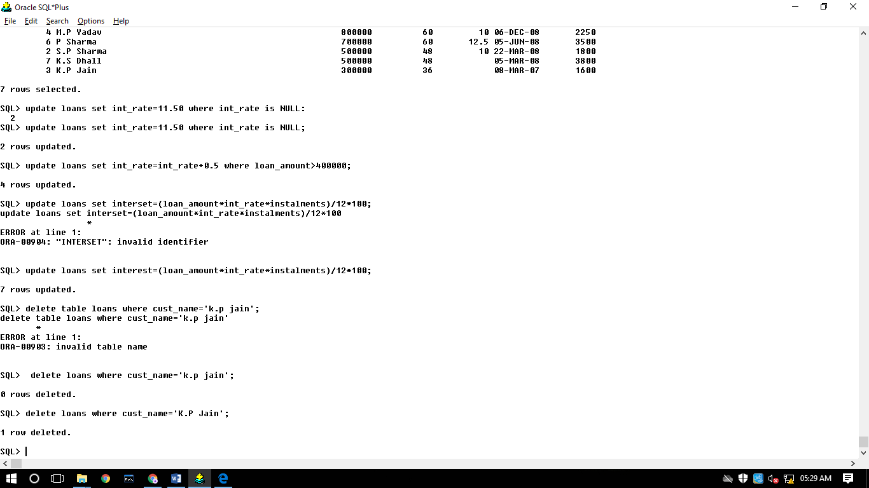

29: Add another column Category of type CHAR(1) in the Loan table.

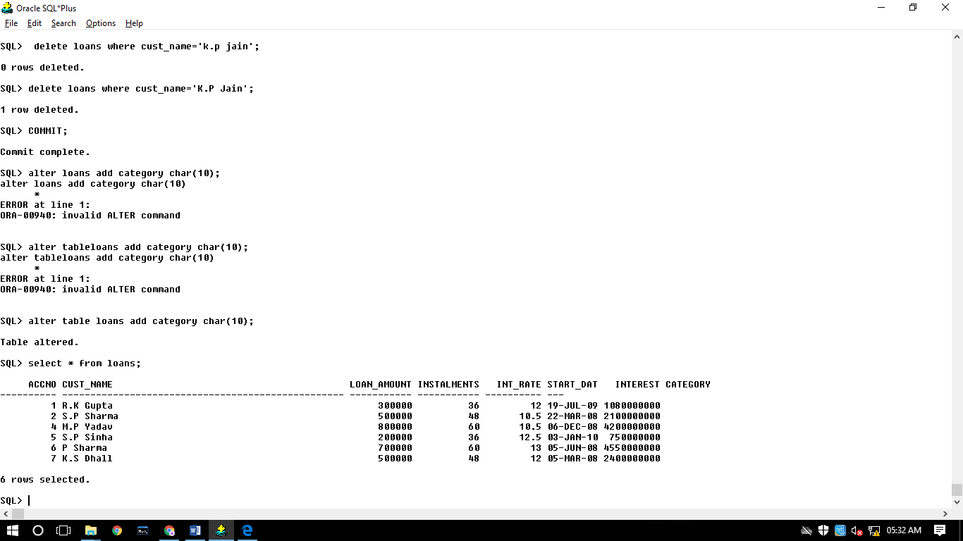

30: Display the sum of all Loan Amount for whose Interest rate is greater than 10.

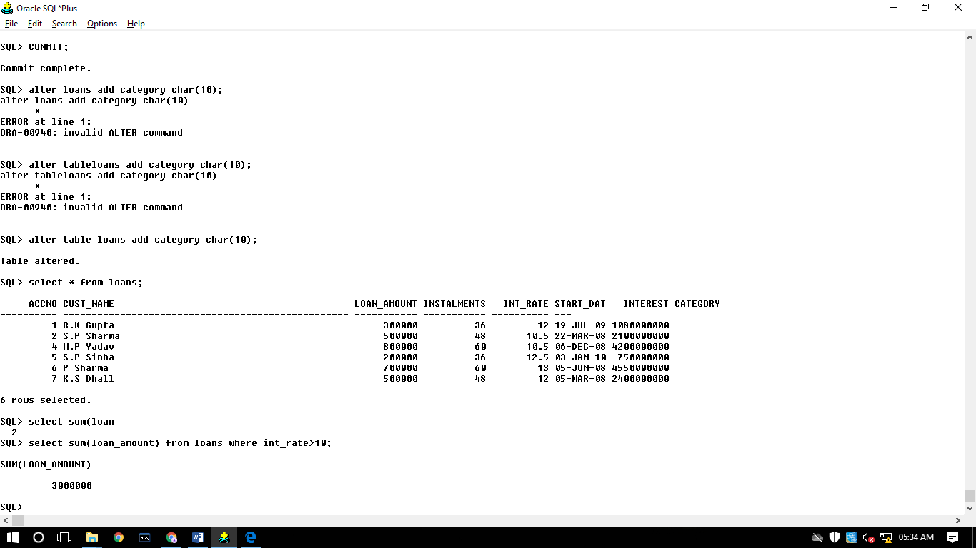

31: Display the Maximum Interest from Loans table.

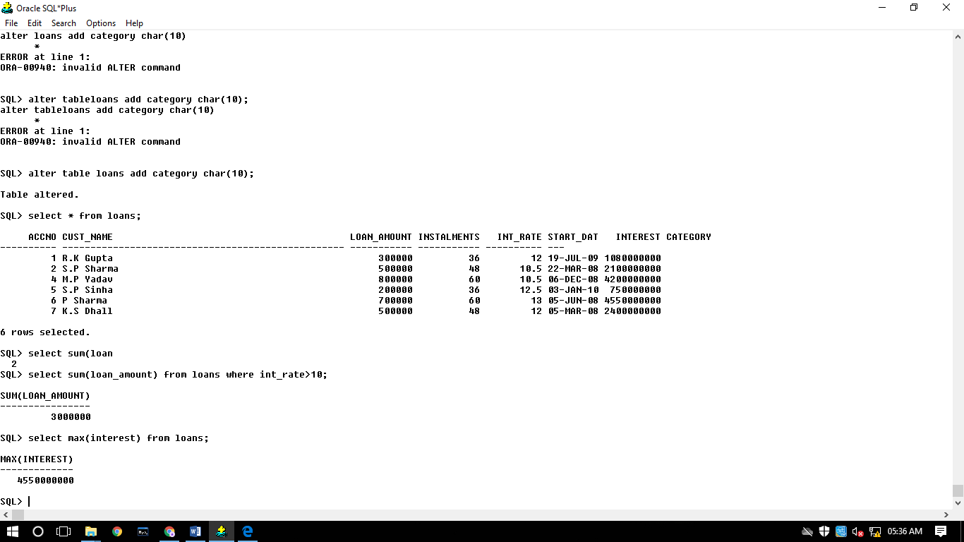

32: Display the count of all loan holders whose name is ending with ‘Sharma’.

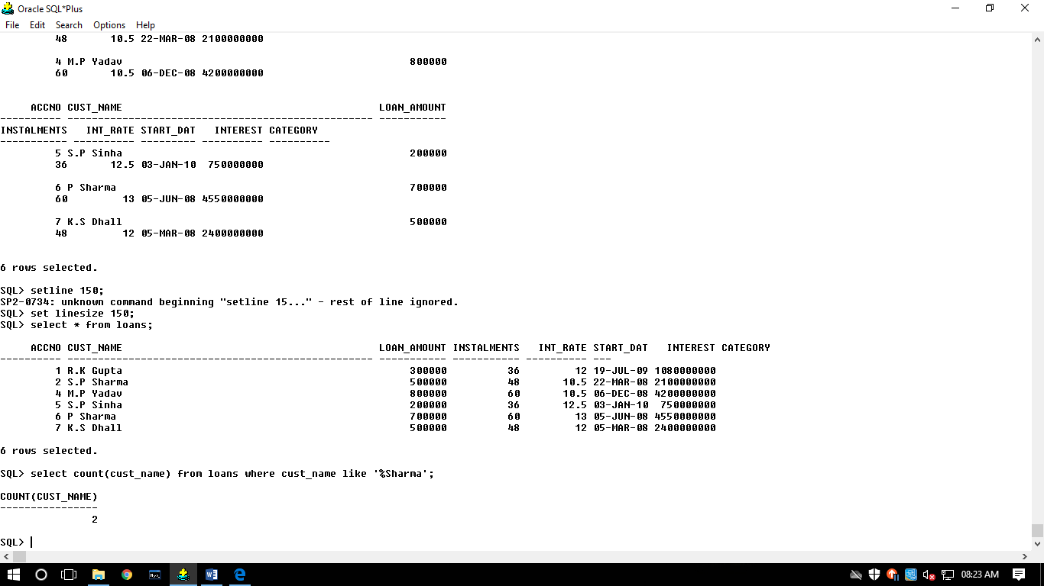

33: Display the count of all loan holders whose Interest is Null.

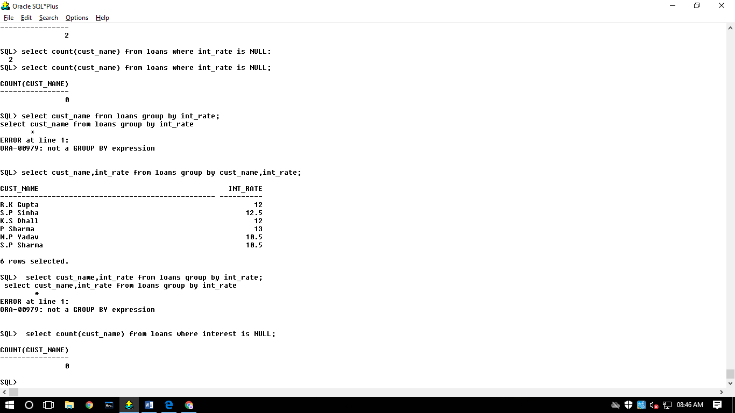

34: Display the Interest wise details of Loan Account Holders.

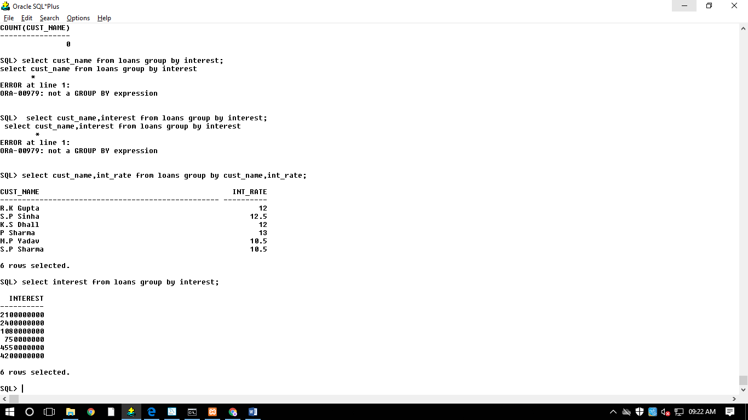

35: Display the Interest wise details of Loan Account Holders with at least 10 installments remaining.

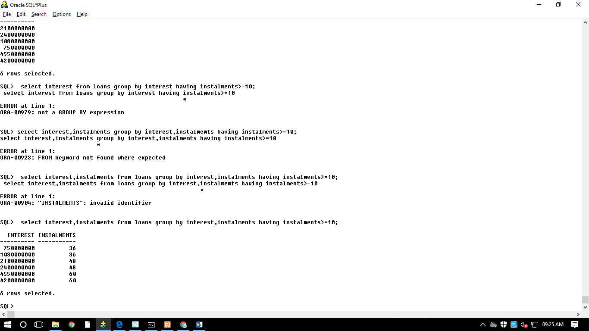

36: Display the Interest wise count of all loan holders whose Installment due is more than 5 in each group

