**EXP 2 EMPLOYEE DATABASE**

**Aim:**

Consider the employee database given below

**emp** (emp_id,emp_name, Street_No, city)

**works** (emp_id, company name, salary)

**company** (company name, city)

**manages** (emp_id, manager_id)

create table emp(emp_id varchar(50) primary key check(emp_id like ’E%’),emp_name varchar(50),street_no int,city varchar(50));

create table company(company_name varchar(50) primary key,city varchar(50));

create table works(emp_id varchar(50) references emp(emp_id),company_name varchar(50) references company(company_name),salary int);

create table manages(emp_id varchar(50) references emp(emp_id),manager_id varchar(50) references emp(emp_id));



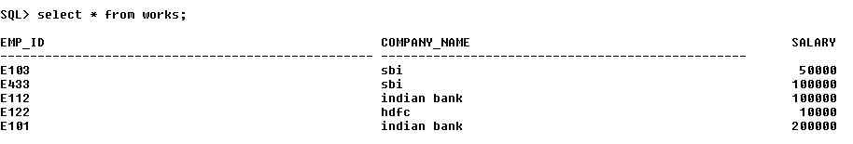

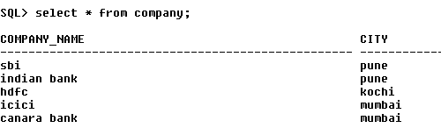



**Note: Emp_id should start with ‘E’ in Emp table and emp_id in works table must be the emp_id from emp table .emp_id and manager_id in manages table must be the emp_id from emp table**

a:Find the names of all employees who work for SBI.

**select emp_name from emp,works where emp.emp_id=works.emp_id and company_name='sbi';**



b Find all employees in the database who live in the same cities as the companies for which they work.

**select emp_name from emp,works,company where emp.emp_id=works.emp_id and works.company_name=company.company_name and emp.city=company.city;**



c. Find all employees who earn more than the average salary of all employees of their

company.

**select emp_name from works,emp where emp.emp_id=works.emp_id and salary>(select avg(salary) from works where company_name in (select company_name from company group by company_name));**



d. Give all managers of SBI a 10 percent raise.

**update works set salary=salary+salary*0.10 where emp_id in((select manager_id from manages)) and company_name='sbi';**

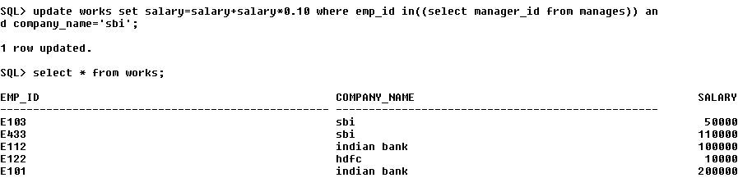

e. Find the company that has the most employees

**select company_name from works group by company_name having count(distinct emp_id)=(select max(count(distinct emp_id)) from works group by company_name);**



f. Find those companies whose employees earn a higher salary, on average than the

average salary at Indian Bank.

**select company_name from works group by company_name having avg(salary)>(select avg(salary) from works where company_name='indian bank');**



g. Query to find name and salary of all employees who earn more than each employee

of ‘Indian Bank’