1.Create a database named Employee. Create a collection named empDetails

You can use any of the fields Name, Age ,e_mail, phone,salary

* Insert 5 documents in it using the different insert() methods and
* Find the details of employee whose name is mohan

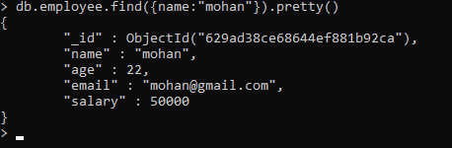

* Fetch the documents of employees whose salary >=5000

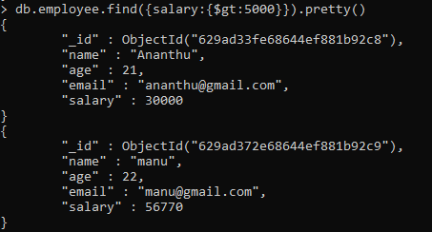

* Find the documents of employees whose name starts with letter r

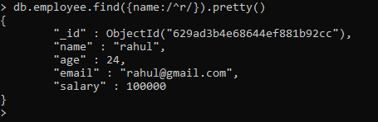

* Find the documents of employees whose name is not in mohan , raju, bhuvan

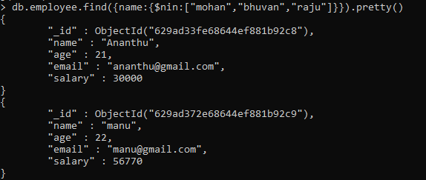

* Find the documents of employees whose names are mohan , raju, bhuvan

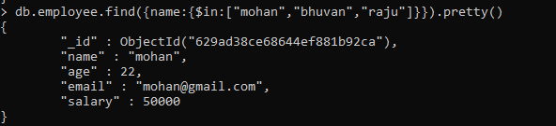

* Retrieve the details of employees whose age is less than 30. Display only the fields name, salary

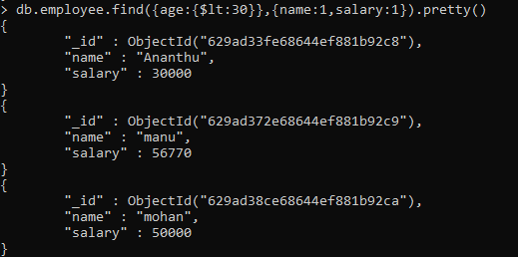

* Find the details of employees whose salary is >5000 and age is < 30

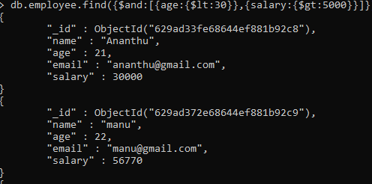

* Update the e-mail of employee whose name is mohan // findOneAndUpdate()



* Delete all the documents of employees whose age>56

