1.**In database Employee.**

1. find the average salary of each dept.

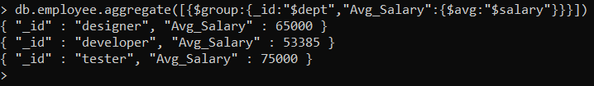

1. find the minimum salary of each dept.

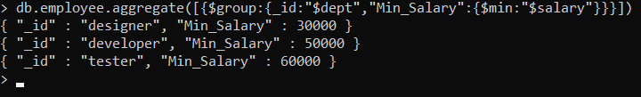

1. find the maximum salary of each dept.

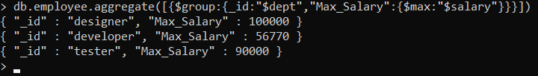

1. find the no.of employees of each dept.

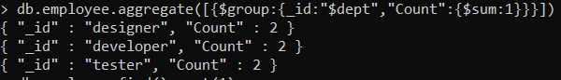

1. sort the collection empDetails in descending order of name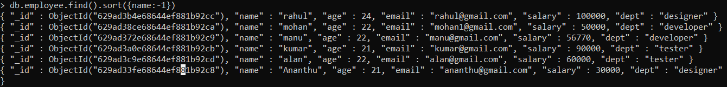
2. Create a text index for ‘name’ and search for names mohan and bhuvan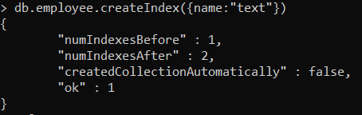

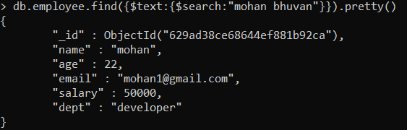

2.create a database Inventory and create an orders collection. Apply MapReduce operation for finding the total purchase of each customer.

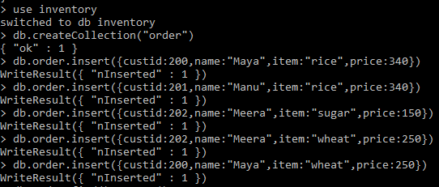

> var mapFunction=function(){emit(this.custid,this.price);};

> var reduceFunction=function(key,values){return Array.sum(values);};

> db.order.mapReduce(mapFunction,reduceFunction,{'out':"map_example"})

{ "result" : "map_example", "ok" : 1 }

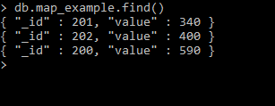

**Example Queries**

>db.emp1.aggregate([{$group:{_id:"$dept","avg sal":{$avg:"$sal"}}}])

> db.emp1.aggregate([{$group:{_id:"$dept","minimum sal":{$min:"$sal"}}}])

> db.emp1.aggregate([{$group:{_id:"$dept","maximum sal":{$max:"$sal"}}}])

> db.emp1.aggregate([{$group:{_id:"$dept","no of emp":{$sum:1}}}])

> db.bookdata.find().sort({"Author":1})

> db.bookdata.find().sort({"Author":-1})

> db.bookdata.createIndex({Title:"text"})

> db.bookdata.find({$text:{$search:"DBMS COA"}})