**Cursor**

**1.Calculate Interest for Fixed Deposit Amount Using Cursors.**

**set intrest as 0 and then update it using the program.**

**set 10% intrest for amount less than or equal to 1000.**

**20% for more then 1000 to 5000.**

**30% for above 5000.**

**declare**

**cursor c is select * from bank;**

**begin**

**for i in c**

**loop**

**if i.amount<1000**

**then**

**update bank set intrate=i.amount*.1 where amount=i.amount;**

**elsif i.amount>1000 and i.amount<5000**

**then**

**update bank set intrate=i.amount*.2 where amount=i.amount;**

**else**

**update bank set intrate=i.amount*.3 where amount=i.amount;**

**end if;**

**end loop;**

**end;**

**/**

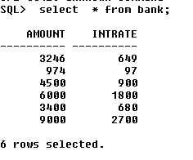

**2. Calculate Electricity Bill Using Cursors**

**declare**

**cursor c is select * from bill;**

**begin**

**for i in c**

**loop**

**if i.unit<100**

**then**

**update bill set amount=i.unit*3 where billno=i.billno;**

**elsif i.unit>100 and i.unit<200**

**then**

**update bill set amount=i.unit*4 where billno=i.billno;**

**else**

**update bill set amount=i.unit*5 where billno=i.billno;**

**end if;**

**end loop;**

**end;**

**/**

