THIS PLAYER FOR SHOWCASE VIDEOS ONLY!!! Hobo Accounts Can Not click on any links (for them (HOBOs) it is only informational). They ONLY CAN: LIKE OR DISLIKE the video and

Film Hobo

*Stardom starts with one scene* Create your project, find a team, get noticed... Search

write on the Discussion Board.

|  |
| --- |
|  |

Hobo

**SHOWCASE**

**PROJECTS SCENES SHORTS PILOTS/FEATURES HOW TO BRIAN**

**PROJECT #224 Format:** Scene **TEAM # 7 (Boston) Title:** Dynamo **Genre:** Drama

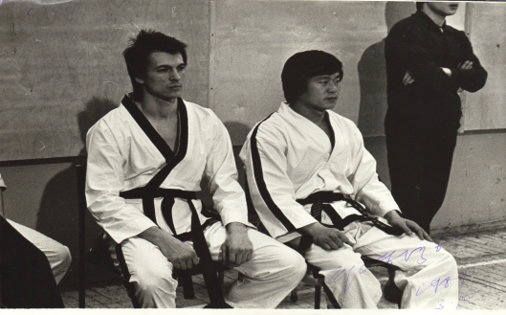

**Writer:** Tom Smith

**Producer:** Sarah Lee

**Director:** Sarah Lee

**John:** Greg Ma

**Scott:** Aaron McCarty

**DP:** Sarah Lee

**Makeup:** Nikita Selivan

**Editor:** Sarah Lee

The Member’s INFO in this PLAYER is only INFORMATIONAL, HOBO Members can NOT click on the links to go to

**Top Actors**

1. John Smith

2. John Dow

3. Karen Do

4. Aaron McCarty 5. Toli Chew

**Top Producers** 1. Tom Saint

2. Lola Carola

3. Ken Track

4. Jamal Smith

5. Nikita Selivan

**Top Directors**

1. Karen Do

2. Ivan Drago

3. Ken Track

4. Kendra Shulman 5. Sandra O’brian

**Top DPs**

HOBO Members and Others

can share that

Play, Pause, Sound Control, Time line

Normal Screen Full Screen

Video Control Panel

MEMBERS” pages

1. Sarah Lee 2. Colle Ace

3 Duran Duran

video with

their email

contacts or

on FB, and other social Media

**SHARE**

Discussion Board

!!! The INFORMATION such as:

|  |  |
| --- | --- |
|  |  |

473 12

|  |  |
| --- | --- |
|  |  |
|  |  |

4. Char Hendrix

5. Oleg Smirnov

**Top Sound Designers** 1. Sarah Lee

2. Colle Ace

**PROJECT #224 Format:** Scene **TEAM # 7 (Boston) Title:** Dynamo **Genre:** Drama

3 Duran Duran 4. Char Hendrix

**Writer:** Tom Smith

**Producer:** Sarah Lee

**Director:** Sarah Lee **John:** Greg Ma **Scott:** Aaron McCarty

5. Oleg Smirnov

**DP:** Sarah Lee **Makeup:** Nikita Selivan Is POPULATED from the Team Page # 11.3

**Editor:** Sarah Lee

**Top Editors** 1. Sarah Lee

2. Colle Ace

3 Duran Duran

This Player is almost the same as the Home page Player on page #2.1 but only without Ratings of the team and the project.

4. Char Hendrix 5. Oleg Smirnov

**TopTalent/Crew**

**Terms of Service**

**Privacy Policy**

**Intellectual Property Rights**

**Film Hobo Inc. 2021**

**About**

**Membership FAQ/Help Contact**