WasteIT System.

Waste management continues to be one of the main challenges that most major cities across the world have to confront on a daily basis. There are a lot of challenges associated with waste collection, segregation, transport, and disposal. Major problems affecting solid waste management are unscientific treatment and ethical problems. This in turn leads to hazards like environmental degradation, water pollution, soil pollution, and air pollution.

That’s why we Team PacMan Rebels are presenting you an new mobile application system(Waste It) towould reduce service costs and improve waste segregation, disposal,  and transportation system.

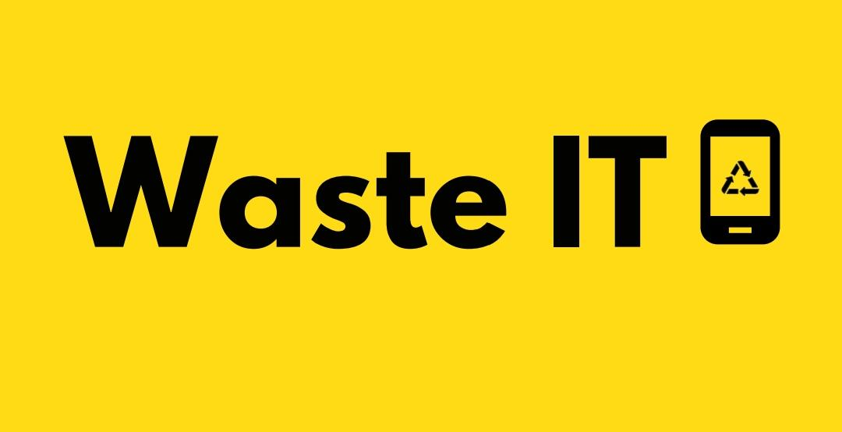

# Model of WasteIT System

WasteIT mobile application will have two interfaces in it, one for it’s both B2C and B2B operations. Our B2C (Business to Client) Operations will Handle collection of Waste Products from each Household that has been associated with our system with a small member fee. Each HouseHold user will be alerted 30 minutes before waste collector will reach their respective homes. Users are incentivised to do segregation of waste at their places only though a points based reward system on the application and whose points could be further be used on for purchases like mobile recharges. These waste materials will be then further segregated again into biodegradable and non biodegradable products.

# 

# 

Our B2B (Business to Business) Operations will deal with disposal system based on type of waste and then selling it further to clients depending upon the products. If it is a Biodegradable waste, then we process it and treat it further to create organic products which clients primarily in agro-related need those products. If it is a Non-Biodegradable waste, then we would sell it to clients and organisations which deal in creating renewable and recyclable products back into the market. WasteIT would be a huge boost to employment generation, has it would provide jobs to many people in the community.

The Main Targeted customer market for this model is "Households". Households produce a lot of trash which is not being properly managed, and as a consequence, the trash never reaches the recycling companies. In addition to this, due to non-segregation of waste materials, hazardous waste is getting mixed with recyclable waste, thereby impacting our health. Therefore By directly reaching out to them, we minimize this risk. In Addition, Since, we would further more selling it to clients that would use this processed waste into a productive use. This helps our Model to be a Zero Waste and Environmentally Useful.

WasteIT will have to educate people about the benefits of recycling and the problems that it causes for the coming generations. People would additionally be tempted to use it because of the incentives attached to the selling of waste. The WasteIT will also have to tie up with various NGOs working in the space of waste management. If the WasteIT starts in a country like India, it could tie up with the government initiatives in their country to gain traction. Many campaigns promote sustainability; the WasteIT should consider being a part of such campaigns to gain traction. Also, WasteIT would tie up with Local Municipalities to help them tackle waste collection problem.