LAB RECORD
Vehicle Service Request Form
Zoho Creator — Basic Fields Use Case | Assignment 10

1. Objective
The objective of this exercise is to design and build a functional “Vehicle Service Request Form” application in Zoho Creator that demonstrates correct usage of all thirteen Basic Fields available in the Form Builder, while solving a real automobile service-centre requirement of scheduling and pre-recording vehicle service and repair requests.

2. Problem Statement
An automobile service centre currently accepts service requests only through phone calls. This leads to double-booked service bays, no advance record of the reported problem, and no way for technicians to prepare parts or cost estimates before the vehicle arrives, causing long waiting times for walk-in customers.
To solve this, a low-code application was designed in Zoho Creator that allows a vehicle owner to submit a service or repair request through a single online form. The form captures owner identity, contact details, vehicle details, issue description, preferred service schedule, and authorization for the service centre to proceed — using every Basic Field type provided by the Form Builder.

3. Scope of the Application
- Application Name: Vehicle Service & Repair Request Management
- Form Name: Service_Request_Form
- Primary Users: Vehicle owners / Service Centre Front Office and Technicians
- Report View: Service_Request_Form Report — list of all submitted service requests
- Report Objective: enable the service centre to filter, schedule, and assign technicians for incoming requests

4. Basic Fields Used and Their Mapping
The table below maps every Basic Field from the Zoho Creator Form Builder palette to the corresponding field created in the Service_Request_Form, along with a representative sample value captured during testing.
Basic Field | Form Field Name | Sample Value Captured
Name | Owner_Name | Ramesh Kannan
Email | Email_Address | ramesh.kannan@example.com
Address | Pickup_Address | 9, Cross Street, Salem, TN, 636001
Phone | Contact_Number | +91 93450 66778
Single Line | Vehicle_Registration_Number | TN 34 AB 5678
Multi Line | Issue_Description | Grinding noise from front brakes; reduced mileage
Number | Odometer_Reading | 45230
Date | Preferred_Service_Date | 19-Aug-2026
Time | Preferred_Dropoff_Time | 9:00 AM
Drop Down | Vehicle_Type | Hatchback
Radio | Service_Type | Breakdown Repair
Multi Select | Additional_Services_Requested | Car Wash, Interior Cleaning, Tyre Rotation
Checkbox | Authorize_Estimate_And_Repair | Checked (Agreed)

Form Layout (Section-wise)
- Section A — Owner Details: Owner Name, Vehicle Registration Number, Vehicle Type
- Section B — Contact Details: Email Address, Contact Number, Pickup Address
- Section C — Vehicle & Issue Details: Odometer Reading, Service Type, Additional Services Requested, Issue Description
- Section D — Scheduling & Authorization: Preferred Service Date, Preferred Drop-off Time, Authorization Checkbox

5. Application Data Model
Before creating the application, the Data Model in Zoho Creator's App Builder was reviewed to confirm that the Service_Request form and the linked Service_Report layer captured every required field with the correct field-type icons (text, email, address, phone, number, date, time, drop-down, and multi-select), as shown below.
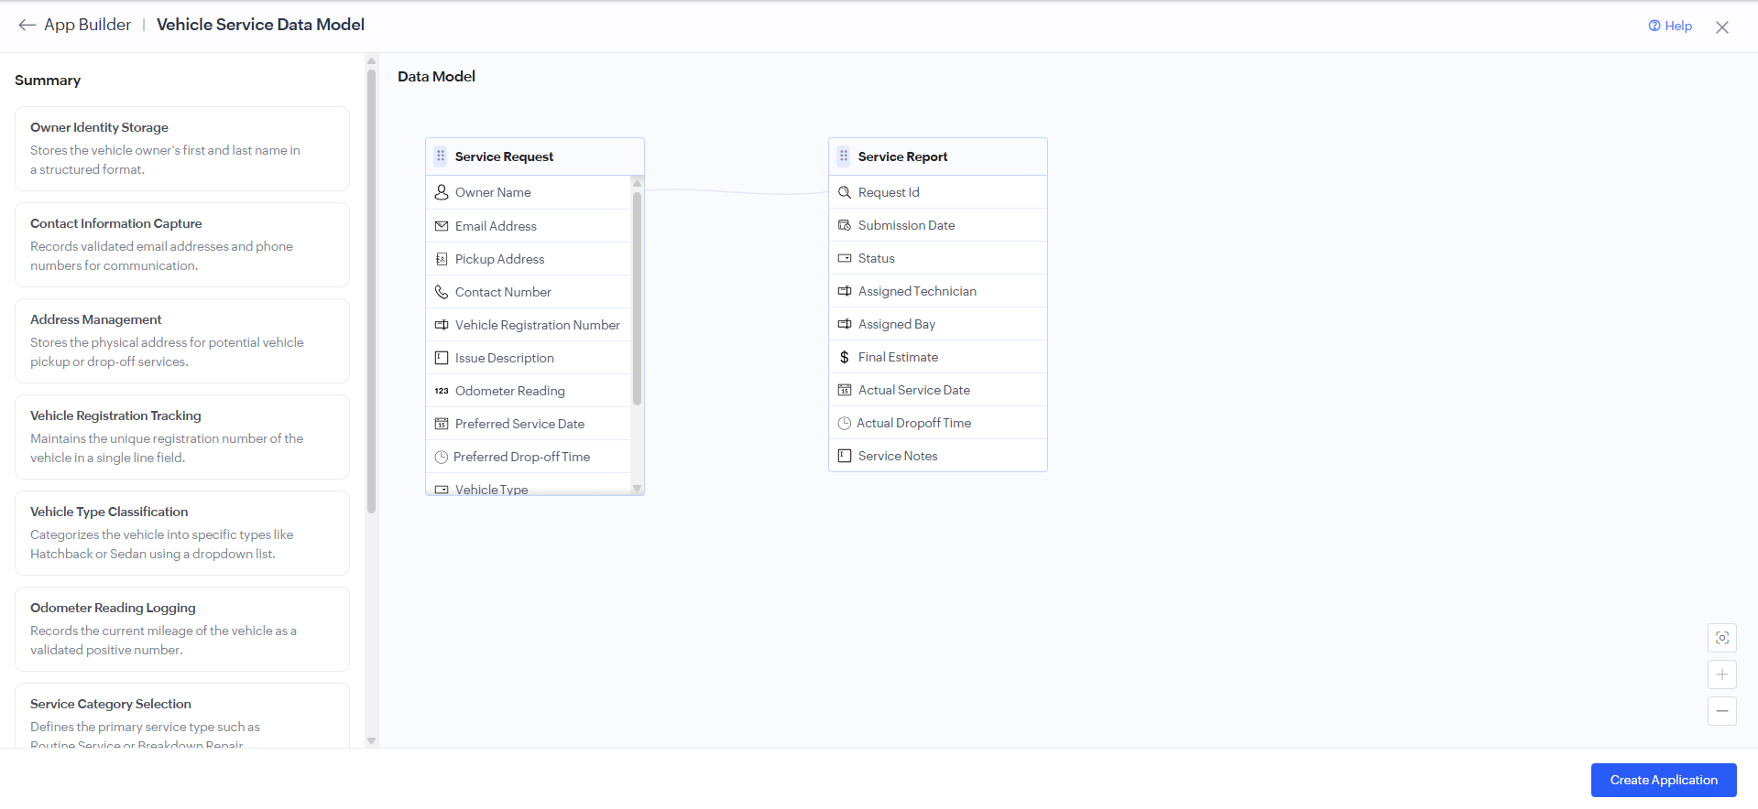
Fig. 1 — App Builder view of the Vehicle Service Data Model, showing the Service Request fields and the linked Service Report.

6. Sample Submitted Record
After publishing the form and submitting a test entry, the record was verified in the Service_Request_Form Report. The report confirms that all thirteen Basic Fields were captured correctly, including the owner's contact and address details, the odometer reading, the selected service type, and the additional services requested.
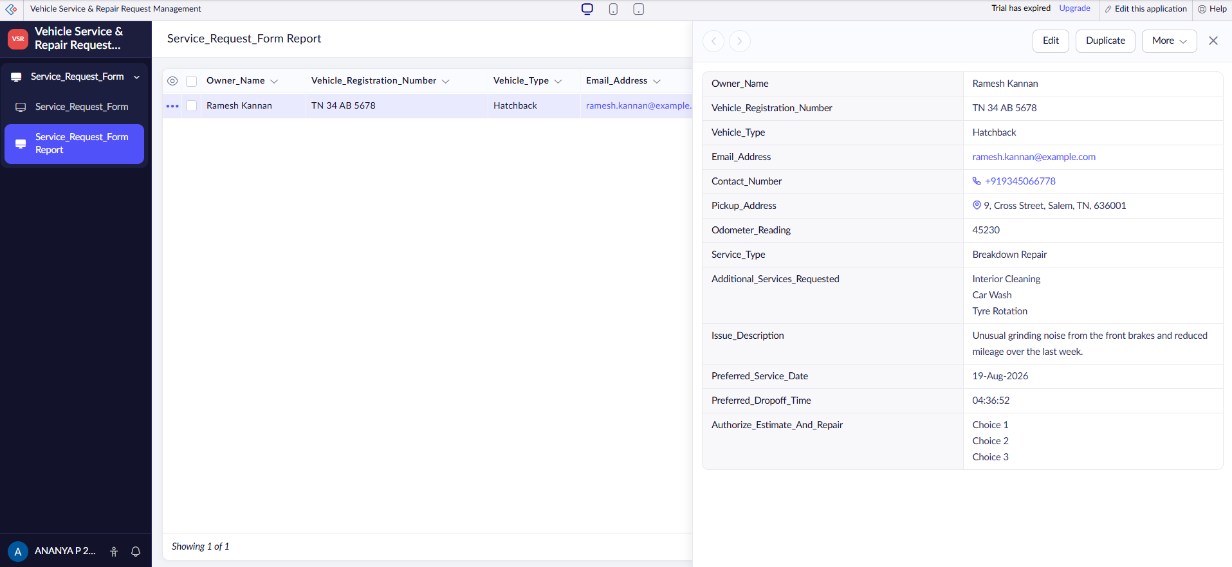
Fig. 2 — Service_Request_Form Report showing a submitted record with owner, vehicle, and scheduling details.
For the final deliverable, at least three sample records should be submitted through the live form so the report reflects multiple owners, vehicle types, and service categories, allowing the filter and scheduling workflow described in Section 8 to be demonstrated fully.

7. Validation Rules Configured
- Owner Name, Phone, Vehicle Registration Number, Vehicle Type, Service Type, and the Authorization Checkbox are mandatory fields.
- Email field: built-in email format validation enabled.
- Phone field: country code format enabled for Indian numbers.
- Number field (Odometer Reading): restricted to positive values only.
- Date field: Preferred Service Date restricted to disallow past dates.
- Checkbox (Authorization): form cannot be submitted unless checked.

8. Workflow Summary
- Step 1: Owner opens the public form link shared via the service centre's website or SMS.
- Step 2: Owner fills in personal, vehicle, issue, and scheduling details across the four sections.
- Step 3: On clicking Submit, Zoho Creator validates all mandatory fields and formats.
- Step 4: A new record is created in the Service_Request_Form Report.
- Step 5: An automated acknowledgement email is triggered to the owner using the Email field value.
- Step 6: The service centre reviews the report, filters by Service Type and Preferred Service Date, and assigns a technician and service bay ahead of the vehicle's arrival.

9. Learning Outcomes
- Understood the purpose and correct use case for each Basic Field in Zoho Creator.
- Learned how to structure a service-request form into logical, customer-friendly sections.
- Practiced configuring field-level validations — mandatory, format, and range checks.
- Understood how form field values feed into report views and service-scheduling workflows.

10. Conclusion
The Vehicle Service Request Form application successfully replaces the service centre's phone-based intake process with a structured online form covering owner identity, contact, vehicle, issue, and scheduling information. All thirteen Basic Fields of the Zoho Creator Form Builder were exercised, mandatory and format validations were applied, and submitted records were verified in the Service_Request_Form Report, meeting the objectives of this lab exercise.

