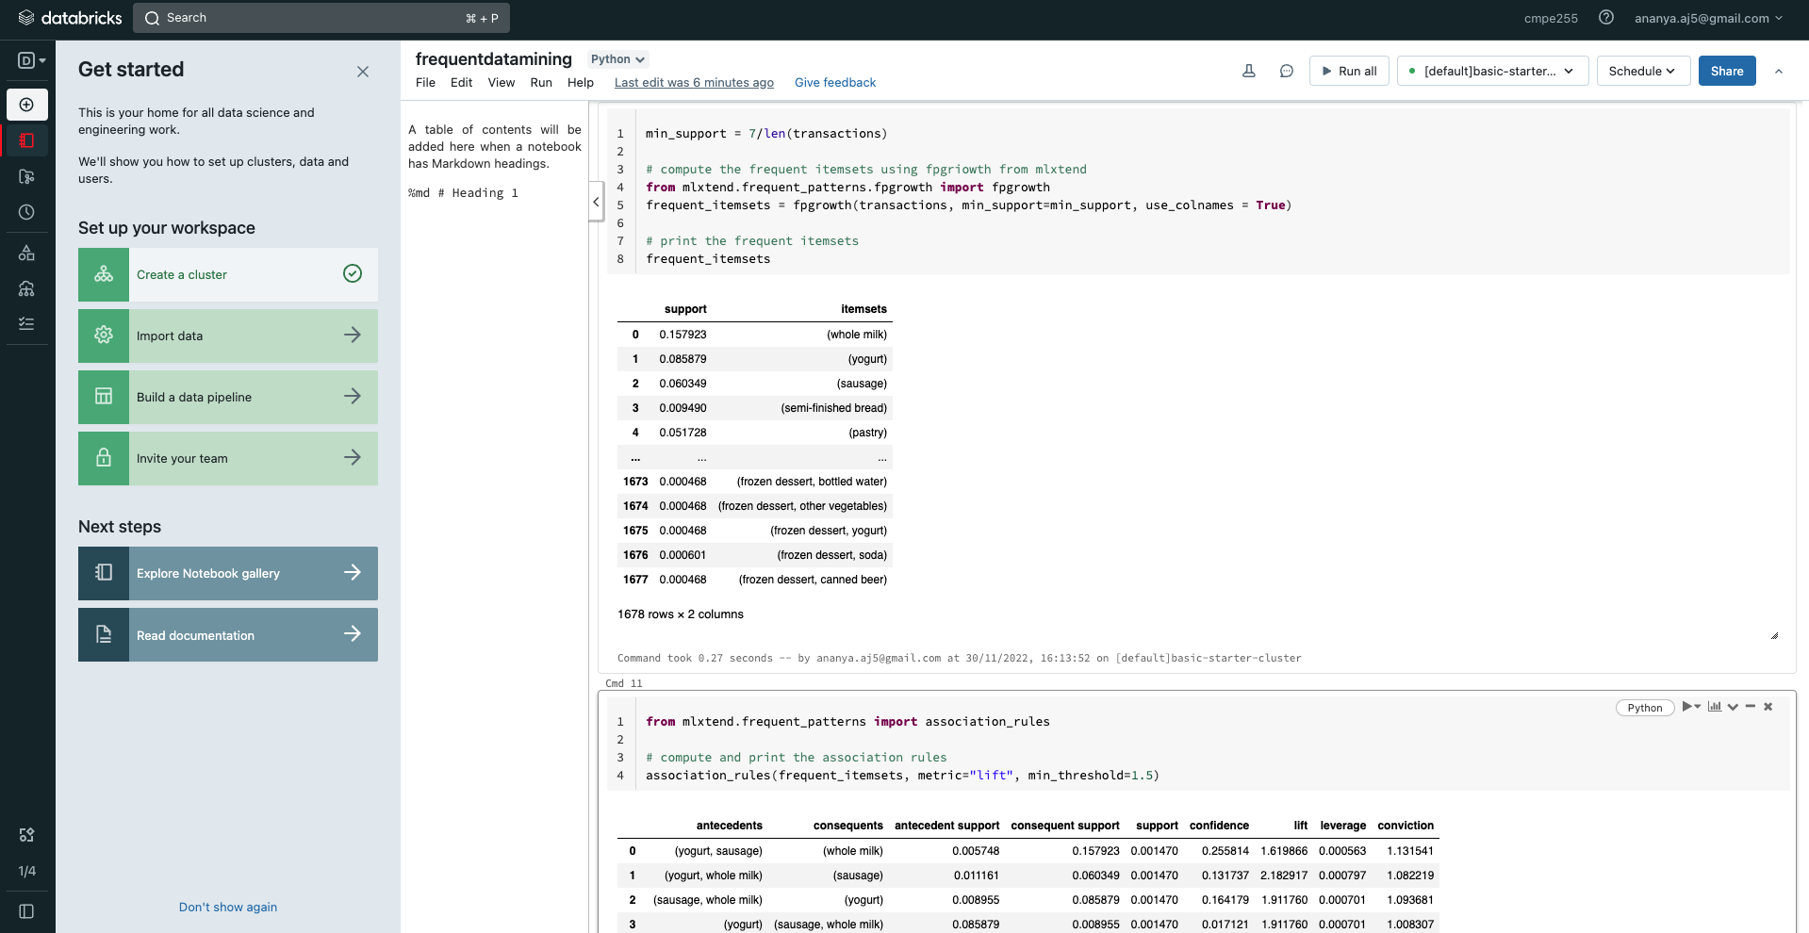

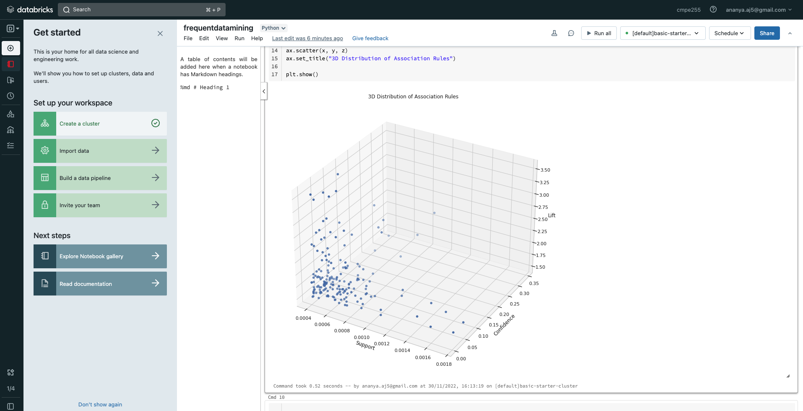

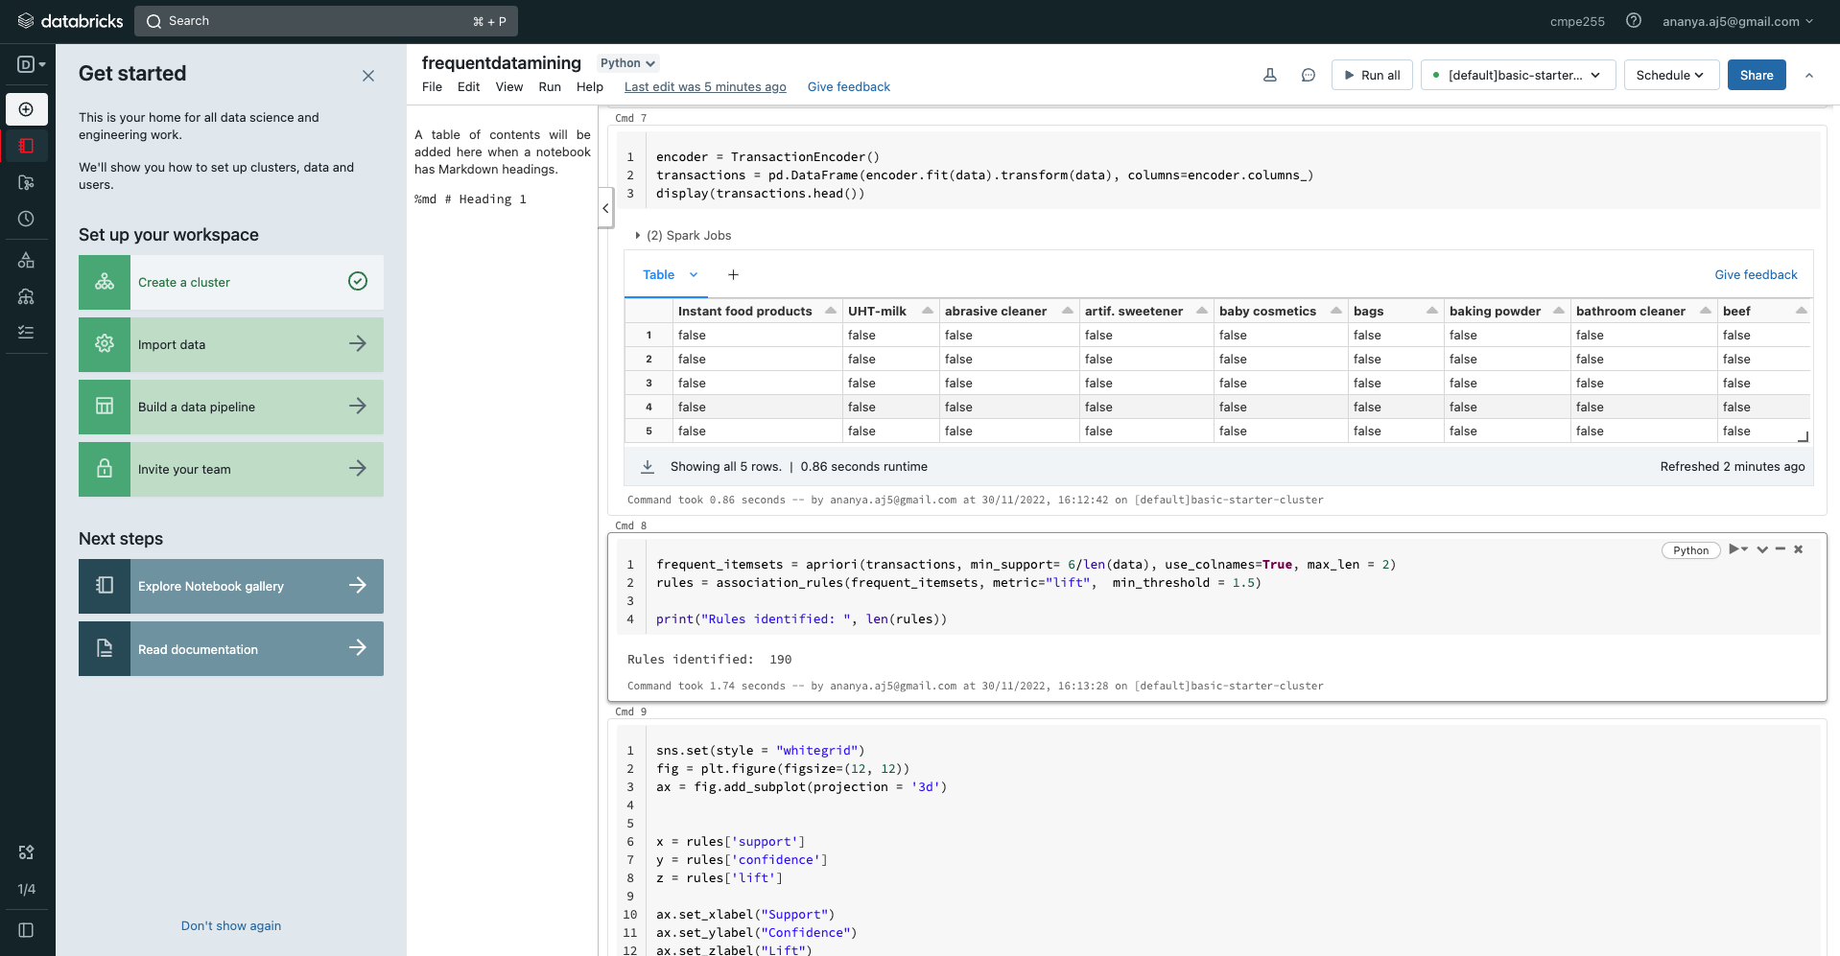

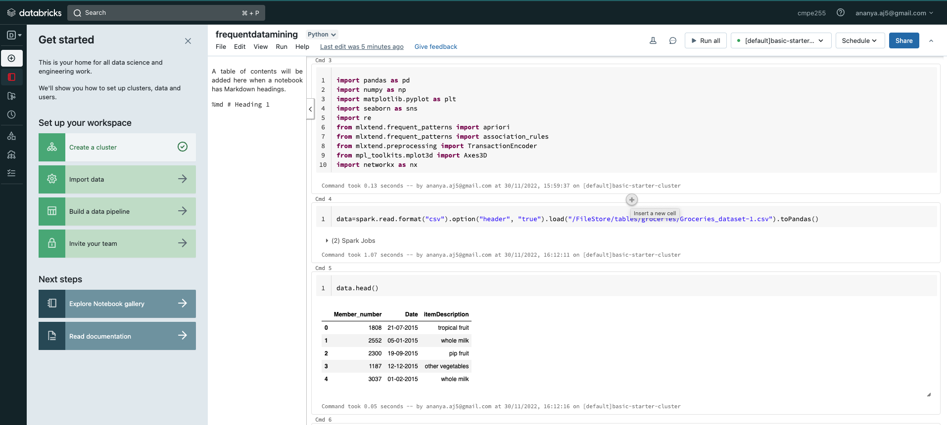

Databricks NB link : <https://dbc-6f979006-1450.cloud.databricks.com/?o=7495885898517657#notebook/4434438878962524/command/4434438878962543>