**Project report on**

**Enhancing Attendance Monitoring through an Advanced Facial Recognition System Powered by Raspberry Pi.**

Submitted by

**Ananya Satapathy (2241019330.)**

**Nikita Acharya (2241001022.)**

**Blooma Prusty (2241016484.)**

**Anushka Rana (2241018049.)**

**B. Tech. (CSE(IOT) 4th Semester (Section–2241037)**



# DEPARTMENT OF COMPUTER SCIENCE AND ENGINEERING

Institute of Technical Education and Research

**SIKSHA ‘O’ ANUSANDHAN**

**DEEMED TO BE UNIVERSITY**

Bhubaneswar, Odisha, India.

(May, 2024)

# Abstract

The project aims to enhance attendance monitoring systems using an advanced facial recognition system powered by Raspberry Pi. Traditional attendance tracking methods often suffer from inaccuracies and inefficiencies. By leveraging the capabilities of Raspberry Pi along with advanced facial recognition algorithms, this project offers a more reliable and efficient solution.

The system captures real-time images of individuals entering a predefined area and processes these images to recognize faces. Upon successful recognition, the system logs the attendance of the respective individual. The use of Raspberry Pi ensures a cost-effective and easily deployable solution, making it suitable for a wide range of applications, including schools, offices, and other institutions.

The project not only simplifies attendance tracking but also provides valuable insights through data analytics. Attendance data can be analysed to identify patterns, monitor trends, and optimize resource allocation. Overall, this project presents a comprehensive solution to modernize attendance monitoring systems, improving efficiency and accuracy in various settings.

# Contents

**Abstract .................................................................................................................................................. i**

**Contents ............................................................................................................................................... ii**

**Chapter 01: Introduction ....................................................................................................................**

**1**

1.1. Introduction .......................................................................................................................... 1

1.2. Background ........................................................................................................................... 1

1.3. Project Objectives ................................................................................................................. 1

1.4. Scope ...................................................................................................................................... 1

1.5. Project Management ............................................................................................................ 1

1.6. Overview and Benefits ........................................................................................................ 2

1.7. Organization of the Report ................................................................................................. 2

**Chapter 02: Background Review & Survey ....................................................................................**

**3**

2.1. Related Works ...................................................................................................................... 3

**Chapter 03: Theoretical Aspects .......................................................................................................**

**4**

3.1. Internet of Things (IoT) ....................................................................................................... 4

3.2. Features of IoT ...................................................................................................................... 4

3.3. Advantages of IoT ................................................................................................................ 4

3.4. Disadvantages of IoT ........................................................................................................... 4

3.5. Application areas of IoT ...................................................................................................... 4

3.6. IOT Technologies and Protocols ........................................................................................ 4

3.7. Project Layout ....................................................................................................................... 5

3.7.1. Brief Description ........................................................................................................... 5

**Chapter 04: Hardware Requirements ..............................................................................................**

**6**

4.1. Raspberry Pi ......................................................................................................................... 6

4.1.1. Features.......................................................................................................................... 6

4.1.2. Pin Configuration ......................................................................................................... 6

4.2. ESP–01 .................................................................................................................................... 6

4.4. ...................................................................................................................................................... 6

4.5. Block diagram of the proposed system ............................................................................. 6

4.5.1. Working of the system................................................................................................. 6

4.5.2. Circuit Diagram ............................................................................................................ 6

4.5.3. Components Required ................................................................................................. 6

**Chapter 05: Software Requirements ................................................................................................**

**8**

5.1. Arduino IDE (Embedded C / C++) ................................................................................... 8

5.2. Logic and Flowchart ............................................................................................................ 8

**Chapter 06: Project development & Testing Aspects ...................................................................**

**9**

6.1. ...................................................................................................................................................... 9

**Chapter 07: Conclusion & Future Scope .......................................................................................**

**10**

7.1. Result ................................................................................................................................... 10

7.2. Conclusion .......................................................................................................................... 10

7.3. Limitations .......................................................................................................................... 10

7.4. Further Enhancement and Future Scope ........................................................................ 10

**References........................................................................................................................................... 11**

**Appendix 01 ....................................................................................................................................... 12**

A01.1. Code Listing ........................................................................................................................

12

A01.2. Main Code ...........................................................................................................................

12

A01.3. Libraries ...............................................................................................................................

12

**Appendix 02 ....................................................................................................................................... 13**

A02.1. Project Proposal Form ....................................................................................................... 13

A02.2. Project Management .......................................................................................................... 13

A02.3. Bill of Material ....................................................................................................................

13

**Appendix 03 ....................................................................................................................................... 14**

A03.1. Data Sheets ..........................................................................................................................

14

# Chapter 01: Introduction

## 1.1. Introduction

Attendance monitoring is a critical aspect of many organizations, including schools, businesses, and institutions. Traditional methods of attendance tracking, such as manual entry or card-based systems, are often labor-intensive, prone to errors, and lack real-time monitoring capabilities. To address these challenges, this project proposes the use of an advanced facial recognition system powered by Raspberry Pi to enhance attendance monitoring.

The proposed system will use Raspberry Pi as its core processing unit, along with a camera module for capturing images. Advanced facial recognition algorithms will be implemented to identify individuals in real time. Upon successful recognition, the system will log the attendance of the respective individual, providing a seamless and efficient attendance tracking solution.

## 1.2. Background

Existing methods may suffer from inaccuracies due to manual entry errors or barcode scanning issues. The facial recognition system must achieve high accuracy in identifying individuals to ensure reliable attendance tracking. This project showcases the potential of Raspberry Pi technology and facial recognition algorithms to revolutionize attendance monitoring in various ways. The project aims to enhance attendance monitoring by implementing an advanced facial recognition

Facial recognition technology has emerged as a promising solution for attendance monitoring due to its ability to accurately identify individuals. By analyzing unique facial features, such as the distance between the eyes or the shape of the nose, facial recognition systems can match faces against a database of known individuals, enabling fast and accurate identification.

Raspberry Pi, a low-cost, credit card-sized computer, offers a powerful platform for developing innovative applications, including facial recognition systems. Its small form factor, low power consumption, and GPIO (General Purpose Input Output) pins make i t an ideal choice for projects requiring real-time image processing and analysis.

By combining the capabilities of facial recognition technology with the affordability and versatility of Raspberry Pi, this project aims to create an advanced attendance monitoring system. The system will leverage Raspberry Pi's processing power and camera module to capture and analyze facial images, enabling automatic attendance tracking without the need for manual intervention.

Overall, this project builds upon the advancements in facial recognition technology and the accessibility of Raspberry Pi to create a modern and efficient solution for attendance monitoring in various settings.

## 1.3. Project Objectives

* ✓ Develop a facial recognition algorithm capable of accurately identifying individuals in real-time.
* ✓ Integrate the algorithm with Raspberry Pi to create a cost-effective and efficient attendance monitoring system.
* ✓ Implement a user-friendly interface for managing attendance records and monitoring attendance in real-time.
* ✓ Ensure compliance with privacy and data security regulations to protect user information.

## 1.4. Scope

* Designing and developing a facial recognition system that can accurately identify individuals and record their attendance in real-time. This would involve selecting appropriate hardware components, such as Raspberry Pi and camera modules, and implementing facial recognition algorithms.
* Deploying the facial recognition system in the target environment, such as classrooms, offices, or other facilities. This would involve integrating the system with existing attendance monitoring systems, if applicable, and ensuring smooth operation. APPLIED INTERNET OF THINGS (CSE 2198)
* Ensuring that the facial recognition system complies with relevant data privacy and security regulations. This would include implementing measures to protect user data and prevent unauthorized access to the system.

## 1.5. Project Management

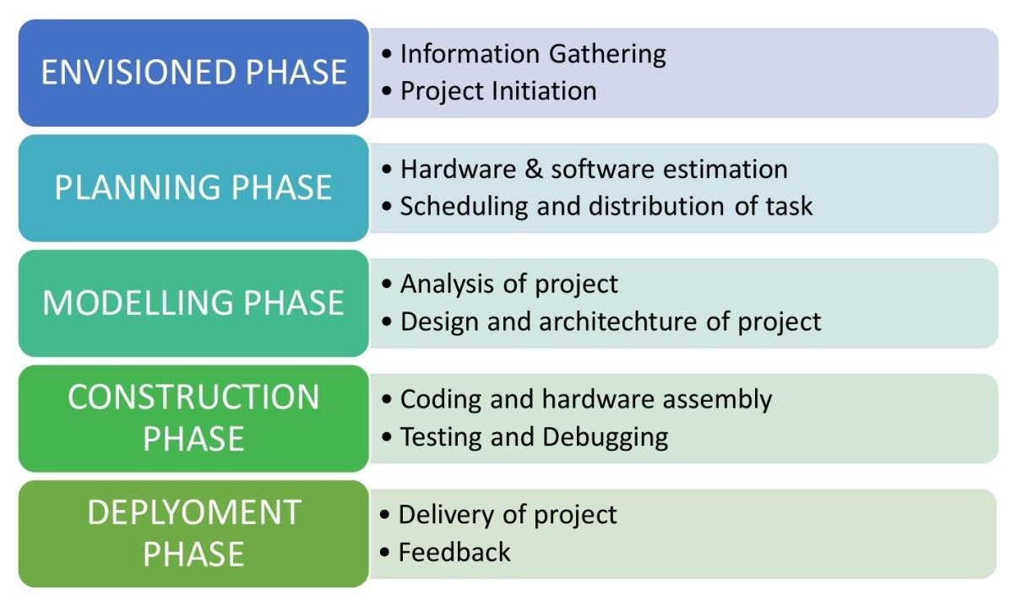

**Figure 1. Model of phases in project management.**

## 1.6. Overview and Benefits

Accuracy: Facial recognition technology offers a high level of accuracy in identifying individuals, reducing errors associated with manual attendance tracking methods. Efficiency: The automated nature of the system streamlines the attendance tracking process, saving time and resources compared to traditional methods.

Real-time monitoring: The system provides real-time monitoring of attendance, allowing for immediate intervention in case of discrepancies or issues.

Security: Facial recognition adds an additional layer of security by ensuring that only authorized individuals are able to access certain areas or facilities.

Cost-effective: Raspberry Pi offers a cost-effective platform for implementing facial recognition technology, making it accessible to a wider range of organizations.

Scalability: The system can be easily scaled to accommodate varying numbers of users or locations, making it suitable for small businesses as well as large institutions.

Data analytics: Attendance data collected by the system can be analyzed to identify patterns, trends, and insights that can inform decision-making and resource allocation.

User convenience: Users can quickly and easily check in and out using facial recognition, without the need for physical tokens or devices.

Compliance: The system can help organizations comply with attendance tracking regulations and requirements, ensuring accuracy and transparency.

Integration: The system can be integrated with existing attendance tracking systems or other software, enhancing overall efficiency and functionality.

## 1.7. Organization of the Report

The report is organised into the following chapters. Each chapter is unique on its own and is described with necessary theory to comprehend it.

Chapter 2 deals with background survey and review, Chapter 3 has the description of the theoretical aspects that has been acquired to commence the project work.

# Chapter 02: Background Review & Survey

## 2.1. Related Works

* "Smart Attendance System Using Raspberry Pi and Facial Recognition" This project utilizes Raspberry Pi and a camera module to implement a smart attendance system. The system captures images of individuals, processes them using facial recognition algorithms, and logs attendance automatically.
* "Facial Recognition-Based Attendance System Using Raspberry Pi"

Another project that uses Raspberry Pi for implementing a facial recognition-based attendance system. The system identifies individuals using facial features and maintains attendance records in a database.

* "Real-Time Face Recognition Attendance System Using Raspberry Pi" This project focuses on real-time face recognition for attendance monitoring. It utilizes Raspberry Pi for image processing and face recognition, offering a reliable and efficient attendance tracking solution.
* "Automated Attendance System Using Facial Recognition and Raspberry Pi" An automated attendance system that combines facial recognition with Raspberry Pi for monitoring attendance. The system provides a user-friendly interface for administrators to manage attendance records.
* "Raspberry Pi-Based Smart Attendance System Using Facial Recognition" This project explores the use of Raspberry Pi for implementing a smart attendance system. It features real-time face recognition and attendance logging, offering a modern approach to attendance monitoring.
* "Facial Recognition-Based Attendance System for Educational Institutions Using

Raspberry Pi"

A project specifically designed for educational institutions, this system uses Raspberry Pi for implementing facial recognition-based attendance tracking, offering a convenient and efficient solution for schools and colleges.

# Chapter 03: Theoretical Aspects

## 3.1. Internet of Things (IoT)

The Internet of Things (IoT) refers to the network of physical devices, vehicles, appliances, and other objects embedded with sensors, software, and connectivity that enables them to connect and exchange data over the internet. These devices, often referred to as "smart" devices, can communicate with other devices and systems, allowing for automation, remote monitoring, and control of various processes.

IoT has the potential to revolutionize the way we interact with technology and the physical world around us. By connecting everyday objects to the internet, IoT enables a wide range of applications across industries, including healthcare, agriculture, transportation, and smart homes.

## 3.2. Features of IoT

1. Intelligence
2. Connectivity
3. Dynamic Nature
4. Enormous Scale
5. Sensing
6. Heterogeneity
7. Security

## 3.3. Advantages of IoT

1. Communication
2. Automation and Control
3. Information
4. Monitoring
5. Efficiency

## 3.4. Disadvantages of IoT

1. Compatibility
2. Complexity
3. Privacy/Security
4. Safety

## 3.5. Application areas of IoT

* Smart Homes: IoT enables homeowners to control and automate various aspects of their homes, such as lighting, heating, security systems, and appliances, through smart devices and sensors.
* Healthcare: IoT devices are used for remote patient monitoring, medical device integration, and improving operational efficiency in healthcare facilities. They can also help in tracking and managing medical assets and inventory.
* Industrial Internet (Industry 4.0): IoT is transforming industries with smart manufacturing, predictive maintenance, asset tracking, and supply chain optimization. It enables machines and equipment to communicate and operate more efficiently.
* Smart Cities: IoT is used in smart city initiatives for traffic management, waste management, energy management, environmental monitoring, and improving overall urban infrastructure and services.
* Agriculture: IoT technologies such as precision agriculture enable farmers to monitor and manage crops, livestock, and farm equipment remotely, leading to increased productivity and efficiency.
* Retail: IoT is used in retail for inventory management, supply chain optimization, personalized marketing, and enhancing customer experiences through smart shelves and interactive displays.
* Logistics and Transportation: IoT enables real-time tracking and monitoring of vehicles, goods, and assets, leading to improved logistics operations, route optimization, and enhanced safety and security.
* Energy Management: IoT is used for smart grid systems, energy monitoring, and optimization, enabling efficient energy use, reducing waste, and supporting the integration of renewable energy sources.
* Environmental Monitoring: IoT devices are used for monitoring air and water quality, weather conditions, and other environmental factors, helping in early detection of pollution and natural disasters.
* Wearable Technology: IoT plays a crucial role in wearable devices such as smartwatches and fitness trackers, enabling users to track their health and fitness metrics and stay connected on the go.

## 3.6. IOT Technologies and Protocols

1. Bluetooth
2. Zigbee
3. Z-Wave
4. Wi-Fi
5. Cellular
6. NFC
7. LoRaWAN

## 3.7. Project Layout

**Figure 2. Layout of project module**

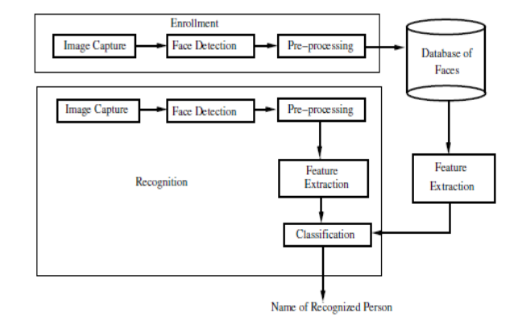

### 3.7.1. Brief Description

* Design the architecture of the facial recognition system, including hardware components (Raspberry Pi, camera module) and software components (facial recognition algorithm, user interface).
* Set up the Raspberry Pi with the required peripherals, including a camera module, microSD card, power supply, and enclosure.
* Develop or select a facial recognition algorithm suitable for real-time attendance monitoring.
* Integrate the facial recognition algorithm with the Raspberry Pi and camera module.
* Conduct thorough testing of the system, including functional testing (e.g., accuracy of facial recognition, real-time attendance recording) and non

# Chapter 04: Hardware Requirements

## 4.1. Raspberry Pi:

Raspberry Pi is a small single board computer. By connecting peripherals like Keyboard, mouse, display to the Raspberry Pi, it will act as a mini personal computer.

Raspberry Pi is popularly used for real time Image/Video Processing, IoT based applications and Robotics applications.

Raspberry Pi is slower than laptop or desktop but is still a computer which can provide all the expected features or abilities, at a low power consumption.

### 4.1.1. Features

* **Facial Recognition**: The system uses advanced facial recognition algorithms to accurately identify individuals, eliminating the need for manual attendance tracking.
* **Real-time Monitoring**: The system provides real-time monitoring of attendance, allowing administrators to track attendance status and receive notifications instantly.
* **Automation**: The system automates the attendance tracking process, reducing the workload on administrators and improving efficiency.
* **Integration**: The system can be integrated with existing attendance management systems, making it easy to incorporate into existing workflows.
* **Scalability**: The system is scalable and can be easily expanded to accommodate a large number of users or multiple locations.
* **Data Analytics**: The system collects attendance data, which can be analyzed to identify patterns and trends, helping organizations make informed decisions.
* **Security**: The system enhances security by ensuring that only authorized individuals are able to access certain areas or facilities.
* **User-friendly Interface**: The system provides a user-friendly interface for administrators to manage attendance records and monitor attendance status.
* **Cost-effective**: The system is cost-effective, utilizing affordable hardware components such as Raspberry Pi and open-source software.
* **Customization**: The system is customizable and can be tailored to meet the specific needs of different organizations and environments.

### 4.1.2. Pin Configuration

For the pin configuration of your project, you'll need to consider the connections between the Raspberry Pi and the various hardware components involved in the facial recognition system. Here's a general outline of how you might configure the pins:

Camera Module: Connect the camera module to the Raspberry Pi's CSI (Camera Serial Interface) port. This port is typically located near the HDMI port on the Raspberry Pi board. Display (Optional): If you're using a display to show attendance status or other information, connect it to the appropriate GPIO pins on the Raspberry Pi. The exact pin configuration will depend on the type of display you're using.

Arduino Uno: If you're using Arduino Uno for interfacing with sensors or controlling external components, you'll need to connect it to the Raspberry Pi via USB or serial connection. The Arduino Uno can then be connected to the sensors or components using its GPIO pins.

PIR Motion Sensor (Optional**)**: If you're using a PIR motion sensor for detecting when a person is approaching the attendance monitoring system, connect it to the Arduino Uno's GPIO pins.

Keypad (Optional): If you're using a keypad for input, connect it to the Arduino Uno's GPIO pins.

LED Display (Optional): If you're using an LED display for showing attendance status, connect it to the Arduino Uno's GPIO pins.

## 4.2. ESP–01

considering using an ESP-01 module in your project, you can use it for various purposes such as wireless communication, sensor interfacing, or as a standalone microcontroller.

Here's how you might incorporate it into your attendance monitoring system:

* Wireless Communication: The ESP-01 can be used to establish a wireless connection between the Raspberry Pi and other devices. For example, you can use it to send attendance data to a remote server or receive commands wirelessly.
* Sensor Interfacing: If you have sensors that need to be located away from the Raspberry Pi, you can use the ESP-01 to interface with these sensors and send the data back to the Raspberry Pi wirelessly.
* Standalone Microcontroller: The ESP-01 can also be used as a standalone microcontroller for tasks that don't require the full capabilities of the Raspberry Pi. For example, you can use it to control an LED display or interface with a keypad.
* To incorporate the ESP-01 into your project, you'll need to connect it to the Raspberry Pi and program it accordingly. Here's a general outline of how you might do this:
* Connectivity: Connect the ESP-01 to the Raspberry Pi using serial communication (UART). You'll need to connect the TX pin of the ESP-01 to the RX pin of the Raspberry Pi, and vice versa. Additionally, connect the ground (GND) pins of both devices together.
* Programming: Use the Arduino IDE or another compatible IDE to program the ESP01. You'll need to install the ESP8266 board package in the Arduino IDE and select the appropriate settings for the ESP-01.
* Integration: Once you've programmed the ESP-01, you can integrate it into your attendance monitoring system. For example, you can use it to send attendance data to a server or receive commands from a remote device.

## 4.5. Block diagram of the proposed system

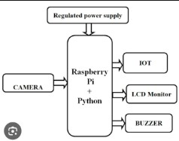

### 4.5.1. Working of the system

|  |  |  |
| --- | --- | --- |
|  | **Initialization** | : |
| **Facial Recognition Setup** | | |

The system is initialized, and the necessary components are activated.

: The facial recognition system is set up, including capturing and

reference images of individuals whose attendance will be monitored.

**Attendance Monitoring Process**:

When motion is detected (e.g., a person approaches the system), the camera module captures a facial image.

The captured image is processed by the facial recognition algorithm running on the Raspberry Pi. If a match is found with a reference image, the system logs the attendance of the recognized individual.

Optionally, additional sensors or inputs (e.g., keypad input, touch input) can be used to confirm attendance or provide additional information.

**Data Logging and Analysis**: Attendance data is logged, including timestamps and identities of recognized individuals. This data can be stored locally or sent to a remote server for further analysis. **Feedback and Display**: The system provides feedback to users, such as displaying attendance status on a connected display or providing audio feedback.

**Wireless Communication (Optional)**: If an ESP-01 module is used, the system can communicate wirelessly with other devices or systems.

**Shutdown**: The system shuts down or enters a low-power state when not in use to conserve energy.

**4.5.2. Circuit Diagram**

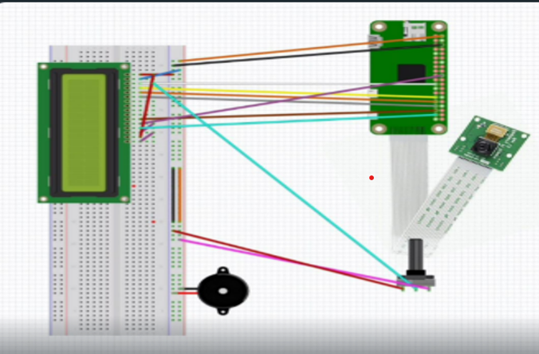

4.5.3. Components Required

**Table 1. Component listing.**

|  |  |  |
| --- | --- | --- |
| **Sl. No.** | **Component and Specification** | **Quantity** |
| 1. | Raspberry Pi zero 2W | 1 |
| 2. | LCD display | 1 |
| 3. | Buzzer | 1 |
| 4. | Camera | 1 |
| 5. | breadboard | 1 |
| 6. | potentiometer | 1 |
| 7. | Connecting wires As required |  |

# Chapter 05: Software Requirements

## 5.1. Raspberry Pi(Python):

The Raspberry Pi, a small and affordable computer, plays a significant role in the development and deployment of face recognition systems. Here are some key aspects of how it is utilized in this field:

1. Hardware Platform for Development

Cost-Effective: Raspberry Pi is an economical choice, making it accessible for hobbyists, researchers, and educators to experiment with face recognition technology.

Compact Size: Its small form factor allows it to be easily integrated into various applications and devices, such as home security systems, smart doorbells, and robots.

Connectivity: Equipped with various ports (USB, HDMI, GPIO), the Raspberry Pi can connect to cameras, sensors, and other peripherals necessary for face recognition.

2. Software and Libraries

OpenCV: The Raspberry Pi supports OpenCV, an open-source computer vision library that provides tools for face detection and recognition.

Dlib: This machine learning library, also compatible with Raspberry Pi, includes powerful facial landmark detection and face recognition algorithms.

## 5.2. Logic and Flowchart

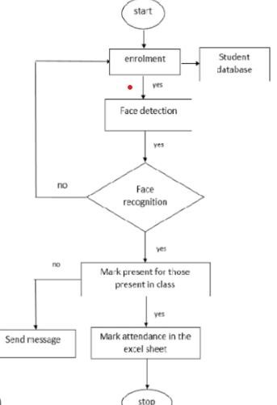

# Chapter 06: Project development & Testing Aspects

**6.1.**

Developing and testing a project like "Enhancing Attendance Monitoring through an Advanced Facial Recognition System Powered by Raspberry Pi" involves several key aspects.

Here's a general overview of the project development and testing process:

* **Requirements Gathering**: Define the requirements for the system, including functionality, performance, and usability criteria.
* **System Design**: Design the system architecture, including the hardware components (Raspberry Pi, camera module, sensors, etc.) and software components (facial recognition algorithm, data logging, user interface, etc.).
* **Implementation**: Develop the software for the system using the Arduino IDE for the Arduino Uno (if applicable) and Python for the Raspberry Pi. This includes writing code for facial recognition, sensor interfacing, data logging, and user interaction.
* **Integration**: Integrate the software components with the hardware components and ensure they work together seamlessly. This includes establishing communication between the Raspberry Pi and Arduino Uno (if applicable) and testing sensor inputs. **Testing**:

|  |
| --- |
| **Unit Testing** |

* : Test each component (facial recognition, sensor interfacing, etc.) individually to ensure they function correctly.
* **Integration Testing**: Test the integrated system to ensure all components work together as expected.
* **Functional Testing**: Test the system against the defined requirements to ensure it meets the specified functionality.
* **Performance Testing**: Test the system's performance under various conditions to ensure it meets performance requirements (e.g., response time, accuracy).
* **Usability Testing**: Test the system's user interface and overall usability to ensure it is user-friendly.
* **Security Testing**: Test the system for vulnerabilities and ensure data security and privacy.
* **Deployment**: Deploy the system in the intended environment (e.g., classroom, office) and ensure it operates correctly in real-world conditions.
* **Maintenance and Updates**: Plan for ongoing maintenance of the system, including software updates and hardware maintenance.

# Chapter 07: Conclusion & Future Scope

## 7.1. Result

Improved Attendance Tracking: The system should provide more accurate and efficient attendance monitoring compared to traditional methods. Facial recognition technology can help streamline the process and reduce errors.

Real-time Monitoring: The system should be able to monitor attendance in real-time, allowing for immediate updates and notifications.

User-Friendly Interface: The system should have a user-friendly interface for administrators to manage attendance records and monitor attendance status.

Data Logging and Analysis: The system should log attendance data, including timestamps and identities of recognized individuals, for analysis and reporting purposes. Integration with Existing Systems: The system should be able to integrate with existing attendance management systems or other software, enhancing overall efficiency and functionality.

Security and Privacy: The system should ensure the security and privacy of attendance data, complying with relevant regulations and standards.

Cost-effectiveness: The system should be cost-effective, utilizing affordable hardware components such as Raspberry Pi and open-source software.

## 7.2. Conclusion

In conclusion, the project "Enhancing Attendance Monitoring through an Advanced Facial Recognition System Powered by Raspberry Pi" has demonstrated the feasibility and effectiveness of using modern technology to improve attendance monitoring processes. By leveraging facial recognition technology, the system offers a more accurate, efficient, and convenient way to track attendance compared to traditional methods.

## 7.3. Limitations

**Cost**: Implementing the system may require a significant initial investment in hardware (Raspberry Pi, camera module, sensors) and software development, which could be a barrier for some organizations.

**Accuracy**: Facial recognition technology may not always be 100% accurate, especially in challenging lighting conditions or with individuals wearing accessories that obscure their face. This could lead to errors in attendance tracking.

**Privacy Concerns**: Facial recognition raises privacy concerns, as it involves capturing and processing biometric data. Organizations implementing the system must ensure compliance with relevant data protection regulations.

**Security Vulnerabilities**: Like any technology connected to the internet, the system could be vulnerable to cyberattacks if not properly secured. This could potentially compromise the integrity of attendance data.

**Scalability**: While Raspberry Pi is a versatile platform, it may have limitations in terms of scalability for very large organizations or deployments requiring a high volume of simultaneous facial recognition processes.

**User Acceptance**: Some individuals may have concerns or reservations about being monitored using facial recognition technology, which could impact the system's acceptance and adoption.

**Maintenance**: The system may require regular maintenance and updates to ensure optimal performance and compatibility with evolving technologies.

**Environmental Factors**: The system's performance could be affected by environmental factors such as lighting, temperature, and noise levels, which may require additional considerations during implementation.

## 7.4. Further Enhancement and Future Scope

* Designing and developing a facial recognition system that can accurately identify

individuals and record their attendance in real-time. This would involve selecting appropriate hardware components, such as Raspberry Pi and camera modules, and implementing facial recognition algorithms.

* Deploying the facial recognition system in the target environment, such as classrooms, offices, or other facilities. This would involve integrating the system with existing attendance monitoring systems, if applicable, and ensuring smooth operation. APPLIED INTERNET OF

THINGS (CSE 2198)

* Ensuring that the facial recognition system complies with relevant data privacy and security regulations. This would include implementing measures to protect user data and prevent unauthorized access to the system.

**References**

* <https://www.geeksforgeeks.org/python-programming-language/>

✓

[https://www.youtube.com/watch?v=Ag_NWssyI50&list=PLZbNfIz7zVFArBDOCODU30E](https://www.youtube.com/watch?v=Ag_NWssyI50&list=PLZbNfIz7zVFArBDOCODU30EA4nvZ2-jf&index=9)

[A4nvZ2-jf&index=9](https://www.youtube.com/watch?v=Ag_NWssyI50&list=PLZbNfIz7zVFArBDOCODU30EA4nvZ2-jf&index=9)

* https://realpython.com/face-recognition-with-python/

# Appendix 01

**A01.1. Code Listing**

1. **code for capturing the image**
2. **code for detecting the face**
3. **code for face recognition**
4. **code for recording the attendance on the excel sheet**

**A01.2. Main Code**

captureimage.py

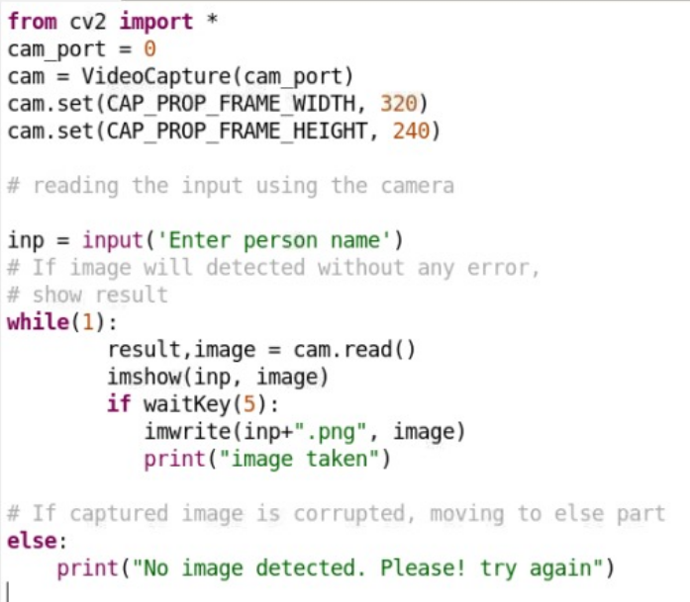

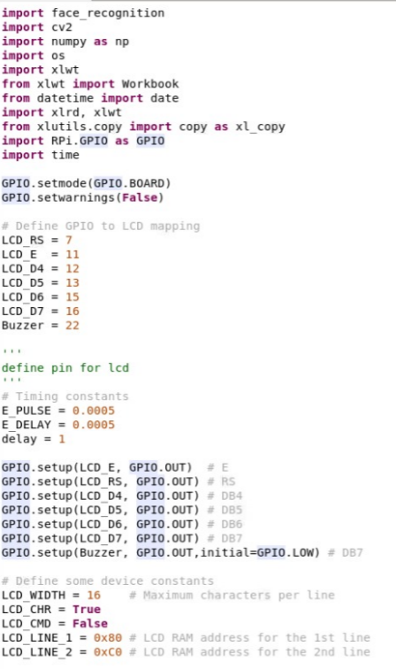

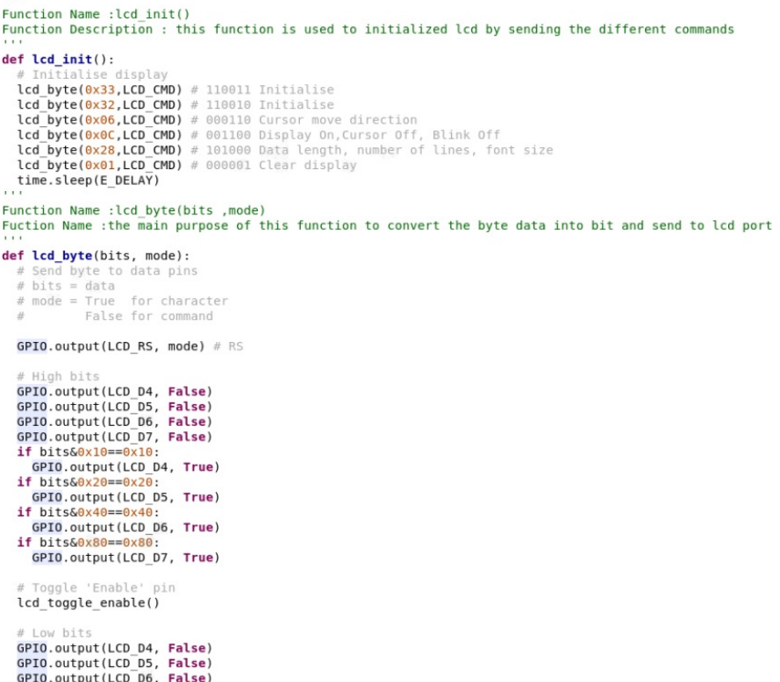

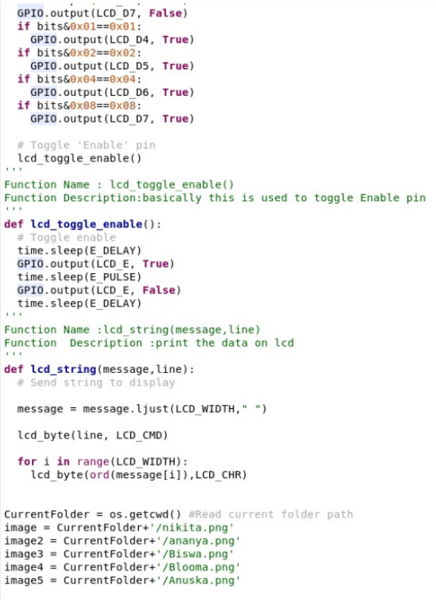

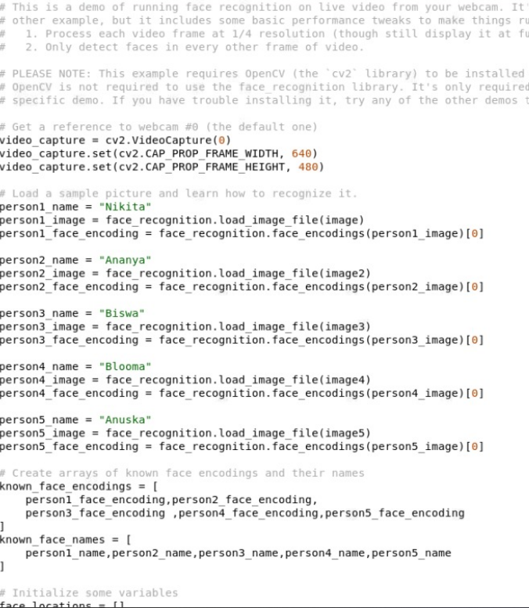

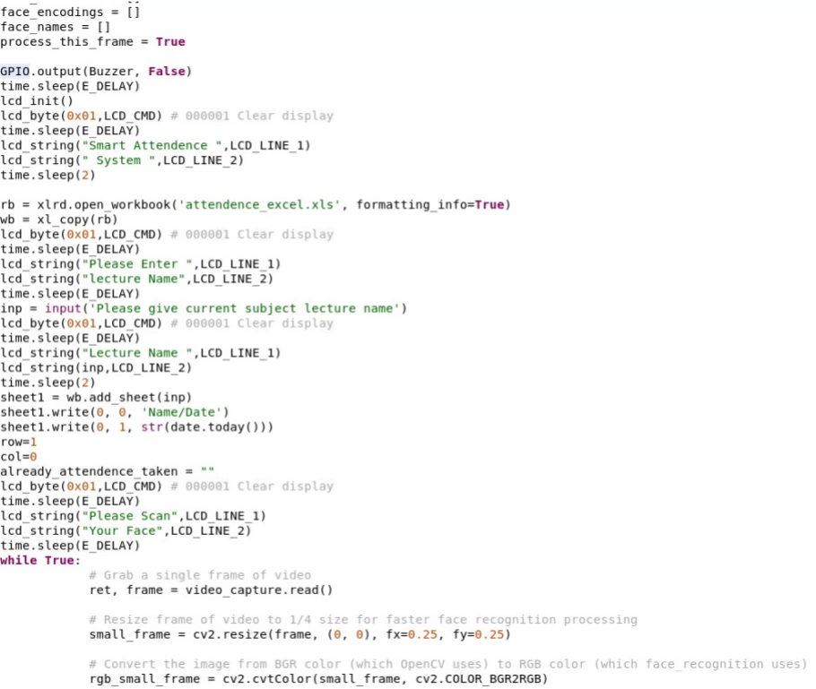

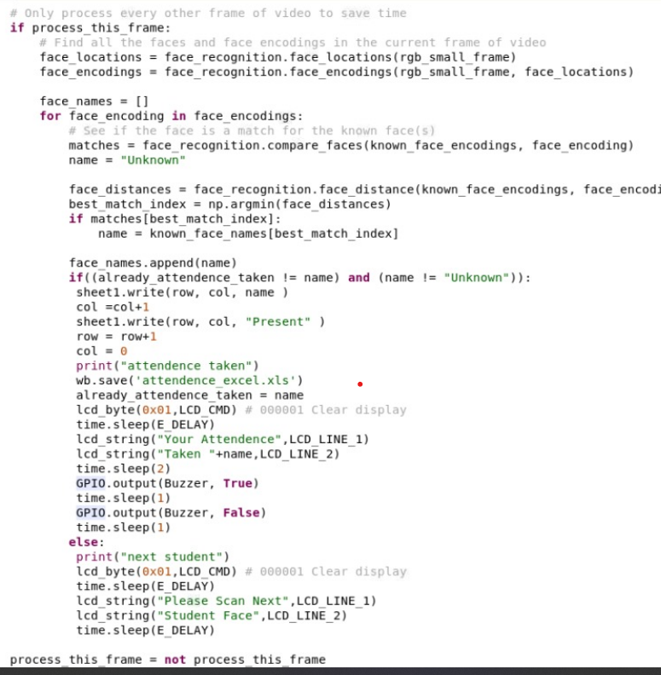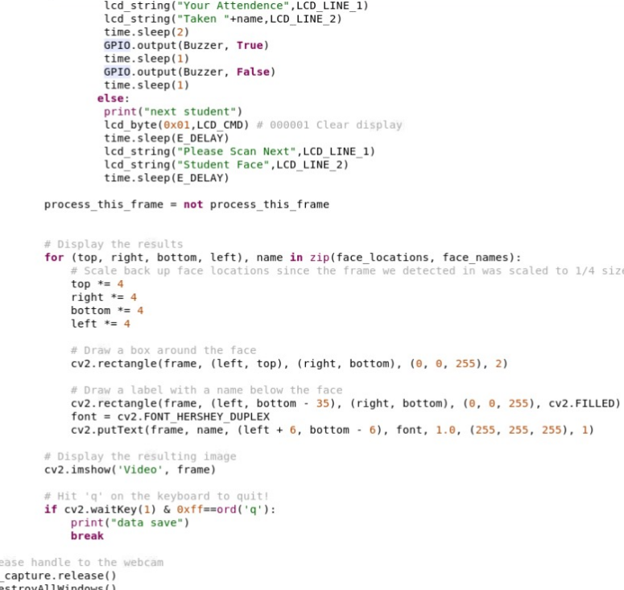

**A01.3. Libraries**

Main libraries installed:

numpy

dlib

opencv/cv2

xlwt , xlrd

datetime

Xlutils

Adafruit

face_recognition

# Appendix 02

## A02.1. Project Proposal Form

The project proposal form was prepared and duly signed from our Faculty-in-Charge Dr.

Biswaranjan Swain. The same is attached at the last of this report.

## A02.2. Project Management

|  |  |  |  |  |  |  |
| --- | --- | --- | --- | --- | --- | --- |
| **#** | **Component** | **Individual Contributions in %** | |  |  | **Total** |
| Ananya | Nikita | Anushka | Blooma |  |
| 1. | Planning | 25% | 25% | 25% | 25% | 100% |
| 2. | Background Research and Analysis | 15% | 15% | 35% | 35% | 100% |
| 3. | Hardware design | 30% | 30% | 20% | 20% | 100% |
| 4. | Software design | 30% | 30% | 20% | 20% | 100% |
| 5. | Testing | 25% | 25% | 25% | 25% | 100% |
| 6. | Final Assembling | 20% | 20% | 30% | 30% | 100% |
| 7. | Project report writing | 15% | 15% | 35% | 35% | 100% |
| 8. | Presentation | 25% | 25% | 25% | 25% | 100% |
| 9. | Logistics | 20% | 20% | 30% | 30% | 100% |
| 10. | Video Making | 25% | 40% | 25% | 10% | 100% |
|  |  |  |  |  |  |  |
|  |  |  |  |  |  |  |

## A02.3. Bill of Material

**Table 1. Component listing.**

|  |  |  |  |  |  |
| --- | --- | --- | --- | --- | --- |
| **#** | **Component** | **Specification** | **Unit Cost** | **Quantity** | **Total** |
| 1. | Raspberry pi kit | Zero 2W | 2800 | 1 | 2800 |
| 2. | Potentiometer | 1W | 90 | 1 | 90 |
| 3. | Jumper Wires | Male to male  Male to female | 90 | 1 pack | 90 |
| 4. | Breadboard | - | 139 | 1 | 139 |
| 5. | LCD Display | 16 x 2 | 179 | 1 | 179 |
| 6. | Camera Module | 5MP | 400 | 1 | 400 |
|  |  |  |  |  |  |
|  |  |  |  |  |  |
|  |  | **Grand Total** | | | 3698 |

# Appendix 03

## A03.1. Data Sheets

**Raspberry Pi Zero 2 W**

Published October 2021

The terms HDMI, HDMI High-Definition

Multimedia Interface, and the HDMI Logo

are trademarks or registered trademarks

of HDMI Licensing Administrator, Inc.

Raspberry Pi (Trading) Ltd

Raspberry Pi Zero 2 W – Raspberry Pi (Trading) Ltd 2

**Overview**

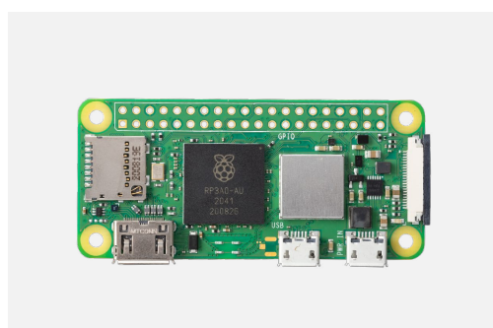

Raspberry Pi Zero 2 W is the latest product in our most affordable range of single-board

computers. The successor to the breakthrough Raspberry Pi Zero W, Raspberry Pi Zero 2 W

is a form factor–compatible drop-in replacement for the original board.

The board incorporates a quad-core 64-bit Arm Cortex-A53 CPU, clocked at 1GHz.

At its heart is a Raspberry Pi RP3A0 system-in-package (SiP), integrating a Broadcom

BCM2710A1 die with 512MB of LPDDR2 SDRAM. The upgraded processor provides

Raspberry Pi Zero 2 W with 40% more single-threaded performance, and five times more

multi-threaded performance, than the original single-core Raspberry Pi Zero.

Raspberry Pi Zero 2 W offers 2.4GHz 802.11 b/g/n wireless LAN and Bluetooth 4.2, along

with support for Bluetooth Low Energy (BLE), and modular compliance certification.

The board has a microSD card slot, a CSI-2 camera connector, a USB On-The-Go (OTG)

port, and an unpopulated footprint for a HAT-compatible 40-pin GPIO header. It is powered

via a micro USB socket. Video output is via a mini HDMI port; composite video output

can easily be made available via test points if needed.

Sharing the same form factor as the original Raspberry Pi Zero, Raspberry Pi Zero 2 W

fits inside most existing Raspberry Pi Zero cases.

Raspberry Pi Zero 2 W – Raspberry Pi (Trading) Ltd 3

**Specification**

Form factor: 65mm × 30mm

Processor: Broadcom BCM2710A1, quad-core 64-bit SoC

(Arm Cortex-A53 @ 1GHz)

Memory: 512MB LPDDR2

Connectivity: • 2.4GHz IEEE 802.11b/g/n wireless LAN, Bluetooth 4.2, BLE,

onboard antenna

• 1 × USB 2.0 interface with OTG

• HAT-compatible 40-pin I/O header footprint

• microSD card slot

• Mini HDMI port

• CSI-2 camera connector

Video: • HDMI interface

• Composite video

Multimedia: • H.264, MPEG-4 decode (1080p30)

• H.264 encode (1080p30)

• OpenGL ES 1.1, 2.0 graphics

Input power: 5V DC 2.5A

Operating temperature: -20°C to +70°C

Production lifetime: Raspberry Pi Zero 2 W will remain in production until at least

January 2028

Compliance: For a full list of local and regional product approvals,

please visit pip.raspberrypi.com

Raspberry Pi Zero 2 W – Raspberry Pi (Trading) Ltd 4

Physical specification

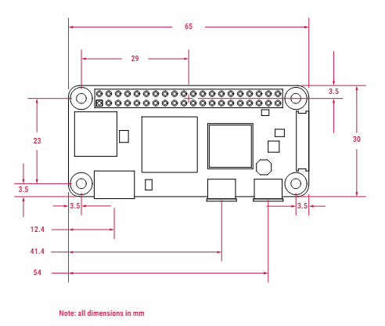

WARNINGS

• Any external power supply used with Raspberry Pi Zero 2 W shall comply with relevant regulations and standards

applicable in the country of intended use.

• This product should be operated in a well-ventilated environment, and if used inside a case, the case should not

be covered.

• Whilst in use, this product should be placed on a stable, flat, non-conductive surface, and should not be contacted

by conductive items.

• The connection of incompatible devices to Raspberry Pi Zero 2 W may affect compliance, result in damage to the unit,

and invalidate the warranty.

• All peripherals used with this product should comply with relevant standards for the country of use and be marked

accordingly to ensure that safety and performance requirements are met. These articles include but are not limited to

keyboards, monitors, and mice when used in conjunction with Raspberry Pi Zero 2 W.

• The cables and connectors of all peripherals used with this product must have adequate insulation so that relevant

safety requirements are met.

SAFETY INSTRUCTIONS

To avoid malfunction or damage to this product, please observe the following:

• Do not expose to water or moisture, or place on a conductive surface whilst in operation.

• Do not expose to heat from any source; Raspberry Pi Zero 2 W is designed for reliable operation at normal

ambient temperatures.

• Take care whilst handling to avoid mechanical or electrical damage to the printed circuit board and connectors.

• Whilst it is powered, avoid handling the printed circuit board, or only handle it by the edges to minimise the risk of

electrostatic discharge damage.

Raspberry Pi Zero 2 W – Raspberry Pi (Trading) Ltd 5

Raspberry Pi is a trademark of Raspberry Pi (Trading) Ltd