1.

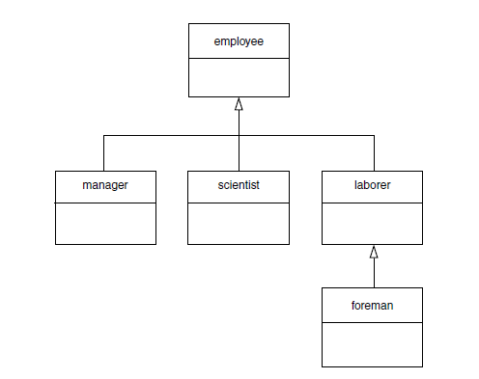

Write a program in C++ to demonstrate inheritance as depicted in above diagram.

2. Write a program that show that two files named ‘Source 1’ and ‘Source 2’ contains sorted list of integers. Read the content of both the files and stores the merged list in sorted form in a new file named ‘Target’.

3. Write a program demonstrating the results of hybrid inheritance

a) without using virtual function

b) using virtual function

4. Write a program to multiply two 2-dimensional matrices using pointers only.

5. Write a program to show the implementation of any three types of functions that you have studied in lectures.

6. Write a program demonstrating the use of polymorphism and friend function simultaneously.

7. Write a program to show the overloading of all types of virtual functions.

8. Write a program showing 3 different levels or positions of static and automatic variables and their consecutive results.

9. Write a program showing the ambiguity of inheritance and its resolution.

10. Write a program to demonstrate overloaded late binding.