**S.D.M.E. Society’s**

**S.D.M. COLLEGE OF ENGINEERING AND**

**TECHNOLOGY DAVALAGIRI, DHARWAD-580002**



(AFFLIATED TO VISVESVARAYA TECHNOLOGY UNIVERSITY)

# Introductory Project Synopsis:

# Library Management System

Course subject professor:

Dr. Vandana Bhat

Professor, Department of Information Science And Engineering

Submitted By: Group No 5

Ananya R Upadhya 2SD21IS006

Priya Mannur 2SD21IS036

Vaishnavi Hegde 2SD21IS057

Aditi Kulkarni 2SD21IS003

Trupti Hasbhi 2SD21IS052

Nisarga Kulkarni 2SD21IS028

**Synopsis**

**Abstract:**

This synopsis presents a Library Management System that employs data structures such as linked lists and binary search trees (BST) to efficiently handle book organization, borrowing, and returning operations. The system aims to streamline the management of library resources, enhance accessibility, and optimize overall operational efficiency. This synopsis outlines the problem statement, objectives, methodology, and expected conclusions of the project.

**Introduction:**

Libraries play a crucial role in providing access to knowledge and fostering a learning environment. Efficient management of library resources and operations is essential for smooth functioning. This project proposes a Library Management System that leverages data structures to store and retrieve book information effectively. By implementing linked lists and binary search trees, the system aims to enhance the organization of books and improve the efficiency of borrowing and returning operations.

**Problem Statement:**

The traditional manual systems for managing library resources often suffer from inefficiencies, including time-consuming book organization, difficulties in book retrieval, and delays in the borrowing and returning processes. The lack of a centralized system leads to errors, loss of books, and challenges in maintaining accurate records. Therefore, there is a need for an automated Library Management System that utilizes appropriate data structures to address these issues.

**Objectives:**

1. Develop a Library Management System that efficiently organizes book information using data structures such as linked lists and binary search trees.

2. Enable quick and accurate retrieval of book information based on various search criteria, including title, author, genre, and ISBN.

3. Implement a robust borrowing and returning module that ensures seamless transactions and tracks book availability in real-time.

4. Facilitate user-friendly interfaces for both library staff and patrons, enabling easy navigation, search, and transaction management.

5. Enhance overall operational efficiency, reduce manual efforts, and improve the user experience in the library.

**Methodology:**

1. Conduct a thorough analysis of existing library management systems and identify the limitations and challenges they face.

2. Design and develop a Library Management System using appropriate data structures, including linked lists for book cataloguing and binary search trees for sorted retrieval.

3. Implement modules for book borrowing and returning, ensuring real-time updates of book availability.

4. Create intuitive user interfaces for staff to manage book organization and operations and for patrons to search and borrow books.

5. Test the system extensively, evaluating its performance, scalability, and robustness.

6. Collect feedback from library staff and patrons to identify areas for improvement and incorporate necessary enhancements.

**Flow Chart- LIBRARY MANAGEMENT SYSTEM:**

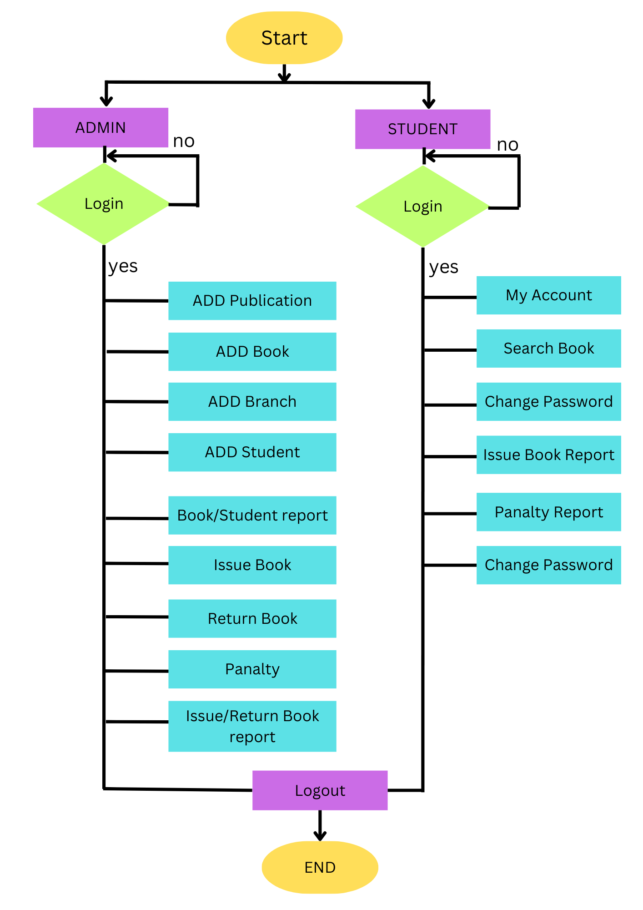

**Conclusion:**

The proposed Library Management System utilizing data structures provides an efficient solution to overcome the limitations of traditional manual systems. By implementing linked lists, hash tables, and binary search trees, the system enhances book organization, enables quick retrieval of book information, and streamlines borrowing and returning operations. The project aims to optimize overall operational efficiency and improve the user experience in the library, ultimately fostering a more effective knowledge-sharing environment.

**References:**

[1]. Ashutosh Tripathi & Ashish Srivastava, The Online Library Management System IOSR Journal of Engineering (IOSRJEN), Vol. 2 Issue 2, Feb.2012

[2]. A.Thendral Mary, S.Ramya, Mr.S.Krishna Murthy, Dr.A.Valarmathi, IJCRT | Volume 5, Issue 4 October 2017 | ISSN: 2320-2882 IJCRT1704024 International Journal of Creative Research Thoughts (IJCRT), ENHANCED LIBRARY MANAGEMENT SYSTEM. 2017

[3]. Ayodeji Iwayemi , Sulaimon Oyeniyi Adebayo, International Journal of Computer Applications (0975 – 8887) Volume 178 – No. 12, May 2019 Development of a Robust Library Management System.

[4] A.D. Liwen Liu, Management of an academic e-libray project, International Conference on Information Management, Innovation Management and Idustrial Engineering, vol.54(8),pp.62-71,2011.

[5] Prof. B.A. Jadhawar, Komal A. Bhosale, Research Paper on Java Interactional Development Environment Programming Tool, International Advanced Research Journal in Science, Engineering and Technology, Volume 4, Special Issue 4, January 2017.

[6] Tsega Weldu Araya, Ass. Pro. Adhana Mengsteab, International Journal of Engineering Research & Technology (IJERT), (This work is licensed under a Creative Commons Attribution 4.0 International License.), Vol. 9 Issue 10, October-2020