

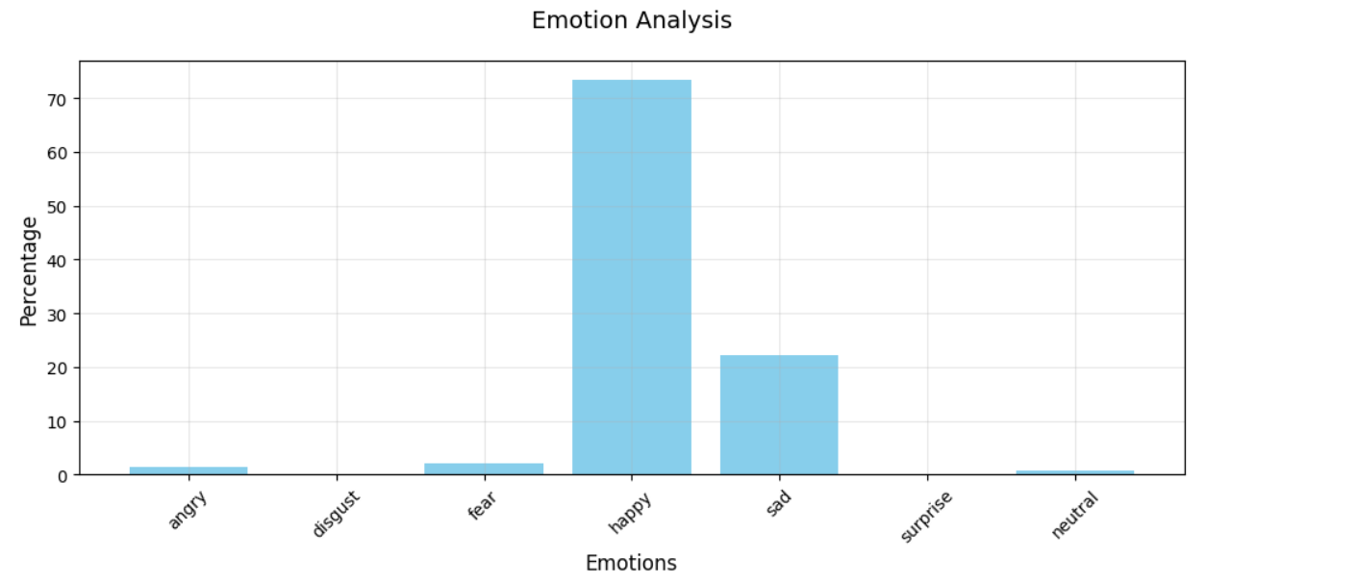

🎭 Based on your dominant emotion (HAPPY), here are your personalized recommendations:

🎵 International Songs:

1. Feel Good Inc. by Gorillaz

🎧 Listen on Spotify: <https://open.spotify.com/track/0d28khcov6AiegSCpG5TuT>

2. Pink Pony Club by Chappell Roan

🎧 Listen on Spotify: <https://open.spotify.com/track/1k2pQc5i348DCHwbn5KTdc>

3. Summer Breeze by Seals and Crofts

🎧 Listen on Spotify: <https://open.spotify.com/track/01UYpHuzHi4eB9PAbDoPY2>

4. Happy Hits by Weekend Hangouts

🎧 Listen on Spotify: <https://open.spotify.com/track/1weF7SQay590RaoQWBz7MT>

5. Up Down (Do This All Day) (feat. B.o.B) by T-Pain

🎧 Listen on Spotify: <https://open.spotify.com/track/6lbhWl34Il0WXm5pX1fM9E>

🎵 Bollywood Songs:

1. Bollywood Party Vibes by Bollywood Slowed And Reverb

🎧 Listen on Spotify: <https://open.spotify.com/track/63d6meFEBfOalWDXNeM0zF>

2. Bollywood Party by Loka

🎧 Listen on Spotify: <https://open.spotify.com/track/6bTc085fPMf8HfB3HZzeKx>

3. deepika by KOAD

🎧 Listen on Spotify: <https://open.spotify.com/track/6nxnPtHEyhIzNaKZQMU3ns>

4. Balam Pichkari by Pritam

🎧 Listen on Spotify: <https://open.spotify.com/track/18e3XXYCv4Tx8uUl1mP3CN>

5. Bollywood Wedding Dance by Bollywood Slowed And Reverb

🎧 Listen on Spotify: <https://open.spotify.com/track/48vLx5kQI0c83E8l2IY4Bi>

🎬 Netflix Recommendations:

1. 10 jours en or

📺 Type: Movie

🎭 Genre: Comedies, Dramas, International Movies

👥 Cast: Franck Dubosc, Claude Rich, Marie Kremer, Mathis Touré, Rufus, Olivier Claverie

📝 Description: When a carefree bachelor is unexpectedly left in charge of a young boy, the two embark on a road trip that will change both of their lives....

2. Miss Dynamite

📺 Type: TV Show

🎭 Genre: Crime TV Shows, International TV Shows, Spanish-Language TV Shows

👥 Cast: Camila Sodi, Iván Sánchez, José María de Tavira, Hugo Stiglitz, José Sefami, Mauricio Isaac, Paulina Gaitán, Mara Cuevas, Mario Zaragoza, Alejandro Durán, Emilio Savinni, Pakey Vázquez, Anilú Pardo, Claudette Maillé, Rodrigo Murray, Camila Selser, Saúl Lisazo, Eréndira Ibarra

📝 Description: Wealthy, beautiful Valentina falls in love, only to realize that her man and her family are involved with one of Mexico's most powerful drug cartels....

3. Monty Python Live (Mostly): One Down, Five to Go

📺 Type: Movie

🎭 Genre: Comedies

👥 Cast: John Cleese, Terry Gilliam, Eric Idle, Terry Jones, Michael Palin

📝 Description: Live from London in a sold-out final show, surviving members of the British comedy troupe reprise old roles and break out in irreverent song and dance....

4. What's Up?

📺 Type: Movie

🎭 Genre: Comedies, Dramas, International Movies

👥 Cast: Hisham Abdulrahman, Turki Al-Yusuf, Mais Hamdan, Khaled Sami, Mishal Al-Mutairi, Hind Muhamed

📝 Description: Flirting with modernity, a young woman must keep her new romance a secret from her conservative brother, who plans to keep her in line with tradition....

5. Welcome to Sajjanpur

📺 Type: Movie

🎭 Genre: Comedies, Dramas, International Movies

👥 Cast: Shreyas Talpade, Amrita Rao, Ravi Kishan, Ila Arun, Rajeshwari Sachdev, Divya Dutta, Yashpal Sharma, Ravi Jhankal, Lalit Mohan Tiwari

📝 Description: An educated man assists the illiterate residents of his village with written correspondence, sometimes manipulating the letters to suit his interests....