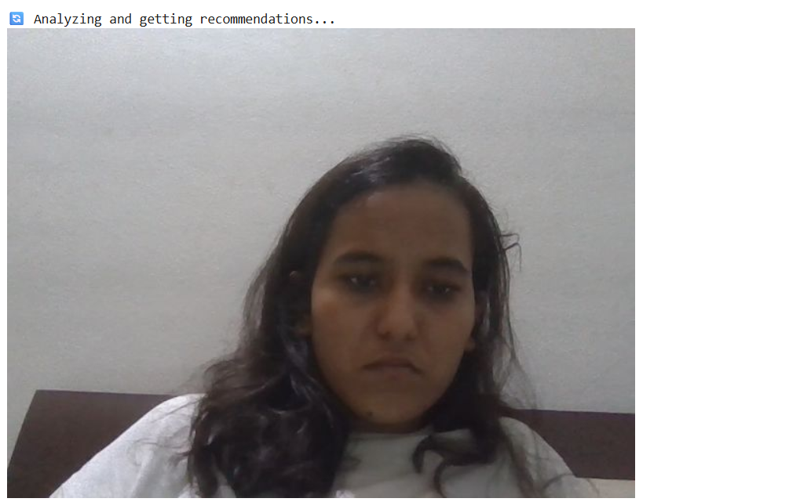

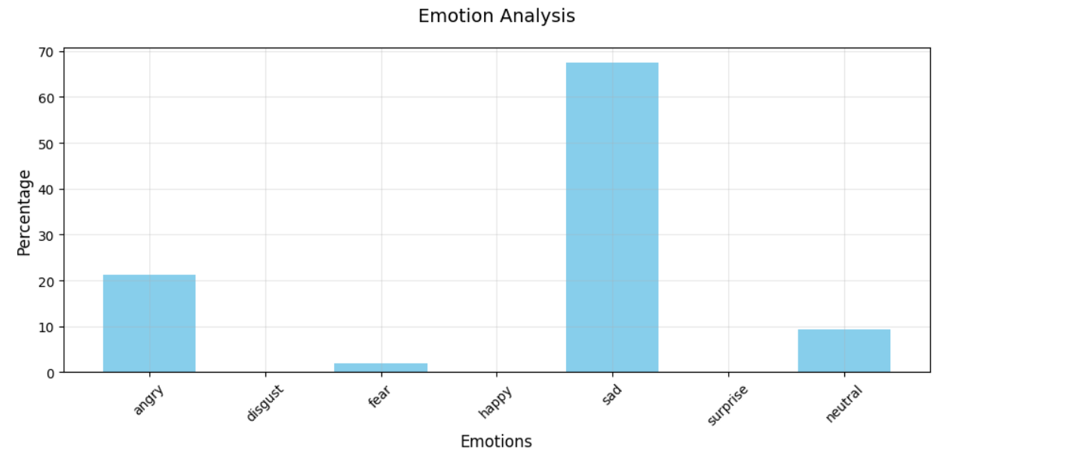

🎭 Based on your dominant emotion (SAD), here are your personalized recommendations:

🎵 International Songs:

1. Emotionally Scarred by Lil Baby

🎧 Listen on Spotify: <https://open.spotify.com/track/7ge7BHazYbVKi8qyZUX1Bm>

2. Heartbreak Anniversary by GIVĒON

🎧 Listen on Spotify: <https://open.spotify.com/track/2QfznFotJNZmnIEYFdzE5T>

3. Heartbreaker by Warren Zeiders

🎧 Listen on Spotify: <https://open.spotify.com/track/4k0pqjIpfO7WV3eFUTgL9m>

4. On Melancholy Hill by Gorillaz

🎧 Listen on Spotify: <https://open.spotify.com/track/0q6LuUqGLUiCPP1cbdwFs3>

5. melancholyism. by Super Whatevr

🎧 Listen on Spotify: <https://open.spotify.com/track/60w2EqVhEnedIgZLtIONnU>

🎵 Bollywood Songs:

1. deepika by KOAD

🎧 Listen on Spotify: <https://open.spotify.com/track/6nxnPtHEyhIzNaKZQMU3ns>

2. Tumhi Dekho Naa - Sitar Lofi by Rishab Rikhiram Sharma

🎧 Listen on Spotify: <https://open.spotify.com/track/3fc3piWEXs8OoJ0oTIrs5V>

3. Bollywood Emotional Songs by Bollywood Slowed And Reverb

🎧 Listen on Spotify: <https://open.spotify.com/track/63kimJT3uHpoHxMeuwuSB0>

4. deepika by KOAD

🎧 Listen on Spotify: <https://open.spotify.com/track/6nxnPtHEyhIzNaKZQMU3ns>

5. Bhor Yahaan by Lofi Origin

🎧 Listen on Spotify: <https://open.spotify.com/track/3KULByf4n4182VcIZbPbf1>

🎬 Netflix Recommendations:

1. NOVA: Killer Volcanoes

📺 Type: Movie

🎭 Genre: Documentaries

👥 Cast: Craig Sechler

📝 Description: Evidence of a mysterious medieval famine leads researchers on a quest for one of the deadliest volcanoes in human history....

2. Invisible City

📺 Type: TV Show

🎭 Genre: Crime TV Shows, International TV Shows, TV Dramas

👥 Cast: Marco Pigossi, Alessandra Negrini, Fábio Lago, Jéssica Córes, Jimmy London, Wesley Guimarães, Áurea Maranhão, Julia Konrad, Thaia Perez, Manu Dieguez, José Dumont, Tainá Medina, Rafael Sieg, Samuel de Assis, Victor Sparapane

📝 Description: After a family tragedy, a man discovers mythical creatures living among humans — and soon realizes they hold the key to his mysterious past....

3. Saath Saath

📺 Type: Movie

🎭 Genre: Dramas, Independent Movies, International Movies

👥 Cast: Deepti Naval, Farooq Shaikh, Satish Shah, Iftekhar, A.K. Hangal, Neena Gupta, Avtar Gill, Javed Khan

📝 Description: A young woman falls for her classmate’s idealistic, non-materialistic ways, but is troubled upon seeing his principles change after they marry....

4. Trixie Mattel: Moving Parts

📺 Type: Movie

🎭 Genre: Documentaries, Music & Musicals

👥 Cast: Brian Firkus

📝 Description: Drag queen Trixie Mattel deals with the bittersweet reality of success in this documentary that explores her rise to fame and subsequent music career....

5. Baahubali 2: The Conclusion (Malayalam Version)

📺 Type: Movie

🎭 Genre: Action & Adventure, Dramas, International Movies

👥 Cast: Prabhas, Rana Daggubati, Anushka Shetty, Tamannaah Bhatia, Sathyaraj, Ramya Krishnan, Nassar, Subbaraju

📝 Description: To avenge his father's death, a young man leads an army into battle against a cruel tyrant in this Malayalam conclusion to the historic saga....