SonarQube Report
Before:
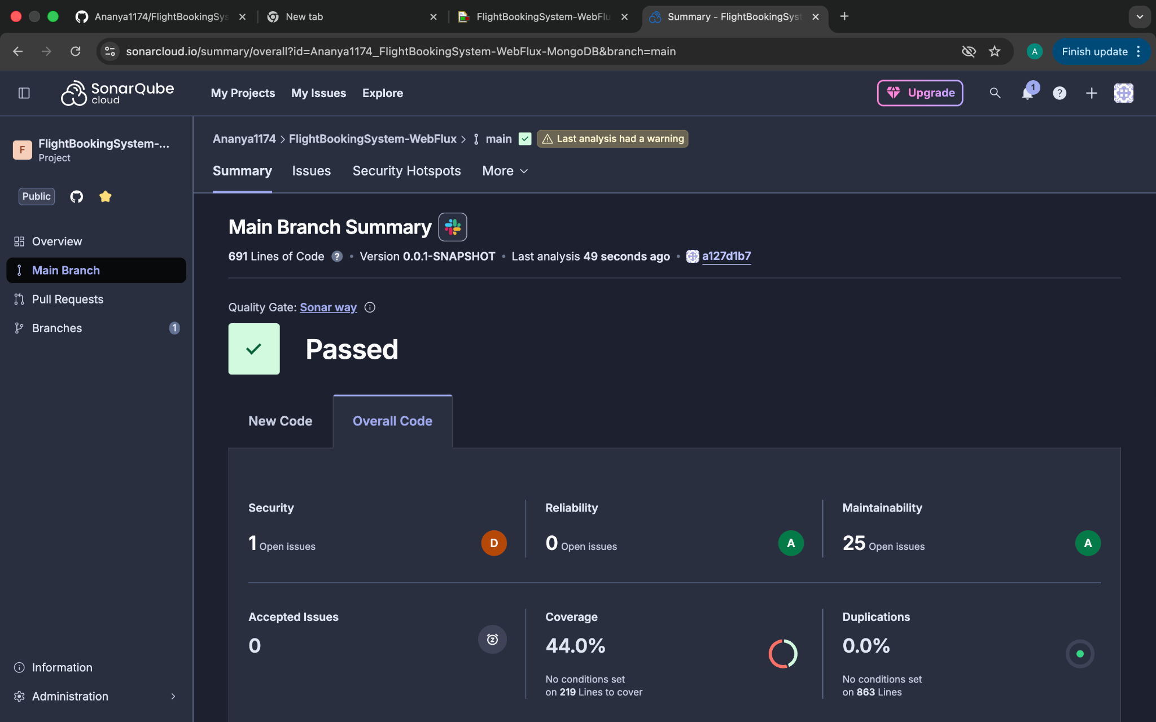
After:
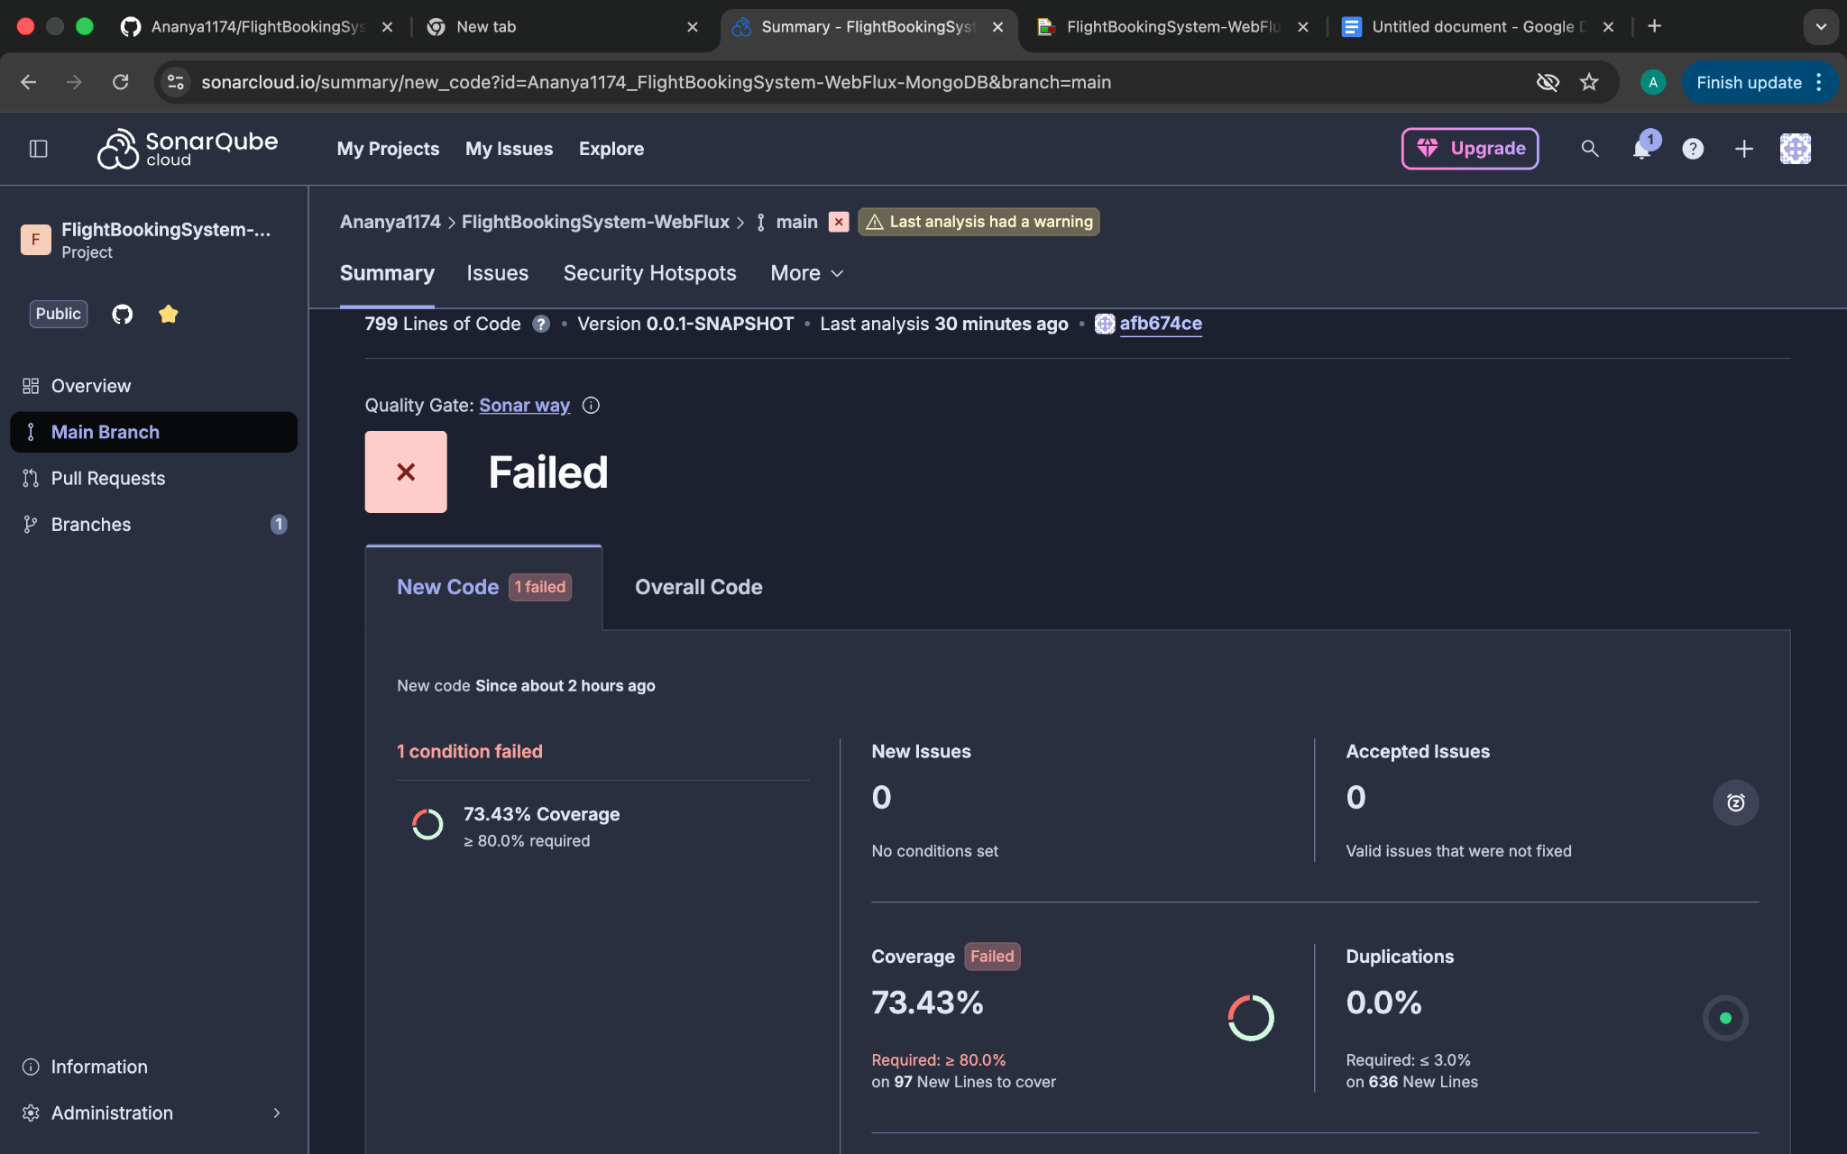

Jacoco Report:
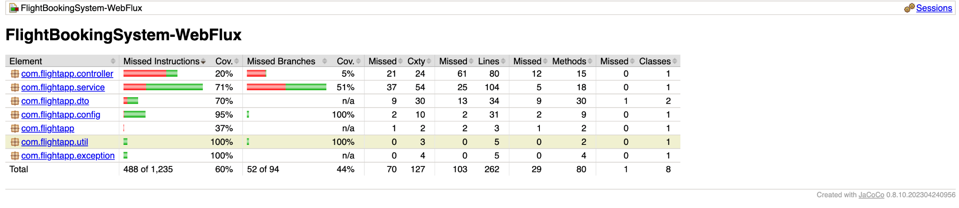

Jmeter Screenshots: Get history by email: Summary Report:
20 requests:
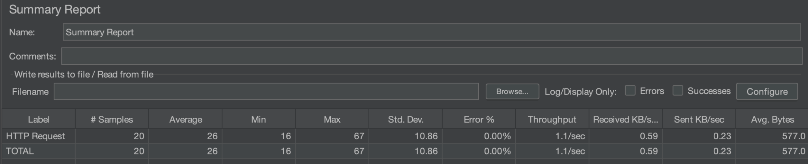
50 requests:
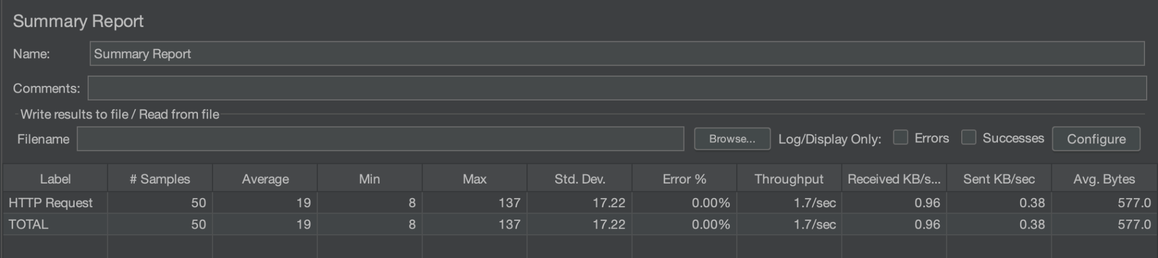
100 requests:
