MIS MODULE 1
SAIM THAKUR

Computer-Based Information Systems (CBIS)
A Computer-Based Information System (CBIS) is a system that uses computers and technology to process data into information and ultimately into knowledge.
It helps organizations in decision-making, operations, and planning.
Key Concepts of CBIS
- Data → Information → Knowledge
  - Data: Raw facts (e.g., numbers, names).
  - Information: Processed data with meaning.
  - Knowledge: Insights gained from information.
- Managing IS is complex because:
  - It has high strategic value.
  - Systems are expensive to acquire, operate, and maintain.
  - IS functions evolve continuously with technology.

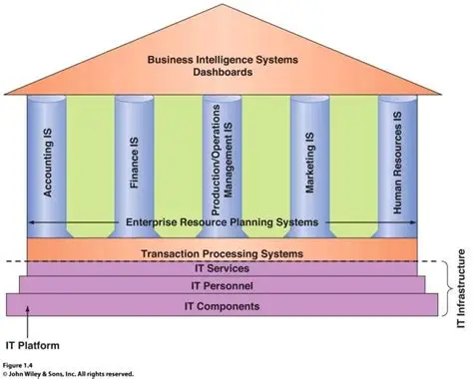

Components of a CBIS
A CBIS is made up of six main parts:
- Hardware → Physical devices (computers, servers, storage, etc.).
- Software → Programs and applications that run on hardware.
- Database → Organized collection of related data.
- Network → Connectivity between computers and devices for communication.
- Procedures → Rules, methods, and guidelines for using the system.
- People → Users, IT staff, managers, and developers.

CBIS can be categorized into two perspectives:
A. Breadth of Support for Information Systems
- Functional Area Information Systems (FAIS)
  - Supports a single department or function.
  - Example:
    - HR System (for employee records, payroll).
    - Marketing System (for managing advertisements, campaigns).
  - 🎯 Focus = One area at a time.
- Enterprise Resource Planning (ERP)
  - Combines all departments into one system.
  - Everyone uses the same database (Finance, HR, Sales, Production).
  - Example: SAP, Oracle ERP.
  - 🎯 Focus = Integration of the whole company.
- Transaction Processing Systems (TPS)
  - Handle everyday routine tasks of a business.
  - Example:
    - ATM transactions.
    - Online ticket booking.
    - Billing at a supermarket.
  - 🎯 Focus = Day-to-day operations.
- Interorganizational Information Systems (IOS)
  - Connects two or more organizations (e.g., company ↔ supplier ↔ customer).
  - Example:
    - Amazon with suppliers and customers.
    - B2B portals (business-to-business).
  - 🎯 Focus = Collaboration between organizations.
- E-Commerce Systems
  - Support buying and selling online.
  - Example: Flipkart, Amazon, Myntra.
  - 🎯 Focus = Electronic business transactions.
B. Support for Organizational Employees
- Knowledge Workers Systems (KWS)
  - Help people who create or use knowledge.
  - Example: Researchers using data analysis software, architects using design tools.
  - 🎯 Focus = Creativity & expertise.
- Office Automation Systems (OAS)
  - Make office work easier and faster.
  - Example: MS Office, Email, Google Workspace.
  - 🎯 Focus = Productivity in office tasks.
- Business Intelligence (BI) Systems
  - Help managers take better decisions using data.
  - Tools:
    - OLAP → Multidimensional analysis.
    - Data Mining → Find patterns & trends.
    - DSS (Decision Support Systems) → Try “what-if” analysis.
  - 🎯 Focus = Better decision-making.
- Expert Systems (ES)
  - Work like a human expert in a specific field.
  - Example: Medical diagnosis system, troubleshooting software.
  - 🎯 Focus = Mimic expert decision-making.
- Dashboards
  - Show important information at a glance (charts, KPIs, trends).
  - Example: Sales dashboard, Website analytics dashboard.
  - 🎯 Focus = Quick overview for managers.

Impact of IT on Organizations
1. Reduction of Middle Managers
- Many routine tasks (like approving leaves, preparing reports, or monitoring inventory) are now automated using IT systems.
- This means fewer managers are needed to handle these repetitive tasks.
- Example:
  - Earlier: A manager would manually track employee attendance and prepare salary reports.
  - Now: Payroll and HR software automatically generates reports.
- ✅ Result: The organizational hierarchy becomes flatter (fewer levels of management).
2. Changing the Manager’s Job
- Managers spend less time on routine paperwork and more on strategic thinking, problem-solving, and planning.
- IT provides real-time data and dashboards that help in making faster and more accurate decisions.
- Example:
  - A sales manager can see live sales trends from different regions on a dashboard instead of waiting for monthly reports.
- ✅ Result: Managers focus on decision-making, innovation, and long-term goals rather than daily operational control.
3. Job Concerns for Employees
- IT and automation raise fears about job loss because machines and software can replace humans in many roles.
- At the same time, IT creates new types of jobs (e.g., data analysts, cybersecurity experts, AI engineers).
- Example:
  - Bank tellers replaced by ATMs.
  - But at the same time, new jobs created in IT support and online banking services.
- ✅ Result: IT changes the nature of jobs, some vanish, while new opportunities emerge.
4. Work Environment & Employees
- Health & Safety: Long working hours on computers may cause eye strain, posture problems, or stress.
- Remote Work: IT enables work-from-home, offering flexibility but also blurring work-life boundaries.
- Accessibility: IT tools help people with disabilities—screen readers for the visually impaired, voice assistants for those with limited mobility.
- Example:
  - Employees with disabilities can now work effectively using assistive technologies.
- ✅ Result: IT has both positive and negative effects on employee well-being.
📌 In summary:
- IT reduces the need for middle management,
- Shifts managers’ roles toward strategic work,
- Creates uncertainty about jobs but also generates new opportunities,
- And significantly shapes the workplace environment—impacting health, flexibility, and inclusivity.

Importance of Information Systems (IS) to society
1. Improves Quality of Life
- Information Systems provide better access to information and services anytime and anywhere.
- Examples: Online banking, e-learning platforms, e-governance, and entertainment services.
- They reduce barriers of distance and time, making life more convenient.
- Personalized recommendations (like in shopping or streaming) make daily activities more efficient and enjoyable.
2. Part of the "Robot Revolution"
- IS forms the backbone of automation, AI, and robotics.
- Routine and repetitive tasks in factories, offices, and homes are increasingly automated.
- Robotics powered by IS helps in industries like manufacturing, logistics, agriculture, and even household chores.
- This leads to increased productivity and efficiency, but also raises questions about the future of work and ethics.
3. Advances in Healthcare
- Telemedicine: IS enables remote consultations, online prescriptions, and healthcare delivery, especially in rural areas.
- Electronic Health Records (EHRs): Securely store and share patient data across hospitals, improving coordination of care.
- AI in Diagnosis and Treatment: IS supports advanced diagnostic tools, predictive analytics, and personalized treatment plans.
- Wearable devices and health apps continuously monitor patient health, empowering people to manage their well-being.
👉 In short, Information Systems are transforming society by enhancing convenience, enabling automation, and revolutionizing sectors like healthcare. They don’t just make processes faster, but also reshape how humans interact with technology, work, and even care for their health.

Organizational Strategy and Information Systems
Organizational Strategy is about how a business responds to its environment and positions itself to achieve competitive advantage.
Information Systems (IS) and Information Technology (IT) play a crucial role in shaping and supporting these strategies.
Business Pressures and Organizational Responses
Organizations face constant pressures that force them to adapt. These pressures can be grouped as follows:
A. Business Pressures
- Market Pressures
  - Globalization: Companies compete not just locally but globally.
  - Changing Workforce: Diverse, mobile, and tech-savvy employees.
  - Powerful Customers: Customers demand higher quality, customization, and lower prices.
- Technology Pressures
  - Rapid Innovation: Technology becomes outdated quickly.
  - Information Overload: Too much data, making it harder to extract useful insights.
- Societal / Political / Legal Pressures
  - Social Responsibility: Pressure to act ethically and sustainably.
  - Government Regulations: Compliance with laws (e.g., data privacy).
  - Security & Terrorism Concerns: Need for IT security systems.
  - Ethical Issues: Data use, employee monitoring, AI ethics.

Porter's Competitive Forces Model
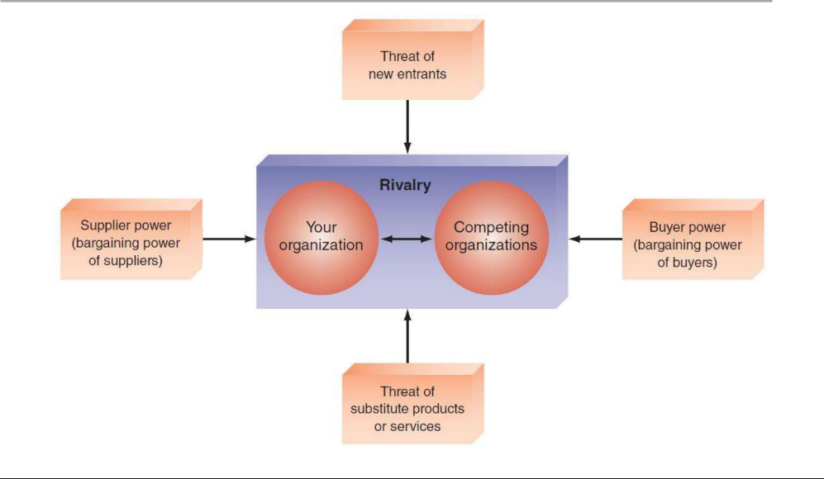
The Five Forces
- Threat of New Entrants
  - New players entering the market increase competition.
  - If entry barriers are low (low cost, few regulations, easy access to technology), new entrants can quickly disrupt existing businesses.
  - Example: Online food delivery startups challenging established restaurants.
  - IS Impact: Information systems can create barriers by providing customer loyalty programs, patents, or operational efficiency that discourage new entrants.
- Bargaining Power of Suppliers
  - Suppliers can influence pricing and availability of resources.
  - If suppliers are few and unique, they have strong power.
  - Example: Intel and AMD having influence over PC manufacturers.
  - IS Impact: IS helps firms diversify their supplier base, use supply chain management systems, and reduce supplier dependency.
- Bargaining Power of Buyers (Customers)
  - Buyers can demand better quality, lower prices, or more services.
  - When customers have many alternatives, their power increases.
  - Example: Consumers choosing between multiple telecom providers.
  - IS Impact: Companies use IS (CRM, personalization, online portals) to improve customer experience and loyalty, reducing buyer power.
- Threat of Substitute Products or Services
  - Substitute products can reduce demand for existing offerings.
  - Example: Online news replacing printed newspapers, or streaming services replacing cable TV.
  - IS Impact: IS helps firms innovate quickly, add value, and differentiate their products so substitutes are less attractive.
- Industry Rivalry (Competitive Rivalry)
  - The intensity of competition among existing players in the industry.
  - High rivalry reduces profitability (price wars, marketing battles, innovation races).
  - Example: Rivalry among smartphone brands like Apple, Samsung, and Xiaomi.
  - IS Impact: Companies use IS for better marketing, operational efficiency, data analytics, and global reach to stay ahead of rivals.
✅ In summary:
Porter’s Five Forces model helps businesses analyze where power lies in an industry and guides them in developing strategies to achieve a competitive advantage.
Role of IS in Porter’s Competitive Forces
1. Threat of New Entrants
- IS Role:
  - Creates barriers to entry by developing strong brand recognition (e.g., Amazon’s recommendation system).
  - Use of databases, patents, and proprietary platforms that are hard to replicate.
  - Automates processes, lowering cost and making it difficult for new entrants to compete on price.
2. Bargaining Power of Suppliers
- IS Role:
  - Supply Chain Management Systems (SCM) enable firms to efficiently manage and diversify suppliers.
  - E-procurement systems allow businesses to find alternative suppliers globally.
  - Real-time tracking ensures transparency and reduces dependency on a single supplier.
3. Bargaining Power of Buyers (Customers)
- IS Role:
  - Customer Relationship Management (CRM) systems enhance loyalty through personalized offers.
  - Data analytics helps in understanding customer needs and reducing switching.
  - Online platforms give more direct communication, improving service quality and response time.
4. Threat of Substitutes
- IS Role:
  - Information systems drive continuous innovation (e.g., Netflix moving from DVD rentals to streaming).
  - Helps in differentiating products with added digital services (mobile apps, IoT integration).
  - Allows quick adaptation to new business models (e.g., Uber replacing traditional taxis).
5. Industry Rivalry (Competitive Rivalry)
- IS Role:
  - Competitive intelligence systems track competitors’ strategies in real time.
  - Advanced analytics and AI help firms optimize pricing and marketing strategies.
  - E-commerce platforms expand customer reach globally, giving competitive advantage.

