MIS MODULE 2

The Database Approach
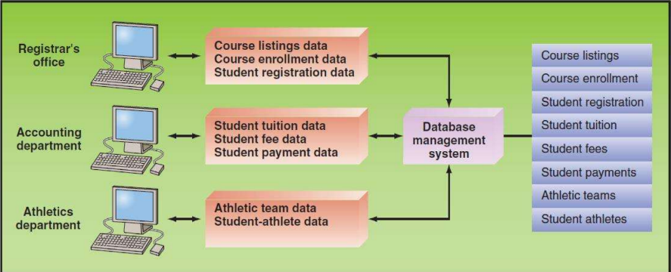
The Database Approach is a way of managing data where information is organized, stored, and accessed systematically using a Database Management System (DBMS).
This method improves efficiency, reduces errors, and ensures data is reliable and secure.
Goals of the Database Approach
DBMS is designed to both minimize problems and maximize benefits:
A. Minimize
- Data Redundancy – Avoid storing the same data in multiple places.
  - Example: Instead of keeping a customer’s address in many files, it’s stored once in the database.
- Data Isolation – Eliminate difficulty in accessing data stored in separate applications.
  - Example: Payroll and HR both need employee data; a centralized database prevents duplication.
- Data Inconsistency – Prevent having different values for the same data.
  - Example: If an employee’s salary is updated in one file but not another → inconsistency arises.
B. Maximize
- Data Security – Protect data from unauthorized access.
  - Example: Role-based access ensures only HR can view salaries.
- Data Integrity – Maintain accuracy and reliability of data.
  - Example: An employee’s age cannot be negative.
- Data Independence – Separate data from the applications that use it.
  - Example: Applications can be updated without affecting the database structure.

Data Hierarchy
The database organizes information into a hierarchical structure:
- Bit → Smallest unit of data (0 or 1).
- Byte → A group of bits (represents a character like “A” or “3”).
- Field → A column in a table, representing an attribute (e.g., Student Name).
- Record → A row in a table, representing one entity (e.g., one student’s details).
- Data File (Table) → A collection of related records (e.g., Student Table).
- Database → A collection of related tables (e.g., University Database with Student & Faculty Tables).
📌 Example:
- University Database → contains Student and Faculty files.
- Student File → has records of individual students.
- Each record has fields like Roll No., Name, Age.

The Relational Database Model
The Relational Database Model is the most common approach used today.
Key Concepts:
- DBMS (Database Management System): Software to create, manage, and use databases.
- Data Model: Defines how data is structured and related.
- Entity: An object or concept (e.g., Student).
- Instance: A specific example of an entity (e.g., Student “John”).
- Attribute: A property of an entity (e.g., Age, Roll No.).
Keys in Relational Databases:
- Primary Key – A unique identifier for each record (e.g., Student Roll No.).
- Secondary Key – Non-unique key used for searching (e.g., Student Name).
- Foreign Key – Connects tables by referencing a primary key in another table (e.g., Course ID in Student Table → links to Course Table).
📌 Example Table: Student Database
Roll No. | Name | Age | Course ID
101 | John | 20 | CSE101
102 | Aisha | 19 | CSE101
103 | Ravi | 21 | MAT202
Here, Roll No. = Primary Key, Name = Secondary Key, Course ID = Foreign Key.

Big Data
Big Data refers to extremely large and complex datasets that challenge the capabilities of traditional data management systems. It is a central concept within Data and Knowledge Management and plays a crucial role in modern decision-making and analytics.
Big Data refers to large, complex, and diverse sets of data that are too big to be processed or analyzed using traditional data management tools (like relational databases or spreadsheets).
It’s not just about the size of data, but also about the speed, variety, and complexity of handling it.
Characteristics of Big Data (The 3Vs)
- Volume
  - Refers to the massive size of datasets.
  - Example: Petabytes of social media posts, sensor readings, or transaction logs.
- Velocity
  - Refers to the speed at which new data is generated and must be processed.
  - Example: Stock market data, IoT device streams, or real-time fraud detection.
- Variety
  - Refers to the diverse formats of data:
    - Structured (e.g., relational databases)
    - Unstructured (e.g., videos, social media posts, images)
    - Semi-structured (e.g., XML, JSON logs)
(Some sources also add Veracity – trustworthiness of data, and Value – business benefit derived from data, making it the “5Vs of Big Data.”)
Issues and Challenges in Big Data
- Untrusted data sources: Data may come from unreliable or inconsistent channels.
- Dirty data: Errors, duplicates, or missing values are common.
- Dynamic nature: Data is constantly changing, especially with real-time streams.
- Scalability issues: Traditional relational databases struggle to manage such data effectively.
Managing and Utilizing Big Data
Big Data, when managed effectively, can unlock hidden patterns, insights, and opportunities:
- Applications:
  - Tracking the spread of diseases
  - Detecting crimes and fraud
  - Predicting consumer behavior
  - Enhancing recommendation systems (e.g., Netflix, Amazon)
- Steps in Managing Big Data:
  - Integration of Information Silos
    - Bringing together fragmented data sources into a unified database environment.
    - Building data warehouses to support decision-making.
  - Analysis and Sense-Making
    - Applying advanced analytics, AI, and machine learning to extract insights.
- Technologies Used:
  - NoSQL Databases (MongoDB, Cassandra, Hadoop, etc.) for unstructured/semi-structured data.
  - Data Warehousing & OLAP for business intelligence.
  - Big Data frameworks (Hadoop, Spark) for distributed storage and processing.

Data Warehouses and Data Marts
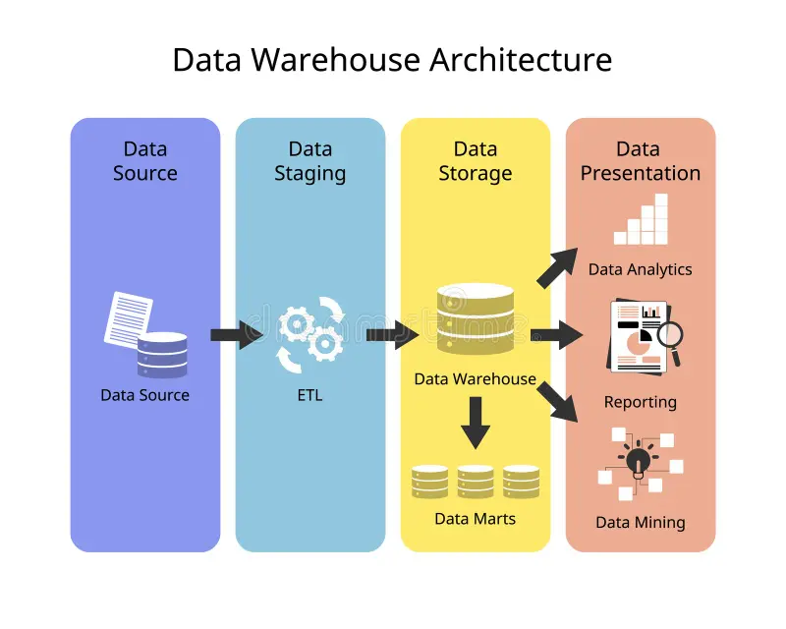
Data Warehouses and Data Marts are core components of Data and Knowledge Management, enabling organizations to handle large volumes of data and transform them into meaningful insights for Business Intelligence (BI) and decision-making.
1. Data Warehouses
A Data Warehouse is a specialized environment designed for Business Intelligence (BI) and Decision Support Systems (DSS).
Key Characteristics:
- Integrated
  - Data is consolidated from multiple operational systems and external sources.
  - Ensures consistency across different formats and sources.
- Time-variant
  - Data is organized along time dimensions (daily, monthly, yearly).
  - Enables trend analysis and historical comparisons.
- Nonvolatile
  - Once data is entered, it is not updated or deleted.
  - Provides a stable historical record for reliable analysis.
- Multidimensional
  - Data is structured to support multidimensional analysis.
  - Uses Online Analytical Processing (OLAP) for slicing, dicing, drilling down, and pivoting.
  - Relational databases can be transformed into data cubes (e.g., sales by product, region, year).
Framework of a Data Warehouse
A complete data warehouse environment includes:
- Source Systems: Operational databases, ERP, CRM, external sources.
- ETL Process (Extraction, Transformation, Load): Cleans, integrates, and loads data.
- Enterprise Data Warehouse (EDW): Central repository for integrated, historical data.
- Metadata Repository: Stores data definitions, structures, and lineage.
- Data Marts: Subsets of the warehouse for departmental use.
- Middleware/Access Layer: Provides tools for queries, reporting, and dashboards.
- BI Applications: DSS, EIS (Executive Information Systems), Reporting tools, OLAP/ROLAP, Data Mining.
2. Data Marts
A Data Mart is a smaller, more focused version of a data warehouse, designed for specific business units or functions.
Key Features:
- Organized around a business dimension (e.g., Marketing, Finance, HR, Supply Chain).
- Supports departmental BI needs with faster, targeted access.
- Often fed from the central data warehouse, but can also exist independently (dependent vs. independent data marts).
- Utilizes OLAP for multidimensional analysis.
.

3. Comparison – Data Warehouse vs. Data Mart
Feature | Data Warehouse | Data Mart
Scope | Enterprise-wide | Department-specific
Size | Very large (TBs–PBs) | Smaller (GBs–TBs)
Users | Top management, analysts, enterprise-wide | Departmental managers, specific teams
Data Source | Multiple enterprise systems | Usually fed from the data warehouse
Complexity | High (enterprise integration) | Lower (focused)
Purpose | Strategic decision-making | Tactical/departmental decision-making

Difficulties of Managing Data Resources
Organizations face multiple challenges in handling their data assets:
- Explosive Growth of Data (Volume)
  - Data increases exponentially over time as organizations collect transactional, operational, social, and sensor-based data.
  - Example: E-commerce platforms generating millions of daily transaction records.
- Data Scattered Across Sources
  - Data often resides in multiple places: internal systems, personal files, cloud storage, and external sources (e.g., suppliers, partners).
  - This fragmentation makes integration and analysis difficult.
- Emergence of New Data Sources
  - Social media, IoT devices, clickstream data, and unstructured formats introduce variety and complexity.
- Data Degradation & Data Rot
  - Over time, data may lose relevance, accuracy, or become corrupted.
  - Example: Customer contact details becoming outdated.
- Data Security, Quality & Integrity Risks
  - Organizations must safeguard data from unauthorized access, hacking, and accidental corruption.
- Changing Legal & Regulatory Requirements
  - Data protection laws (e.g., GDPR in Europe, HIPAA in healthcare) differ across industries and countries, requiring compliance and constant updates.

Establishing an Information Policy (Data Governance)
To overcome these challenges, organizations adopt information policies within a broader Data Governance framework.
Data Governance
- Ensures accountability and control over enterprise data.
- Involves Master Data Management (MDM) to maintain consistent and reliable “master data” (e.g., customer, supplier, product details).
- Governance is considered a core component of any data warehouse environment.
Privacy Codes & Policies
- Policies define how data—especially personal information—is collected, stored, and used.
- Opt-in Model: Users explicitly grant permission before their data is used.
- Opt-out Model: Users’ data can be used unless they explicitly request otherwise.
- P3P (Platform for Privacy Preferences): A technical framework that allows websites to communicate their privacy practices to users’ browsers.
Privacy Policy Guidelines
Policies typically cover:
- Data Collection
  - Only gather data for legitimate business purposes.
  - Ensure data is adequate, relevant, and not excessive.
- Data Confidentiality
  - Enforce physical, technical, and administrative security measures to prevent unauthorized access.
  - Define rules for how long data is stored, disclosed, or maintained.
- Transparency in Data Usage
  - Organizations must clarify:
    - Where records are stored.
    - How accuracy is ensured.
    - Who has access to data.
    - Under what conditions data may be shared or sold.

Ensuring Data Quality
High-quality data is the foundation for accurate decision-making.
What Defines Data Quality?
- Accuracy & Reliability: Data must reflect real-world facts correctly.
- Consistency: Data must be uniform across systems.
- Timeliness: Data must be up-to-date and available when needed.
Role of DBMS in Data Quality
A Database Management System (DBMS) supports data quality by:
- Maximizing → Security, Integrity, Independence.
- Minimizing → Redundancy, Isolation, Inconsistency.
Data Quality in Data Warehouses
- In data warehouse environments, data quality is an explicit, essential component.
- ETL processes ensure cleansing, standardization, and validation before loading.
Maintaining Data Accuracy (Privacy Guidelines)
- Verify sensitive personal data before entry.
- Keep records current and necessary.
- Make data accessible for correction when disputes arise.
- Note disagreements or alternative versions provided by individuals.
Combating Data Degradation
- Regular updates and audits are needed to address data rot (e.g., outdated records, broken links, expired references).

Business Intelligence (BI)
Business Intelligence (BI) plays a crucial role in enabling organizations to make informed decisions by transforming raw data into meaningful insights. It encompasses various applications and processes for data analysis and the presentation of results.
BI for Data Analytics
These applications analyze and process data to uncover insights.
- OLAP (Online Analytical Processing)
→ Lets you view and analyze data from multiple dimensions (e.g., sales by region, product, time).
→ Works with data cubes in data warehouses.
- Data Mining
→ Finds hidden patterns and relationships in data.
→ Two main purposes:
  - Prediction: Forecast future trends/behaviors.
  - Discovery: Find new, unknown patterns.
- Decision Support Systems (DSS)
→ Provide managers with tools for "what-if" analysis, sensitivity testing, and goal-seeking to make better decisions.

BI for Presenting Results
Once data is analyzed, BI tools present the results so managers can understand and act on them.
- Dashboards
→ Provide a visual snapshot of KPIs and metrics.
→ Features include:
  - Drill-down (see details behind summary data)
  - CSFs (Critical Success Factors)
  - KPIs (Key Performance Indicators)
  - Real-time status updates
  - Trend analysis & exception reporting
- Data Visualization
→ Converts complex data into graphs, charts, maps for easier understanding.
→ Examples: GIS (geographic maps), Reality mining (tracking behavior patterns).
- Real-Time BI
→ Processes and shows insights instantly as data is generated.
→ Useful for fast-moving industries like stock trading, e-commerce, or ride-hailing (e.g., Uber’s dynamic pricing).

