**Spring Core and Maven**

**Output Screens (Mandatory)**

**SpringCore-MavenEx-1**

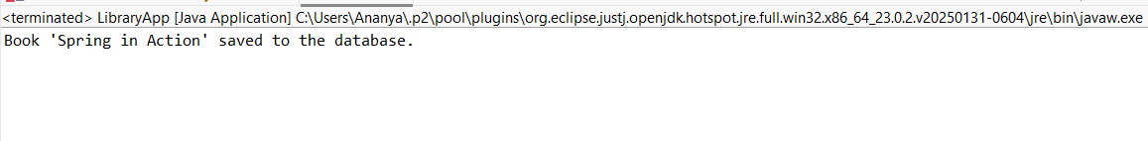

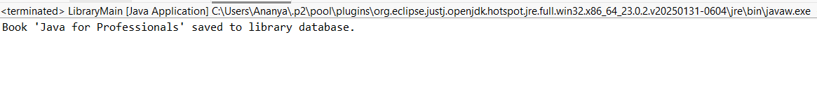**SpringCore-MavenEx-2**

**SpringCore-MavenEx-4**

