Spring Core and Maven
Output Screens (Mandatory)
SpringCore-MavenEx-1
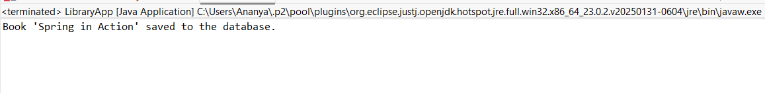
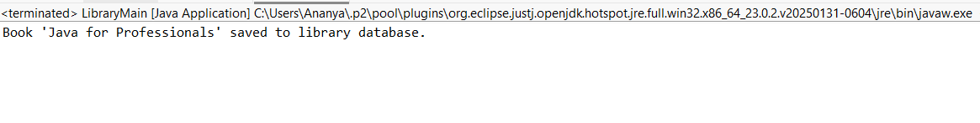
SpringCore-MavenEx-2
SpringCore-MavenEx-4
