Spring Data JPA with Hibernate
Output Screens
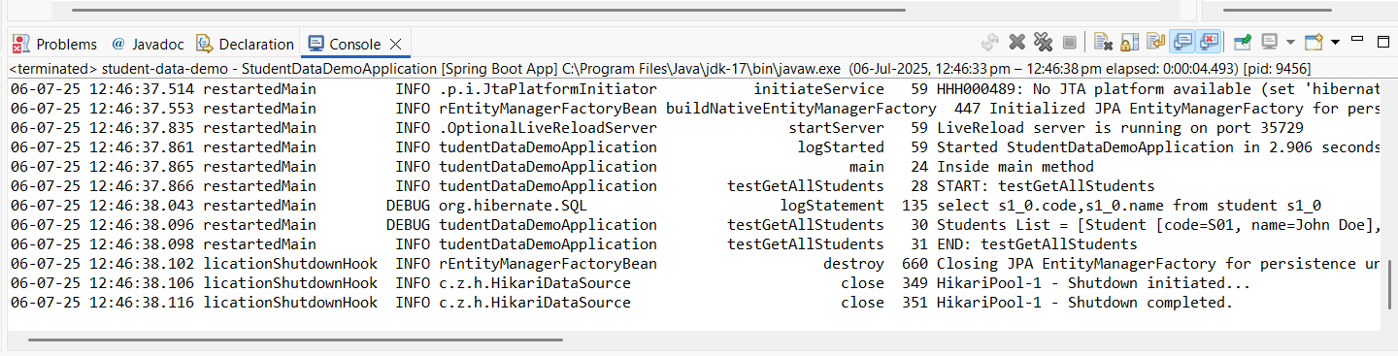
Hands on-1

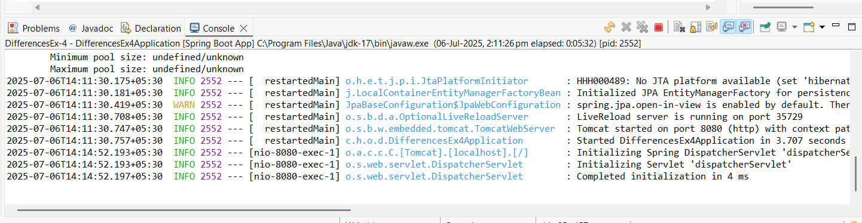
Hands on-4

Difference between JPA, Hibernate and Spring Data JPA
Feature | JPA (Java Persistence API) | Hibernate | Spring Data JPA
Type | Specification (Interface/API) | Implementation (Framework) | Abstraction built on top of JPA
Purpose | Defines standard for ORM in Java | Provides actual ORM functionality | Simplifies JPA-based persistence using Spring
Provider | Maintained by Java EE / Jakarta EE | Developed by Red Hat | Maintained by the Spring Team
Dependency | javax.persistence / jakarta.persistence | org.hibernate | org.springframework.data.jpa
Code Boilerplate | Requires more manual coding | Slightly less than JPA | Minimizes boilerplate with repository interfaces and custom queries
Query Language | JPQL (Java Persistence Query Language) | Supports JPQL and HQL (Hibernate Query Language) | Uses JPQL, native SQL, and derived query methods from method names
Ease of Use | Moderate — needs EntityManager, etc. | Easier than plain JPA | Very easy — most CRUD operations are automatic
Custom Queries | Must be written manually | Can use HQL/Criteria API | Supports @Query, native queries, method naming for automatic query generation
Transaction Management | Manual or container-managed | Supports manual and JTA | Integrated with Spring’s transaction management
Vendor Neutrality | Yes — designed to be implemented by many (Hibernate, EclipseLink, etc.) | No — Hibernate-specific features | No — ties to Spring ecosystem
Main Advantage | Platform-independent ORM standard | Powerful and flexible ORM engine | Rapid development with minimal configuration

