Gated Multimodal Fusion with Uni-Modal Supervision for Product Recommendation Using Image and Text Embeddings
Ananya  School of Computer Applications  Dayananda Sagar University  Bengaluru, India  SCA25MSD011@dsu.edu.in | Ms. Priyanka Rukesh  School of Computer Applications  Dayananda Sagar University  Bengaluru, India

Abstract—Product recommendation benefits from both what a product looks like and how it is described, yet most multimodal recommenders rely on large pretrained encoders and user–item interaction graphs. We study multimodal product recommendation in which both the image encoder and the text encoder are trained entirely from scratch on the product catalog. A ResNet-style CNN embeds product photos, a Transformer with its own tokenizer embeds product titles, and a gated fusion unit learns, per feature and per product, how much to trust each modality. Training combines a supervised contrastive loss, an image–text contrastive loss and a uni-modal supervision term that counters modality imbalance. On 44,013 fashion products, evaluated on 6,602 unseen test products with three seeds and paired bootstrap tests, the final model reaches NDCG@10 of 0.958 for similar-product recommendation, 0.775 when colour must also match, 0.595 for text search and 0.847 for photo search, improving significantly on all four tasks over plain gated fusion. We further compare SGD, Adam and AdamW, run ablations, and introduce a noisy-title benchmark: when titles are missing, a text-only model collapses to 0.074 while the fused model retains 0.761, and noise-aware training keeps accuracy above an image-only model under every title corruption tested.
Index Terms—multimodal recommendation, gated fusion, contrastive learning, modality imbalance, missing modality, product retrieval.
I. Introduction
Online shops recommend products through “similar items” lists and search boxes. A product is described by two complementary signals: its photo, which captures shape, pattern and style, and its title, which names the product type, brand and colour. Multimodal recommendation combines both, and has become an active research area [1]–[15].
Most recent multimodal recommenders, however, feed features from large pretrained networks into graphs built from user–item interactions [1]–[9]. Such systems need interaction histories, which are unavailable for new products (cold start), and depend on pretraining at web scale [16], [17]. Moreover, recent analyses report that text often dominates the image in e-commerce and that multimodal models can even underperform text-only ones [10], [13], a symptom of modality imbalance [24], [25]. Finally, real catalogs contain short, missing or wrong titles, a situation that fusion models are rarely tested on [12], [21].
This work studies content-based multimodal product recommendation with encoders trained entirely from scratch, and makes the following contributions:
- A lightweight model (3.8 M parameters) with a CNN image encoder, a Transformer title encoder and a gated fusion unit [27], trained end-to-end from random initialisation, that answers four query types with one embedding: similar product, text, photo, and photo + text.
- Uni-modal supervision that counters modality imbalance and significantly improves all four tasks; it is compared with gradient modulation (OGM) [24] and noise-aware training.
- A controlled study of six fusion strategies and three optimizers (SGD, Adam, AdamW), each tuned on validation, with three seeds, ablations and paired bootstrap significance tests.
- A noisy-title benchmark showing that fusion keeps working when titles are missing, that plain fusion over-trusts damaged text, and that noise-aware training removes this weakness.
II. Related Work
A. Multimodal Recommender Systems
Graph-based models dominate recent multimodal recommendation. LATTICE [1] learns modality-aware item–item graphs, and MICRO [2] adds contrastive modality fusion. MMGCL [3], BM3 [4] and MMSSL [5] use self-supervised and contrastive objectives, while FREEDOM [6], DRAGON [7], LGMRec [8] and MENTOR [9] refine graph construction and cross-modal alignment. These methods consume pre-extracted image and text features and require user–item interactions. Yuan et al. [11] show that modality encoders trained end-to-end can rival ID-based recommenders, and surveys [14], [15] note the shift towards large pretrained models.
B. Vision–Language Models and Fashion Retrieval
CLIP [16] and SigLIP [17] learn aligned image and text encoders from hundreds of millions of pairs. FashionCLIP [18] and FashionViL [19] adapt this to fashion, and CLIP4Cir [20] composes a reference image with a text modification. All rely on large pretrained backbones; in contrast, our encoders are learned from the catalog alone.
C. Missing Modalities and Modality Imbalance
Ma et al. [21] show that multimodal Transformers are sensitive to missing modalities; missing-aware prompts [22] and shared–specific features [23] improve robustness in classification, and Malitesta et al. [12] impute missing features before training a recommender. Multimodal networks also tend to rely on the easiest modality: OGM-GE [24] modulates per-modality gradients, Du et al. [25] identify “modality laziness”, and Zhang et al. [10] report that text-only recommenders can beat multimodal ones. Table I summarises the 25 most relevant studies since 2021.

TABLE I
Summary of Related Work (2021–2025)
Ref. | Title (short) | Authors | Year, venue | Model used | Results reported | Limitation w.r.t. this work
[1] | LATTICE: Mining latent structures for multimedia recommendation | J. Zhang et al. | 2021, ACM MM | Modality-aware item–item graph learning + graph convolution | Beats SOTA multimedia recommenders on 3 datasets | Needs interaction data; frozen pretrained features
[2] | MICRO: Latent structure mining with contrastive modality fusion | J. Zhang et al. | 2023, IEEE TKDE | LATTICE + contrastive shared/specific fusion | Improves LATTICE-style baselines | Interaction-dependent; no single-modality queries
[3] | MMGCL: Multi-modal graph contrastive learning for micro-video rec. | Z. Yi et al. | 2022, SIGIR | Graph contrastive learning with modality masking | Better accuracy and faster convergence on 2 datasets | Masking only as augmentation, not missing queries
[4] | BM3: Bootstrap latent representations for multi-modal rec. | X. Zhou et al. | 2023, WWW | Bootstrapped self-supervision, cross-modal alignment | Beats prior models; 2–9× less training time | Pre-extracted features; ID embeddings
[5] | MMSSL: Multi-modal self-supervised learning for rec. | W. Wei et al. | 2023, WWW | Adversarial structure learning + cross-modal contrast | Outperforms SOTA multimodal recommenders | Complex training; not end-to-end
[6] | FREEDOM: Freezing and denoising graph structures | X. Zhou, Z. Shen | 2023, ACM MM | Frozen item graph + denoised user–item graph | Competitive accuracy at much lower cost | Fixed pretrained features; graph-level fusion
[7] | DRAGON: Homogeneous graphs for multimodal rec. | H. Zhou et al. | 2023, ECAI | User–user and item–item graphs, attentive concatenation | Shows common fusions can hurt accuracy | Concatenation fusion; interaction-dependent
[8] | LGMRec: Local and global graph learning | Z. Guo et al. | 2024, AAAI | Local graph + global hypergraph learning | Improves graph-based recommenders | Heavy model; no missing-modality design
[9] | MENTOR: Multi-level self-supervised learning | J. Xu et al. | 2025, AAAI | ID-guided multi-level cross-modal alignment | Reduces the modality gap | Needs interaction history
[10] | Modality-balanced learning for multimedia rec. (CKD) | J. Zhang et al. | 2024, ACM MM | Counterfactual knowledge distillation | Text-only can beat multimodal; CKD fixes it | Pre-extracted features; extra distillation
[11] | Where to go next? ID- vs. modality-based recommenders | Z. Yuan et al. | 2023, SIGIR | End-to-end trained modality encoders vs IDs | Modality-based models can rival ID-based | Large pretrained encoders; no fusion study
[12] | Do we need to drop items with missing modalities? | D. Malitesta et al. | 2024, CIKM | Graph-based imputation of missing features | Dropping items is unnecessary and harmful | Imputes before training, not at query time
[13] | Does multimodality improve recommenders as expected? | H. Zhou et al. | 2025, arXiv | Large re-evaluation study | Gains modest; text matters most in e-commerce; 29.3% reproducible | Analysis only, no new model
[14] | Multimodal recommender systems: A survey | Q. Liu et al. | 2024, ACM CSUR | Survey | Taxonomy of multimodal recommenders | Little on from-scratch encoders
[15] | Multimodal pretraining, adaptation and generation for rec.: A survey | Q. Liu et al. | 2024, KDD | Survey | Maps the move to large pretrained models | Low-resource training under-explored
[16] | CLIP: Learning transferable visual models from NL supervision | A. Radford et al. | 2021, ICML | Image–text dual encoder, 400M pairs | Zero-shot transfer on 30+ datasets | Web-scale data and compute
[17] | SigLIP: Sigmoid loss for language–image pre-training | X. Zhai et al. | 2023, ICCV | Pairwise sigmoid contrastive loss | 84.5% ImageNet zero-shot with 4 TPUs | Still large-scale pretraining
[18] | FashionCLIP: General fashion concepts | P. J. Chia et al. | 2022, Sci. Rep. | CLIP fine-tuned on fashion | Transferable fashion representations | Relies on pretrained CLIP; no fusion
[19] | FashionViL: Fashion-focused V+L representation learning | X. Han et al. | 2022, ECCV | Fashion V+L Transformer, multi-view contrast | SOTA on 5 fashion tasks | Heavy pretraining, large model
[20] | CLIP4Cir: Conditioned and composed image retrieval | A. Baldrati et al. | 2022, CVPR | Combiner network over CLIP features | Composed image + text retrieval | Pretrained CLIP backbone
[21] | Are multimodal Transformers robust to missing modality? | M. Ma et al. | 2022, CVPR | Study + fusion-strategy search | Sensitive to missing modality; fusion is data-dependent | Classification, not retrieval
[22] | Multimodal prompting with missing modalities | Y.-L. Lee et al. | 2023, CVPR | Missing-aware prompts on ViLT | Robust with <1% trainable parameters | Needs a large pretrained backbone
[23] | ShaSpec: Missing modality via shared-specific features | H. Wang et al. | 2023, CVPR | Shared + specific features, residual fusion | +3–5% over SOTA (medical) | Medical / classification only
[24] | OGM-GE: On-the-fly gradient modulation | X. Peng et al. | 2022, CVPR | Per-modality gradient modulation | Clear gains over standard fusion | Audio-visual classification only
[25] | On uni-modal feature learning in supervised multi-modal learning | C. Du et al. | 2023, ICML | Uni-modal teacher / ensemble | Identifies modality laziness | Classification only

Compared with these studies, our work (i) trains both encoders from scratch without interaction data, (ii) handles a missing modality at query time rather than by imputation, (iii) evaluates fusion under corrupted titles, and (iv) combines gated fusion with uni-modal supervision to counter modality imbalance in product retrieval.
III. Proposed Method
A. Problem Formulation
Each product i has a photo x_{i} and a title t_{i}. The goal is an encoder that maps (x_{i}, t_{i}) to an L2-normalised embedding f_{i} such that products of the same type (and colour) are close. Recommendation ranks catalog items by cosine similarity to a query embedding; a query may contain a photo, a title-like text, or both.
B. Encoders Trained from Scratch
The image encoder is a ResNet-style CNN [28] with a 3×3 stem and six residual blocks (32→64→128→256 channels, three stride-2 stages). A 64×64 photo yields an 8×8×256 feature map, average-pooled into h_{img} ∈ ℝ²⁵⁶. Titles are lower-cased and split into words; the vocabulary (3,862 words) is built from training titles only. A 2-layer Transformer [29] (width 128, 4 heads, learned positions, 16 tokens) with masked mean pooling and a linear layer gives h_{txt} ∈ ℝ²⁵⁶. No pretrained weights are used anywhere.
C. Gated Fusion
Following gated multimodal units [27], a gate decides per dimension how much each modality contributes:
g = σ(W_{g}[h_{img} ; h_{txt}] + b_{g}) (1)
h = g ⊙ h_{img} + (1 − g) ⊙ h_{txt} (2)
A two-layer MLP maps h to the 128-dimensional embedding f, which is L2-normalised. Linear heads also give per-modality embeddings z_{img} and z_{txt} in the same space. When a modality is absent at query time, its feature is replaced by a learned null vector, so text-only and photo-only queries use the same model (Fig. 1).
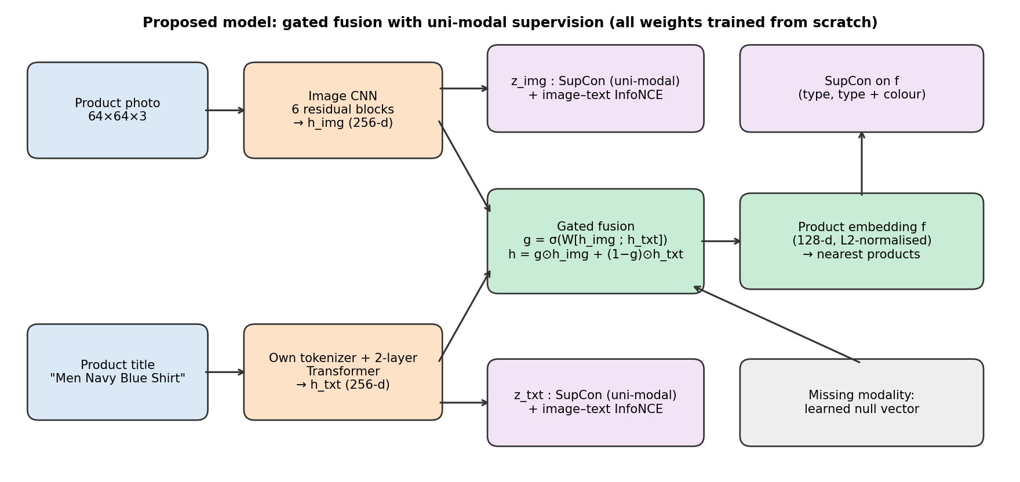
Fig. 1. Proposed model. Both encoders are trained from scratch; the gated fusion produces one product embedding used for all query types.
D. Training Objectives
The main objective is the supervised contrastive loss [26] on the fused embedding, with the product type (and, at half weight, type + colour) as labels:
ℒ_{sup} = SupCon(f, y_{type}) + 0.5·SupCon(f, y_{type+colour}) (3)
A symmetric image–text contrastive loss (InfoNCE, as in [16]) aligns z_{img} and z_{txt} of the same product. To counter modality imbalance, uni-modal supervision applies the supervised contrastive loss to each modality separately, so that neither encoder can rely on the other [25]:
ℒ = ℒ_{sup} + ℒ_{itc} + λ_{uni}[SupCon(z_{img}) + SupCon(z_{txt})] (4)
with λ_{uni} = 0.5. We also evaluate two alternatives on the same model: OGM gradient modulation [24] adapted to contrastive training (the gradients of the dominant encoder are scaled by 1 − tanh(α(ρ − 1)), where ρ is the ratio of modality strengths; α = 0.3 chosen on validation), and noise-aware training, in which 50% of training titles are damaged (30–100% of words removed, or replaced by another product's title) on the fusion input while labels stay correct, teaching the gate when not to trust text.
IV. Experimental Setup
A. Dataset
We use the Fashion Product Images (Small) catalog [33]. Product types with fewer than 20 items are removed, leaving 44,013 products in 90 types. A stratified 70/15/15 split gives 30,809 training, 6,602 validation and 6,602 test products; test products are never used for training, tuning or model selection. Photos are padded to a white square and resized to 64×64.
B. Baselines
All baselines share the same encoders, losses and training budget: an image-only CNN, a text-only Transformer, early fusion (concatenation + MLP), late fusion (equal-weight sum of image and text similarities) and cross-attention fusion (title tokens attend over the 8×8 image regions).
C. Evaluation
We report NDCG@10 [32] on the test products for four tasks: (i) similar products: each product queries the rest of the catalog and results of the same type are relevant; (ii) the same with type and colour; (iii) text search with shopper queries built from metadata (e.g. “navy blue shirts for men”), relevant = same colour, type and gender; and (iv) photo search, where the photo alone is the query. Results are the mean ± standard deviation over three seeds; differences are tested with a paired bootstrap over queries [35].
D. Implementation
The models are implemented in PyTorch [34] and trained on one NVIDIA T4 GPU (Kaggle) for 30 epochs with batch size 256, mixed precision, a one-epoch warm-up and a cosine learning-rate schedule; the epoch with the best validation score is kept. For each optimizer the learning rate is tuned on validation: SGD (Nesterov momentum 0.9) 0.1, Adam 0.003, AdamW 0.003 (weight decay 0.05). SGD, selected on validation, is used for all method comparisons. One run takes about 6 minutes.
V. Results and Discussion
A. Comparison of Fusion Methods
TABLE II
Test NDCG@10 of Fusion Methods (Mean ± Std, 3 Seeds)
Model | Similar (type) | Type + colour | Text search | Photo search
Image-only CNN | 0.813 ± 0.003 | 0.372 ± 0.004 | — | 0.813 ± 0.003
Text-only Transformer | 0.956 ± 0.000 | 0.779 ± 0.002 | 0.548 ± 0.073 | —
Early fusion | 0.955 ± 0.001 | 0.752 ± 0.001 | 0.552 ± 0.022 | 0.828 ± 0.004
Late fusion | 0.954 ± 0.001 | 0.735 ± 0.004 | 0.680 ± 0.017 | 0.811 ± 0.001
Cross-attention | 0.956 ± 0.000 | 0.761 ± 0.001 | 0.561 ± 0.010 | 0.833 ± 0.005
Gated fusion | 0.956 ± 0.001 | 0.765 ± 0.002 | 0.568 ± 0.016 | 0.831 ± 0.008
Gated + uni-modal | 0.958 ± 0.002 | 0.775 ± 0.004 | 0.595 ± 0.041 | 0.847 ± 0.001
Table II shows that adding titles lifts similar-product accuracy from 0.813 (image only) to about 0.956. Plain gated fusion is significantly better than early and late fusion on similar products (p = 0.001 vs. late fusion) and than the image-only model on photo search. The text-only model is strong on type + colour (0.779) because titles literally contain type and colour words, and late fusion is best for text search (0.680). With uni-modal supervision, the gated model becomes the best model for similar products (0.958) and photo search (0.847).
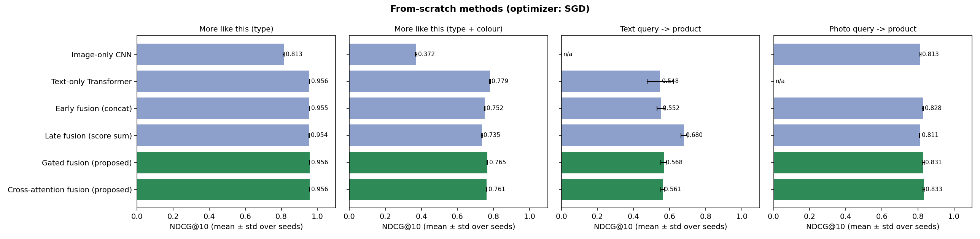
Fig. 2. Test NDCG@10 of the six fusion methods for the four tasks (mean ± std over three seeds).
B. Optimizer Comparison
TABLE III
Optimizer Comparison on Gated Fusion (Test NDCG@10)
Optimizer | LR | Similar (type) | Type + colour | Text search | Photo search
SGD | 0.1 | 0.956 ± 0.001 | 0.765 ± 0.002 | 0.568 ± 0.016 | 0.831 ± 0.008
Adam | 0.003 | 0.956 ± 0.001 | 0.752 ± 0.004 | 0.563 ± 0.014 | 0.823 ± 0.002
AdamW | 0.003 | 0.957 ± 0.001 | 0.757 ± 0.006 | 0.585 ± 0.010 | 0.821 ± 0.006
All three optimizers reach nearly the same accuracy (within about 0.01, Table III), and their training curves converge similarly (Fig. 3). SGD is best on type + colour and photo search, AdamW on text search. Adam and AdamW behave almost identically, because decoupled weight decay has little effect over 30 short epochs. Training the model at all matters far more than the choice of optimizer.
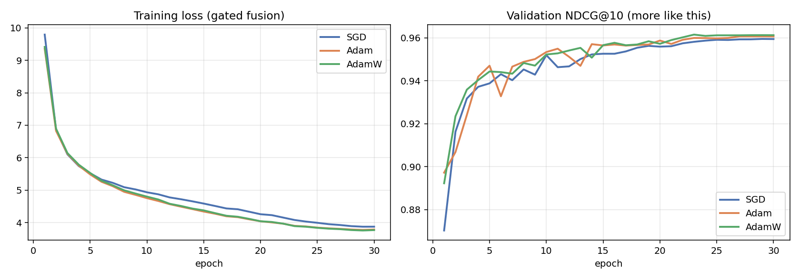
Fig. 3. Training loss and validation NDCG@10 of the gated model for SGD, Adam and AdamW.
C. Ablation Study
TABLE IV
Ablation of the Gated Model (Test NDCG@10)
Variant | Similar (type) | Type + colour | Text search | Photo search
Gated fusion (full) | 0.956 | 0.765 | 0.568 | 0.831
− supervised contrastive | 0.786 | 0.450 | 0.199 | 0.627
− image–text contrastive | 0.954 | 0.744 | 0.487 | 0.804
− consistency loss | 0.957 | 0.768 | 0.556 | 0.825
− modality dropout | 0.960 | 0.776 | 0.568 | 0.839
Removing the supervised contrastive loss causes the largest drop (similar products 0.956 → 0.786). Removing the image–text contrastive loss mainly hurts text search (0.568 → 0.487), confirming that aligning the two modalities is what enables cross-modal queries. Two components we initially proposed, modality dropout and a missing-modality consistency loss, did not help on clean data and are reported here for completeness.
D. Countering Modality Imbalance
TABLE V
Modality-Balancing Variants of the Gated Model
Variant | Similar (type) | Type + colour | Text search | Photo search
Gated fusion (original) | 0.956 ± 0.001 | 0.765 ± 0.002 | 0.568 ± 0.016 | 0.831 ± 0.008
+ OGM (α = 0.3) | 0.957 ± 0.000 ▲ | 0.767 ± 0.002 | 0.572 ± 0.021 | 0.837 ± 0.002 ▲
+ uni-modal supervision | 0.958 ± 0.002 ▲ | 0.775 ± 0.004 ▲ | 0.595 ± 0.041 ▲ | 0.847 ± 0.001 ▲
+ noise-aware training | 0.893 ± 0.001 ▼ | 0.531 ± 0.010 ▼ | 0.272 ± 0.007 ▼ | 0.783 ± 0.036 ▼
+ noise-aware + uni-modal | 0.913 ± 0.002 ▼ | 0.529 ± 0.006 ▼ | 0.282 ± 0.021 ▼ | 0.809 ± 0.030 ▼
▲/▼ in Table V mark significant improvements/drops versus the original gated model (paired bootstrap, p < 0.05). Uni-modal supervision improves all four tasks significantly (p < 0.001 for each): similar products 0.956 → 0.958, type + colour 0.765 → 0.775, text search 0.568 → 0.595 and photo search 0.831 → 0.847. Giving each encoder its own learning signal prevents the title branch from doing all the work. OGM gives only small gains, and noise-aware training lowers clean accuracy, as expected for a model trained on deliberately damaged titles.
E. Robustness to Missing and Wrong Titles
TABLE VI
Similar-Product NDCG@10 under Damaged Titles
Model | Clean | 30% words removed | 60% removed | No title | 20% wrong | 50% wrong
Image-only | 0.807 | 0.807 | 0.807 | 0.807 | 0.807 | 0.807
Text-only | 0.955 | 0.698 | 0.444 | 0.074 | 0.610 | 0.269
Late fusion | 0.953 | 0.844 | 0.737 | 0.768 | 0.835 | 0.697
Gated | 0.957 | 0.783 | 0.596 | 0.737 | 0.726 | 0.428
Gated + uni-modal | 0.960 | 0.792 | 0.607 | 0.761 | 0.732 | 0.445
Gated + noise-aware + uni-modal | 0.911 | 0.877 | 0.845 | 0.807 | 0.885 | 0.851
To test catalogs with poor titles, we damage the titles of the test products (photos untouched) and re-evaluate; each condition is averaged over three random draws (Table VI, Fig. 4). Without titles, the text-only model collapses to 0.074, whereas the fused models keep 0.737–0.807 because the photo carries the recommendation. Plain fusion, however, over-trusts damaged text: at 60% of words removed the gated model falls to 0.596, below the image-only model (0.807). Noise-aware training removes this weakness: it is the most robust model in every damaged condition (0.845 at 60% removed, 0.851 with 50% wrong titles) and never falls below image-only, at the cost of lower clean accuracy (0.911). A deployment can therefore choose the clean-accuracy model or the robust model according to catalog quality.
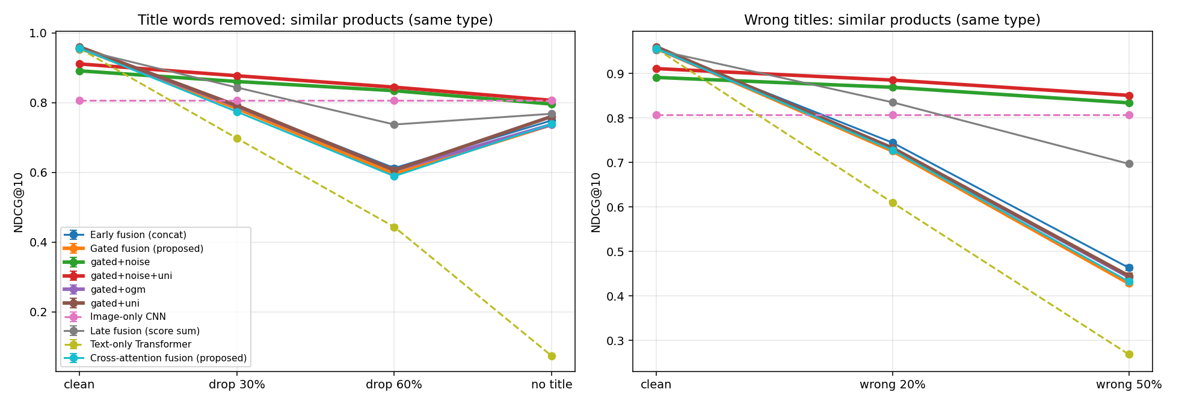
Fig. 4. Similar-product NDCG@10 when title words are removed (left) or titles are wrong (right).
F. Demonstration System and Product Generation
The final model is deployed in a Streamlit web application that answers similar-product, text, photo and photo + text queries on the 6,602 unseen products in real time on a laptop CPU, since the model has only 3.8 M parameters. Fig. 5 shows typical results: a text query returns black handbags, a photo of a black watch returns other black watches, adding the words “white watch” to the same photo keeps the product type but changes the colour, and a purple T-shirt retrieves other purple T-shirts.
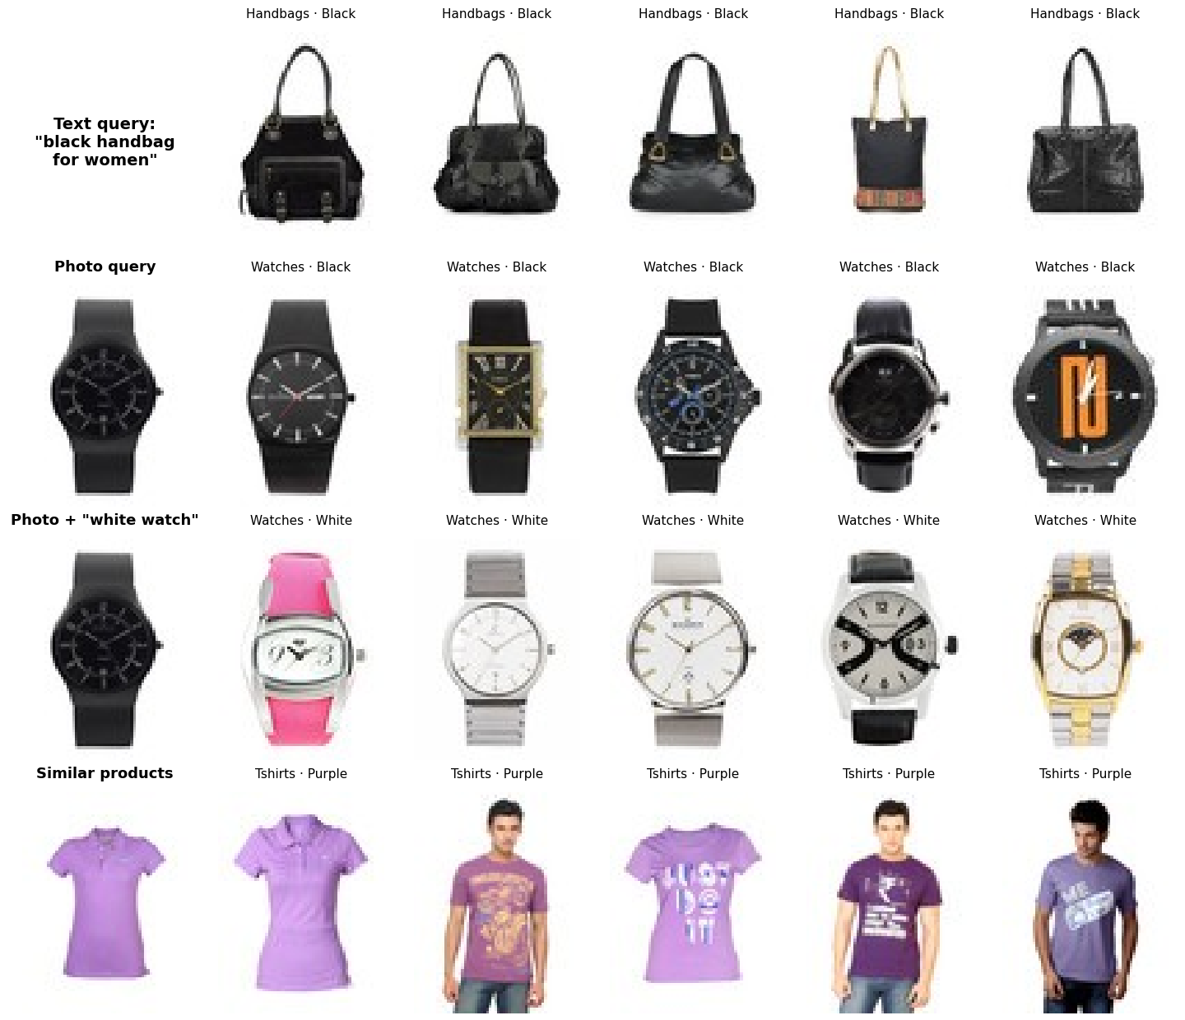
Fig. 5. Top-5 recommendations of the final model for a text query, a photo query, a photo + text query and a similar-product query (products not seen in training).
As a complementary experiment, a conditional DCGAN [30] trained from scratch with DiffAugment [31] generates new 64×64 product images per category; after fixing an initial mode collapse, its Fréchet distance in CLIP feature space improved from 0.72 (untrained generator) to 0.50, and 14% of generated images are recognised as the requested category (chance 7%). Image quality remains limited by the small CPU training budget.
VI. Limitations
Relevance is derived from product metadata rather than real user interactions, and product titles in this catalog contain the type and colour words, which favours text. Images are small (64×64) to keep training cheap. The noise rate for noise-aware training (50%) was not tuned; a lower rate may retain more clean accuracy. Pretrained models such as CLIP [16] are expected to be more accurate but were deliberately excluded to study fusion under from-scratch training.
VII. Conclusion and Future Work
We presented a multimodal product recommender whose image and text encoders are trained entirely from scratch and fused by a gated unit with uni-modal supervision. On 6,602 unseen products it reaches NDCG@10 of 0.958 for similar products and 0.847 for photo search, significantly improving over plain gated fusion on all four tasks. A controlled comparison showed that fusion design matters more than the optimizer, and a new noisy-title benchmark showed that fusion keeps recommendations working when titles are missing and that noise-aware training makes it robust to damaged titles. Future work includes tuning the noise rate, adaptive trust in the title at inference time, larger images, and evaluation with real user interaction data.
References
[1] J. Zhang, Y. Zhu, Q. Liu, S. Wu, S. Wang, and L. Wang, “Mining latent structures for multimedia recommendation,” in Proc. 29th ACM Int. Conf. Multimedia (MM), 2021.
[2] J. Zhang et al., “Latent structure mining with contrastive modality fusion for multimedia recommendation,” IEEE Trans. Knowl. Data Eng., vol. 35, no. 9, pp. 9154–9167, 2023.
[3] Z. Yi, X. Wang, I. Ounis, and C. Macdonald, “Multi-modal graph contrastive learning for micro-video recommendation,” in Proc. 45th Int. ACM SIGIR Conf., 2022.
[4] X. Zhou et al., “Bootstrap latent representations for multi-modal recommendation,” in Proc. ACM Web Conf. (WWW), 2023, pp. 845–854.
[5] W. Wei, C. Huang, L. Xia, and C. Zhang, “Multi-modal self-supervised learning for recommendation,” in Proc. ACM Web Conf. (WWW), 2023, pp. 790–800.
[6] X. Zhou and Z. Shen, “A tale of two graphs: Freezing and denoising graph structures for multimodal recommendation,” in Proc. 31st ACM Int. Conf. Multimedia (MM), 2023.
[7] H. Zhou, X. Zhou, and Z. Shen, “Enhancing dyadic relations with homogeneous graphs for multimodal recommendation,” in Proc. 26th Eur. Conf. Artif. Intell. (ECAI), 2023.
[8] Z. Guo et al., “LGMRec: Local and global graph learning for multimodal recommendation,” in Proc. AAAI Conf. Artif. Intell., vol. 38, no. 8, 2024, pp. 8454–8462.
[9] J. Xu, Z. Chen, S. Yang, J. Li, H. Wang, and E. C. H. Ngai, “MENTOR: Multi-level self-supervised learning for multimodal recommendation,” in Proc. AAAI Conf. Artif. Intell., vol. 39, no. 12, 2025, pp. 12908–12917.
[10] J. Zhang, G. Liu, Q. Liu, S. Wu, and L. Wang, “Modality-balanced learning for multimedia recommendation,” in Proc. 32nd ACM Int. Conf. Multimedia (MM), 2024, pp. 7551–7560.
[11] Z. Yuan et al., “Where to go next for recommender systems? ID- vs. modality-based recommender models revisited,” in Proc. 46th Int. ACM SIGIR Conf., 2023.
[12] D. Malitesta, E. Rossi, C. Pomo, T. Di Noia, and F. D. Malliaros, “Do we really need to drop items with missing modalities in multimodal recommendation?” in Proc. 33rd ACM Int. Conf. Inf. Knowl. Manage. (CIKM), 2024.
[13] H. Zhou, Y. Zhang, A. Sun, and Z. Shen, “Does multimodality improve recommender systems as expected? A critical analysis and future directions,” arXiv:2508.05377, 2025.
[14] Q. Liu et al., “Multimodal recommender systems: A survey,” ACM Comput. Surv., vol. 57, no. 2, 2024.
[15] Q. Liu et al., “Multimodal pretraining, adaptation, and generation for recommendation: A survey,” in Proc. 30th ACM SIGKDD Conf. Knowl. Discov. Data Mining (KDD), 2024.
[16] A. Radford et al., “Learning transferable visual models from natural language supervision,” in Proc. 38th Int. Conf. Mach. Learn. (ICML), 2021, pp. 8748–8763.
[17] X. Zhai, B. Mustafa, A. Kolesnikov, and L. Beyer, “Sigmoid loss for language image pre-training,” in Proc. IEEE/CVF Int. Conf. Comput. Vis. (ICCV), 2023, pp. 11975–11986.
[18] P. J. Chia et al., “Contrastive language and vision learning of general fashion concepts,” Sci. Rep., vol. 12, Art. no. 18958, 2022.
[19] X. Han, L. Yu, X. Zhu, L. Zhang, Y.-Z. Song, and T. Xiang, “FashionViL: Fashion-focused vision-and-language representation learning,” in Proc. Eur. Conf. Comput. Vis. (ECCV), 2022.
[20] A. Baldrati, M. Bertini, T. Uricchio, and A. Del Bimbo, “Effective conditioned and composed image retrieval combining CLIP-based features,” in Proc. IEEE/CVF Conf. Comput. Vis. Pattern Recognit. (CVPR), 2022.
[21] M. Ma, J. Ren, L. Zhao, D. Testuggine, and X. Peng, “Are multimodal Transformers robust to missing modality?” in Proc. IEEE/CVF Conf. Comput. Vis. Pattern Recognit. (CVPR), 2022, pp. 18177–18186.
[22] Y.-L. Lee, Y.-H. Tsai, W.-C. Chiu, and C.-Y. Lee, “Multimodal prompting with missing modalities for visual recognition,” in Proc. IEEE/CVF Conf. Comput. Vis. Pattern Recognit. (CVPR), 2023, pp. 14943–14952.
[23] H. Wang, Y. Chen, C. Ma, J. Avery, L. Hull, and G. Carneiro, “Multi-modal learning with missing modality via shared-specific feature modelling,” in Proc. IEEE/CVF Conf. Comput. Vis. Pattern Recognit. (CVPR), 2023.
[24] X. Peng, Y. Wei, A. Deng, D. Wang, and D. Hu, “Balanced multimodal learning via on-the-fly gradient modulation,” in Proc. IEEE/CVF Conf. Comput. Vis. Pattern Recognit. (CVPR), 2022.
[25] C. Du et al., “On uni-modal feature learning in supervised multi-modal learning,” in Proc. 40th Int. Conf. Mach. Learn. (ICML), 2023.
[26] P. Khosla et al., “Supervised contrastive learning,” in Adv. Neural Inf. Process. Syst. (NeurIPS), 2020.
[27] J. Arevalo, T. Solorio, M. Montes-y-Gómez, and F. A. González, “Gated multimodal units for information fusion,” in Proc. Int. Conf. Learn. Represent. (ICLR) Workshop, 2017.
[28] K. He, X. Zhang, S. Ren, and J. Sun, “Deep residual learning for image recognition,” in Proc. IEEE Conf. Comput. Vis. Pattern Recognit. (CVPR), 2016.
[29] A. Vaswani et al., “Attention is all you need,” in Adv. Neural Inf. Process. Syst. (NeurIPS), 2017.
[30] A. Radford, L. Metz, and S. Chintala, “Unsupervised representation learning with deep convolutional generative adversarial networks,” in Proc. Int. Conf. Learn. Represent. (ICLR), 2016.
[31] S. Zhao, Z. Liu, J. Lin, J.-Y. Zhu, and S. Han, “Differentiable augmentation for data-efficient GAN training,” in Adv. Neural Inf. Process. Syst. (NeurIPS), 2020.
[32] K. Järvelin and J. Kekäläinen, “Cumulated gain-based evaluation of IR techniques,” ACM Trans. Inf. Syst., vol. 20, no. 4, pp. 422–446, 2002.
[33] P. Aggarwal, “Fashion product images (small),” Kaggle dataset, 2019. [Online]. Available: https://www.kaggle.com/datasets/paramaggarwal/fashion-product-images-small
[34] A. Paszke et al., “PyTorch: An imperative style, high-performance deep learning library,” in Adv. Neural Inf. Process. Syst. (NeurIPS), 2019.
[35] B. Efron and R. J. Tibshirani, An Introduction to the Bootstrap. New York, NY, USA: Chapman & Hall, 1993.

