MITTI MITRA

Design & Architecture Document
Farm Details → Soil Microbiome Assessment → Crop Recommendation

1. Executive Summary
Mitti Mitra is an idea to support farmers in making decision. It collects basic farm context location, recent crop rotation, current crop condition, field size and irrigation then presents a soil microbiome health estimate and a suggested next crop/soil-improvement plan. The input form is the first screen and the results and recommendation dashboard is the second screen.
Important: The screenshots seem to be a product concept / prototype. The score displayed and the benefits expected should only be considered as model estimates, until confirmed by soil testing, agronomic evidence and field trials.

2. What the Two Screens Show

Screen 1: Farm Details (Step 1 of 2)
- Location: Village, district and state. The app can optionally use the device location to pre-populate location context.
- Crop history (Previous 2–3 crops): Displaying crop history by seasons, e.g. Kharif, Rabi and Zaid. This assists the system to comprehend rotation patterns.
- Present crop: Crop type, crop stage (sown / standing / near harvest), crop age (days), field size and irrigation source.
- Validates the required information and submits the farm profile to the recommendation process.
- Language toggle for English/Hindi language and farmer profile entry point.

Screen 2: Soil Microbiome Results (Step 2 of 2)
- Farm context: Displays the chosen location and the crop rotation sequence to help the farmer understand on what to base the recommendation.
- A single score between 0 and 100 quantifies the model's estimate of the microbiome score. The sample image shows 72/100, and is labeled as moderate/“theek-thaak.”
- Microbial indicators: Individual status bars are displayed for nitrogen fixers, beneficial bacteria and fungi.
- Risk message: Flags repeated cereal-cereal cropping as a possible cause of less diversity.
- Next-crop suggestion: It is recommended that the sample should be followed up by summer moong (green gram), green manure dhaincha and Rabi choice of mustard or chickpea.
- Reasons and benefits: Communicates the recommendation to the farmer in a farmer-friendly way, including nitrogen contribution, pest/disease cycle disruption and soil-structure benefits.
- Actions: Farmer can save the plan or share it with Kisan Mitra.

3. Proposed User Flowchart
The flow below extracts the farmer journey from the internal processing steps. It is a high-level proposed flow, it's not a claim that all backend services exist.
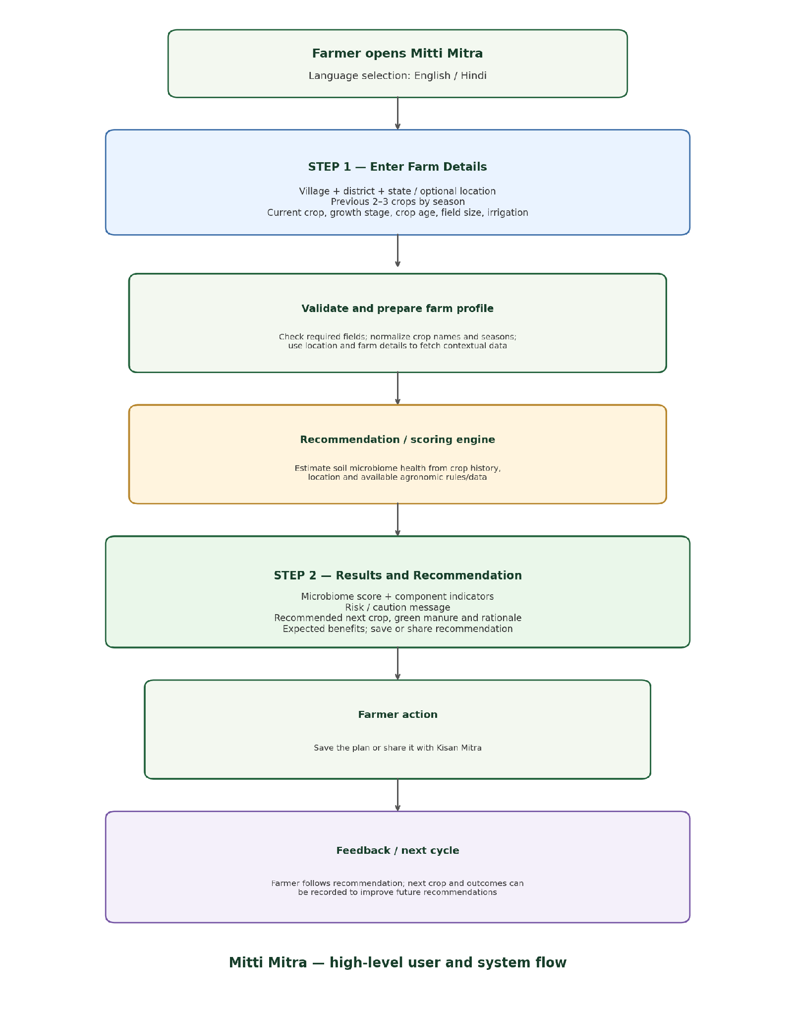

4. Proposed System Architecture
Here's a practical architecture that could be structured into the following layers:
A. Presentation layer (mobile/web UI): details of the farm form, toggle of the language, presentation of validation messages, result dashboard, save/share controls and accessible farmer friendly labels.
B. Application/API layer: Validates the request, returns a request ID, can perform authentication if necessary, and then returns a structured recommendation response.
C. Farm profile and crop-history service: Records and/or temporarily manages field information relating to location, crop seasons, crop sequence, current crop stage, field size, and irrigation information (consent and privacy rules apply).
D. Documented crop-rotation rules and location/season constraints are applied by Agronomy and recommendation engine. Use of a predictive model should be based on appropriate labelled data for training and evaluation.
E. Data layer: This can include crop calendars, regional agronomy advice, weather/soil data, crop prices or mandi data, and field/soil test records for validation (where available).
F. Explanation and localization layer: Transforms technical outputs into easy-to-understand explanations, warnings and Hindi/English text; maintains a relationship between the recommendation and the evidence.
G. Persistence and sharing: If the user consents, stores plans and feedback that are saved; if not, summarizes without unnecessary personal and/or location data that is shareable.

5. Data Flow (Input to Output)
- Farmer inputs a farm record and crop history.
- The UI validates the fields and formats the data uniformly.
- API receives the profile and checks that the field size is positive and that the values for crop-age are plausible.
- Combines crop rotation with season, location and available agronomic data for the recommendation engine.
- Only if there is a defensible basis for those outputs, does a microbiome-health estimate and component indicators are generated by a scoring module.
- Filters the options for next-crop, with rules for season, water availability, suitability and rotation compatibility.
- Explanation module returns the recommendation, rationale, caveats and expected benefits.
- UI shows the results; farmer saves/share the plan and can give outcomes feedback later.

6. Key Business Rules and Validation
- Allow location to be specific enough to cover regional crop suitability; if location permission is denied, allow the location to be entered manually.
- Ensure that minimum necessary information for the crop history is required for the model and clearly indicate optional fields.
- Ensure units and ranges are checked for field size and crop age – don't assume the data is valid.
- Recommendations should take into account what has just been occurring; the sowing window; the local climate; the availability of water; and the duration of the crop.
- Avoid giving out microbiome indicators as laboratory facts, when they are only assumed based on the crop history.
- Include confidence statements and/or refer to a soil test or local agricultural specialist if evidence is low.
- Avoid compulsory saving/ sharing the farm information and ask permission before saving/ sharing the information outside the farm.

7. Non-Functional Requirements
- Usability: Large touch targets, clear icons, short sentences, low literacy-friendly explanations and Hindi/English support.
- Performance: Display loading indicator, return a response quickly, gracefully deal with poor connectivity.
- Reliability: Gracefully handle missing datasets, unavailable weather/market services and failed requests.
- Privacy and security: Only ask for the required information, secure saved farm information, secure transport, and offer deletion/consent control.
- Explainability: For each recommendation, include key factors and the evidence/rule that led to the recommendation.
- Maintainability: Avoid hard coding crop rules, season calendars, localized text and model versions in the UI.

