ANALYSING THE STRUCTURE AND COMPONENTS OF TIME SERIES DATASETS USING PLOTS

Practical 1

Ananya Kaushal

2022-01-12

**INTRODUCTION:**

A time series is a sequence of data points that occur in successive order over some period of time. This can be contrasted with cross-sectional data, which captures a point-in-time. In investing, a time series tracks the movement of the chosen data points, such as a security’s price, over a specified period of time with data points recorded at regular intervals.

There is no minimum or maximum amount of time that must be included, allowing the data to be gathered in a way that provides the information being sought by the investor or analyst examining the activity.

**AIM:**

The aim of this experiment is to choose any four time series data and to plot and identify the different components and nature of the data.

**ABOUT THE DATA:**

This dataset provides data from 1st January 2013 to 24th April 2017 in the city of Delhi, India. The 4 parameters here are meantemp, humidity, wind_speed, meanpressure. From the given data, four datasets are formed with each parameter separately and are plotted as a time series.

**PROCEDURE:**

Required packages are installed and imported.

#install.packages('tseries')  
library(tseries)

## Warning: package 'tseries' was built under R version 4.1.2

## Registered S3 method overwritten by 'quantmod':  
## method from  
## as.zoo.data.frame zoo

library(readxl)

Data is read as a csv file.

data = read.csv("DailyDelhiClimateTest.csv")

1. Dataset: Mean Temperature

data1=data[,c(1,2)]  
data1<-ts(data1[,2],start=1)  
head(data1)

## [1] 15.91304 18.50000 17.11111 18.70000 18.38889 19.31818

ts.plot(data1)

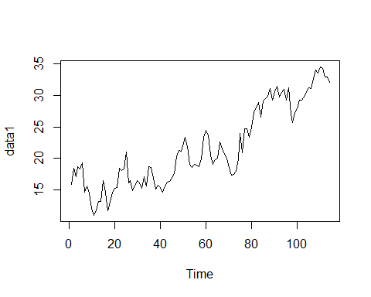

***Figure1: Time series plot for Mean Temperature***

2. Dataset: Mean Humidity

data2=data[,c(1,3)]  
data2<-ts(data2[,2],start=1)  
head(data2)

## [1] 85.86957 77.22222 81.88889 70.05000 74.94444 79.31818

ts.plot(data2)

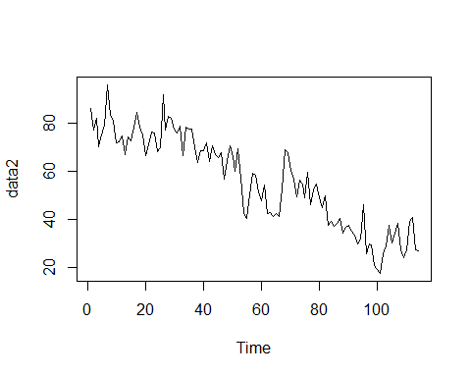

***Figure2: Time series plot for Mean Humidity***

3. Dataset: Mean Wind Speed

data3=data[,c(1,4)]  
data3<-ts(data3[,2],start=1)  
head(data3)

## [1] 2.743478 2.894444 4.016667 4.545000 3.300000 8.681818

ts.plot(data3)

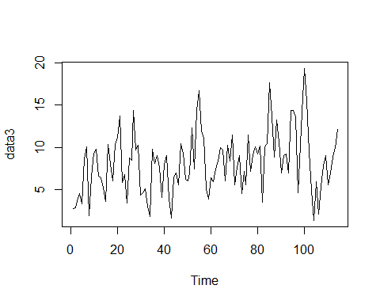

***Figure3: Time series plot for Wind Speed***

4. Dataset: Mean Pressure

data4=data[,c(1,5)]  
data4<-ts(data4[,2],start=1)  
head(data4)

## [1] 59.000 1018.278 1018.333 1015.700 1014.333 1011.773

ts.plot(data4)

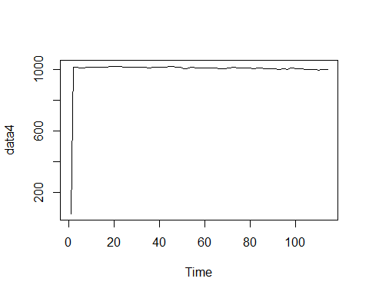

***Figure4: Time series plot for Mean Pressure***

**CONCLUSION:**

From the above plots we can make the following assumptions about the nature of the time series of the selected datasets:

* Dataset 1: Mean Temperature – We can see an increasing trend component but the existence of seasonal or cyclical component is not effectively understandable from the plot alone.
* Dataset 2: Mean Humidity – We observe a decreasing trend component and since the seasonal variation isn’t constant, there is multiplicative seasonality.
* Dataset 3: Wind Speed – The data can be said to follow a slightly positive trend. Since the seasonal variation isn’t constant, there is multiplicative seasonality.
* Dataset 4: Mean Pressure - Clearly there is no trend, seasonality or cyclical component.