Determining Stationarity of Dataset using ACF Plot

Practical 2

Ananya Kaushal

2022-01-19

**INTRODUCTION:**

ACF plays an important role in time series analysis. It helps in identifying the order of dependency in any time series data and also gives a clue regarding the nature of the time series data. In the practical, we determine the stationarity of the dataset using the ACF plot.

**AIM:**

The aim of this practical is to take any time series data set from a specific domain and analyze the nature of the given data, using ACF plot.

**PROCEDURE:**

Importing the package ‘astsa’ which contains our required dataset- UnempRate.

library(astsa)

**About the data:**

This dataset contains provides Monthly U.S. unemployment rate in percent unemployed from Jan, 1948 to Nov, 2016, where the number of observations are n = 827. The format of the dataset is: Time-Series [1:827] from 1948 to 2017: 4 4.7 4.5 4 3.4 3.9 3.9 3.6 3.4 2.9 ... and so on.

|  |  |
| --- | --- |
| S.No | Monthly Percent of Unemployed people in the US |
| 1 | 4.0 |
| 2 | 4.7 |
| 3 | 4.5 |
| 4 | 4.0 |
| 5 | 3.4 |

*Table 1: Monthly US unemployment rate in percent*

In the above table, serial numbers represent months starting from January 1948 to November 2016, so 1 stands for January 1948 and there is 4 percent unemployment rate in that month in the US.

**Plotting the time series of the data:**

plot(UnempRate, main = "Monthly Unemployment Rate in Percent in the US")

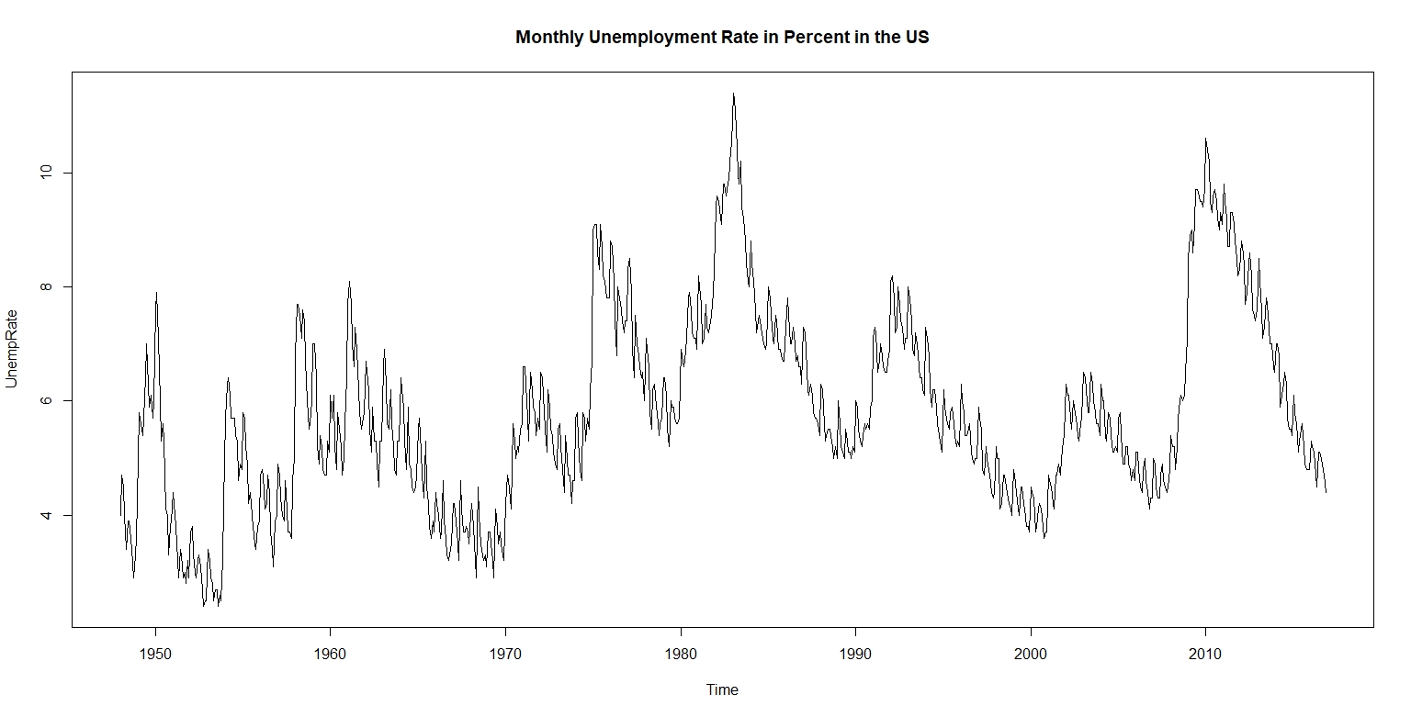

*Figure 1: Time Series plot of the dataset Unemprate*

*(The y-axis represents the Unemployment Rate in Percent, while the x-axis represents the years 1948-2016.)*

**INTERPRETATIONS:**

From the above plot we can make some assumptions about the nature of the plot:

* The plot above shows no apparent trend, which means there is no long term increase or decrease in the data. There is no increase or decrease in the average Unemployment Rate.
* There can be noticed a seasonality in the plot. Since the variation in seasonality is not constant, it is multiplicative seasonality.
* There is a peak in Unemployment around the year 1983-84. Another peak is noticed in the year 2010 leading to a fall in the Unemployment rate.

**Plotting the ACF Plot:**

acf(UnempRate,ylim=c(-1,1))

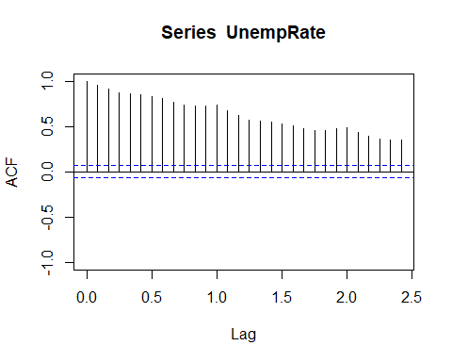

*Figure 2: ACF plot of the dataset UnempRate*

*(The y-axis represents the ACF value, while the x-axis represents the lag.)*

**INTERPRETATIONS:**

This plot gives the autocorrelation measures of the linear relationship between *lagged values* of a time series.

The ACL value is clearly significant for all of the lags, which indicate the existence of dependencies amongst the observations.

Hence, there is a strong dependency between the observations in the data and therefore the data is not stationary.

**CONCLUSION:**

In this practical we learnt more about analyzing the nature of a time series plot, and the usage of ACF plots to determine order of dependencies and stationarity.

We can observe that our dataset about the Unemployment rate in the US is a seasonal data. We do not notice any significant decrease in the Unemployment rate throughout these 70 years, which is to say that the unemployment issue in the US is still to be resolved.