FORECASTING FUTURE VALUES OF MICROSOFT STOCKS

Ananya Kaushal

2022-02-01

**INTRODUCTION**

If you have a time series that can be described using an additive model with increasing or decreasing trend and no seasonality, you can use Holt’s exponential smoothing to make short-term forecasts.

Holt’s exponential smoothing estimates the level and slope at the current time point. Smoothing is controlled by two parameters, alpha, for the estimate of the level at the current time point, and beta for the estimate of the slope beta of the trend component at the current time point.

The parameters alpha and beta have values between 0 and 1.

The values that are closer to 0 means that little weight is placed on the most recent observations when making forecasts of future values.

**AIM**

The aim of this experiment is to use Holts exponential smoothing to forecast future values of a suitable dataset.

**ABOUT THE DATASET**

The dataset ‘p3_2’ gives information about the stock information of Microsoft from 04/01/2015 to 04/01/2016

**PROCEDURE**

Calling the ‘astsa’ library and the dataset

library(astsa)

## Warning: package 'astsa' was built under R version 4.0.5

p4<-read.csv("p3_2.csv")  
head(p4)

## High  
## 1 40.76  
## 2 40.74  
## 3 41.78  
## 4 41.91  
## 5 41.69  
## 6 41.62

Plotting using the ‘ts.plot’ function

ts.plot(p4, main="Microsoft Stock")

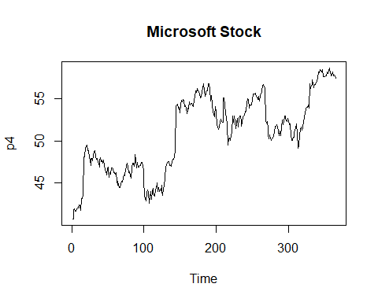

Figure 1: Plot for the Microsoft Stock

Using HoltWinters() to forecast the future values

p4forecast<-HoltWinters(p4, gamma=F)  
head(p4forecast$fitted)

## xhat level trend  
## [1,] 40.72000 40.74 -0.02000000  
## [2,] 41.76252 41.78 -0.01747745  
## [3,] 41.89287 41.91 -0.01712649  
## [4,] 41.67239 41.69 -0.01760928  
## [5,] 41.60227 41.62 -0.01773395  
## [6,] 41.93309 41.95 -0.01690643

plot(p4forecast)  
  
library(forecast)

## Warning: package 'forecast' was built under R version 4.0.5

## Registered S3 method overwritten by 'quantmod':  
## method from  
## as.zoo.data.frame zoo

##   
## Attaching package: 'forecast'

## The following object is masked from 'package:astsa':  
##   
## gas

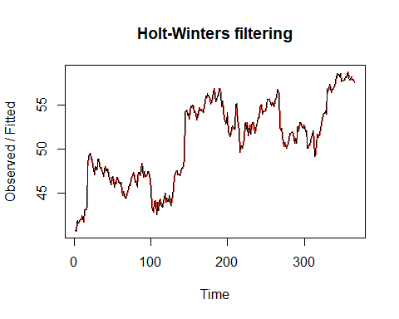

Figure 2: Graph after Holt-Winters filtering

Plotting the forecasted data

forecast_data<-forecast(p4forecast, h=5)  
plot(forecast_data)

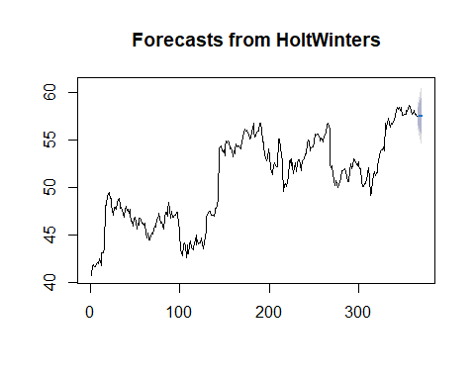

Figure 3: Forecasted data

**CONCLUSION**

From the above graph, we can conclude that the data remains stationary for the next five data points.