Autoregressive Models of Different Orders

Practical 5

Ananya Kaushal

1940233

**INTRODUCTION:**

An autoregressive (AR) model predicts future behavior based on past behavior. It’s used for forecasting when there is some correlation between values in a time series and the values that precede and succeed them.

In an AR model, the value of the outcome variable (Y) at some point t in time is — like “regular” linear regression — directly related to the predictor variable (X). Where simple linear regression and AR models differ is that Y is dependent on X and previous values for Y.

An AR (p) model is an autoregressive model where specific lagged values of y t are used as predictor variables.

**OBJECTIVES:**

The main objectives of this practical are:

1. Generate AR (1) processes of size 500 with phi=-0.8,-0.5,-0.3, 0.3, 0.7, 0.8.
2. Compare the behavior of ACF plots and time series plots in each of the above simulation.
3. Discuss the behavior of ACF plots of AR (1) process with phi=0.3 and 0.9 and n=10000.

**PROCEDURE:**

* Generating AR (1) processes of size 500 with phi values -0.8,-0.5,-0.3, 0.3, 0.7, 0.8 as sim1, sim2, sim3, sim4, sim5 and sim6 respectively.

sim1<-arima.sim(list(ar=c(-0.8)),n=500)  
sim2<-arima.sim(list(ar=c(-0.5)),n=500)  
sim3<-arima.sim(list(ar=c(-0.3)),n=500)  
sim4<-arima.sim(list(ar=c(0.3)),n=500)  
sim5<-arima.sim(list(ar=c(0.7)),n=500)  
sim6<-arima.sim(list(ar=c(0.8)),n=500)

* Plotting Time series plots of the simulated AR (1) processes sim1, sim2, sim3, sim4, sim5 and sim6 respectively.

par(mfrow=c(3,2))  
ts.plot(sim1)  
ts.plot(sim2)  
ts.plot(sim3)  
ts.plot(sim4)  
ts.plot(sim5)  
ts.plot(sim6)

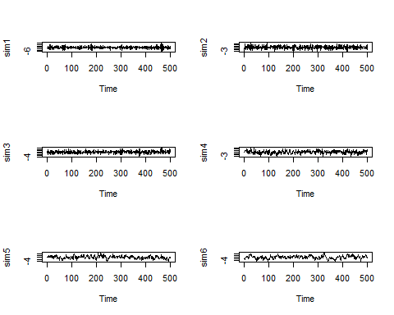

Figure 1: Time series plots of the simulations with different phi values

**INFERENCE:**

From figure 1, we can say that they all show stationarity. As the phi value approaches 1, they tend to become non – stationary.

* Plotting ACF plots of the simulated AR (1) processes sim1, sim2, sim3, sim4, sim5 and sim6 respectively.

par(mfrow=c(3,2))  
acf(sim1); acf(sim2); acf(sim3); acf(sim4); acf(sim5); acf(sim6);

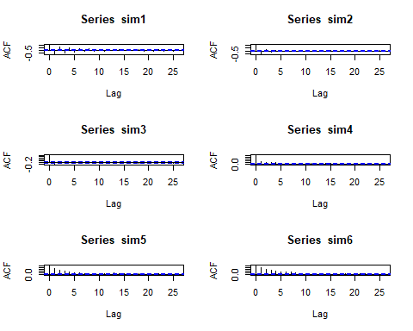

Figure 2: ACF Plots of the simulations with different phi values

**INFERENCE:**

From figure 2, we can conclude that when the phi value is negative, the ACF values are oscillating and when they are positive, the ACF values are exponentially decreasing in the ACF plots.

* Plotting PACF plots of the simulated AR (1) processes sim1, sim2, sim3, sim4, sim5 and sim6 respectively.

par(mfrow=c(3,2))  
pacf(sim1); pacf(sim2); pacf(sim3); pacf(sim4); pacf(sim5); pacf(sim6);

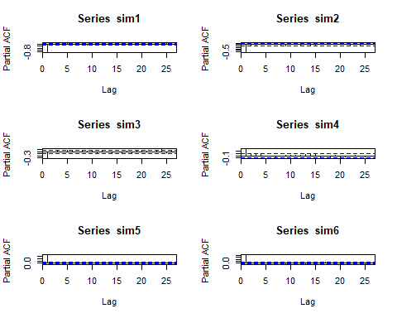

Figure 3: PACF Plots of the simulations with different phi values

**INFERENCE:**

From figure 3, we can conclude that the values cut off after lag = 1. For the negative phi values, the pcaf value is negative at lag 1 and for positive, it is positive at lag 1.

* Plotting Time series plots of the simulated AR (1) processes sim1, sim2, sim3, sim4, sim5 and sim6 respectively.

AR1=arima.sim(model=list(ar = 0.3),n=10000)#simulation of AR(1) with ?? =0.3  
acf(AR1)  
AR1=arima.sim(model=list(ar = 0.9),n=10000)#simulation of AR(1) with ?? =0.9  
acf(AR1)

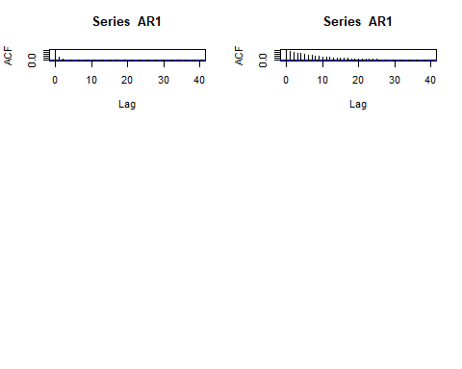

Figure 4: ACF Plots for the simulations with size 10000

**CONCLUSION:**

We can say that they all show stationarity. As the phi value approaches 1, they tend to become non – stationary. From figure 2, we can conclude that when the phi value is negative, the ACF values are oscillating and when they are positive, the ACF values are exponentially decreasing in the ACF plots.

We can also conclude that the values cut off after lag = 1. For the negative phi values, the PCAF value is negative at lag 1 and for positive, it is positive at lag 1.